Question Two:  
Unfortunately, I do not have any android device to try this on. I may have to skip this.

Question Four:

1. select u.username, t.user_id, count(t.user_id) as total_trainings

from users u, training_details t

where t.user_id=u.user_id

group by u.username, t.user_id

2.

3. select u.username, t.user_id, count(t.training_id)

from users u, training_details t

where u.user_id=t.user_id

group by u.username, t.user_id

having count(t.training_id

 )>1

Question Five:

Matches range a-z and 0-9

Question Six:

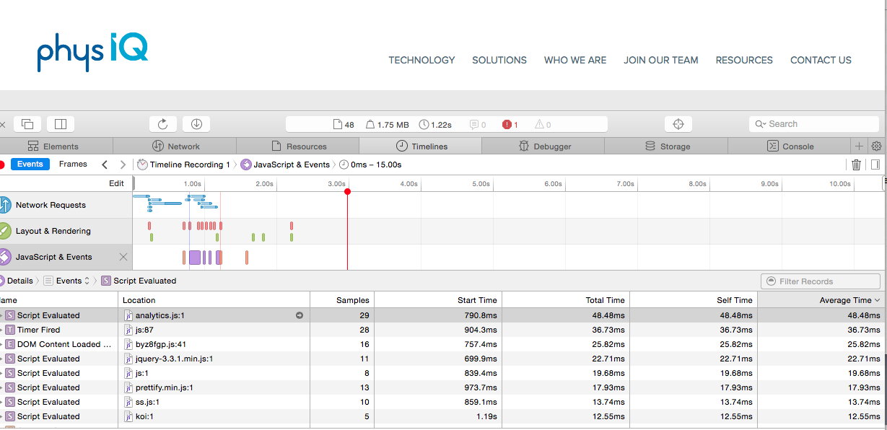

Question Seven:

I start by looking at the code results and logs. If it involves a source file, I look at that file as well. Then I look at the code. I try to re-create the problem being encountered in a test environment for best results in finding a resolution. I take it step by step starting from base and testing each step to the end performing sanity checks.