Filippo Zallocco

CS610

10/19/2023

Professor Turbe’

Project 3 – analysis

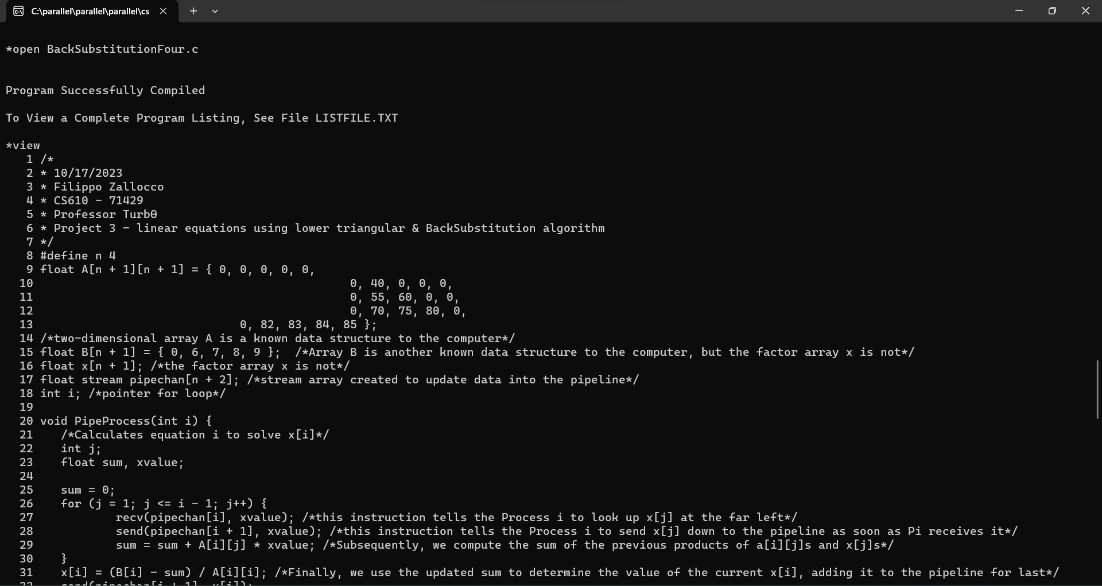

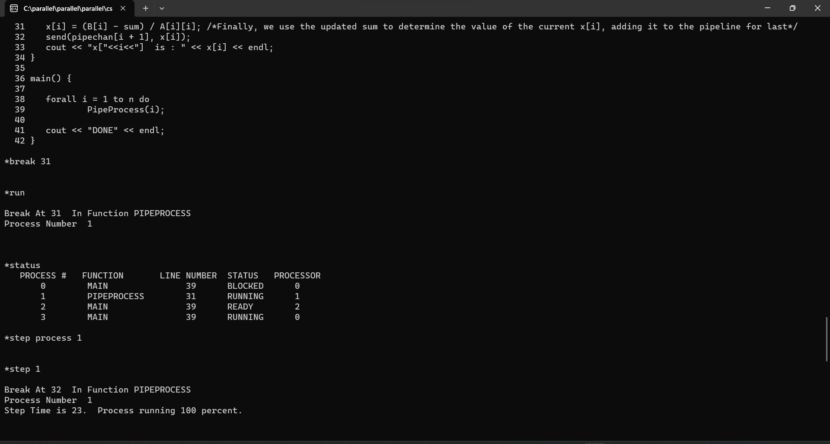

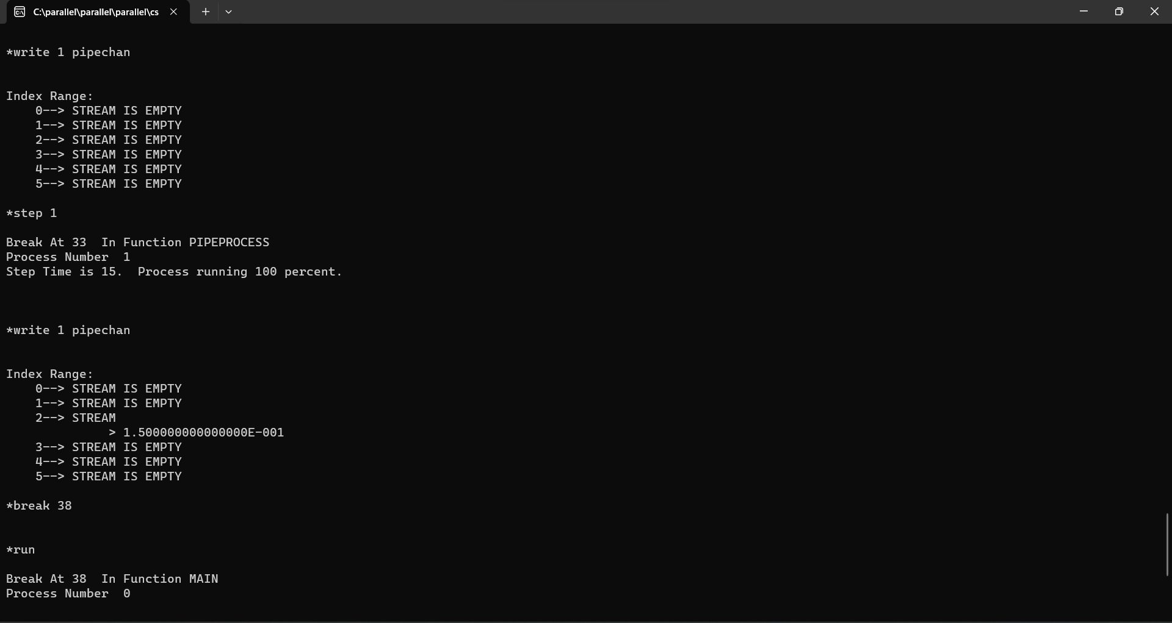

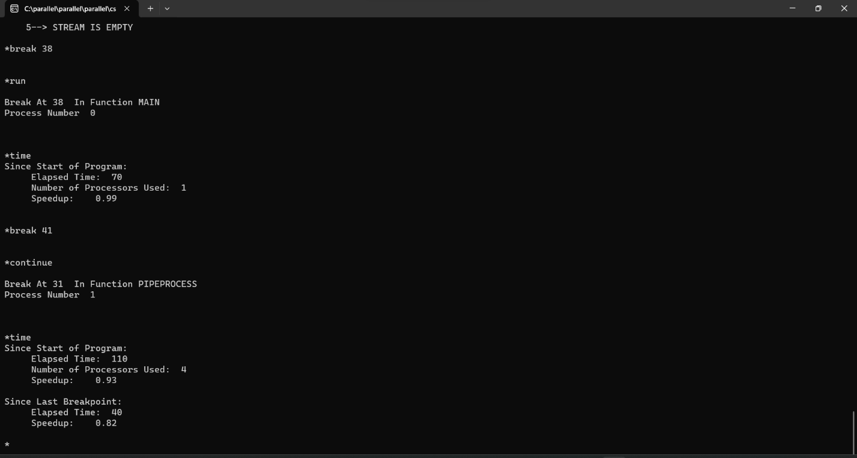

In this section, we run the first debugging commands we have learned in Project 1 and 2. After compiling the code, viewing the script in the terminal, I set a breakpoint at line 31. This allows me to run the program until line 31 on loop. In fact, Setting the break in the middle of the program, I can check the value of the x array and the stream contents.

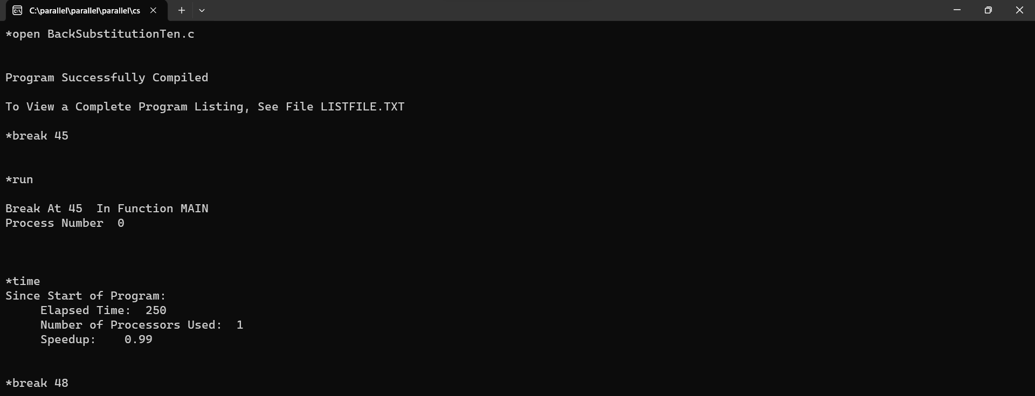

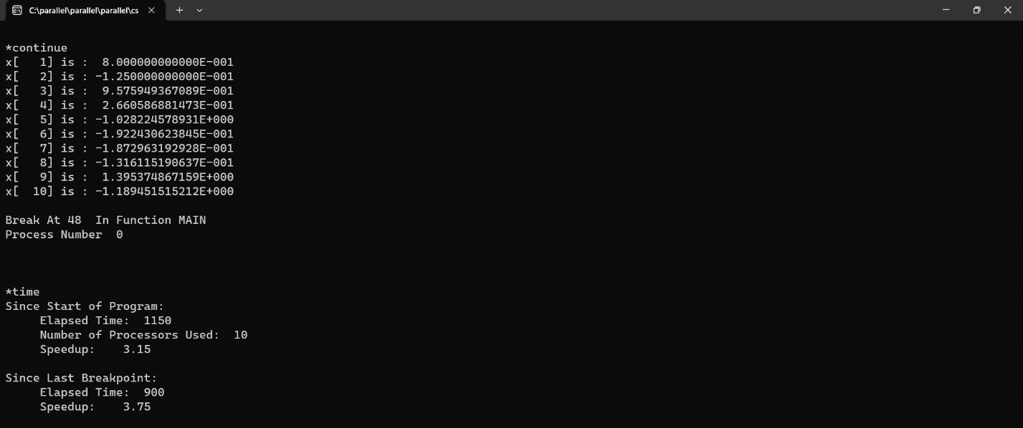

In this instance, I set a time function at line 45, where the parallel code begins, and line 48, where the print “DONE” instruction is. We may appreciate that the parallel section spreads the workload out over ten processors, carrying out the operations in 250 nano seconds. On the other hand, the final sequential code, which includes the final print instruction, requires 900 nano seconds.

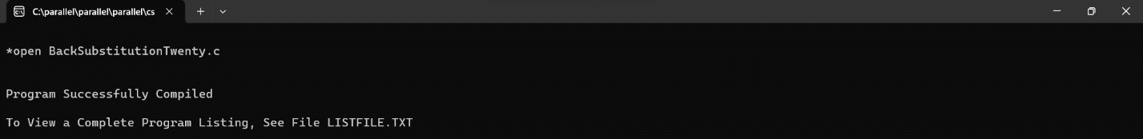

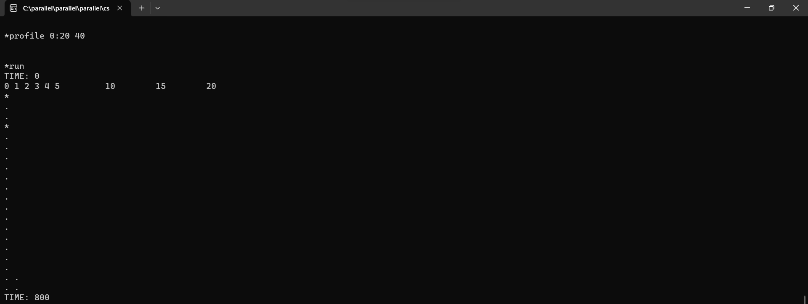

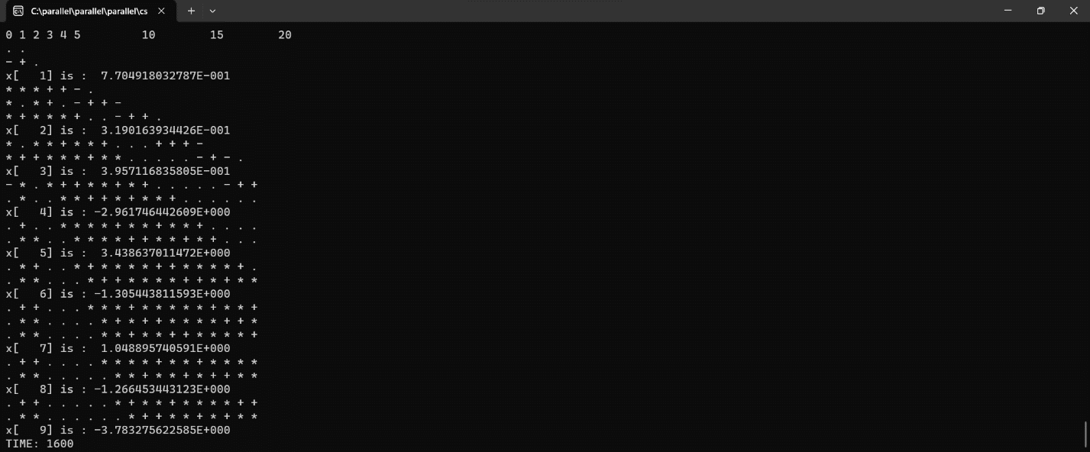

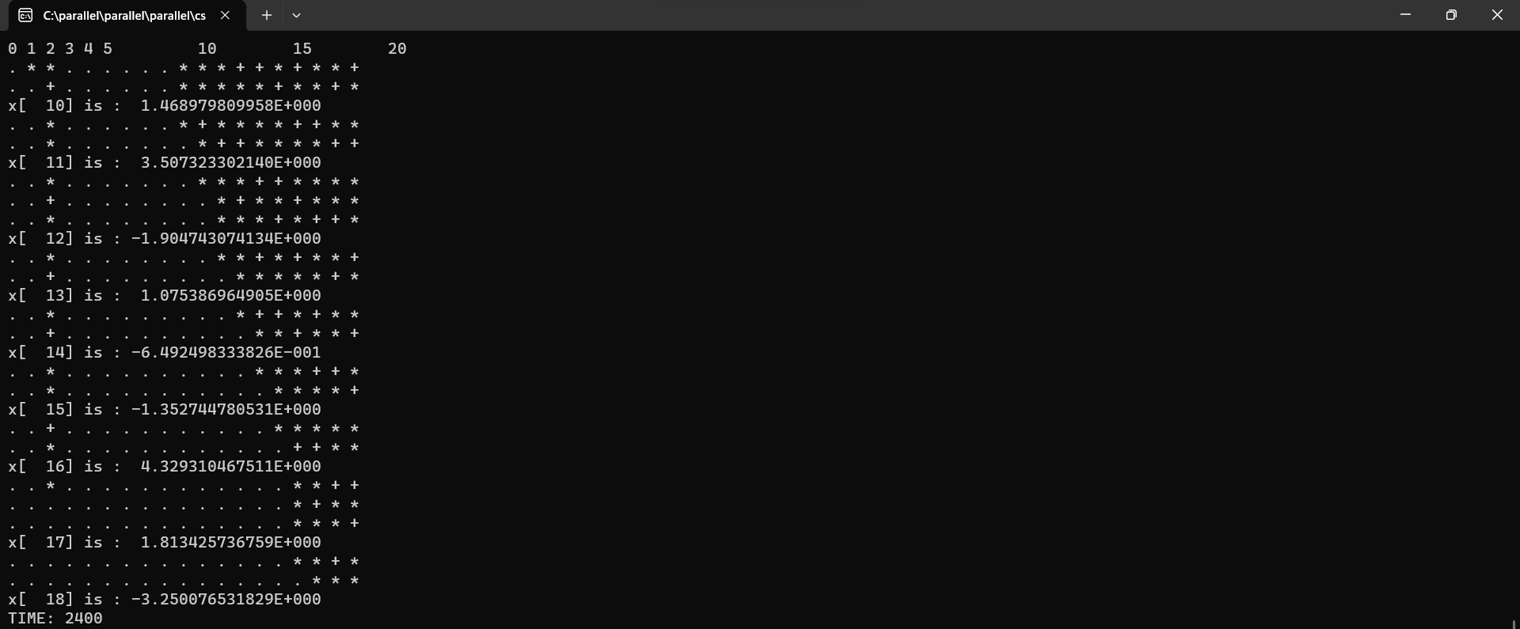

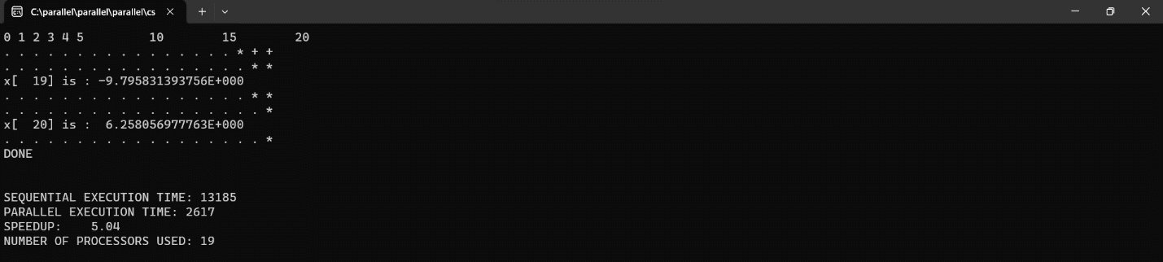

Finally, we test the profile function to study the histogram of the processors’ performance at intervals of 40 nano seconds. After 800, there is only one processor being used and the code execution is largely sequential. At 1600 nano seconds, the simulated environment calculated 9 vectors with multiple processors, and at 2400 nano seconds, 8 more vectors were added to the x array, relying on fewer processors as the program terminated. All in all, the parallel execution was 5 times faster than the sequential execution.