Filippo Zallocco

CS610

10/26/2023

Professor Turbe’

Project 4 – Analysis

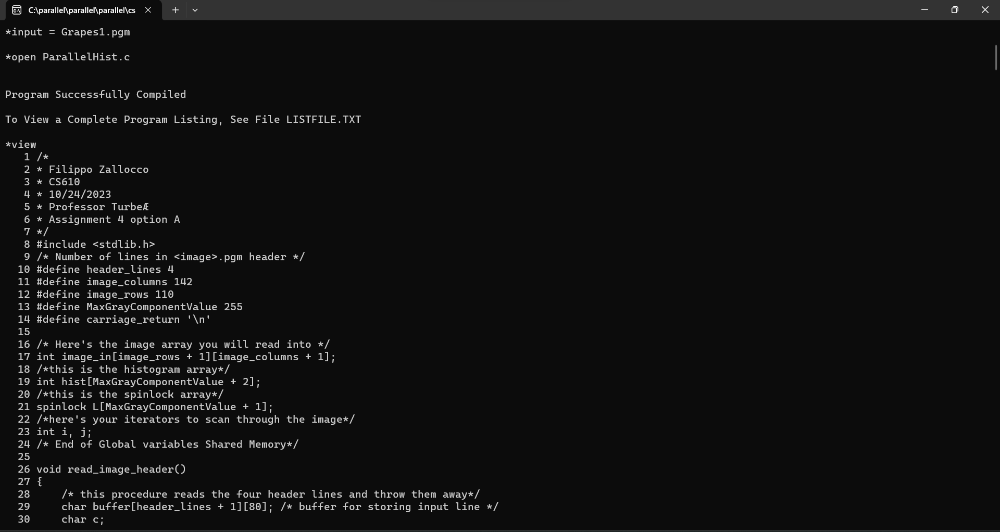

In this snapshot, I import the image Grapes and load the parallel program ParallelHist.c. Next, I set up a break at line 68, the end of the parallel loop.

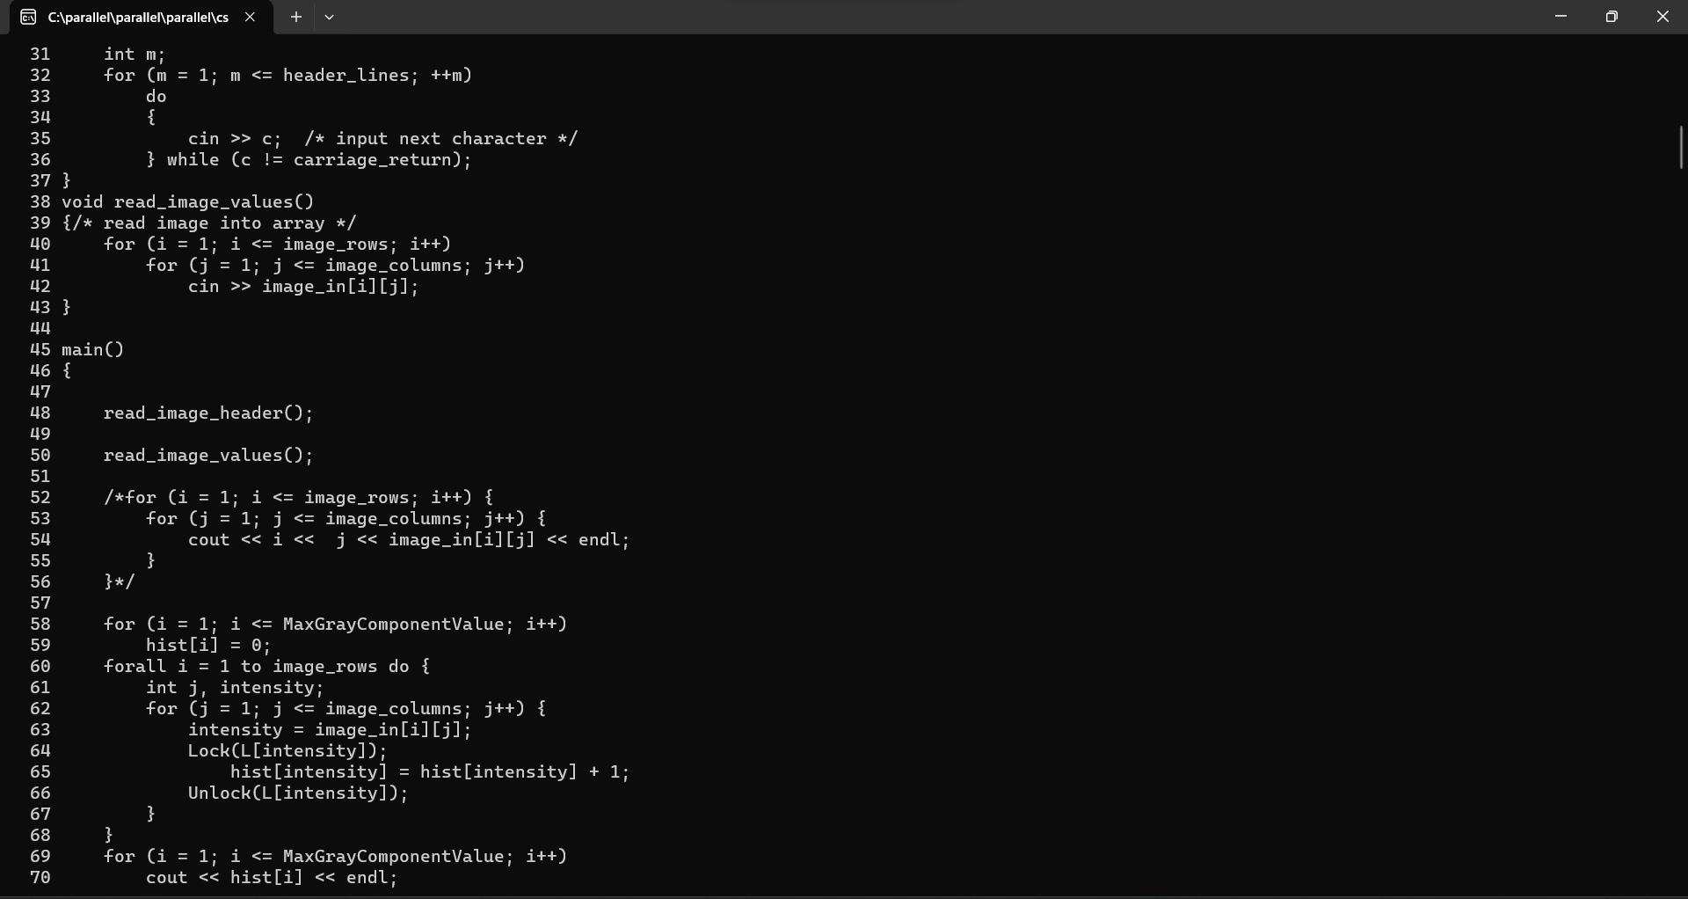

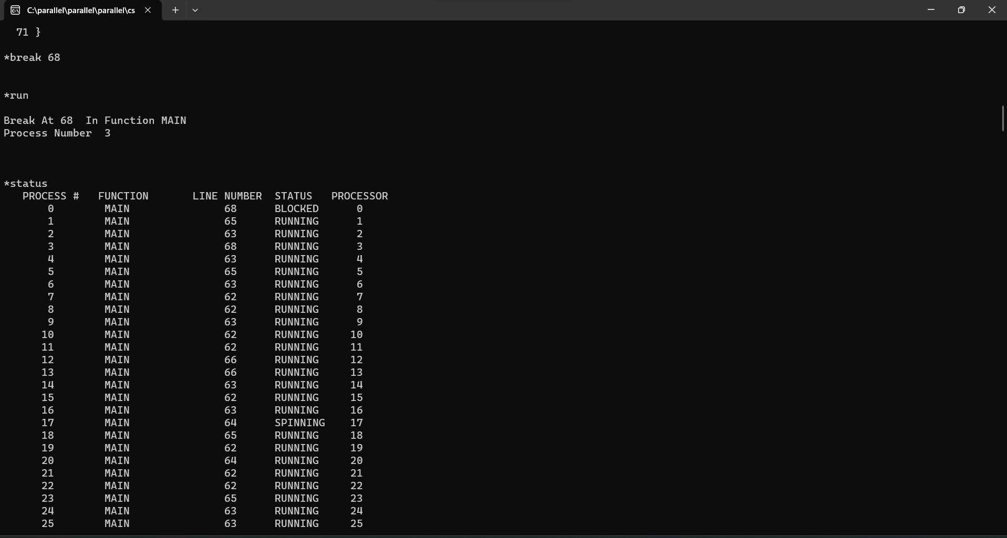

After running the program, I type status into the terminal to instruct the system to display all parallel processes created divided into running and spinning.

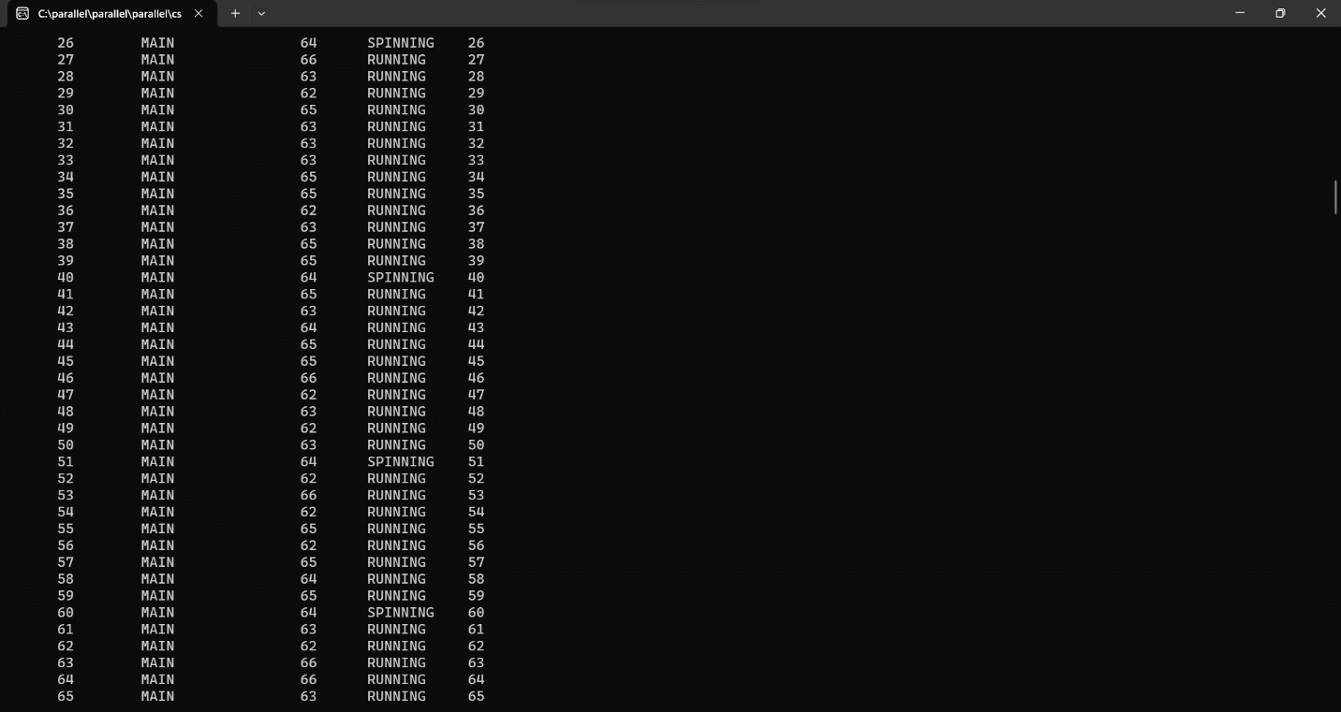

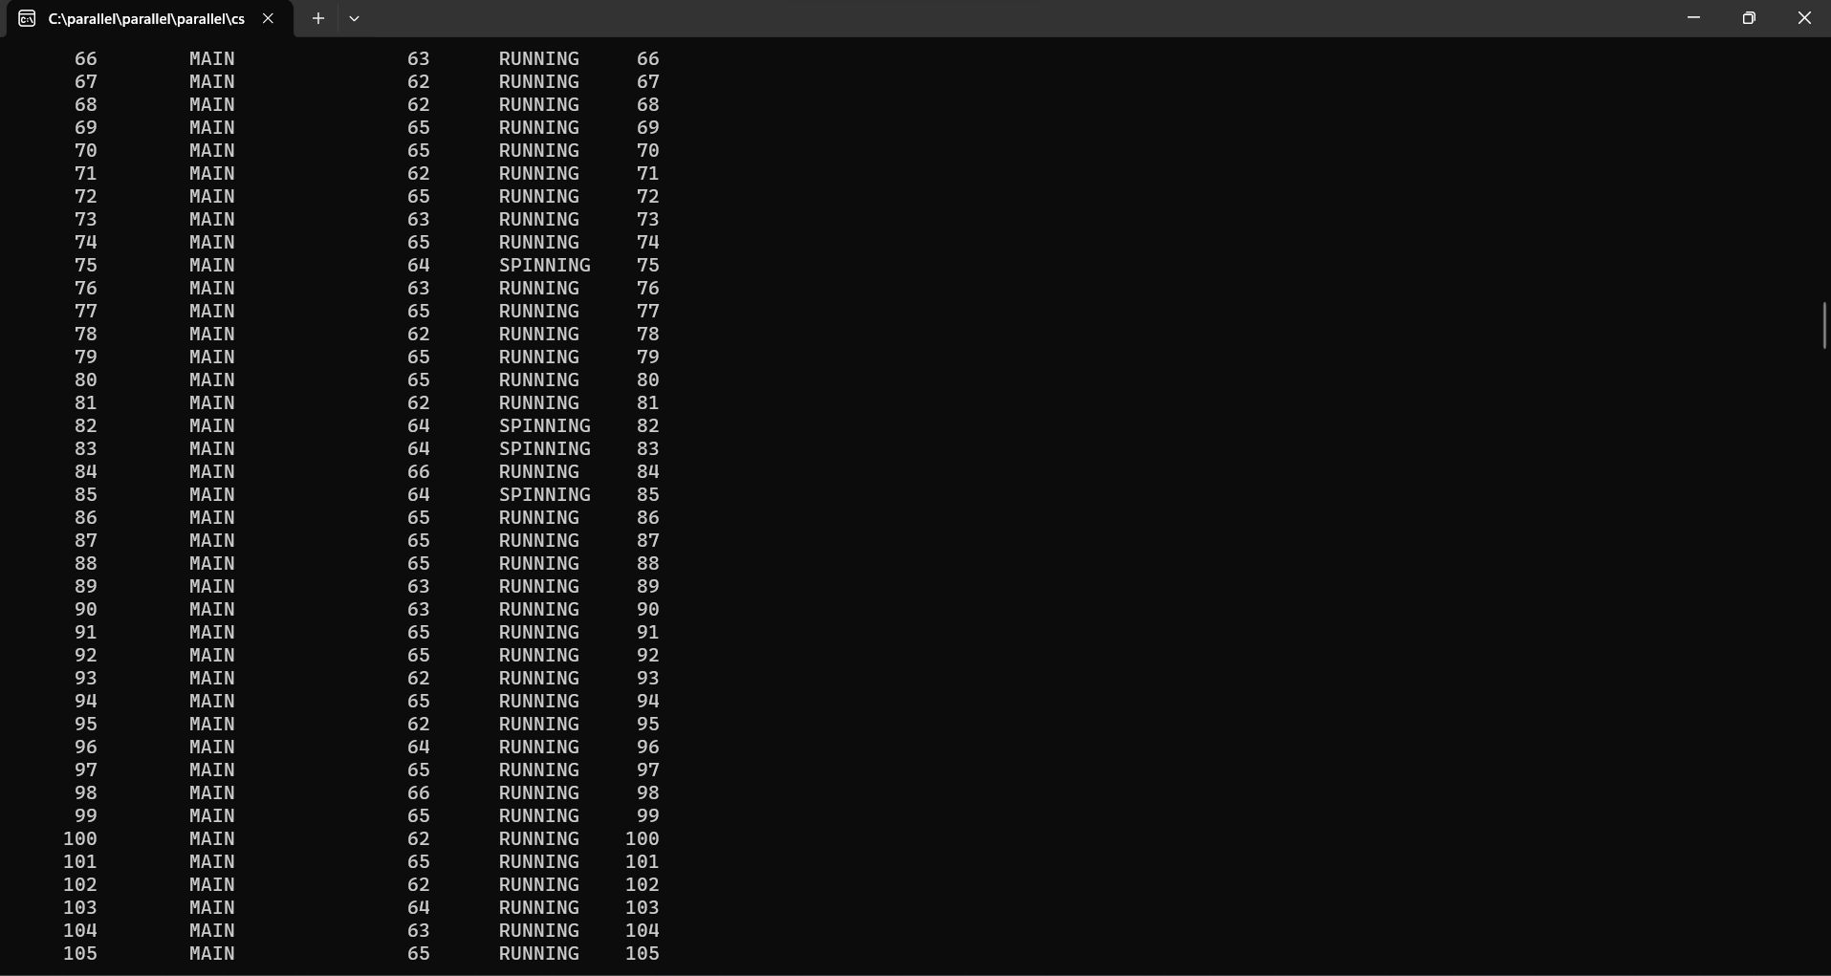

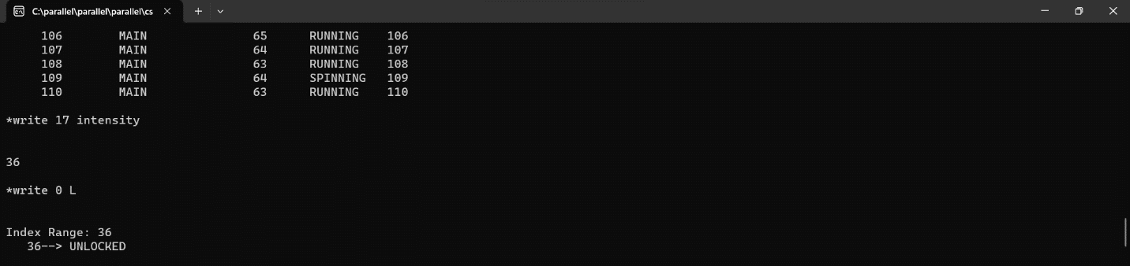

At the end of the table, I look into the spinning process 17’s intensity and find the value 36. Subsequently, I enter the value 36 inside the spinklock array L to understand whether the spinning process is locked or not.

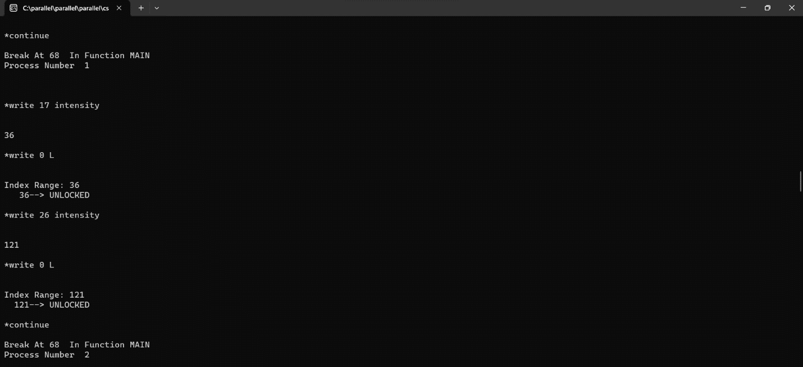

Since process 17 is unlocked because it is waiting to be used by the system, I proceed with my analysis by entering ‘continue’ into the terminal to study a different process. Upon writing process 26 intensity, I obtain the value 121. The index 121 of the array spinlock L returns ‘UNLOCKED’ as its value, thus confirming my hypothesis.

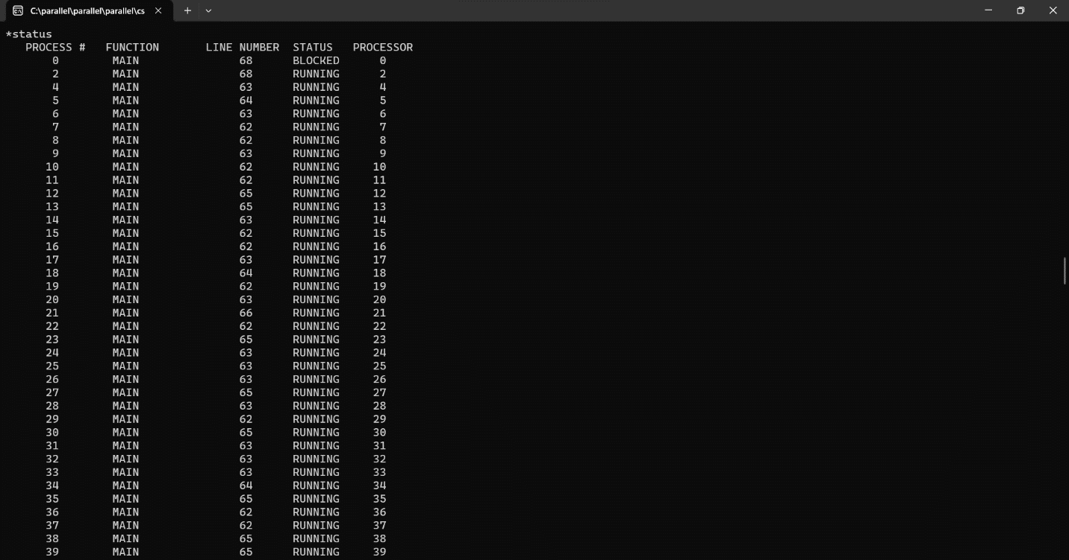

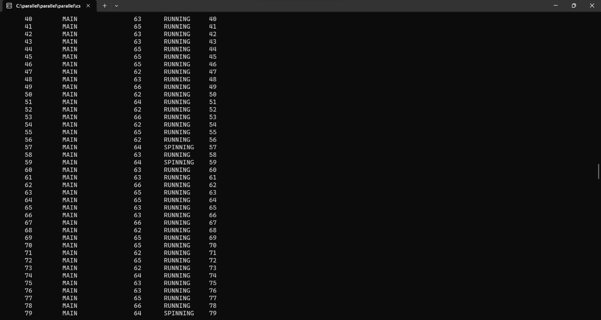

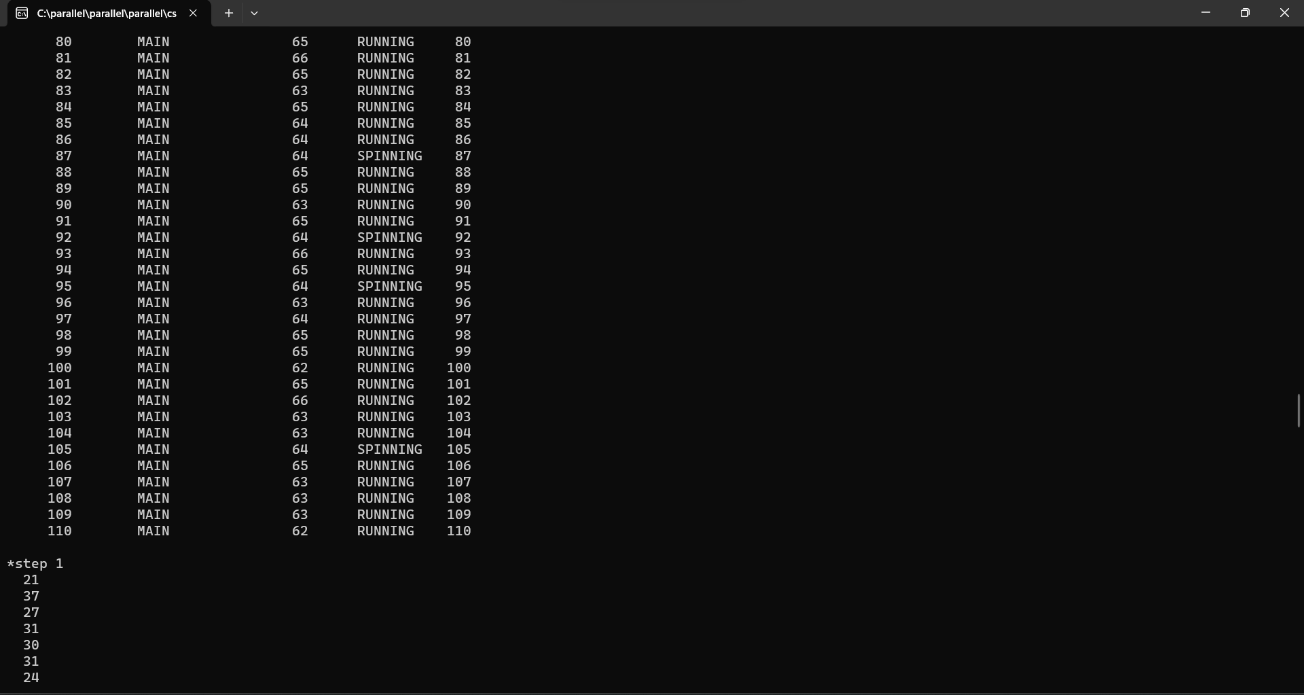

In fact, the process table now reports that both processes 17 and 26 are being used by the system. That is they are running.

When I enter step 1 into the terminal, the program finally displays its output and delivers a summary report at the bottom, describing the performance difference between parallel and sequential execution of the same program.

