Firebird GDB to SQL Server Importer
User Help and Operating Guide
Version 1.1.1.4 | May 2026

Purpose
Use this tool to import data from a Firebird .gdb database into an existing SQL Server database structure. It is designed for controlled Ortems data migration, validation, and demo-data transfer scenarios. The importer loads data only; it does not create the SQL Server schema.

Typical use: prepare the SQL Server schema, test both connections, select tables, review options, run the import, then check the final message and log.
Do not open Ortems against a partially loaded database after an aborted or failed import.

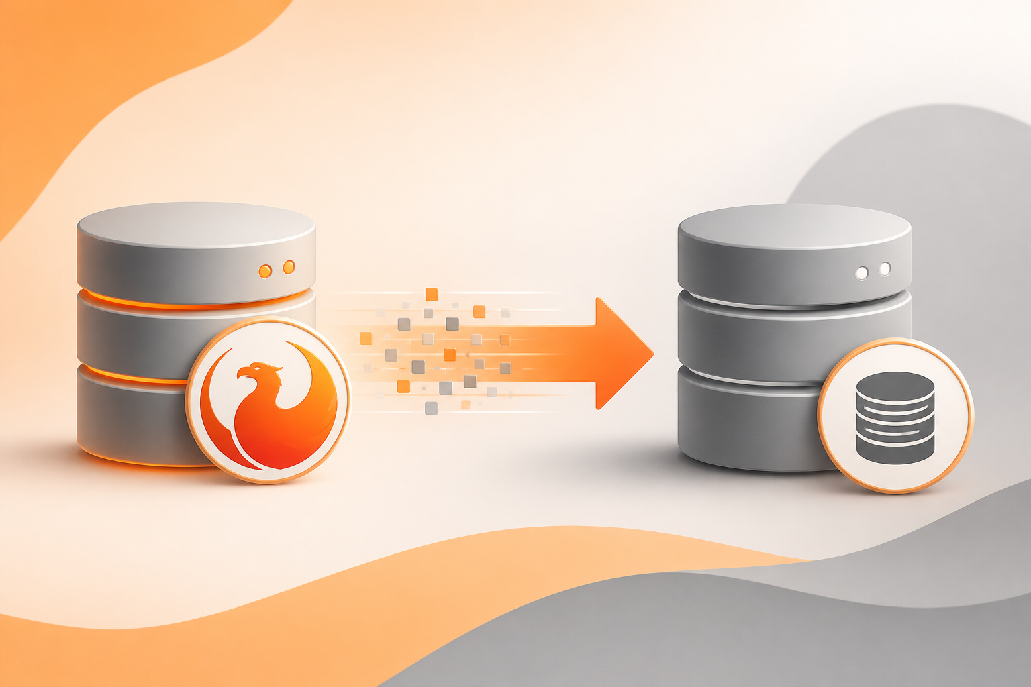

Contents
- 1. Before You Start
- 2. Quick Start: The Usual Import Flow
- 3. Main Screen Areas
- 4. Import Options Explained
- 5. Progress Bar and Final Result Message
- 6. Logs and Diagnostics
- 7. How to Read the Final Status
- 8. Ortems-Safe Import Notes
- 9. Troubleshooting Checklist
- 10. Safe Operating Practices
- 11. Preparing a Blank SQL Server Database

1. Before You Start
Confirm these items before running the importer. Most failed imports come from missing drivers, missing permissions, or a SQL Server database that has not been prepared with the Ortems schema.
- Firebird ODBC driver installed and available to the application.
- SQL Server ODBC driver installed on the workstation.
- Access to the source Firebird .gdb file and valid credentials. The default is often SYSDBA/masterkey, but use your environment credentials when they differ.
- An existing SQL Server database with the required Ortems schema and tables already created.
- SQL Server permissions to insert data, clear selected tables when requested, and disable/re-enable triggers when that option is used.
- A current backup of the target SQL Server database before any reload or destructive operation.
Important
This importer is not a schema creation tool. If the SQL Server database is blank, create the Ortems database objects first. See section 11.

2. Quick Start: The Usual Import Flow
Use this sequence for most migrations. Do not skip the connection tests; they catch the simplest problems before any data is changed.
1. Open the importer from the approved application folder.
2. Select the source Firebird .gdb file using Browse.
3. Confirm the Firebird server, port, user, and password.
4. Click Test Firebird Connection and continue only when the connection succeeds.
5. Enter the SQL Server target: server, database, authentication mode, and schema.
6. Click Test SQL Server Connection and continue only when the connection succeeds.
7. Click Load Table List and select the tables to import.
8. Review the import options before running. Pay special attention to clear/append behavior and foreign-key ordering.
9. Click Run Import and monitor the status line, progress bar, counters, and live log.
10. At the end, read the final message box. If there are warnings, skipped rows, failed tables, or errors, open the generated log before using the database.

3. Main Screen Areas
Area | What it does
Source (Firebird) | Selects the .gdb file and defines the Firebird connection settings. Start here.
Target (SQL Server) | Defines the SQL Server instance, database, authentication mode, and schema that will receive the imported data.
Tables to Import | Shows the source table list after a successful Firebird connection. Only checked tables are included in the run.
Run Area | Contains Run Import, Abort, batch size, progress bar, current log file, and the live execution log.
Footer | Shows the overall status, error count, and warning count during and after the import.

4. Import Options Explained
These options control how the importer treats existing data, dependencies, and data cleanup. For Ortems imports, the safest default is usually to keep foreign-key ordering enabled and to review the log after every run.
Option | Use it when... | What to watch
Clear selected tables before load | You are doing a full reload or clean migration. | Existing data in the selected destination tables is removed before import. Confirm backups and dependencies first.
Skip duplicate PK rows in append mode | You are appending into a database that may already contain some rows. | Rows are skipped only when the duplicate is confirmed by primary-key logic. Review skipped-row counts in the log.
Order tables by SQL Server FK dependencies | Most imports, especially Ortems data imports. | Parent tables are loaded before dependent tables when SQL Server metadata allows it. Keep this enabled unless support tells you otherwise.
Convert empty strings to NULL when target column is nullable | You want cleaner SQL Server data and the target column allows NULL. | Blank source values become NULL only when the target column is nullable.
Use safe fallback/default for NULL values in NOT NULL columns | Mandatory target columns may be blank in the source data. | The tool applies deterministic fallback values to avoid losing entire rows. Review the log to understand every applied fallback.
Temporarily disable target table triggers during clear/load | Triggers create side effects or slow down bulk copy. | Triggers are re-enabled after the import. If the run is interrupted, manually verify trigger state before using the database.

5. Progress Bar and Final Result Message
The progress bar shows the overall advancement of the import. It starts at 0% when the run begins, moves by selected table, and updates during row batches when the source row count can be estimated.
- The progress label shows the current table, table sequence, rows read, inserted rows, and skipped rows when available.
- The footer status shows operational messages, such as connection checks, active table, and final status.
- The live log gives detailed execution information while the import is running.
At the end, the application displays one of the following outcomes:
Message | Meaning
Import completed successfully | No failed tables and no counted errors. Review warnings if any are reported.
Import completed with issues | The process reached the end, but warnings, skipped rows, errors, or failed tables require review.
Import aborted | The user clicked Abort or the process stopped before completion. Treat the target database as partial until it is corrected and reloaded.
Import failed before start | Validation, connection, source file, or table-selection checks prevented the import from running.

6. Logs and Diagnostics
Each run creates a dedicated log file under the application log folder:
.\log\import_YYYYMMDD_HHMMSS.log
The log is the main evidence for support and troubleshooting. It includes connection status, selected options, import order, row counts, insert failures, ADO/SQL Server errors, failed-row snapshots, Ortems sanitizer actions, warnings, skipped rows, and the final summary.
Best practice
Keep the log from every failed or warning run. It is usually the fastest way to identify missing parent rows, foreign-key failures, trigger side effects, and Ortems startup inconsistencies.

7. How to Read the Final Status
Signal | What to do next
Errors = 0 and failed tables = 0 | The import is considered successful. Still review warnings if they are present.
Warnings > 0 | The process corrected, skipped, or adjusted data. Read the log before relying on the migrated database.
Failed tables > 0 | One or more selected tables could not be fully imported. Resolve the table-specific root cause before opening Ortems.
Aborted | The target may be partially loaded. Correct the issue and rerun the import before using the database.
Skipped duplicate rows | Rows already existed in append mode and were confirmed by primary-key logic on the target.

8. Ortems-Safe Import Notes
The importer includes Ortems-focused safeguards to reduce startup issues after migration. These safeguards are designed to keep parent-child relationships coherent, avoid known unsafe rows, and repair specific mandatory effectivity dates when safe values can be inferred from the source data.
- The tool applies semantic Ortems table ordering before final SQL Server foreign-key ordering.
- Known startup-sensitive rows or tables may be quarantined, skipped, or reported in the log.
- WO header and phase consistency is checked before loading when the required tables are part of the selected dataset.
- Complete orphan WO chains can be skipped to avoid broken target data.
- If Ortems reports a startup error after import, use the Ortems error message, table names, and the latest import log together. The log is usually where the broken relationship becomes visible.

9. Troubleshooting Checklist
Problem | Recommended action
Firebird connection fails | Verify the .gdb path, server name, port, Firebird service, ODBC driver, user, and password.
SQL Server connection fails | Verify SQL Server name, database name, authentication mode, network access, and permissions.
No tables are listed | Test the Firebird connection first and confirm the source database contains user tables.
Foreign-key errors occur | Keep FK ordering enabled, import required parent tables, and review failed-row snapshots for missing parent keys.
Duplicate errors occur | Use duplicate skipping only when append mode is expected. Confirm that the duplicate already exists in the target database.
Ortems does not open after import | Do not keep using the database blindly. Review the log for PL_0170, PL_0445, PL_0451-related cleanup, skipped rows, missing phases, and WO/header-phase relationships.

10. Safe Operating Practices
- Run the import first in a test SQL Server database, not directly in a production Ortems environment.
- Back up the target database before using Clear selected tables before load.
- Keep the generated log file as evidence for each test and migration run.
- Do not open Ortems against a partially loaded database after an abort or severe failure.
- After any failed import, validate SQL Server constraints, triggers, and table counts before rerunning.
- When sharing an issue for support, include the log file, target database name, selected options, and any Ortems startup error screenshots.

11. Preparing a Blank SQL Server Database
Use this section only when the SQL Server database is empty and does not yet contain the Ortems schema. The importer expects the tables and database objects to already exist before the import starts.
Before you import
Do not click Run Import against a blank SQL Server database. First create the Ortems database objects using Ortems Environment Manager, then return to the importer.

When this step is required
- The target SQL Server database is new or blank.
- The database connection works, but the Ortems tables have not been created yet.
- Ortems Environment Manager reports that the database is empty.

Step-by-step schema creation
1. Open Ortems Environment Manager.
2. Create a new environment or select the environment that points to the target SQL Server database.
3. Enter or confirm the SQL Server connection information: server, database, authentication mode, user, password if required, and schema.
4. Click Test to validate the connection.
5. If the database is empty, Environment Manager will show a message or blue link indicating that the database is empty.
6. Click the blue database-empty link to open the object creation window.
7. In the new window, click Create the objects.
8. Wait until the object creation process finishes successfully. If an error appears, fix the connection, permissions, or database configuration before continuing.
9. Close the object creation window and return to Environment Manager.
10. Test the environment connection again to confirm that the Ortems objects now exist.
11. Open the importer, test the SQL Server connection, load the table list, review the options, and run the import.
Permission reminder
Creating the Ortems database objects may require higher SQL Server permissions than importing data. If object creation fails, ask the database administrator to verify the account privileges.

After the schema is created
- Use the importer only to load data into the existing objects.
- Keep the same target database and schema that were validated in Environment Manager.
- If the import fails later, troubleshoot the import log first; do not recreate the schema unless instructed to do so.

End of user help

