

**Professor:** Gabriel Castillo Cortés

**Team:** Maria Fernanda Zetter Cervantes  
Alfredo Emmanuel Garcia Falcon  
Jose Carlos Vargas Del Río

**Project:** The Dashboard

The Dashboard: Covid-19

**Introduction**

This project consists of a tool able to display gathered information about Covid-19 in Mexico. The data was stored in a single spreadsheet where everyone can see it, and everyone was able to do the proper filter to get the information needed. But there was no easy way to visualize the data, just rows and columns with information. Our job was to make it easy to read and understand so everyone could see the data in a way we can make conclusions about this pandemic and prevent cases in the future.

We were able to gather the data, process and display it in a way all the audience would be able to understand what is happening about Covid-19. The following chart represents information collected from different government entities and hospitals that attend patients with symptoms related to this disease.

**Dev Log**

Overall the project while it wasn’t exactly hard it had its own set of issues, we were able to create most of the things following the labs and the stuff seen in class but giving format to graphs was something that was a pain, for example the pie chart was really tough to work with it didn’t respect the margins we set for it neither it would be added to the place we wanted to in the visuals it was hard to work with in general.

Another thing that was hard to grasp was how to correctly create the json file so that it would actually help in the creation of the table, specifically the one that took us the most was the “Cases and death of patients with an existing condition” graph. What we did was to correct some snippets in the code that was given to us the ‘covid.py’ and what we did was creating a file for each graph so that this could work for us.

As we are not so well versed in pandas it took us a while to be able to compare the data and extract the information as we wanted. Also the data was too big and sometimes it gave us lots of problems when processing it and we weren't able to visualize correctly, so we had to filter the file and extract only the data we needed for the specific set so that then we could actually work on it.

**Charts**

1. **Cases and deaths of patients with an existing condition.** This chart represents the relationship between the deaths and the previous condition of patients with Covid-19 in December. We can see that, despite smoking patients were the most infected, there were less deaths than pneumonia and diabetes.

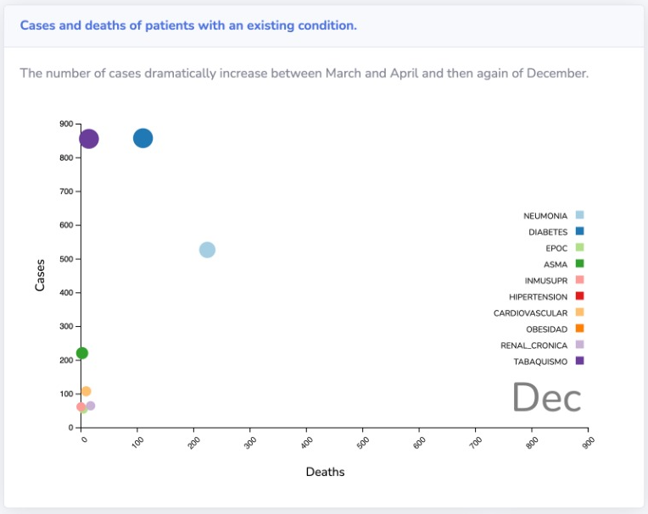

1. **Main preconditions.** Here is the classic cake chart displaying the main preconditions of patients diagnosed with Covid-19. We can see pneumonia is the condition with most cases and smoking has the least cases.

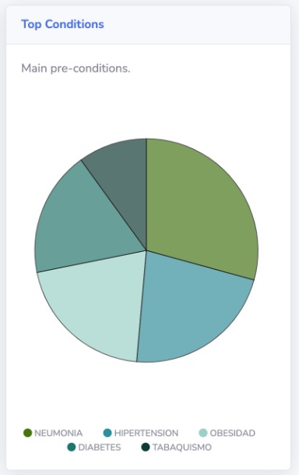

1. **Total cases by month.** This chart tracks the total cases through the year by month. We can clearly see the infection wave where we had a lot of infections suddenly and the population were worried about it.

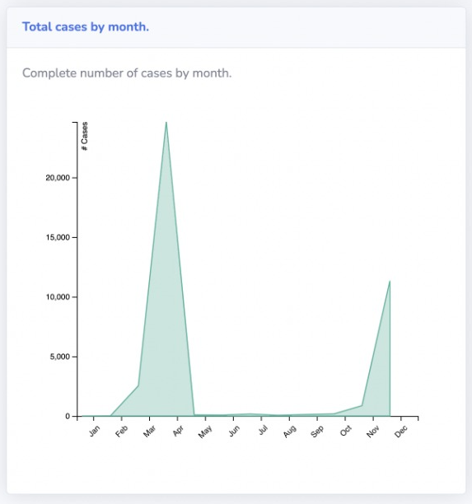

1. **Cases by state in Mexico.** This chart represents the cumulative number of cases of covid per state, this can help us identify which state is struggling the most with the number of infections, this could be helpful to see which state needs more urgent actions or see which state isn't doing their best in handling the situation. Of course the reasons could vary depending on many things, in this case for example it could be that DF-CDMX has the biggest number of persons per state in the country so that could be an explanation, but for these we would need to observe more data to get more conclusive results.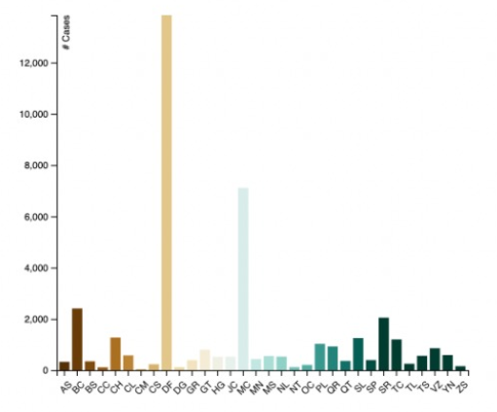

**Conclusion**

This project was very interesting. We could have an experience of real world data mining. We gathered real data about a specific topic, processed it and displayed it in a friendly way. We learned new tools that we can use in the industry and we set the base of data visualization so we can further learn more things about it and grow our professional skills.