SwinRGBTrack with shared hierarchical representations

and post-encoder fusion for RGB-T tracking
Zhigang Feng*, Rui Chang
School of Automation, Shenyang Aerospace University, Shenyang 110136, China

Abstract
RGB-T tracking requires shared representations that retain modality-specific information while using complementary observations for target matching. We propose SwinRGBTrack, which combines shared hierarchical visual representations, cross-modal adaptation within relation layers, and post-encoder fusion. The first three stages of Swin-B extract features at a stride of 16. During template–search relation encoding, bidirectional bottleneck prompts exchange modality states, while a thermal-infrared-specific low-rank branch adapts the attention projections. The two target-conditioned representations are then fused and passed to a unified decoder for classification and bounding-box regression. This design integrates inter-modal state exchange and intra-modal projection adaptation into target relation modeling, adding approximately 0.402 M adaptation parameters. On the common LasHeR test sequences, SwinRGBTrack achieves precision, normalized precision, and success rates of 72.68%, 68.70%, and 57.67%, respectively. On the full GTOT test set, maximum precision and maximum success rates reach 91.72% and 78.68%. These are the highest overall scores among the methods re-evaluated on the respective datasets. On the full RGBT234 test set, the corresponding scores are 85.67% and 64.13%. Attribute-level and frame-level analyses further show how the framework uses complementary modalities for localization under partial occlusion, illumination changes, and scale variation.
Keywords: RGB-T tracking; Swin Transformer; Hierarchical representations; Cross-modal fusion; Prompt learning; Low-rank adaptation

1 Introduction
RGB-T tracking estimates the state of a target throughout paired visible and thermal infrared sequences, given its initial bounding box. Visible images provide texture and color information, whereas thermal infrared images can preserve target contours under insufficient illumination. Appearance changes, thermal crossover, and background interference alter the reliability of both modalities. A tracker must therefore extract complementary cues under the constraints imposed by the target template while maintaining target–background discrimination. Benchmarks such as LasHeR and VTUAV include occlusion, scale variation, and complex acquisition conditions, providing diverse scenarios for examining cross-modal representations and fusion strategies [1, 2].
Target localization depends on both semantic discrimination and spatial sampling density. The Vision Transformer (ViT) models long-range relationships through global attention [3], whereas the Swin Transformer builds hierarchical representations through window attention, shifted-window interactions, and progressive downsampling [4]. The spatial resolution of the backbone output determines the localization grid and the size of subsequent template–search relation computations. SwinTrack separates visual feature extraction from target relation modeling [5], providing a structural basis for balancing representation depth and matching cost. Extending this architecture to RGB-T tracking also requires specifying how shared visual parameters accommodate different imaging statistics and where the two modality streams should be combined.
We connect the third-stage output of a shared Swin-B backbone to a two-stream template–search relation encoder, retaining visual features with a stride of 16 and 512 channels. The two modalities maintain separate token sequences during encoding, receive prompts from the other modality at each layer, and are fused at the encoder output. The representations being fused therefore already encode target relations conditioned on the template, and their complementary information remains available to subsequent search decoding. This arrangement connects visual feature extraction, target-conditioned interaction, and unified prediction by placing fusion within the target matching process.
To adapt the shared relation network to modality differences, we combine bidirectional bottleneck prompts with thermal-infrared-specific low-rank adaptation (LoRA). The prompts transform the auxiliary modality state into a residual at the layer input, while LoRA adds a low-rank update to the thermal attention projections. These mechanisms adjust the features entering a relation layer and the mappings within that layer, respectively. Together, they introduce approximately 0.402 M parameters and form an information exchange path with the subsequent equal-weight fusion and channel bias. Beyond prompt-based state transfer alone, the design assigns distinct roles to state exchange and projection adaptation within a separate target relation network.
This work makes three contributions. First, we develop an RGB-T tracking framework that connects a shared hierarchical visual front end to two-stream relation encoding, fuses the modalities after target-conditioned representations have formed, and localizes the target through unified decoding. Second, we combine bidirectional state prompts with thermal-specific low-rank projection adaptation inside the relation layers, enabling cross-modal interaction and modality-specific adjustment around a shared core. Third, overall comparisons, structural comparisons, and attribute analyses assess the resulting framework. SwinRGBTrack obtains the highest overall scores within the respective LasHeR and GTOT re-evaluation sets, while evaluations across datasets and frame-level case studies characterize the conditions under which it succeeds or fails.

2 Related work

2.1 RGB-T tracking and cross-modal fusion
RGB-T fusion methods use modality selection and interaction to mitigate information degradation under different imaging conditions. MaCNet combines modality-aware attention with competitive learning, CAT introduces challenge-specific branches, and FANet aggregates features according to their quality [6, 7, 8]. MANet++ uses multiple adapters to model modality differences, DMCNet exchanges information through mutual conditioning, and APFNet adopts attribute-driven progressive fusion [9, 10, 11]. These approaches incorporate cross-modal complementarity into target representations through feature quality, challenge categories, and conditional dependencies.
Transformer trackers incorporate cross-modal fusion into target relation modeling. TBSI bridges the search regions of the two modalities through the template to strengthen target-related interactions [12]. GMMT, CKD, and CSTNet investigate generative fusion, coupled knowledge distillation, and channel–spatial interactions, respectively [13, 14, 15]. AFTER selects fusion paths through attention routing [16]. Our work focuses on the interface between a shared hierarchical visual front end and a target relation network: it retains two-stream encoding states, introduces lightweight adaptation within relation layers, and combines the encoded representations into a unified decoder input.
Modality differences, frequency components, and temporal information offer further perspectives on fusion. MFNet compensates for modality differences and reselects features [17], while FHAT organizes complementary features through frequency hybrid awareness [18]. BTMTrack strengthens target association through dual-template bridging and temporal–modal candidate elimination [19]. TCM-tracking uses temporal correlation to drive cross-modal interaction and also provides a lightweight backbone variant [20]. MMSTC jointly models spatial target–background relationships and their temporal consistency, propagating historical tracking cues through quality-aware decoding [21]. These temporal approaches draw on information sources that differ from the per-frame relation encoding used here.
Table 1. Fusion mechanisms and information paths in representative RGB-T methods.
Method | Core mechanism | Information path and structural focus
MFNet [17] | Modality difference compensation and feature reselection | Compensation and reselection of fused modality features
FHAT [18] | Frequency hybrid awareness | Complementary high- and low-frequency information
BTMTrack [19] | Dual-template bridging and candidate elimination | Dynamic templates and temporal–modal candidate association
TCM-tracking [20] | Temporal correlation-driven cross-modal interaction | Temporal interaction with base and lightweight variants
SwinRGBTrack | Bidirectional prompts, TIR LoRA, and post-encoder fusion | Shared hierarchical front end, relation-layer adaptation, and post-encoder fusion
Table 1 summarizes fusion strategies based on modality differences, frequency information, and temporal association. SwinRGBTrack uses a shared visual front end to provide a consistent feature interface, then exchanges and adapts modality information within relation layers. Thus, the representations are conditioned on the template before fusion, and the fused features remain involved in search decoding.

2.2 Transformer tracking and hierarchical visual representations
Transformers provide a common formulation for modeling relationships between template and search regions. ViT establishes global connections directly over token sequences [3]. The Swin Transformer instead computes attention within local windows and expands interactions through shifted windows and patch merging [4]. Hierarchical downsampling yields stages with different spatial densities and channel capacities. The selected backbone output stage therefore affects both localization granularity and the scale of subsequent relation computations.
SwinTrack combines a Swin visual backbone with a template–search relation network, separating visual feature extraction from target matching [5]. We retain this organization and extend the shared first three backbone stages to paired RGB-T inputs. Only the single-scale third-stage output is used for target relation encoding. Cross-modal prompts and thermal-specific projection adaptation are introduced within the relation layers, and fusion is placed between relation encoding and decoding. The backbone progressively builds hierarchical representations, while matching operates on a fixed-scale feature grid.

2.3 Cross-modal prompts and low-rank adaptation
ViPT transfers a frozen RGB foundation model to multimodal tracking through modality-related prompts [22]. MPLT inserts mutual prompt modules with attention mechanisms into backbone layers [23]. BAT establishes bidirectional adaptation in a two-stream Transformer with shared parameters and combines the outputs for target prediction [24]. These studies show that lightweight state interactions can reuse pretrained representations. SDSTrack combines symmetric adaptation with self-distillation, UnTrack uses a unified model for different auxiliary modalities, and HATrack addresses modality misalignment and representation differences through spatial recalibration and heterogeneous adaptation [25, 26, 27].
LoRA represents a weight update as the product of two low-rank matrices, providing a parameter-constrained adaptation space for a shared network [28]. We place bidirectional prompts at the inputs of a separate relation encoder and introduce LoRA only into the query, key, and value (QKV) projections of the thermal stream. Relative to SwinTrack, these mechanisms explicitly introduce information from the other modality into target relation modeling. Relative to ViPT, MPLT, and BAT, the framework adapts both the input states and modality-specific projections of the relation layers while retaining unified relation decoding after two-stream encoding. These choices define the architecture studied in this work.

3 Method

3.1 Framework and tracking formulation
SwinRGBTrack consists of shared visual representation learning, cross-modal adaptation within relation layers, post-encoder fusion, and target prediction, as shown in Fig. 1. RGB and thermal infrared (TIR) template and search images pass through a shared Swin-B backbone to obtain third-stage features. Within each modality, template and search tokens are concatenated and passed to an eight-layer relation encoder. Bidirectional prompts transfer the auxiliary modality state before each layer update, and QKV LoRA adapts the attention mappings in the TIR stream. The encoded template and search features are fused separately across modalities. A single relation decoder layer then updates the search representation, followed by classification and bounding-box regression to localize the target.
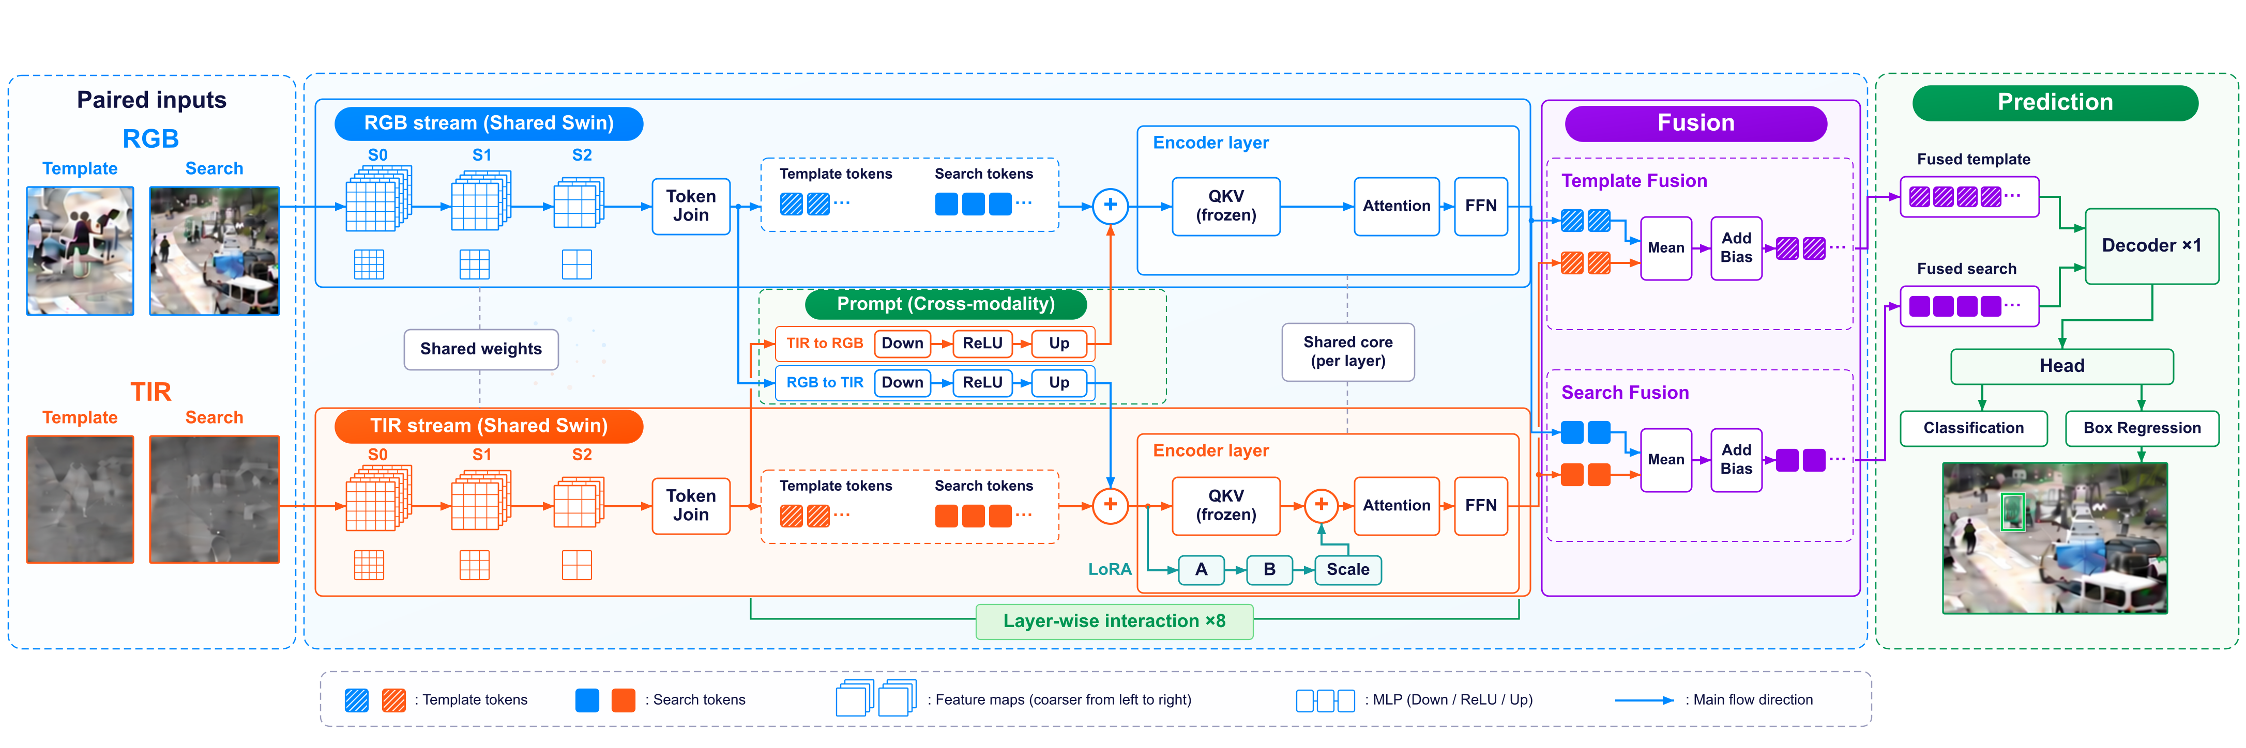
Fig. 1. Overview of SwinRGBTrack. Hatched and solid blocks denote template and search features, respectively. Join denotes token concatenation within each modality. The relation encoder streams share their core parameters, with QKV LoRA applied in the TIR stream. Mean + Bias denotes equal-weight fusion with a shared channel bias.
Let zᵐ and xᵐ denote the template and search regions of modality m ∈ {R,T}. Let B, Eᵐ, Φ, D, and H denote the shared backbone, modality-adapted relation encoder, fusion function, relation decoder, and prediction head, respectively. The encoder produces template features ${\text{F}}_{\text{z}}^{\text{m}}$ and search features ${\text{F}}_{\text{x}}^{\text{m}}$, whose cross-modal fusion outputs are ${\text{F}}_{\text{z}}$ and ${\text{F}}_{\text{x}}$. The overall mapping is
$\text{(}{\text{F}}_{\text{z}}^{\text{m}}\text{, }{\text{F}}_{\text{x}}^{\text{m}}\text{) = }{\text{E}}^{\text{m}}\text{(}\text{B}\text{(}{\text{z}}^{\text{m}}\text{), }\text{B}\text{(}{\text{x}}^{\text{m}}\text{)); }{\text{F}}_{\text{q}}\text{ = Φ(}{\text{F}}_{\text{q}}^{\text{R}}\text{, }{\text{F}}_{\text{q}}^{\text{T}}\text{), q∈\{}\text{z,x}\text{\}}$ (1)
$\text{b}\text{̂ = }\text{H}\text{(}\text{D}\text{(Q=}{\text{F}}_{\text{x}}\text{, K=V=[}{\text{F}}_{\text{z}}\text{; }{\text{F}}_{\text{x}}\text{]))}$ (2)
The semicolon in Eq. (2) denotes concatenation along the token dimension. The predicted box b̂ is mapped back to the original image using the crop position and scale. Equation (1) specifies the output interface of each encoder stream; the streams are coupled through bidirectional prompts that exchange their pre-update states at every relation layer, as described in Section 3.4.

3.2 Shared hierarchical visual representations
The shared visual front end extracts local texture and contour information through window attention, establishes cross-window connections through alternating window shifts, and progressively integrates neighboring features through patch merging. The relation encoder then applies template constraints to transform image features into matching representations for the specified target. Visual content modeling and target relation modeling thus provide distinct interfaces for cross-modal adaptation.
Let N be the number of tokens, C the channel dimension, and M the window side length. The main computational terms for global and window attention are, respectively [4],
${\text{Ω}}_{\text{global}}\text{ ≈ 4}\text{N}{\text{C}}^{\text{2}}\text{ + 2}{\text{N}}^{\text{2}}\text{C}\text{; }{\text{Ω}}_{\text{window}}\text{ ≈ 4}\text{N}{\text{C}}^{\text{2}}\text{ + 2}{\text{M}}^{\text{2}}\text{NC}$ (3)
For a fixed window size, the attention correlation term within windows grows linearly with the number of tokens. The full model also includes channel projections, forward passes for both modalities, and global attention in the relation layers. The size of the latter depends on the backbone output grid.
We use the first three stages of Swin-B with a patch size of 4 and a window side length of 12. The stages contain 2, 2, and 18 blocks, with 128, 256, and 512 channels, respectively. Only the third stage provides features to the relation encoder. Table 2 lists the feature dimensions at each stage.
Table 2. Feature dimensions in the first three stages of the shared Swin-B backbone.
Stage (index) | Blocks | Channels | Template grid | Search grid | Stride
Stage 1 (0) | 2 | 128 | 48×48 | 96×96 | 4
Stage 2 (1) | 2 | 256 | 24×24 | 48×48 | 8
Stage 3 (2) | 18 | 512 | 12×12 | 24×24 | 16
Template and search inputs are 192 × 192 and 384 × 384 pixels, respectively. Only the third-stage output enters the relation encoder.
The third stage produces a 12 × 12 template grid and a 24 × 24 search grid, giving 720 tokens per modality. Its 512-channel output directly matches the relation encoder dimension. The second-stage output would contain 2,880 tokens, resulting in a global attention matrix with 16 times as many elements as the third-stage output. Further downsampling would reduce the density of the localization grid. The third-stage interface therefore balances representation depth, spatial sampling, and the scale of relation computation.
The RGB and TIR template and search images share the same visual parameters but undergo separate feature computations. The shared front end aligns their channel dimensions and spatial grids, while adaptation in the relation layers adjusts the matching representations to different imaging conditions.

3.3 Post-encoder cross-modal fusion
The main fusion operation combines the two modality representations into a unified representation. Its position determines when complementary information enters target matching. Figure 2 illustrates three possible interfaces: after the backbone, after the encoder, and after the decoder. We use post-encoder fusion so that each modality first establishes template–search relations and the resulting joint representation then participates in target decoding.
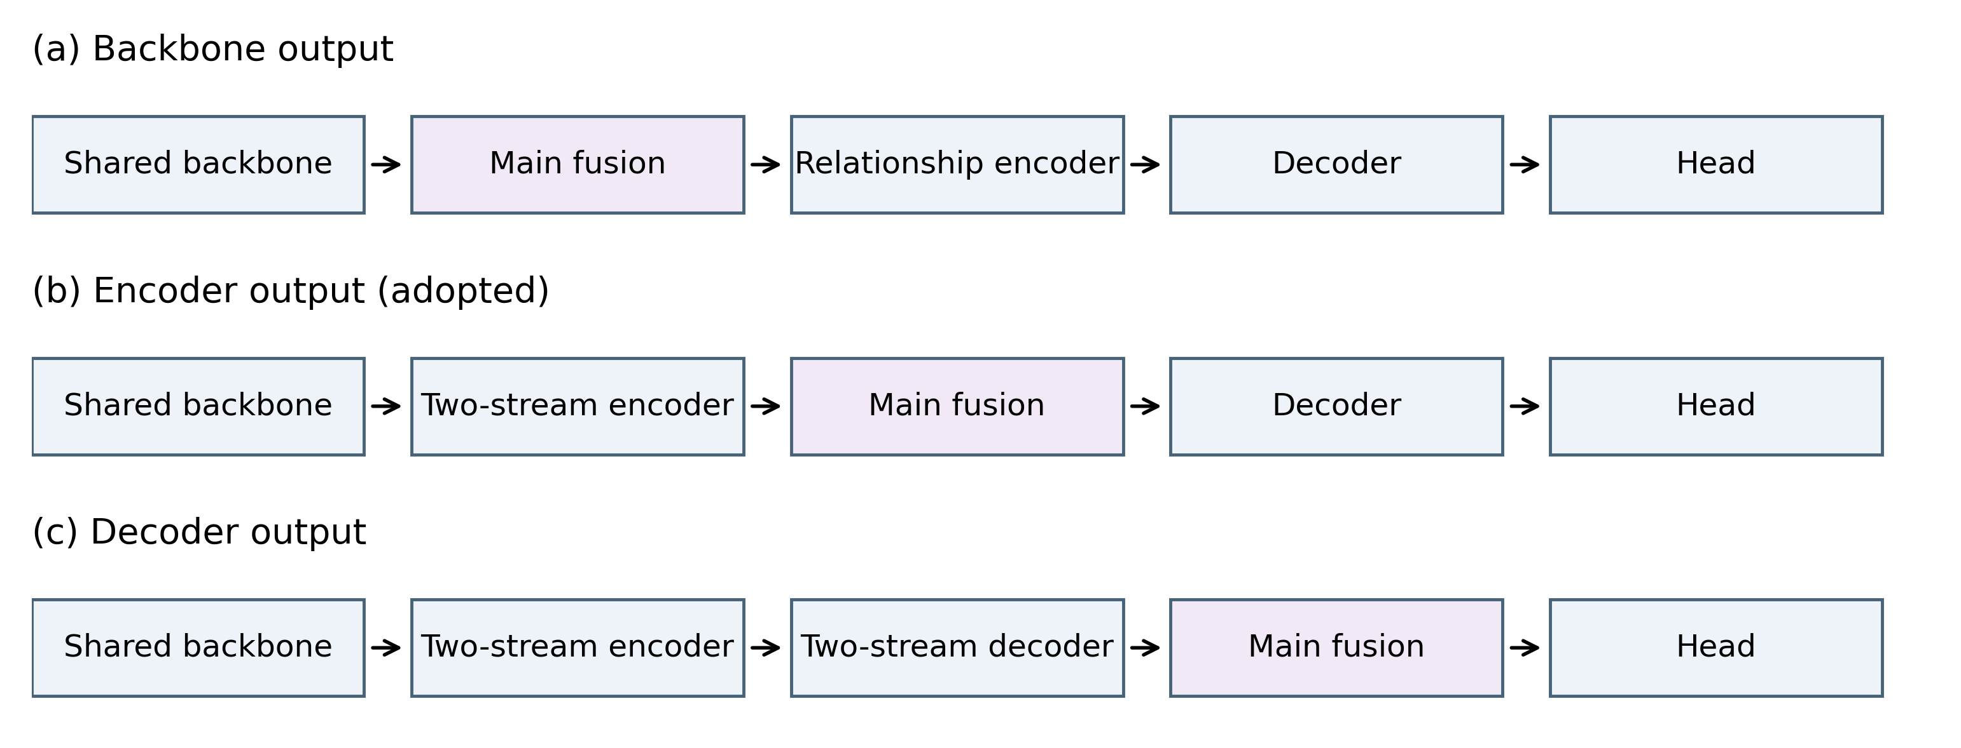
Fig. 2. Three positions for cross-modal fusion. Fusion after the backbone, encoder, and decoder operates on visual features, target-conditioned encoded features, and decoded features, respectively. SwinRGBTrack uses post-encoder fusion with bidirectional prompt interactions inside the relation encoder.
Post-backbone fusion directly combines visual responses before the relation encoder has applied template constraints to them. Post-decoder fusion combines search features after they have been decoded separately in the two streams. Post-encoder fusion lies between these alternatives: it retains the formation of separate target relations while allowing the fused representation to influence subsequent search feature updates.
Bidirectional prompts and the main fusion operation serve different purposes. Layer-wise prompts exchange states through residual connections while preserving two token sequences. The post-encoder fusion function separately combines the template outputs and the search outputs across modalities to form a unified decoder input. Layer-wise interaction is thus followed by final fusion, allowing auxiliary modality information to influence relation formation throughout encoding.

3.4 Bidirectional prompts and thermal-specific low-rank adaptation

3.4.1 Bidirectional bottleneck prompts
Let ${\text{U}}_{\text{l}}^{\text{R}}$ and ${\text{U}}_{\text{l}}^{\text{T}}$ denote the RGB and TIR input states at layer l, each containing both template and search tokens. The prompt mappings for the two directions use separate 512 → 16 → 512 bottlenecks. Down-projection, activation, and up-projection generate residuals from the auxiliary modality:
${\text{Ũ}}_{\text{l}}^{\text{R}}\text{ = }{\text{U}}_{\text{l}}^{\text{R}}\text{ + }{\text{P}}_{\text{l}}^{\text{T→R}}\text{(}{\text{U}}_{\text{l}}^{\text{T}}\text{); }{\text{Ũ}}_{\text{l}}^{\text{T}}\text{ = }{\text{U}}_{\text{l}}^{\text{T}}\text{ + }{\text{P}}_{\text{l}}^{\text{R→T}}\text{(}{\text{U}}_{\text{l}}^{\text{R}}\text{)}$ (4)
${\text{P}}_{\text{l}}\text{(U) = }{\text{W}}_{\text{up,l}} \text{ReLU}\text{(}{\text{W}}_{\text{down,l}}\text{U}\text{ + }{\text{a}}_{\text{l}}\text{) + }{\text{c}}_{\text{l}}$ (5)
Both directions generate prompts from the pre-update states using independent mappings before the shared relation layer is applied. The bottleneck changes the channel representation without increasing the token count. Prompts are applied to both template and search tokens, introducing auxiliary modality information into target relation computation at the next layer.
The weights and biases of the prompt up-projection are initialized to zero, while the down-projection uses a nonzero initialization. Each new branch therefore starts with a zero residual and learns a cross-modal increment, preserving the existing relation representation at initialization.

3.4.2 Thermal-specific QKV low-rank branch
For a linear projection W in a shared relation layer, the RGB stream retains the original mapping and the TIR stream adds a low-rank update [28]. This asymmetric parameterization provides a dedicated adjustment for thermal imaging differences while retaining the shared mapping:
${\text{W}}_{\text{R}}\text{ = W; }{\text{W}}_{\text{T}}\text{ = W + }\frac{\text{α}}{\text{r}}\text{BA}\text{, r=8, α=16}$ (6)
For $\text{W}\text{∈}{\text{R}}^{{\text{d}}_{\text{out}}\text{×}{\text{d}}_{\text{in}}}$, the low-rank matrices satisfy $\text{A}\text{∈}{\text{R}}^{\text{r}\text{×}{\text{d}}_{\text{in}}}$ and $\text{B}\text{∈}{\text{R}}^{{\text{d}}_{\text{out}}\text{×}\text{r}}$. The update is applied to the attention QKV projection with rank r = 8 and scaling parameter α = 16. The low-rank branch is enabled only in the TIR stream; the RGB stream uses the shared core projection.
The output-side low-rank matrix is initialized to zero, while the input-side matrix uses a nonzero initialization, so adaptation starts from a zero update. LoRA adjusts the query, key, and value projections in the thermal stream, whereas the prompts inject the other modality state into the layer input. The former changes the mapping used to compute intra-modal relations; the latter supplements the observations available for matching. Together, they adapt the relation layers.
Across eight layers, the prompt and LoRA modules add approximately 0.402 M parameters: 0.271 M for the prompts and 0.131 M for LoRA. This is the parameter increment of the adaptation modules, rather than the size of the full model. The parameters updated during optimization are described in Appendix A.1.

3.5 Equal-weight fusion and channel bias
The two encoder outputs have matching dimensions and corresponding token positions. The same fusion function is applied separately to the template and search features. It averages the two modality features with equal weights and adds a channel bias shared by all tokens. For either type of region feature,
${\text{F}}_{\text{fused}}\text{ = 0.5}{\text{F}}_{\text{R}}\text{ + 0.5}{\text{F}}_{\text{T}}\text{ + }{\text{b}}_{\text{c}}$ (7)
where ${\text{b}}_{\text{c}}$ is a channel bias shared across all tokens. Equation (7) preserves the common feature scale and applies a fixed channel-wise offset for residual calibration. Input-dependent cross-modal interactions are handled by the preceding prompts and LoRA, and the fused representation is subsequently used in template–search decoding. Appendix A.5 gives the parameterization of the residual branch.

3.6 Relation decoding and training objective
After obtaining the fused features ${\text{F}}_{\text{z}}$ and ${\text{F}}_{\text{x}}$, a single relation decoder layer uses search tokens as queries and the concatenated template–search sequence as keys and values to update the target-conditioned search representation. The prediction head produces classification responses and bounding-box regression outputs, which are mapped back to the original image coordinates using the crop transformation.
The training objective combines Varifocal Loss for classification with the generalized intersection-over-union (GIoU) loss on positive bounding-box samples [29, 30]. Both terms have a weight of 2:
$\text{L}\text{ = 2}{\text{L}}_{\text{VFL}}\text{ + 2}{\text{L}}_{\text{GIoU}}$ (8)

4 Experiments

4.1 Implementation
The model is implemented in PyTorch and runs on a single NVIDIA GeForce RTX 4090 GPU with 48 GB of memory. Template and search inputs are 192 × 192 and 384 × 384 pixels, respectively, and the first three stages of Swin-B provide the visual features. The relation encoder has eight layers, a hidden dimension of 512, and eight attention heads per layer. The decoder has one layer. The prompt bottleneck dimension is 16, and LoRA uses rank 8 and a scaling parameter of 16.

4.2 Overall performance and LasHeR attributes
The experiments cover LasHeR, GTOT, RGBT210, RGBT234, and VTUAV. We report PR/NPR/SR on LasHeR, PR/SR on RGBT210, and MPR/MSR on the other datasets. VTUAV is evaluated separately on its short-term (ST) and long-term (LT) subsets. Table 3 summarizes results across datasets. The following sections present re-evaluations under common evaluation rules, attribute analyses, and structural comparisons. Appendix A specifies the evaluation scope and aggregation rules.

Table 3. RGB-T tracking results across datasets (%).
Method | Venue | Backbone | Pretraining | GTOT  MPR | GTOT  MSR | RGBT210  PR | RGBT210  SR | RGBT234  MPR | RGBT234  MSR | LasHeR  PR | LasHeR  NPR | LasHeR  SR
DAPNet [31] | ACM MM 2019 | VGG-M | ImageNet | 88.2 | 70.7 | — | — | 76.6 | 53.7 | 43.1 | 38.3 | 31.4
MANet [32] | ICCVW 2019 | VGG-M | ImageNet | 89.4 | 72.4 | — | — | 77.7 | 53.9 | 45.5 | — | 32.6
mfDiMP [33] | ICCVW 2019 | ResNet-50 | ImageNet | — | — | 78.6 | 55.5 | — | — | 44.7 | 39.5 | 34.3
CAT [7] | ECCV 2020 | VGG-M | ImageNet | 88.9 | 71.7 | 79.2 | 53.3 | 80.4 | 56.1 | 45.0 | 39.5 | 31.4
APFNet [11] | AAAI 2022 | VGG-M | ImageNet | 90.5 | 73.7 | — | — | 82.7 | 57.9 | 50.0 | 43.9 | 36.2
DMCNet [10] | TNNLS 2022 | VGG-M | ImageNet | — | — | 79.7 | 55.5 | 83.9 | 59.3 | 49.0 | 43.1 | 35.5
ProTrack [34] | ACM MM 2022 | ViT-B | SOT | — | — | — | — | 78.6 | 58.7 | 50.9 | — | 42.1
DRGCNet [35] | IEEE SJ 2023 | VGG-M | ImageNet | — | — | — | — | 82.5 | 58.1 | 48.3 | 42.3 | 33.8
QAT [36] | ACM MM 2023 | ResNet-50 | ImageNet | 91.5 | 75.5 | 86.8 | 61.9 | 88.4 | 64.3 | 64.2 | 59.6 | 50.1
CMD [37] | CVPR 2023 | ResNet-50 | ImageNet | 89.2 | 73.4 | — | — | 82.4 | 58.4 | 59.0 | 54.6 | 46.4
ViPT [22] | CVPR 2023 | ViT-B | SOT | — | — | — | — | 83.5 | 61.7 | 65.1 | — | 52.5
TBSI [12] | CVPR 2023 | ViT-B | SOT | — | — | 85.3 | 62.5 | 87.1 | 63.7 | 69.2 | 65.7 | 55.6
STMT [38] | TCSVT 2024 | ViT-B | SOT | — | — | 83.0 | 59.5 | 86.5 | 63.8 | 67.4 | 63.4 | 53.7
TATrack [39] | AAAI 2024 | ViT-B | SOT | — | — | 85.3 | 61.8 | 87.2 | 64.4 | 70.2 | 66.7 | 56.1
BAT [24] | AAAI 2024 | ViT-B | SOT | — | — | — | — | 86.8 | 64.1 | 70.2 | — | 56.3
TBSI+GMMT [13] | AAAI 2024 | ViT-B | SOT | — | — | — | — | 87.9 | 64.7 | 70.7 | 67.0 | 56.6
UnTrack-T [26] | CVPR 2024 | ViT-B | SOT | — | — | — | — | 83.7 | 61.8 | 66.7 | — | 53.6
SDSTrack [25] | CVPR 2024 | ViT-B | SOT | — | — | — | — | 84.8 | 62.5 | 66.5 | — | 53.1
OneTracker [40] | CVPR 2024 | ViT-B | ImageNet | — | — | — | — | 85.7 | 64.2 | 67.2 | — | 53.8
CSTNet [15] | IEEE SJ 2025 | ViT-B | — | — | — | 86 | 63.5 | 88.4 | 65.2 | 71.5 | 67.9 | 57.2
CAFormer [41] | AAAI 2025 | ViT-B | SOT | 91.8 | 76.9 | 85.6 | 63.2 | 88.3 | 66.4 | 70.0 | 66.1 | 55.6
BTMTrack [19] | IVC 2025 | ViT-B | SOT | — | — | 87.5 | 63.7 | 88.3 | 65.4 | 72.3 | 68.5 | 58.0
TCM-base [20] | IVC 2026 | ViT-B | SOT | 89.6 | 75.5 | 85.5 | 63.4 | 86.2 | 64.0 | 71.0 | 67.0 | 56.5
HATrack [27] | ESWA 2026 | ViT-B | — | 93.4 | 76.9 | — | — | 88.2 | 65.3 | 71.3 | 67.5 | 57.1
SwinRGBTrack † | This work | Swin-B³ | SwinTrack →  RGB-T | 91.72 | 78.68 | 84.19 | 62.02 | 85.67 | 64.13 | 72.68 | 68.70 | 57.67
Results for external methods are taken from the cited publications. SOT denotes single-object tracking pretraining; Swin-B³ denotes the first three stages of Swin-B; UnTrack-T is the thermal-specific variant. A dash indicates that the corresponding result or information was not provided.
† Our results use the full GTOT and RGBT234 test sets and the common LasHeR test sequences. Appendix A specifies the literature selection criteria and evaluation settings. Published results and our re-evaluation results should be interpreted within their respective protocols.

In Table 3, SwinRGBTrack achieves LasHeR PR/NPR scores of 72.68%/68.70% and a GTOT MSR of 78.68%, exceeding the corresponding reported values of the other listed methods. Its PR/SR on RGBT210 are 84.19%/62.02%, and its MPR/MSR on RGBT234 are 85.67%/64.13%. These comparisons are restricted to the listed methods. We next examine localization performance through re-evaluations under common rules and attribute-level analyses.
LasHeR includes 19 challenge attributes [1]. Table 4 compares 14 baseline methods with SwinRGBTrack on 245 common test sequences using the same ground truth, first-frame handling, and equal weighting of sequences. Each method retains its own training and initialization settings.
Table 4. Tracking results on the common LasHeR test sequences (%).
Method | Publication date | Venue | PR↑ | NPR↑ | SR↑
MaCNet [6] | 2020-01-10 | Sensors | 48.35 | 42.16 | 35.07
CAT [7] | 2020 | ECCV | 45.11 | 39.57 | 31.38
FANet [8] | 2021 | T-IV | 44.21 | 38.43 | 30.90
MANet++ [9] | 2021 | TIP | 46.74 | 40.47 | 31.38
DMCNet [10] | 2022 | TNNLS early access | 49.13 | 43.20 | 35.57
APFNet [11] | 2022-06-28 | AAAI | 50.15 | 44.06 | 36.33
TBSI [12] | 2023-06 | CVPR | 70.46 | 66.53 | 56.18
MPLT [23] | 2023-08-31 | arXiv | 72.06 | 68.01 | 57.12
BAT [24] | 2024-03-24 | AAAI | 70.28 | 66.44 | 56.28
SDSTrack [25] | 2024-06 | CVPR | 66.62 | 62.79 | 53.19
UnTrack-Uni [26] | 2024-06 | CVPR | 63.77 | 60.13 | 51.30
TBSI+GMMT [13] | 2024 | AAAI | 70.67 | 66.97 | 56.59
CSTNet [15] | 2025 | IEEE Sensors J. | 71.82 | 67.92 | 56.94
AFTER [16] | 2025 | TIP | 70.36 | 65.91 | 55.15
Ours | This work | — | 72.68 | 68.70 | 57.67
Bold and underlined values denote the best and second-best results, respectively. The subsequent re-evaluation tables use the same convention.
SwinRGBTrack achieves the highest PR, NPR, and SR among the methods in Table 4, with scores of 72.68%, 68.70%, and 57.67%, respectively. These exceed MPLT by 0.62, 0.69, and 0.55 percentage points and BAT by 2.40, 2.26, and 1.39 percentage points. The improvements in both center-error and region-overlap metrics indicate better target center estimation and bounding-box coverage within this comparison.
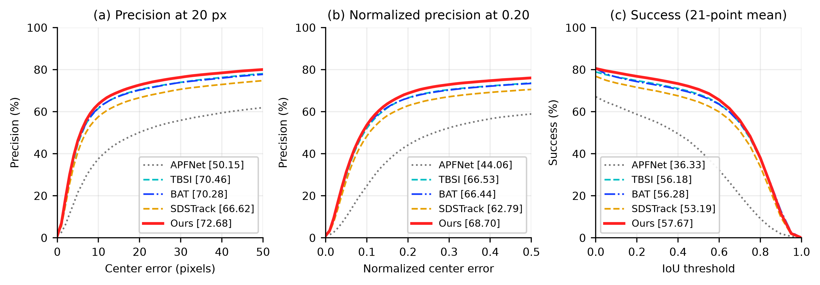
Fig. 3. Overall performance curves on LasHeR. The five methods use the same 245 test sequences. The legends report PR@20, NPR@0.20, and SR, respectively.
Figure 3 shows performance across center-error and overlap thresholds. SwinRGBTrack has higher summary scores than the four baselines plotted, consistent with their relative ordering in Table 4. The curves also show how center localization and region coverage vary with the evaluation threshold.
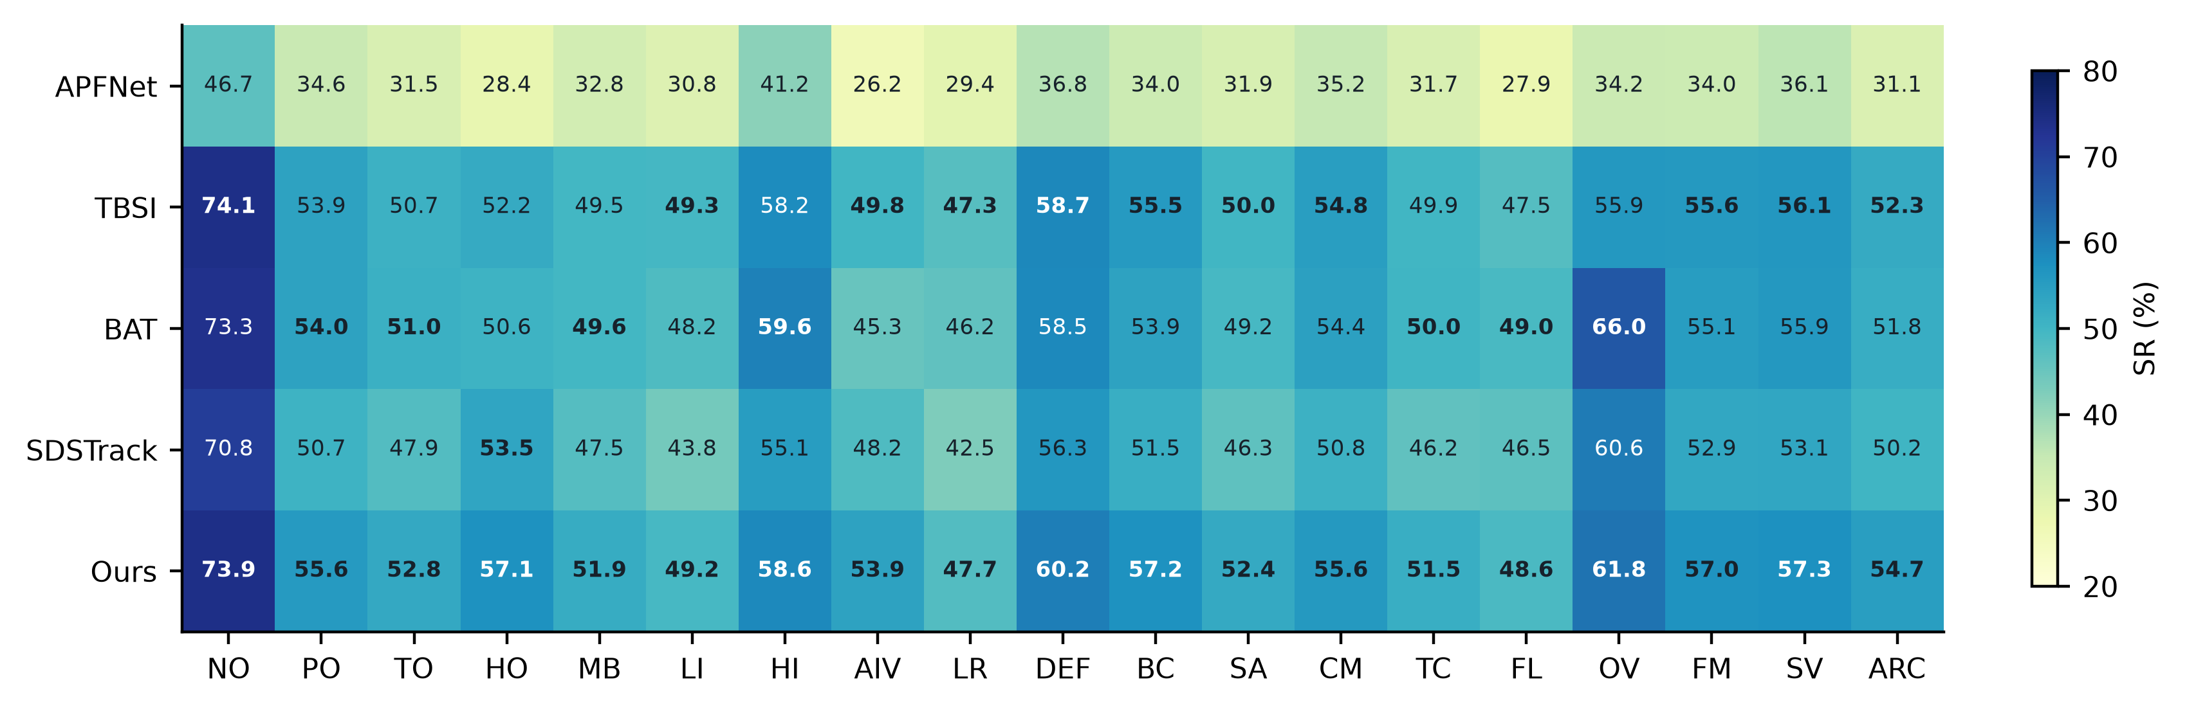
Fig. 4. SR heatmap for the 19 LasHeR attributes. All columns share a common color scale, and the top two values in each column are bold. Table 5 defines the attributes and lists the sequence counts.
Figure 4 and Table 5 show that SwinRGBTrack achieves PR/SR scores of 66.53%/57.15% under transparent occlusion (HO) and 64.15%/53.91% under abrupt illumination variation (AIV), the highest values among the five methods plotted. Its SR scores under partial occlusion (PO) and total occlusion (TO) are 55.60% and 52.77%, also exceeding the four baselines. These scores remain below the 73.95% SR for no occlusion (NO), indicating that occlusion still reduces region coverage. Cross-modal complementarity can mitigate observation degradation, but its benefit is constrained by the target information that remains visible.
Under low illumination (LI), SwinRGBTrack obtains an SR of 49.25%, close to the 49.30% of TBSI. For out-of-view (OV) sequences, its PR/SR of 71.26%/61.80% are below the 76.84%/66.05% of BAT. Its SR under low resolution (LR) is 47.69%. These attributes point to two difficulties: insufficient target information and a limited search range. Complementary observations can help maintain matching, but they cannot readily recover missing spatial detail or targets outside the search region.

Table 5(a). LasHeR attributes involving occlusion and imaging degradation (%).
Metric | Method | NO | PO | TO | HO | MB | LI | HI | AIV | LR | DEF
PR | APFNet [11] | 66.69 | 47.43 | 41.96 | 27.86 | 45.90 | 41.80 | 60.38 | 32.07 | 46.05 | 45.75
PR | TBSI [12] | 91.36 | 67.70 | 64.16 | 59.41 | 63.10 | 61.29 | 73.81 | 58.23 | 63.89 | 71.64
PR | BAT [24] | 90.18 | 67.50 | 64.14 | 56.31 | 62.36 | 60.37 | 75.28 | 51.38 | 62.69 | 72.16
PR | SDSTrack [25] | 87.57 | 63.55 | 60.71 | 60.22 | 59.92 | 54.14 | 69.36 | 54.31 | 57.50 | 69.50
PR | Ours | 91.19 | 70.24 | 67.10 | 66.53 | 66.41 | 61.87 | 74.75 | 64.15 | 64.99 | 74.45
SR | APFNet [11] | 46.69 | 34.55 | 31.54 | 28.44 | 32.82 | 30.76 | 41.17 | 26.23 | 29.44 | 36.79
SR | TBSI [12] | 74.11 | 53.89 | 50.74 | 52.23 | 49.55 | 49.30 | 58.16 | 49.79 | 47.29 | 58.72
SR | BAT [24] | 73.32 | 53.97 | 51.00 | 50.56 | 49.63 | 48.25 | 59.64 | 45.29 | 46.16 | 58.49
SR | SDSTrack [25] | 70.79 | 50.69 | 47.87 | 53.46 | 47.48 | 43.84 | 55.13 | 48.25 | 42.52 | 56.31
SR | Ours | 73.95 | 55.60 | 52.77 | 57.15 | 51.93 | 49.25 | 58.55 | 53.91 | 47.69 | 60.15
Sequence counts N: NO = 33, PO = 214, TO = 86, HO = 16, MB = 88, LI = 51, HI = 34, AIV = 7, LR = 68, DEF = 46. NO: no occlusion; PO: partial occlusion; TO: total occlusion; HO: transparent occlusion; MB: motion blur; LI: low illumination; HI: high illumination; AIV: abrupt illumination variation; LR: low resolution; DEF: deformation.
Table 5(b). LasHeR attributes involving background, motion, and appearance variation (%).
Metric | Method | BC | SA | CM | TC | FL | OV | FM | SV | ARC | ALL
PR | APFNet [11] | 45.33 | 43.03 | 47.97 | 43.30 | 37.62 | 36.42 | 45.30 | 50.00 | 40.75 | 50.15
PR | TBSI [12] | 69.83 | 62.02 | 69.42 | 62.52 | 60.89 | 64.62 | 69.36 | 70.20 | 64.17 | 70.46
PR | BAT [24] | 67.85 | 61.35 | 68.09 | 62.73 | 62.05 | 76.84 | 68.56 | 69.70 | 63.15 | 70.28
PR | SDSTrack [25] | 64.72 | 57.60 | 63.82 | 57.87 | 59.82 | 70.00 | 65.78 | 66.52 | 61.32 | 66.62
PR | Ours | 72.51 | 65.30 | 70.59 | 65.07 | 62.93 | 71.26 | 71.57 | 72.15 | 67.83 | 72.68
SR | APFNet [11] | 33.98 | 31.86 | 35.23 | 31.71 | 27.90 | 34.16 | 34.02 | 36.14 | 31.13 | 36.33
SR | TBSI [12] | 55.47 | 49.99 | 54.83 | 49.90 | 47.45 | 55.94 | 55.63 | 56.12 | 52.30 | 56.18
SR | BAT [24] | 53.89 | 49.15 | 54.42 | 50.01 | 49.03 | 66.05 | 55.12 | 55.92 | 51.80 | 56.28
SR | SDSTrack [25] | 51.49 | 46.32 | 50.79 | 46.19 | 46.55 | 60.62 | 52.86 | 53.11 | 50.18 | 53.19
SR | Ours | 57.15 | 52.36 | 55.64 | 51.50 | 48.60 | 61.80 | 56.95 | 57.32 | 54.74 | 57.67
Sequence counts N: BC = 77, SA = 106, CM = 132, TC = 147, FL = 20, OV = 7, FM = 192, SV = 221, ARC = 108, ALL = 245. BC: background clutter; SA: similar appearance; CM: camera motion; TC: thermal crossover; FL: frame loss; OV: out of view; FM: fast motion; SV: scale variation; ARC: aspect ratio change; ALL: overall results.

4.3 Evaluation on GTOT and RGBT234

4.3.1 GTOT
The GTOT test set contains 50 sequences, 7,850 frames, and seven challenge attributes [42]. Table 6 evaluates DAPNet, MANet, MaCNet, APFNet, AFTER, and SwinRGBTrack using identical coordinate conversions, evaluation thresholds, and frame-weighted aggregation.
Table 6. Tracking results on the full GTOT test set (%).
Method | Sequences | MPR↑ | MSR↑
DAPNet [31] | 50 | 88.18 | 70.66
MANet [32] | 50 | 89.58 | 72.48
MaCNet [6] | 50 | 88.48 | 69.75
APFNet [11] | 50 | 90.62 | 73.74
AFTER [16] | 50 | 91.64 | 78.51
SwinRGBTrack | 50 | 91.72 | 78.68
MPR is the proportion of frames with a center error strictly below 5 pixels. MSR is the trapezoidal area under the frame-weighted, 21-point success curve. Appendix A describes the use of the two modality-specific ground-truth annotations.
SwinRGBTrack obtains the highest MPR/MSR in Table 6, at 91.72%/78.68%, exceeding AFTER by 0.08 and 0.17 percentage points. Relative to APFNet, the gains are 1.10 and 4.94 percentage points, with the larger difference in region overlap. These results indicate that the proposed framework maintains both center localization accuracy and bounding-box coverage on GTOT.
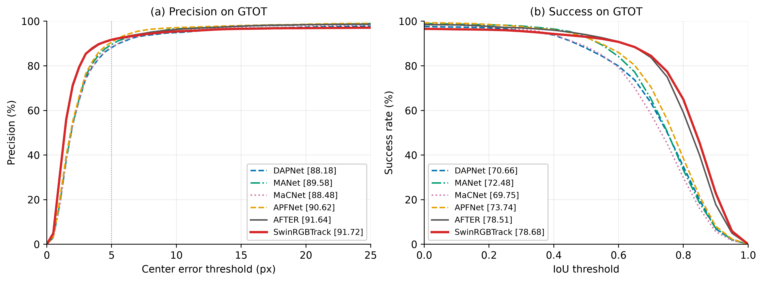
Fig. 5. Overall precision and success curves on GTOT. All six methods use the full set of 50 sequences. The legends report MPR@5 and MSR (%), respectively.
In Fig. 5, the overall curves of SwinRGBTrack and AFTER are close, with SwinRGBTrack showing small advantages in MPR and MSR. Their behavior across thresholds motivates a closer examination of individual scenarios. Figure 6 compares the methods across the seven challenge attributes.
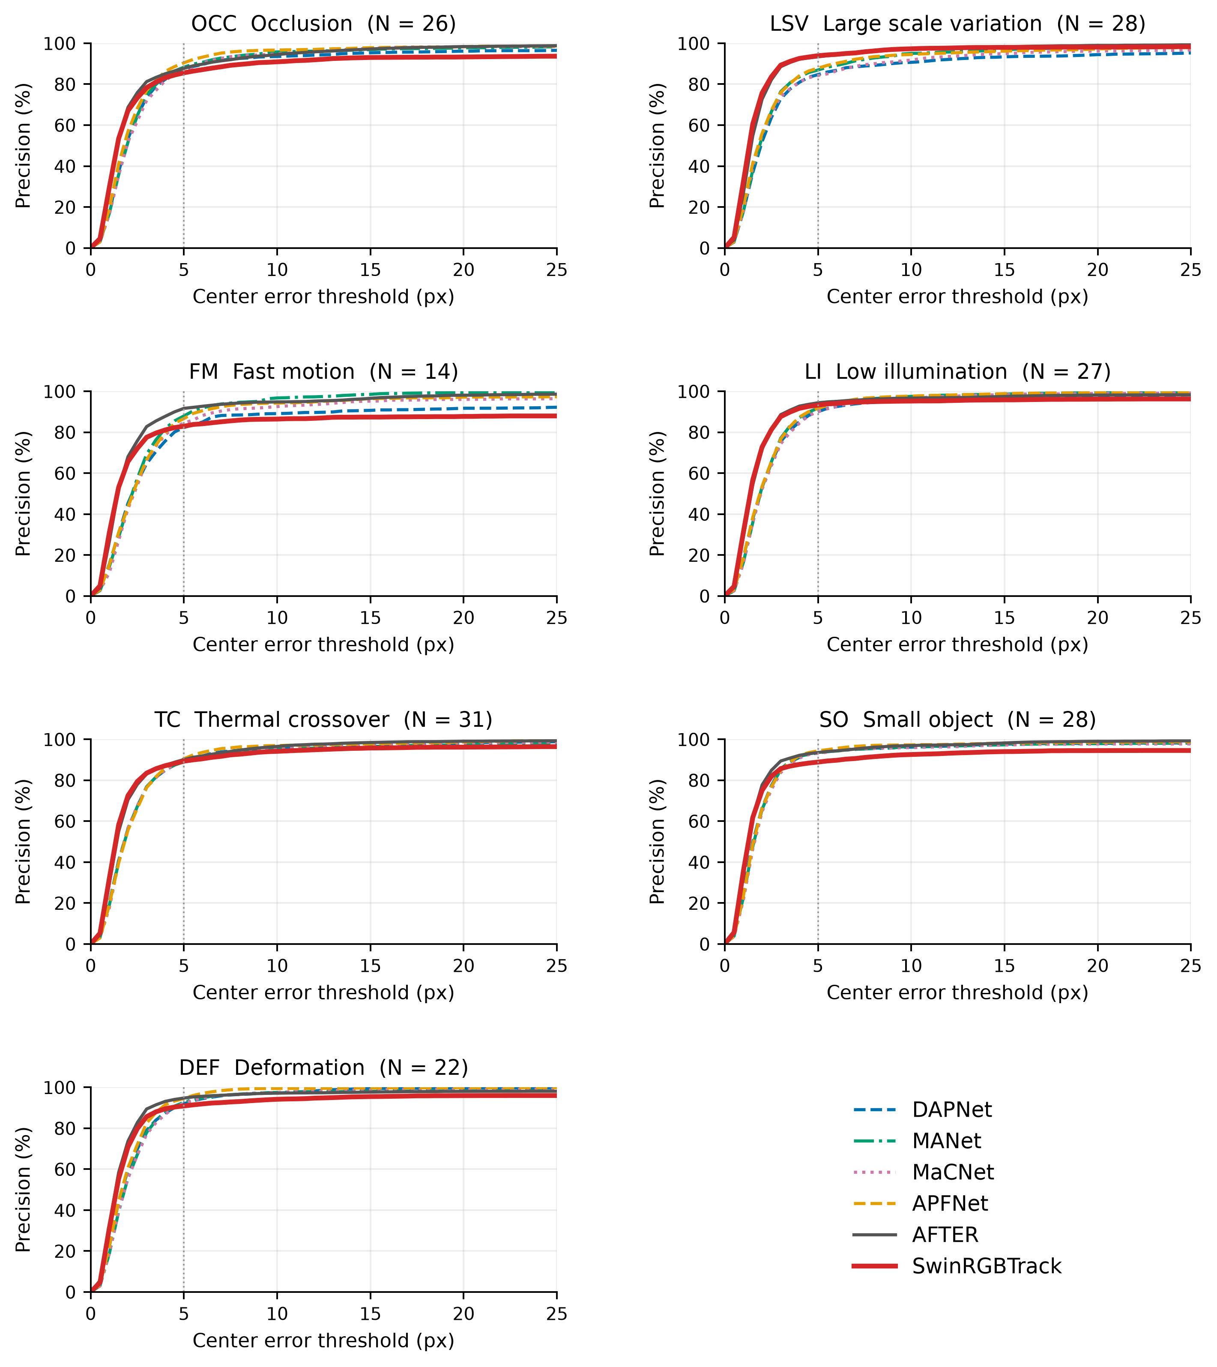
Fig. 6(a). Precision curves for the seven GTOT attributes. OCC: occlusion; LSV: large scale variation; FM: fast motion; LI: low illumination; TC: thermal crossover; SO: small object; DEF: deformation. N denotes the number of sequences.
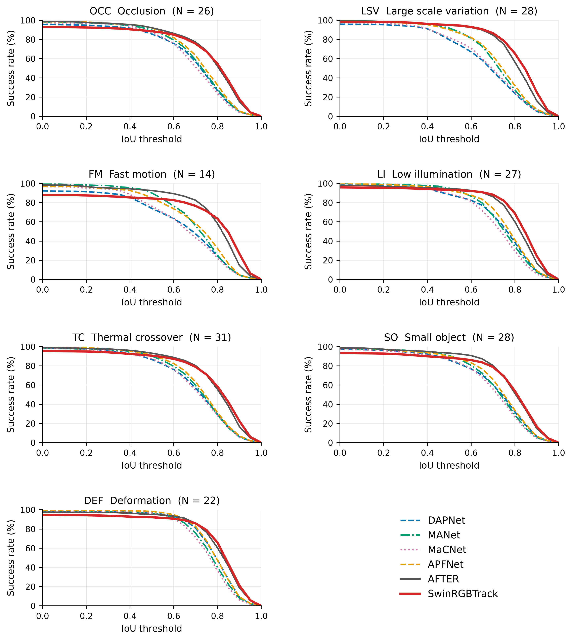
Fig. 6(b). Success curves for the seven GTOT attributes. Sequence groups, methods, and colors are the same as in Fig. 6(a). Results for each attribute are weighted by the number of frames in the group.
For large scale variation (LSV), SwinRGBTrack achieves the highest MPR/MSR among the six methods, at 93.92%/80.53%. Under low illumination (LI), its MSR of 79.57% exceeds the 78.79% of AFTER. Its MPR under fast motion (FM) is 82.91%, and its MSR under occlusion (OCC) is 73.59%, below the corresponding AFTER scores of 91.65% and 76.28%. Its MPR for small objects (SO) is 88.87%. Thus, the framework performs well under scale variation and some forms of imaging degradation, while rapid displacement and small targets remain challenging for center localization.

4.3.2 RGBT234
On the full RGBT234 test set, SwinRGBTrack achieves MPR/MSR scores of 85.67%/64.13%. Table 7 further compares methods on 232 common test sequences. Appendix A.3 specifies the sequence set and aggregation rules.
Table 7. Tracking results on the common RGBT234 test sequences (%).
Method | MPR↑ | MSR↑
APFNet [11] | 82.97 | 58.02
SDSTrack [25] | 84.68 | 62.39
UnTrack-Uni [26] | 84.10 | 62.38
TBSI+GMMT [13] | 88.26 | 64.97
Ours | 85.57 | 63.99
All methods are evaluated with RGBT toolkit 1.0.1, both modality-specific ground truths, and equal weighting of sequences. UnTrack-Uni denotes the unified model variant.
On the common sequences, SwinRGBTrack obtains MPR/MSR scores of 85.57%/63.99%, ranking second on both metrics among the compared methods. The gains over SDSTrack are 0.89 and 1.60 percentage points, while those over UnTrack-Uni are 1.47 and 1.61 percentage points. TBSI+GMMT achieves the highest scores, at 88.26%/64.97%. Together with the LasHeR and GTOT results, this comparison shows that the framework can be applied across datasets, with its relative performance varying according to scene composition and target conditions.
In Table 8, SwinRGBTrack achieves MPR/MSR scores of 86.69%/65.26% under partial occlusion (PO) and 86.63%/65.81% under scale change (SC). The scores are 78.45%/57.27% under low resolution (LR) and 81.06%/59.41% under fast motion (FM). This pattern is consistent with the small-object and fast-motion results on GTOT: limited spatial information and large inter-frame displacement both make target matching more difficult.

Table 8(a). RGBT234 attributes involving background, motion, deformation, and occlusion (%).
Metric | Method | BC | CM | DEF | FM | HO | LI
MPR | APFNet [11] | 82.81 | 77.87 | 78.23 | 79.16 | 74.27 | 84.29
MPR | SDSTrack [25] | 81.23 | 84.84 | 83.22 | 81.01 | 80.35 | 86.60
MPR | UnTrack-Uni [26] | 80.69 | 85.30 | 80.04 | 80.94 | 79.48 | 80.43
MPR | TBSI+GMMT [13] | 85.63 | 89.07 | 85.09 | 84.87 | 83.44 | 88.97
MPR | Ours | 81.11 | 84.78 | 84.45 | 81.06 | 80.76 | 87.44
MSR | APFNet [11] | 55.55 | 56.37 | 56.11 | 51.10 | 50.87 | 56.94
MSR | SDSTrack [25] | 57.23 | 63.00 | 62.75 | 58.40 | 57.51 | 63.55
MSR | UnTrack-Uni [26] | 55.92 | 63.97 | 61.09 | 59.48 | 57.43 | 58.10
MSR | TBSI+GMMT [13] | 59.66 | 66.61 | 64.57 | 61.23 | 60.68 | 64.55
MSR | Ours | 57.72 | 64.17 | 64.19 | 59.41 | 59.17 | 64.23
Sequence counts N: BC = 53, CM = 89, DEF = 75, FM = 32, HO = 94, LI = 63. BC: background clutter; CM: camera motion; DEF: deformation; FM: fast motion; HO: heavy occlusion; LI: low illumination. The RGBT234 definition of HO differs from transparent occlusion in LasHeR.
Table 8(b). Remaining RGBT234 attributes and overall results (%).
Metric | Method | LR | MB | NO | PO | SC | TC | ALL
MPR | APFNet [11] | 84.43 | 74.43 | 94.75 | 86.29 | 83.11 | 82.25 | 82.97
MPR | SDSTrack [25] | 84.44 | 84.80 | 93.70 | 84.89 | 85.71 | 81.61 | 84.68
MPR | UnTrack-Uni [26] | 81.53 | 85.78 | 92.05 | 85.05 | 84.15 | 82.66 | 84.10
MPR | TBSI+GMMT [13] | 88.09 | 90.51 | 96.96 | 89.14 | 88.82 | 84.14 | 88.26
MPR | Ours | 78.45 | 83.63 | 93.60 | 86.69 | 86.63 | 82.82 | 85.57
MSR | APFNet [11] | 56.53 | 54.50 | 68.01 | 60.60 | 57.94 | 58.10 | 58.02
MSR | SDSTrack [25] | 60.32 | 63.22 | 71.08 | 63.30 | 64.39 | 60.78 | 62.39
MSR | UnTrack-Uni [26] | 58.16 | 64.61 | 70.98 | 63.32 | 63.55 | 63.00 | 62.38
MSR | TBSI+GMMT [13] | 62.54 | 67.63 | 73.58 | 65.32 | 66.81 | 63.08 | 64.97
MSR | Ours | 57.27 | 63.53 | 71.60 | 65.26 | 65.81 | 62.16 | 63.99
Sequence counts N: LR = 50, MB = 55, NO = 41, PO = 96, SC = 120, TC = 28, ALL = 232. LR: low resolution; MB: motion blur; NO: no occlusion; PO: partial occlusion; SC: scale change; TC: thermal crossover; ALL: overall results.

4.4 Short-term and long-term results on VTUAV
The short-term (ST) and long-term (LT) VTUAV test subsets contain 176 and 74 sequences, respectively [2]. Results are expressed as MPR/MSR; in the official benchmark, MPR uses a center-error threshold of 20 pixels. Table 9 lists published results, and Table 10 presents the SwinRGBTrack results separately. Appendix A.4 describes the evaluation and comparison scope.
Table 9. Published short-term and long-term results on VTUAV (%).
Method | ST MPR | ST MSR | LT MPR | LT MSR
Trans-MMSTC [21] | 83.9 | 67.7 | 54.4 | 45.5
MACFT [43] | 80.1 | 66.8 | 54.1 | 46.7
QAT [36] | 80.1 | 66.7 | — | —
MPLT [23] | 79.7 | 65.4 | 50.9 | 43.9
BAT [24] | 79.4 | 64.1 | 51.5 | 42.5
HMFT [2] | 75.8 | 62.7 | 41.4 | 35.5
mfDiMP [33] | 67.3 | 55.4 | 31.5 | 27.2
FSRPN [2] | 65.3 | 54.4 | 36.6 | 31.4
ADRNet [44] | 62.2 | 46.6 | 23.5 | 17.5
DAFNet [45] | 62.0 | 45.8 | 25.3 | 18.8
Results for DAFNet, ADRNet, FSRPN, mfDiMP, and HMFT are taken from [2], and those for BAT, MPLT, MACFT, and Trans-MMSTC are taken from [21]. QAT is identified by [36]. A dash indicates an unreported result.
Table 10. SwinRGBTrack results on the short-term and long-term VTUAV subsets (%).
Subset | MPR | MSR
ST | 84.86 | 77.00
LT | 63.24 | 55.61
The ST and LT subsets contain 176 and 74 sequences, respectively. Metrics are aggregated with equal weighting of sequences. Equivalence to the official benchmark protocol has not been verified; these results are therefore presented separately from Table 9.
SwinRGBTrack achieves MPR/MSR scores of 84.86%/77.00% on ST and 63.24%/55.61% on LT. These results demonstrate its application to both short-term and long-term UAV target localization under the evaluation settings used here. LT includes more complex target states, such as sustained out-of-view intervals, and yields lower scores than ST. Because the sequence composition and model selection differ between the two subsets, this gap reflects their respective overall test conditions and cannot be attributed solely to sequence length.

4.5 Qualitative results and failure analysis
We examine four successful tracking cases and two failure cases qualitatively. Table 11 reports their full-sequence SR scores. Figures 7 and 8 show frames sampled at approximately 20%, 50%, and 80% of each sequence and compare TBSI, BAT, and SwinRGBTrack. The RGB images show predictions and ground-truth boxes, while the TIR images show the corresponding modality-specific ground truth. This presentation relates complementary visual cues to the tracking state.
Table 11. Full-sequence SR for the six qualitative examples (%).
Sequence | Case | TBSI | BAT | SDSTrack | Ours
ab_bikeoccluded | Success | 68.91 | 6.34 | 69.51 | 71.33
bikeboyintodark | Success | 48.14 | 28.70 | 26.38 | 59.40
bluegirlbiketurn | Success | 51.76 | 24.17 | 22.29 | 65.08
blkboydown | Success | 45.47 | 47.91 | 50.81 | 69.98
bikefromlight | Failure | 10.41 | 64.29 | 73.95 | 11.43
lowerfoamboard | Failure | 65.22 | 65.51 | 67.97 | 25.83
All examples are drawn from the common LasHeR test set.
In Table 11, SwinRGBTrack achieves SR scores of 59.40%–71.33% on the four successful cases, exceeding the listed baselines under occlusion, illumination changes, and background interference. Its scores fall to 11.43% and 25.83% in the two failure cases, which illustrate target identity loss and persistent drift.
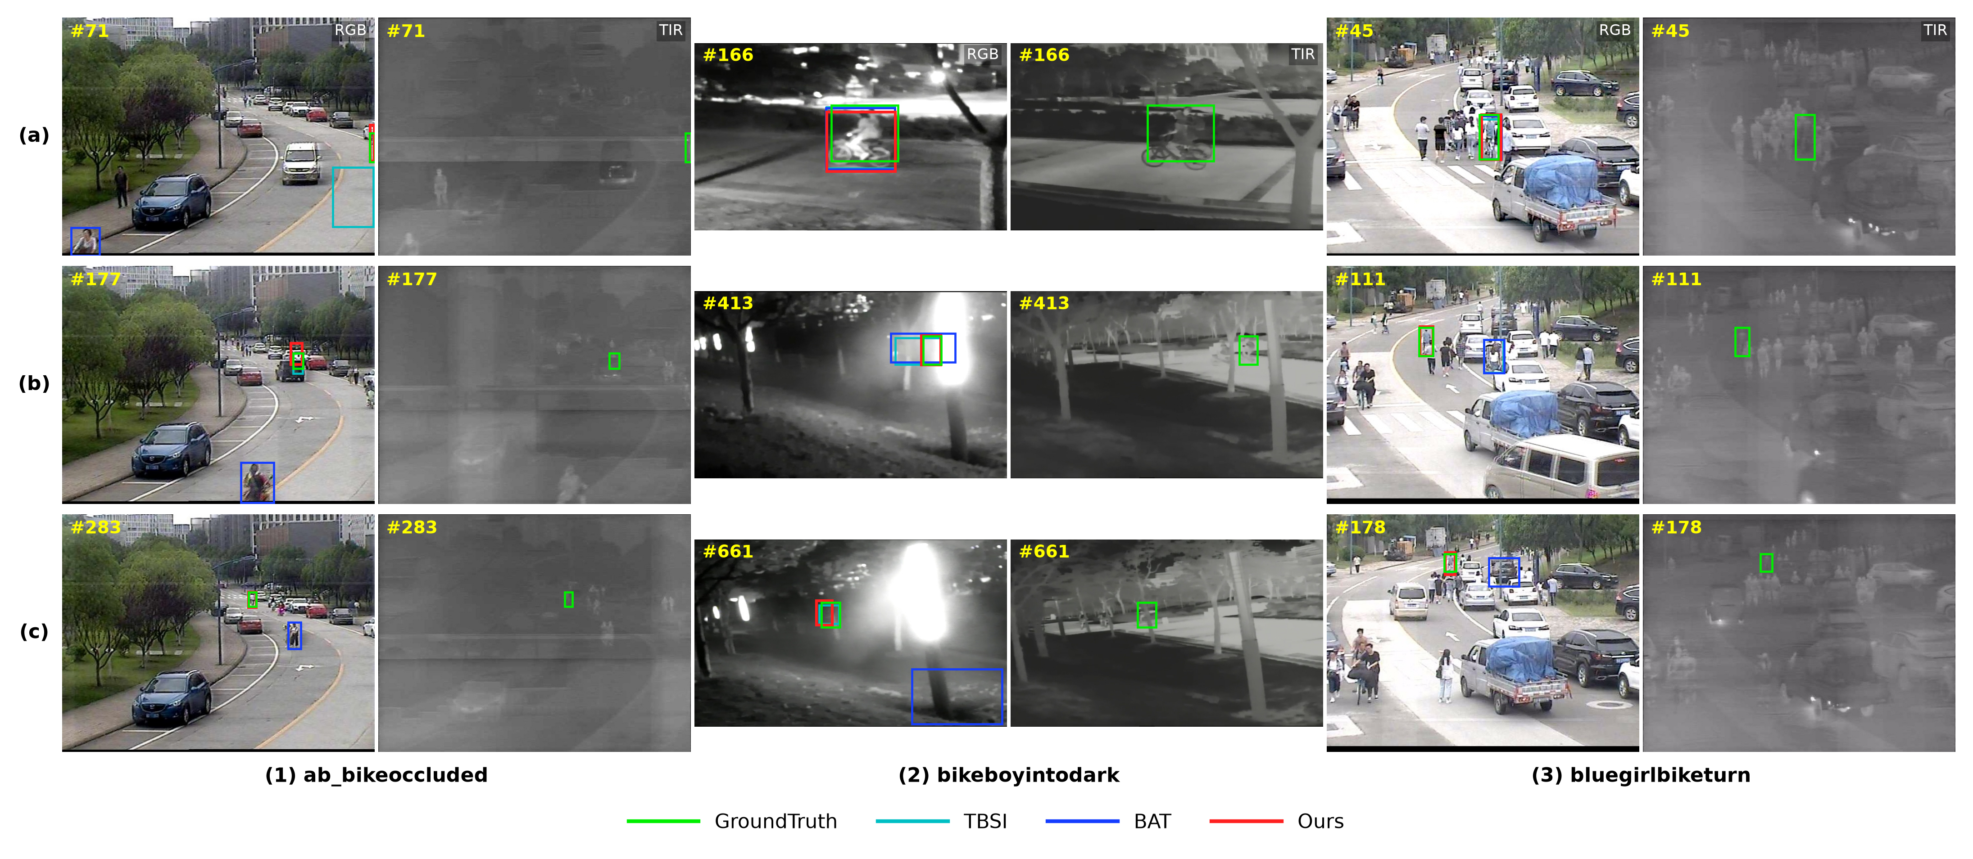
Fig. 7. Tracking under occlusion, illumination changes, and similar backgrounds. The column groups show ab_bikeoccluded, bikeboyintodark, and bluegirlbiketurn, each with RGB followed by TIR. Corner labels indicate frame numbers. Green denotes ground truth and red denotes SwinRGBTrack; the other colors are defined in the legend.
In Fig. 7, SwinRGBTrack maintains localization near the target during partial occlusion in ab_bikeoccluded. In frame 661 of bikeboyintodark, its prediction remains close to the target, while BAT has shifted toward the lower right. In bluegirlbiketurn, nearby pedestrians and vehicles create similar-appearance interference, but SwinRGBTrack continues to follow the original target at frames 111 and 178. The paired thermal images preserve target contours in some frames with reduced visible contrast, providing evidence of complementary observations in these cases.
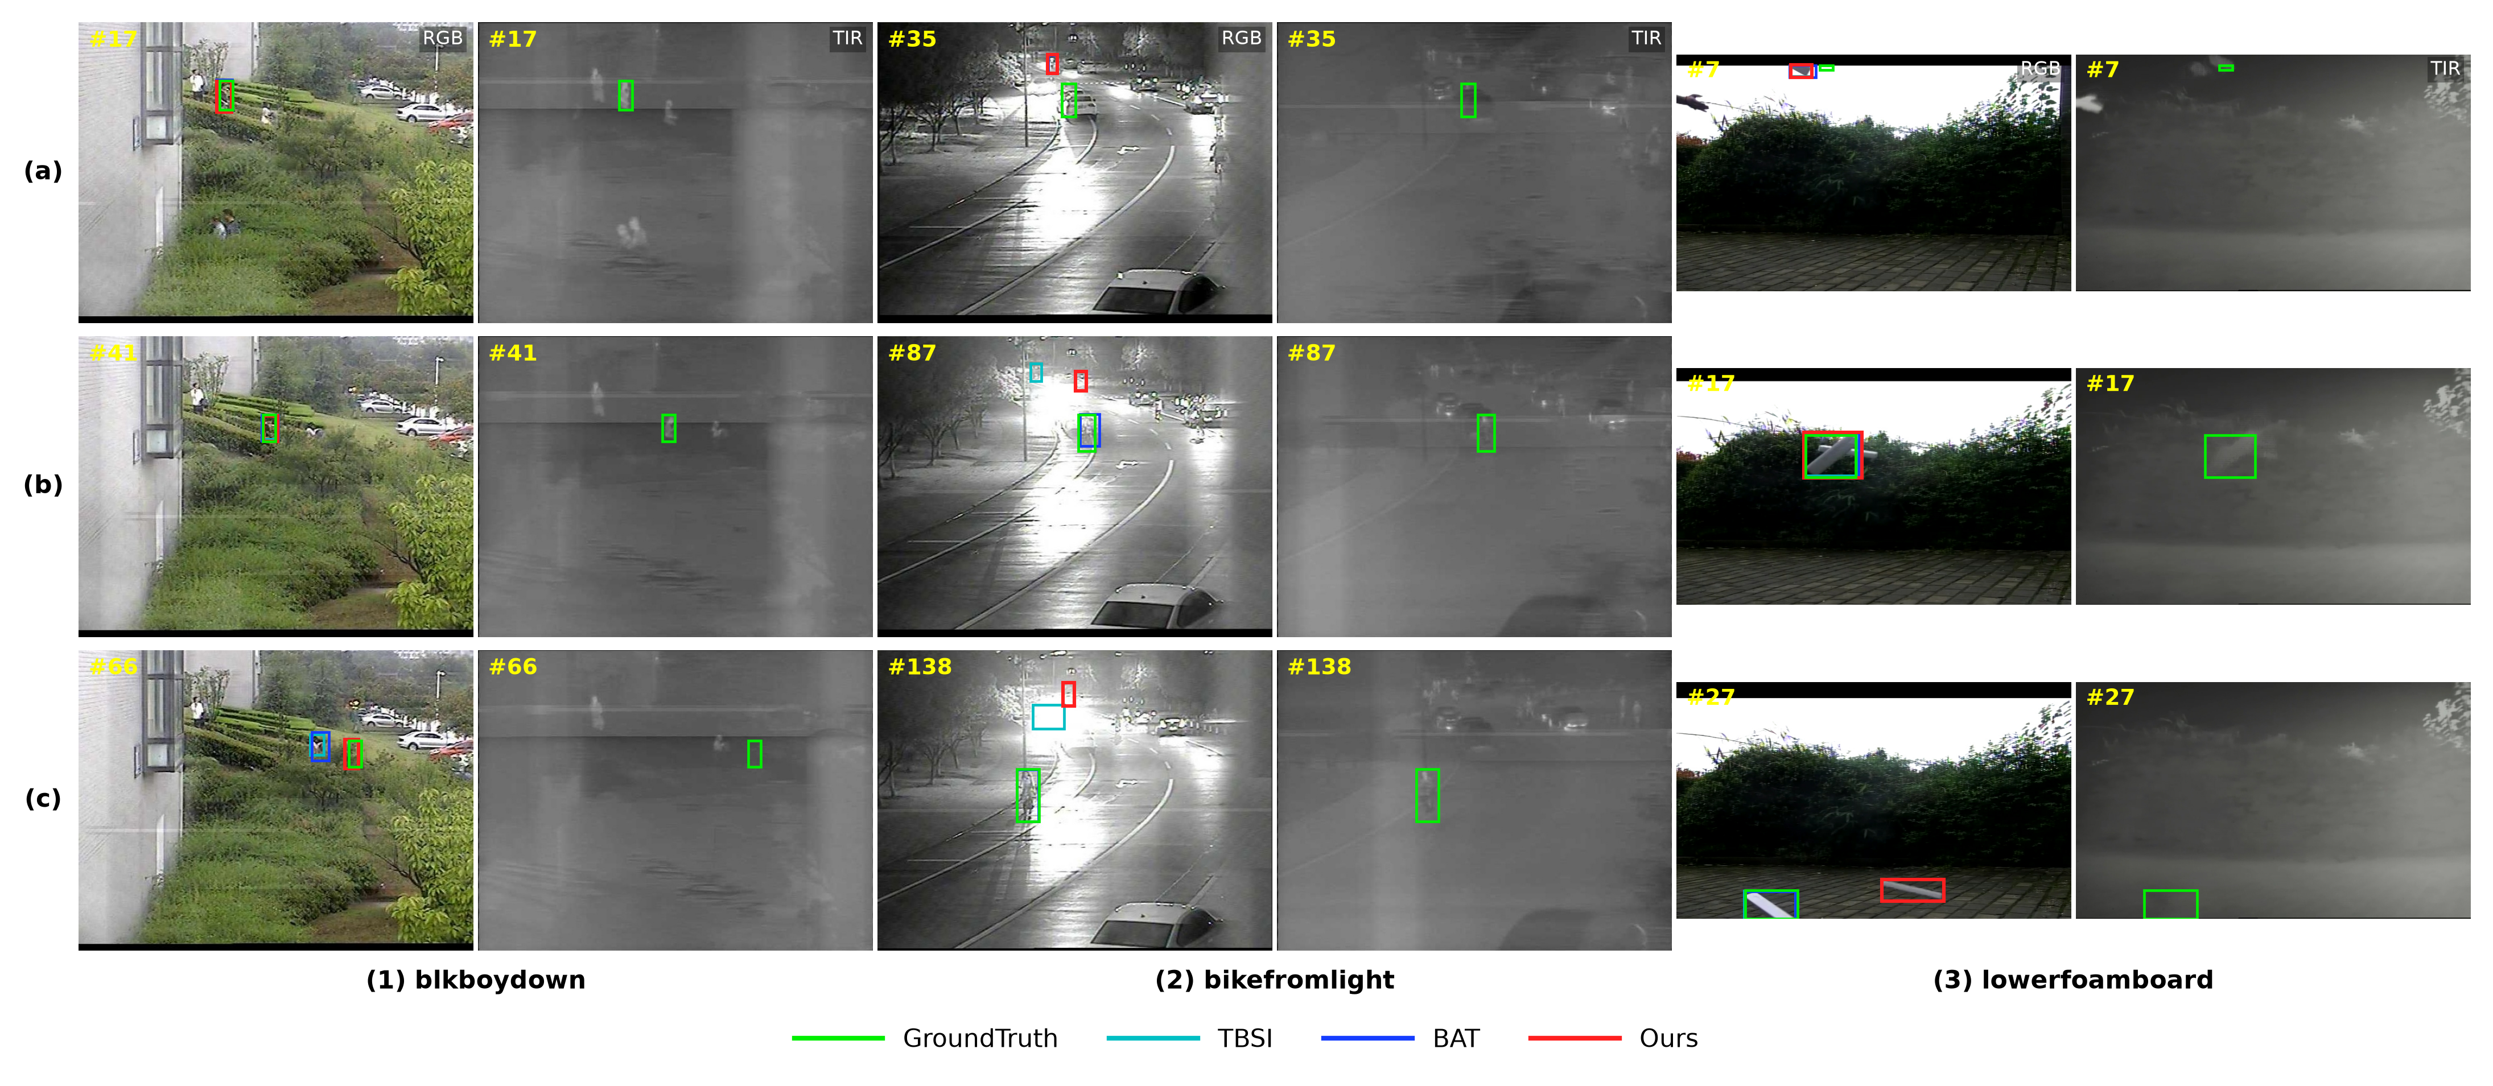
Fig. 8. Stable tracking and drift examples. The column groups show blkboydown, bikefromlight, and lowerfoamboard. Frame sampling, modality order, and colors follow Fig. 7.
In Fig. 8, SwinRGBTrack maintains relatively stable target coverage in blkboydown. In bikefromlight, however, it has already deviated from the cyclist at frame 35 and remains in a distracting region above the target at frames 87 and 138. Its SR is 11.43%, compared with 64.29% for BAT and 73.95% for SDSTrack. In lowerfoamboard, the prediction is close to the target at frame 17 but does not remain so at frame 27. Persistent mismatch after the initial deviation indicates limited recovery from an incorrect search state.
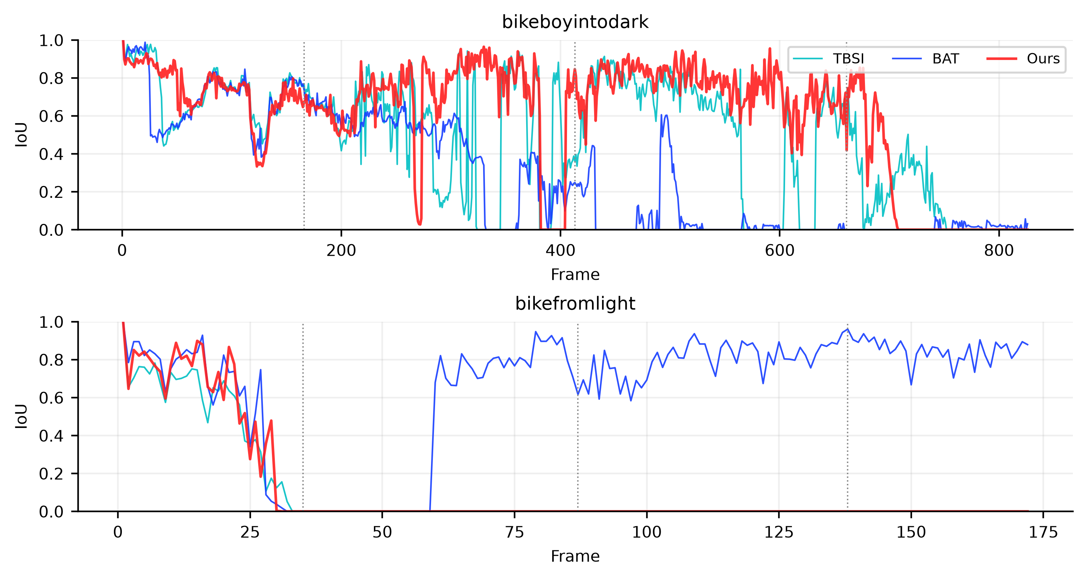
Fig. 9. Frame-level IoU for bikeboyintodark and bikefromlight. The three methods use the same ground truth. Vertical dashed lines mark the frames shown in the qualitative examples.
Figure 9 shows that overlap is maintained during parts of bikeboyintodark, whereas bikefromlight exhibits sustained low IoU. The former illustrates complementary localization when visible observations degrade; the latter shows target identity loss from which the tracker fails to recover under strong interference. These temporal patterns support the local observations in Figs. 7 and 8.

4.6 Fusion position and joint adaptation
Table 12 compares single-modality inputs, fusion positions, and related structural variants, while Table 13 examines a static channel bias and joint Prompt–LoRA adaptation. Both tables use PS/NPS/SS to measure center localization and region coverage under common metric definitions, as specified in Appendix A.2.
Table 12. Results for different fusion positions and structural variants (%).
Architecture | PS | SS
TIR-only | 44.09 | 36.67
Fixed mean after backbone | 49.17 | 40.55
RGB-only | 55.26 | 44.41
Explicit fusion at each encoder layer | 67.44 | 52.08
Adaptive fusion after decoder | 68.47 | 56.04
Mean after encoder (EncFuse) | 71.43 | 58.62
Layer-wise Prompt–LoRA + post-encoder fusion | 72.63 | 59.51
PS denotes center precision, and SS is the area under the success curve. All variants use the same metric definitions.
The EncFuse baseline, which averages the features after encoding, achieves PS/SS scores of 71.43%/58.62%. These exceed post-decoder adaptive fusion by 2.96 and 2.58 percentage points and are higher than those of the other listed configurations without joint adaptation. Adding prompts and LoRA within the relation layers yields the highest PS/SS in the table, at 72.63%/59.51%. These results support the studied combination of fusion between relation encoding and decoding with lightweight adaptation during relation formation.
Table 13. Results for a static channel bias and joint adaptation (%).
Configuration | PS | NPS | SS
EncFuse | 71.43 | 75.37 | 58.62
+ Static channel bias | 71.50 | 75.56 | 58.61
+ Bidirectional prompts + TIR LoRA | 72.63 | 76.23 | 59.51
EncFuse denotes the post-encoder mean-fusion baseline. NPS denotes normalized center precision.
Relative to EncFuse, the joint Prompt–LoRA configuration improves PS/NPS/SS by 1.20, 0.86, and 0.89 percentage points, achieving the highest scores in Table 13. Adding a static channel bias changes PS by +0.07 percentage points and SS by −0.01 percentage points, leaving performance close to the baseline. The larger gains occur with joint adaptation, suggesting that exchanging modality states and adapting thermal projections together can improve matching. This comparison measures their combined effect and does not isolate the contribution of either module.

5 Discussion
The four components form an information path from visual representation to target localization. The shared Swin front end encodes the paired observations on a common spatial grid. Bidirectional prompts and thermal LoRA adapt target-conditioned representations within the relation layers, and post-encoder fusion passes their complementary information to a unified decoder. The overall results on LasHeR and GTOT and the structural comparisons support this organization within the evaluated settings. The RGBT234 and VTUAV results further characterize its behavior for different targets and acquisition conditions.
Attribute-level results and frame-level examples reveal related failure conditions. Low resolution and small objects reduce the spatial information available for matching, while fast motion and sustained out-of-view intervals increase the risk of mismatch within local search. The model uses fixed-grid representations and local search without long-term target re-detection, so drift can persist after target identity is lost. The prompt exchanges do not use explicit reliability gating, and equal-weight fusion does not adapt the modality weights to the scene. Incorporating modality quality into relation updates and improving recovery after target loss are therefore concrete directions for further work.

6 Conclusion
We have presented SwinRGBTrack, a unified RGB-T tracking framework that connects shared hierarchical visual representations, cross-modal adaptation within relation layers, post-encoder fusion, and target prediction. Bidirectional prompts exchange modality states, while thermal-specific LoRA adapts the attention projections. The two target-conditioned representations are fused before search decoding. SwinRGBTrack achieves the highest overall scores within the respective LasHeR and GTOT re-evaluation sets, and results on RGBT234 and the short-term and long-term VTUAV subsets further demonstrate the applicability of the framework under the stated evaluation conditions. Structural comparisons support the combination of post-encoder fusion and joint relation-layer adaptation. Small objects, fast motion, and sustained out-of-view intervals remain difficult; future work will address modality reliability and target recovery.

References
[1] Li C, Xue W, Jia Y, et al. LasHeR: A Large-Scale High-Diversity Benchmark for RGBT Tracking. IEEE Transactions on Image Processing, 2022, 31: 392–404. https://github.com/BUGPLEASEOUT/LasHeR
[2] Zhang P, Zhao J, Wang D, Lu H, Ruan X. Visible-Thermal UAV Tracking: A Large-Scale Benchmark and New Baseline. CVPR, 2022. https://arxiv.org/abs/2204.04120
[3] Dosovitskiy A, Beyer L, Kolesnikov A, et al. An Image is Worth 16x16 Words: Transformers for Image Recognition at Scale. ICLR, 2021. https://arxiv.org/abs/2010.11929
[4] Liu Z, Lin Y, Cao Y, et al. Swin Transformer: Hierarchical Vision Transformer Using Shifted Windows. ICCV, 2021: 10012–10022. https://arxiv.org/abs/2103.14030
[5] Lin L, Fan H, Zhang Z, Xu Y, Ling H. SwinTrack: A Simple and Strong Baseline for Transformer Tracking. NeurIPS, 2022, 35. https://arxiv.org/abs/2112.00995
[6] Zhang H, Zhang L, Zhuo L, Zhang J. Object Tracking in RGB-T Videos Using Modal-Aware Attention Network and Competitive Learning. Sensors, 2020. https://doi.org/10.3390/s20020393
[7] Li C, Liu L, Lu A, Ji Q, Tang J. Challenge-Aware RGBT Tracking. ECCV, 2020. https://www.ecva.net/papers/eccv_2020/papers_ECCV/html/4010_ECCV_2020_paper.php
[8] Zhu Y, Li C, Tang J, Luo B. Quality-Aware Feature Aggregation Network for Robust RGBT Tracking. IEEE Transactions on Intelligent Vehicles, 2021. https://doi.org/10.1109/TIV.2020.2980735
[9] Lu A, Li C, Yan Y, Tang J, Luo B. RGBT Tracking via Multi-Adapter Network with Hierarchical Divergence Loss. IEEE Transactions on Image Processing, 2021. https://doi.org/10.1109/TIP.2021.3087341
[10] Lu A, Qian C, Li C, Tang J, Wang L. Duality-Gated Mutual Condition Network for RGBT Tracking. IEEE Transactions on Neural Networks and Learning Systems (early access), 2022. https://doi.org/10.1109/TNNLS.2022.3157594
[11] Xiao Y, Yang M, Li C, Liu L, Tang J. Attribute-Based Progressive Fusion Network for RGBT Tracking. AAAI, 2022. https://doi.org/10.1609/aaai.v36i3.20187
[12] Hui T, Xun Z, Peng F, et al. Bridging Search Region Interaction With Template for RGB-T Tracking. CVPR, 2023. https://openaccess.thecvf.com/content/CVPR2023/html/Hui_Bridging_Search_Region_Interaction_With_Template_for_RGB-T_Tracking_CVPR_2023_paper.html
[13] Tang Z, Xu T, Wu X, Zhu X F, Kittler J. Generative-Based Fusion Mechanism for Multi-Modal Tracking. AAAI, 2024. https://doi.org/10.1609/aaai.v38i6.28325
[14] Lu A, Zhao J, Li C, Xiao Y, Luo B. Breaking Modality Gap in RGBT Tracking: Coupled Knowledge Distillation. ACM MM, 2024. https://openreview.net/pdf/1010215327f166d2e5e7c38dbfe0d322f5957c4b.pdf
[15] Li Y, Wang B, Li Y. Transformer-Based RGB-T Tracking With Channel and Spatial Feature Fusion. IEEE Sensors Journal, 2025, 25: 28891-28904. https://doi.org/10.1109/jsen.2025.3579339
[16] Lu A, Wang W, Li C, Tang J, Luo B. AFTER: Attention-Based Fusion Router for RGBT Tracking. IEEE Transactions on Image Processing, 2025, 34: 4386–4401. https://doi.org/10.1109/TIP.2025.3586467
[17] Zhang Q, Liu X, Zhang T. RGB-T tracking by modality difference reduction and feature re-selection. Image and Vision Computing, 2022, 127: 104547. https://doi.org/10.1016/j.imavis.2022.104547
[18] Lei L, Li X. RGB-T tracking with frequency hybrid awareness. Image and Vision Computing, 2024, 152: 105330. https://doi.org/10.1016/j.imavis.2024.105330
[19] Zhang Z, Zeng B, Ni X, Du Y. BTMTrack: Robust RGB-T tracking via dual-template bridging and temporal-modal candidate elimination. Image and Vision Computing, 2025, 162: 105676. https://doi.org/10.1016/j.imavis.2025.105676
[20] Zhao Y, Wu Y, Cao K, Zhang D, Liu B, Wan G. TCM-tracking: Real-time cross-modal interactive RGBT tracking based on temporal correlation. Image and Vision Computing, 2026, 168: 105943. https://doi.org/10.1016/j.imavis.2026.105943
[21] Zhang T, Jiao Q, Zhang Q, Han J. Exploring Multi-modal Spatial-Temporal Contexts for High-performance RGB-T Tracking. IEEE Transactions on Image Processing, 2024, 33: 4303–4318. https://doi.org/10.1109/TIP.2024.3428316
[22] Zhu J, Lai S, Chen X, Wang D, Lu H. Visual Prompt Multi-Modal Tracking. CVPR, 2023: 9516–9526. https://openaccess.thecvf.com/content/CVPR2023/html/Zhu_Visual_Prompt_Multi-Modal_Tracking_CVPR_2023_paper.html
[23] Luo Y, Guo X, Feng H, Ao L. RGB-T Tracking via Multi-Modal Mutual Prompt Learning. arXiv preprint, 2023. https://arxiv.org/abs/2308.16386
[24] Cao B, Guo J, Zhu P, Hu Q. Bi-directional Adapter for Multimodal Tracking. AAAI, 2024. https://doi.org/10.1609/aaai.v38i2.27852
[25] Hou X, Xing J, Qian Y, et al. SDSTrack: Self-Distillation Symmetric Adapter Learning for Multi-Modal Visual Object Tracking. CVPR, 2024. https://openaccess.thecvf.com/content/CVPR2024/html/Hou_SDSTrack_Self-Distillation_Symmetric_Adapter_Learning_for_Multi-Modal_Visual_Object_Tracking_CVPR_2024_paper.html
[26] Wu Z, Zheng J, Ren X, et al. Single-Model and Any-Modality for Video Object Tracking. CVPR, 2024. https://openaccess.thecvf.com/content/CVPR2024/html/Wu_Single-Model_and_Any-Modality_for_Video_Object_Tracking_CVPR_2024_paper.html
[27] Wang S, Li Y, Deng L, Sun G, Dong M, Zhu L. HATrack: Cross-modal fusion RGBT tracking with heterogeneous adapter. Expert Systems with Applications, 2026, 323: 132426. https://doi.org/10.1016/j.eswa.2026.132426
[28] Hu E J, Shen Y, Wallis P, et al. LoRA: Low-Rank Adaptation of Large Language Models. ICLR, 2022. https://arxiv.org/abs/2106.09685
[29] Zhang H, Wang Y, Dayoub F, Sünderhauf N. VarifocalNet: An IoU-aware Dense Object Detector. CVPR, 2021: 8514–8523. https://openaccess.thecvf.com/content/CVPR2021/html/Zhang_VarifocalNet_An_IoU-Aware_Dense_Object_Detector_CVPR_2021_paper.html
[30] Rezatofighi H, Tsoi N, Gwak J, et al. Generalized Intersection over Union: A Metric and a Loss for Bounding Box Regression. CVPR, 2019: 658–666. https://arxiv.org/abs/1902.09630
[31] Zhu Y, Li C, Luo B, et al. Dense Feature Aggregation and Pruning for RGBT Tracking. Proceedings of the 27th ACM International Conference on Multimedia, 2019: 465-472. https://doi.org/10.1145/3343031.3350928
[32] Li CL, Lu A, Zheng AH, et al. Multi-Adapter RGBT Tracking. 2019 IEEE/CVF International Conference on Computer Vision Workshop (ICCVW), 2019: 2262-2270. https://doi.org/10.1109/iccvw.2019.00279
[33] Zhang L, Danelljan M, Gonzalez-Garcia A, et al. Multi-Modal Fusion for End-to-End RGB-T Tracking. 2019 IEEE/CVF International Conference on Computer Vision Workshop (ICCVW), 2019: 2252-2261. https://doi.org/10.1109/iccvw.2019.00278
[34] Yang J, Li Z, Zheng F, et al. Prompting for Multi-Modal Tracking. Proceedings of the 30th ACM International Conference on Multimedia, 2022: 3492-3500. https://doi.org/10.1145/3503161.3547851
[35] Mei J, Zhou D, Cao J, et al. Differential Reinforcement and Global Collaboration Network for RGBT Tracking. IEEE Sensors Journal, 2023, 23: 7301-7311. https://doi.org/10.1109/jsen.2023.3244834
[36] Liu L, Li C, Xiao Y, et al. Quality-Aware RGBT Tracking via Supervised Reliability Learning and Weighted Residual Guidance. Proceedings of the 31st ACM International Conference on Multimedia, 2023: 3129-3137. https://doi.org/10.1145/3581783.3612341
[37] Zhang T, Guo H, Jiao Q, et al. Efficient RGB-T Tracking via Cross-Modality Distillation. 2023 IEEE/CVF Conference on Computer Vision and Pattern Recognition (CVPR), 2023: 5404-5413. https://doi.org/10.1109/cvpr52729.2023.00523
[38] Sun D, Pan Y, Lu A, et al. Transformer RGBT Tracking With Spatio-Temporal Multimodal Tokens. IEEE Transactions on Circuits and Systems for Video Technology, 2024, 34: 12059-12072. https://doi.org/10.1109/tcsvt.2024.3425455
[39] Wang H, Liu X, Li Y, et al. Temporal Adaptive RGBT Tracking with Modality Prompt. Proceedings of the AAAI Conference on Artificial Intelligence, 2024, 38: 5436-5444. https://doi.org/10.1609/aaai.v38i6.28352
[40] Hong L, Yan S, Zhang R, et al. OneTracker: Unifying Visual Object Tracking with Foundation Models and Efficient Tuning. 2024 IEEE/CVF Conference on Computer Vision and Pattern Recognition (CVPR), 2024: 19079-19091. https://doi.org/10.1109/cvpr52733.2024.01805
[41] Xiao Y, Zhao J, Lu A, Li C, Yin B, Lin Y, Liu C. Cross-modulated Attention Transformer for RGBT Tracking. Proceedings of the AAAI Conference on Artificial Intelligence, 2025, 39(8): 8682–8690. https://doi.org/10.1609/aaai.v39i8.32938
[42] Li C, Cheng H, Hu S, et al. Learning Collaborative Sparse Representation for Grayscale-Thermal Tracking. IEEE Transactions on Image Processing, 2016, 25: 5743-5756. https://doi.org/10.1109/tip.2016.2614135
[43] Luo Y, Guo X, Dong M, Yu J. Learning Modality Complementary Features with Mixed Attention Mechanism for RGB-T Tracking. Sensors, 2023, 23(14): 6609. https://doi.org/10.3390/s23146609
[44] Zhang P, Wang D, Lu H, Yang X. Learning Adaptive Attribute-Driven Representation for Real-Time RGB-T Tracking. International Journal of Computer Vision, 2021, 129(9): 2714–2729. https://doi.org/10.1007/s11263-021-01495-3
[45] Gao Y, Li C, Zhu Y, et al. Deep Adaptive Fusion Network for High Performance RGBT Tracking. Proceedings of the IEEE/CVF International Conference on Computer Vision Workshops, 2019. https://openaccess.thecvf.com/content_ICCVW_2019/html/VISDrone/Gao_Deep_Adaptive_Fusion_Network_for_High_Performance_RGBT_Tracking_ICCVW_2019_paper.html
[46] zjc. RGBT toolkit, version 1.0.1 [software]. 2023-06-19. https://pypi.org/project/rgbt/1.0.1/
[47] Gu A, Dao T. Mamba: Linear-Time Sequence Modeling with Selective State Spaces. arXiv:2312.00752, 2023. https://arxiv.org/abs/2312.00752

Appendix A Implementation and evaluation conditions

A.1 Optimization and model selection
Optimization starts from SwinTrack weights previously adapted to RGB-T tracking. This continued-training stage uses FP32, the AdamW optimizer, and a batch size of 16 for 3 epochs, with 60,000 template–search pairs sampled per epoch. The learning rate and weight decay are both 10⁻⁴, and the random seed is 42. The backbone, encoder core, decoder, and fusion residual are frozen, while the prompts, LoRA modules, prediction head, and some normalization parameters are updated. The stated epoch count refers only to this continued-training stage.
LasHeR, GTOT, and RGBT234 use the same model, selected according to sequence-averaged success scores in the test summaries. Models for the ST and LT subsets of VTUAV are selected separately. No independent validation set is used for model selection.

A.2 Metrics for LasHeR and the structural comparisons
The overall LasHeR results, curves, and attribute analyses use the same 245 common test sequences. Attribute groups may overlap; Table 5 lists the sequence counts for each group.
PR is the sequence-averaged proportion of frames with a center error no greater than 20 pixels. NPR normalizes horizontal and vertical center errors by the ground-truth width and height, respectively, and uses a normalized-error threshold of 0.20. SR is the mean success rate at 21 IoU thresholds, 0, 0.05, …, 1, with success defined by a strict greater-than comparison. Metrics are calculated separately for each sequence and then averaged with equal weights:
$\text{PR = }{\text{mean}}_{\text{s}} {\text{P}}_{\text{s}}\text{(e≤20); NPR = }{\text{mean}}_{\text{s}} {\text{P}}_{\text{s}}\text{(}{\text{e}}_{\text{norm}}\text{≤0.20)}$ (9)
$\text{SR = }{\text{mean}}_{\text{s}}\text{ [}\frac{\text{1}}{\text{21}}\sum_{\text{k=0}}^{\text{20}}{{\text{P}}_{\text{s}}\text{(}\text{IoU}\text{>}\frac{\text{k}}{\text{20}}\text{)}}\text{]}$ (10)
The first prediction is set to the initial ground-truth box. An invalid prediction is replaced by the preceding box, and non-positive annotations follow the evaluation tool's special-value rules. In Tables 12 and 13, PS is the proportion of frames with a center error no greater than 20 pixels. NPS divides the center distance by the square root of the ground-truth box area and uses a threshold of 0.5. SS is the trapezoidal area under the success curve at 21 equally spaced IoU thresholds from 0 to 1, with success defined by a greater-than-or-equal comparison. Each metric is calculated per sequence before equal-weight averaging. Thus, NPS/SS and the overall NPR/SR use the distinct definitions specified above.

A.3 GTOT and RGBT234
GTOT and RGBT234 are evaluated using RGBT toolkit 1.0.1 [46]. Four-parameter predictions encode the top-left coordinates, width, and height; eight-parameter predictions are converted from four corner coordinates. Coordinates are rounded according to the toolkit rules. Each prediction is compared with both the RGB and TIR ground truths, taking the smaller center error and the larger IoU. GTOT uses double-precision geometric calculations after compatible coordinate conversion.
For GTOT, the precision curve samples center-error thresholds from 0 to 25 pixels in increments of 0.5 pixels. MPR uses a strict threshold of less than 5 pixels. The success curve uses 21 IoU thresholds, and its trapezoidal integral gives MSR, with success defined by a strict greater-than comparison. Curves are weighted by frame count. The first box for each method already matches the initial RGB ground truth, and no additional first-frame reset is applied.
The GTOT attributes OCC, LSV, FM, LI, TC, SO, and DEF contain 26, 28, 14, 27, 31, 28, and 22 sequences, respectively. Attribute groups may overlap. Each group includes all corresponding frames and the same six methods.
For RGBT234, MPR is the proportion of frames with a center error no greater than 20 pixels, and MSR is the mean success rate over 21 IoU thresholds with a strict greater-than success criterion. Sequences are weighted equally. Tables 7 and 8 use 232 common sequences, excluding orangeman1 and man4 for all methods because of prediction-length mismatches. Table 3 separately reports SwinRGBTrack results on all 234 sequences.

A.4 VTUAV and the scope of literature comparisons
VTUAV MPR/MSR are computed following the official benchmark protocol, with equal weighting of sequences over each complete subset, and ST and LT reported separately. The annotation sampling, handling of the two modality-specific ground truths, and aggregation rules follow the official evaluation procedure. Tables 9 and 10 therefore report results under a common protocol and can be compared directly. Table 9 lists published results, and Table 10 presents the SwinRGBTrack results obtained under the same official protocol.
The literature comparison in Table 3 includes methods with a reported LasHeR PR no greater than 72.68%. Table 9 includes methods whose reported ST and LT MPR do not exceed the corresponding SwinRGBTrack results. These tables describe performance within the listed subsets and do not represent complete benchmark rankings. Tables 4, 6, and 7 compare publicly available predictions under common evaluation rules on their respective datasets.

A.5 Parameterization of the fusion residual
The fusion residual is parameterized by channel concatenation, input projection, and spatial state processing:
${\text{F}}_{\text{base}}\text{ = 0.5}{\text{F}}_{\text{R}}\text{ + 0.5}{\text{F}}_{\text{T}}\text{; u = LN(}{\text{P}}_{\text{in}}\text{([}{\text{F}}_{\text{R}}\text{; }{\text{F}}_{\text{T}}\text{]))}$ (A1)
$\text{v}\text{ = }{\text{M}}_{\text{fwd}}\text{(u); s = v + Rev(}{\text{M}}_{\text{bwd}}\text{(Rev(v)))}$ (A2)
${\text{F}}_{\text{fused}}\text{ = }{\text{F}}_{\text{base}}\text{ + }{\text{P}}_{\text{out}}\text{(s)}$ (A3)
Here, Pin and Pout are the input and output linear projections, LN denotes layer normalization, and Mfwd and Mbwd are the forward and backward Mamba operators [47]. Equation (A1) concatenates features along the channel dimension, and Rev reverses the token order. Equation (A2) first applies forward processing, then supplements its output through backward processing. Template and search features use the same parameters in separate calls, and states are not propagated across frames.
In the evaluated model, the input projection weights and biases and the output projection weights are all zero; only the output bias is nonzero. The residual in Eq. (A3) is therefore independent of the input, and the fusion mapping reduces to Eq. (7).

* Corresponding author E-mail address: 20093079@sau.edu.cn

