**Lab objectives:**

**- Create and Use user defined functions in a RPGLE program**

**Requirements to pass the lab:**

Successfully run the WhatDay program demonstrating user defined functions.

1/2 – get the day of week and day name user defined functions to work and

– support a longer form of the date in Result3 new code in WhatDayRPG (Tuesday December 25, 2018)

2/2 – Support a DateWords user function for Result3 field = DateWords(DateIn)

User Defined Functions

Two user defined functions are created and used. DayOfWeek( ) returns a day number from 1 to 7 for any date passed and DayName( ) returns the day name from Monday to Sunday for any date passed to the function.

Four members are stored in a source physical file called UDFunction (User Defined Functions)

**DateProcs** – contains the function solution code

**DateProtos** – contains the prototypes for the functions used by every program that uses the function and used by DateProcs

**WhatDayDsp** – a display file allowing users to enter dates so the functions can be tested (available in BCI433LIB/LAB10)

**WhatDayRPG** – A program that uses the display file and the date functions to convert a date to it’s day of week number and day of week name.

We will create modules, for DateProcs and WhatDayRPG and then combine those modules into a working program called **WHATDAY**.

User enters a date:

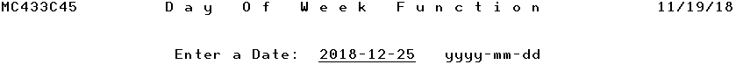

User presses enter key

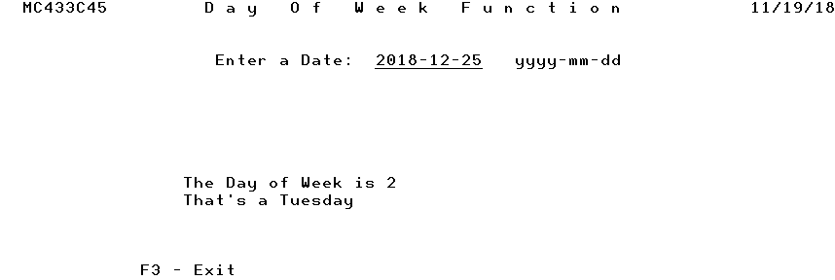

DATEPROTOS contains two prototypes

The Prototype for DayOfWeek

________________________________________________________

________________________________________________________

________________________________________________________

The Prototype for DayName

________________________________________________________

________________________________________________________

________________________________________________________

DayOfWeek and DayName are not RPGLE functions. But, they can be created and then used by all programmers. The RPGLE compiler would reject

DayOut = DayName(WorkDate);

The prototype is telling the compiler to accept DayName as legitimate.

WHATDAYDSP

A R OUTPUT CF03(03)

A OVERLAY

A RESULT1 30 O 11 19

A RESULT2 30 O 12 19

A RESULT3 30 O 13 19

A 16 15'F3 - Exit'

A R INPUT

A DATEIN L B 4 37

A 90 DSPATR(PR)

A 4 22'Enter a Date:'

A 4 50'yyyy-mm-dd'

A 1 21'D a y O f W e e k F u n c t -

A i o n'

A 1 4USER

A 1 72DATE

A EDTCDE(Y)

The following code is supplied in class by your professor:

WHATDAYRPG (use back of this sheet)

DATEPROCS (Use back of this sheet)

Supporting an answer for Result3 field:

