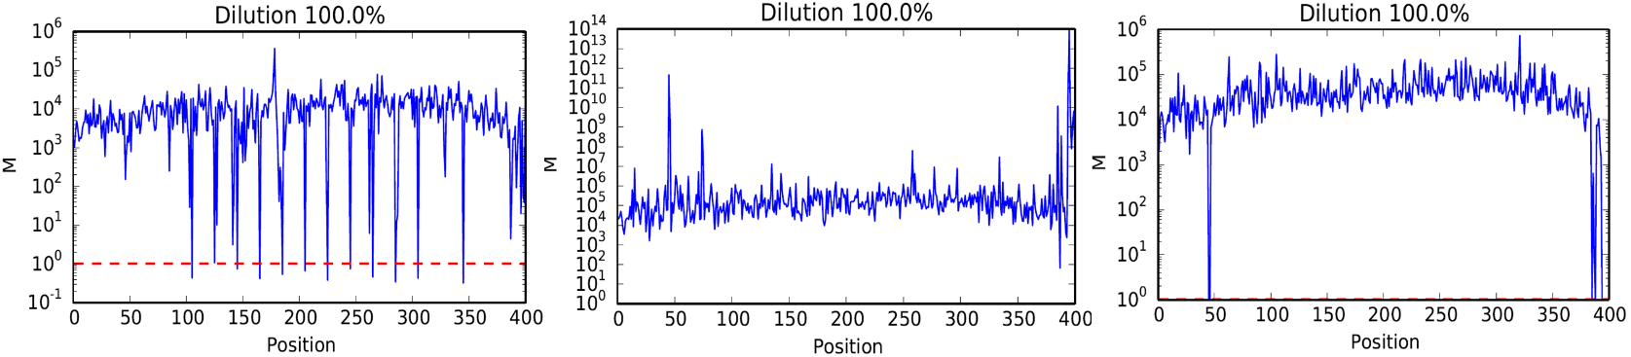

(a) Jeffrey’s prior (b) Log-normal prior (c) Improper prior