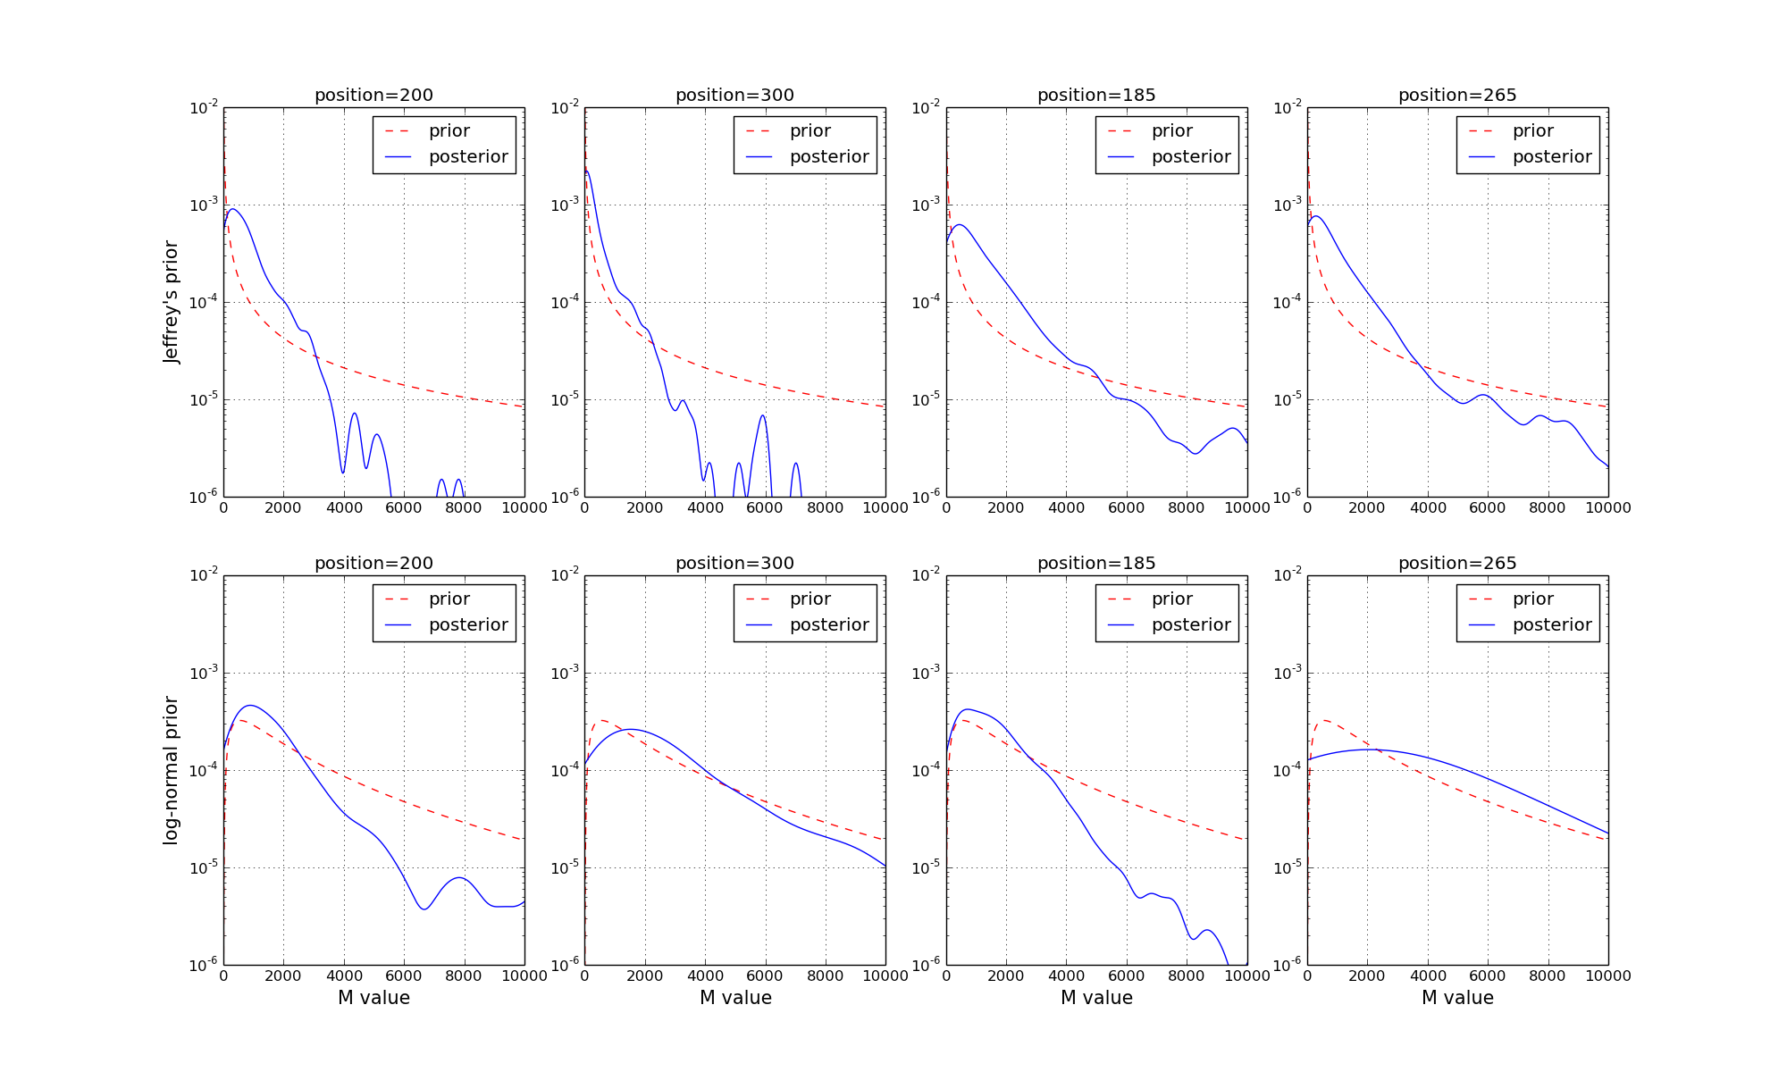

Reference Positions

Mutant Positions