How to calibrate the birdview:
- First make a normal camera calibration to get the camera matrix and the distortion matirx. For examples look at open cv (http://docs.opencv.org/2.4/doc/tutorials/calib3d/camera_calibration/camera_calibration.html) (You can also use a old calibration file if the camera is the same)

- Place the car on the calibration pattern.
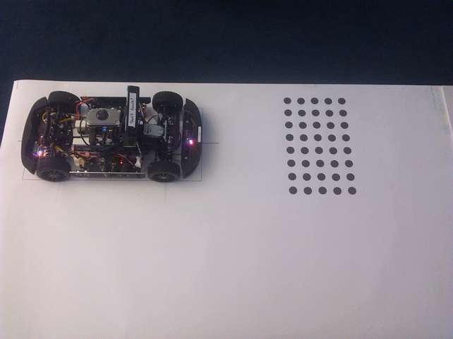
The calibration patter must be very plane. There mustn't be any waves in it.

- Take a picture with the camera. (i.e. run the software an take one of the debug pictures)
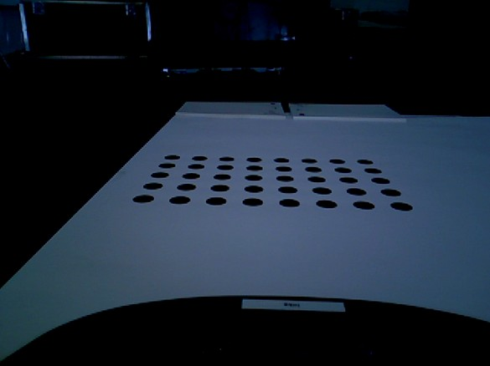

- run test_oadrive_birdViewCal [1][2]
[1]pathToPic/00018.png
[2]destinationFolder/BirdviewCal.yml
[3]folderWithIntrinsicCal/xtion_intrinsic_calib_low_res.yml

-check if the right points were found. If no points found you can try following things:
-a other picture
- make everything white (except the points)
- make a better contrast/other light source

- adjust the parameters:
20mm should be 7 pixel (look at the console)
set the yOffset (you shouldn't see anything from the chassi)
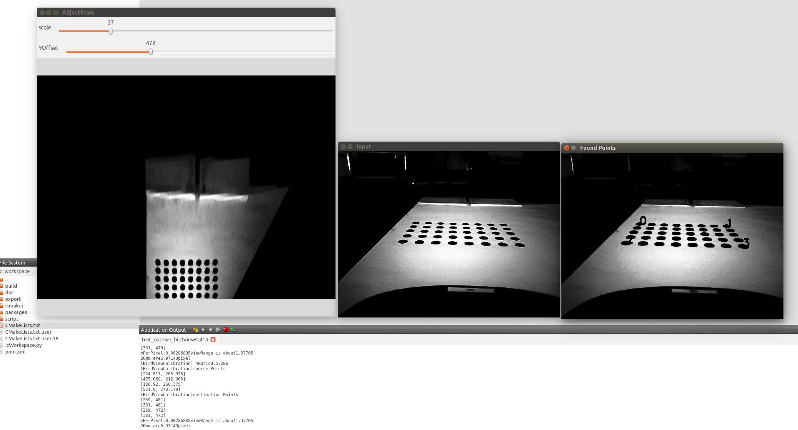
- press any key to save the calibration
- copy the calibration to the car config folder

