**Project: Back-testing of a ROA Fundamental Strategy**

Zhongnan (Chandler) Fang

(UC Berkeley)

**Q1.** Consider the following long-short strategy: At the end of each month, we rank stocks by ROA (using the latest available information at that time); We get long the top 20% and short the bottom 20% of the ROA distribution, using equal weighting on the selected stocks. We keep the same portfolio until the end of the next month. Etc.

**a. Compute the time-series of returns of the portfolio (per dollar long). Draw the graph of the cumulative returns.**

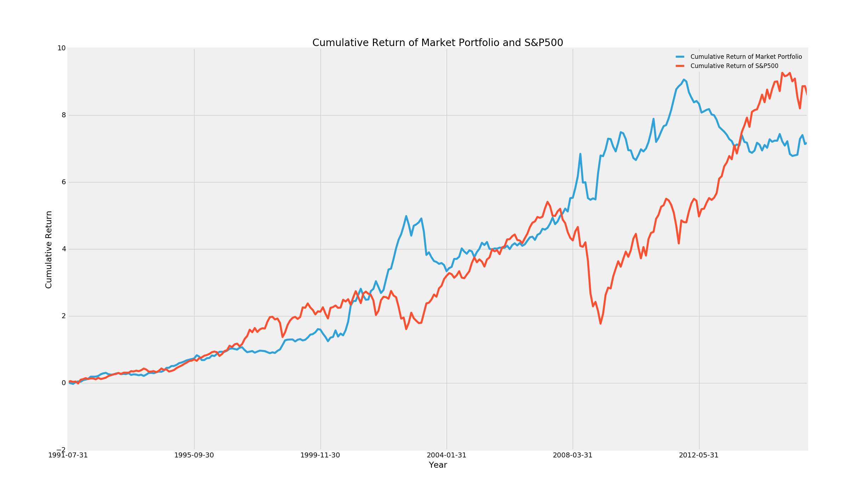

Figure 1 - Cumulative Return of Portfolio and SP500

According to the graph above, we can tell that the cumulative return of the portfolio is slightly below the index return over the testing period. The main reason resulting in this could be as below:

1. The ROA factor itself did not work well as a portfolio construction signal
2. The single factor model could be relatively weak explaining the market return
3. The ROA data only came out once a year, and most of the companies publish their ROA annual data on December. Though we repeatedly working on monthly-ranking and monthly-rebalance, the actual rebalance frequency is more close to annually because of the data.

Interestingly, we can observe significant divergence during the S&P500 drawdown period, during which the ROA-oriented portfolio significantly over-performed the index. One possible reason could be during the bearish market time, investors become risk averse and are more likely to buy value stocks.

**b. What is the Information ratio?**

The [information ratio](https://en.wikipedia.org/wiki/Information_ratio) is an extension of the Sharpe ratio which replaces the risk-free rate of return with the scalar expected return of a benchmark portfolio, E(rb)E(rb),

Information ratio could be calculated using the formula below:

According to the data, we calculated the information ratio of ROA to be -**0.0168**

The information ratio is negative as the portfolio return is lower than the SP500 index, which suggests that the ROA might not be an effective factor.

**c. Draw 12 months rolling volatility of the returns and compare to the volatility of the S&P500.**

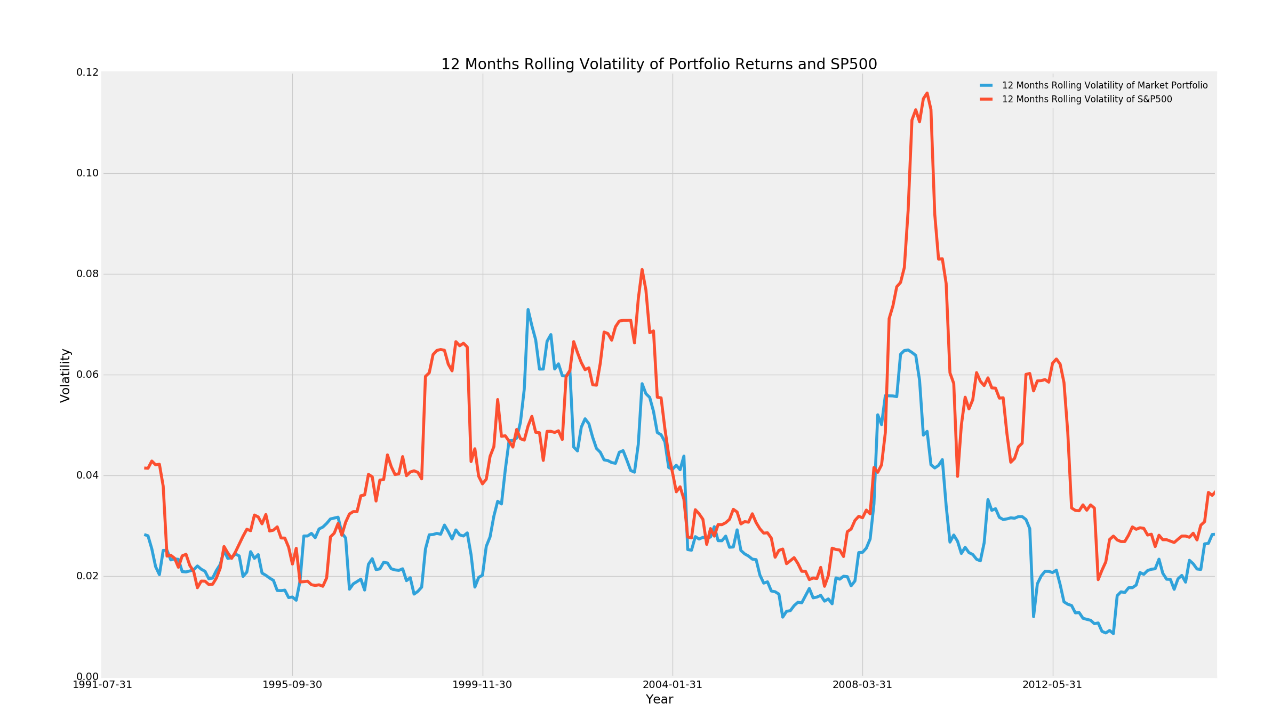

Figure 2 - 12 Month Rolling Volatility of Portfolio Returns and SP500

As it is shown above, the portfolio rolling volatility is lower than the SP500 volatility during the most period of time. Specifically, during 1999 and 2008 the SP500 had larger fluctuation than our ROA portfolio and the portfolio volatility is significantly lower than the market volatility.

**d.** **Assume this is the unique strategy of a fund: what leverage do you suggest to use if the fund is targeting same volatility as the SP500 index.**

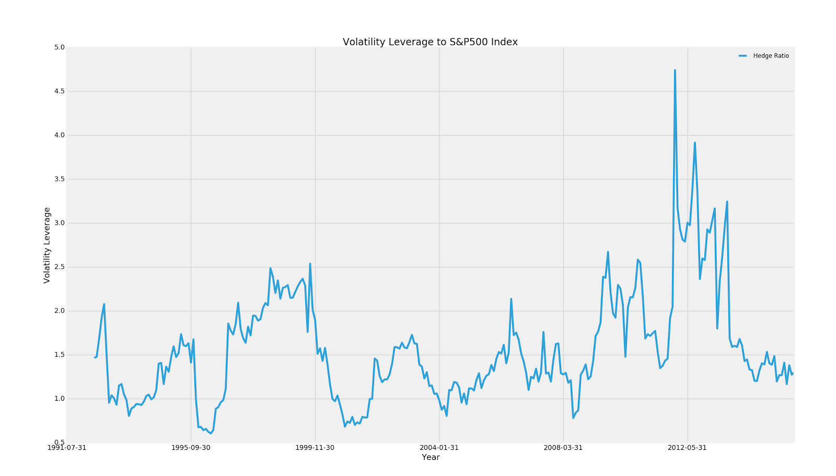

Figure 3 – Volatility Leverage to S&P500

From Figure 2 and Figure 3, we can set a fixed level of leverage around 1.1 - 1.2 during the most of time. While the market crashed down, however, we could increase our leverage to 2 to match the same level of volatility as the market. Using the 1.2x leverage ratio for 1991-1995, 1999-2008 and 2x leverage ratio for 1995-1999, 2008-2012, we are able to roughly target our volatility at the S&P500 index level.

Also, we could use optimization method to minimized the error, which could get a empirically optimized result. Finally, we can do the cointegration test of the vol difference, and check whether it is stationary.

**Q2.** Now, we consider some possible improvements to the basic strategy:

**a. *Industry Neutrality:* we change the signal by sorting stocks within their industry. We select the top 20% and short the bottom 20% of the ROA distribution *within each industry*. Does that improve the Information ratio computed in question 1? Draw the two cumulative returns lines on a same graph.**

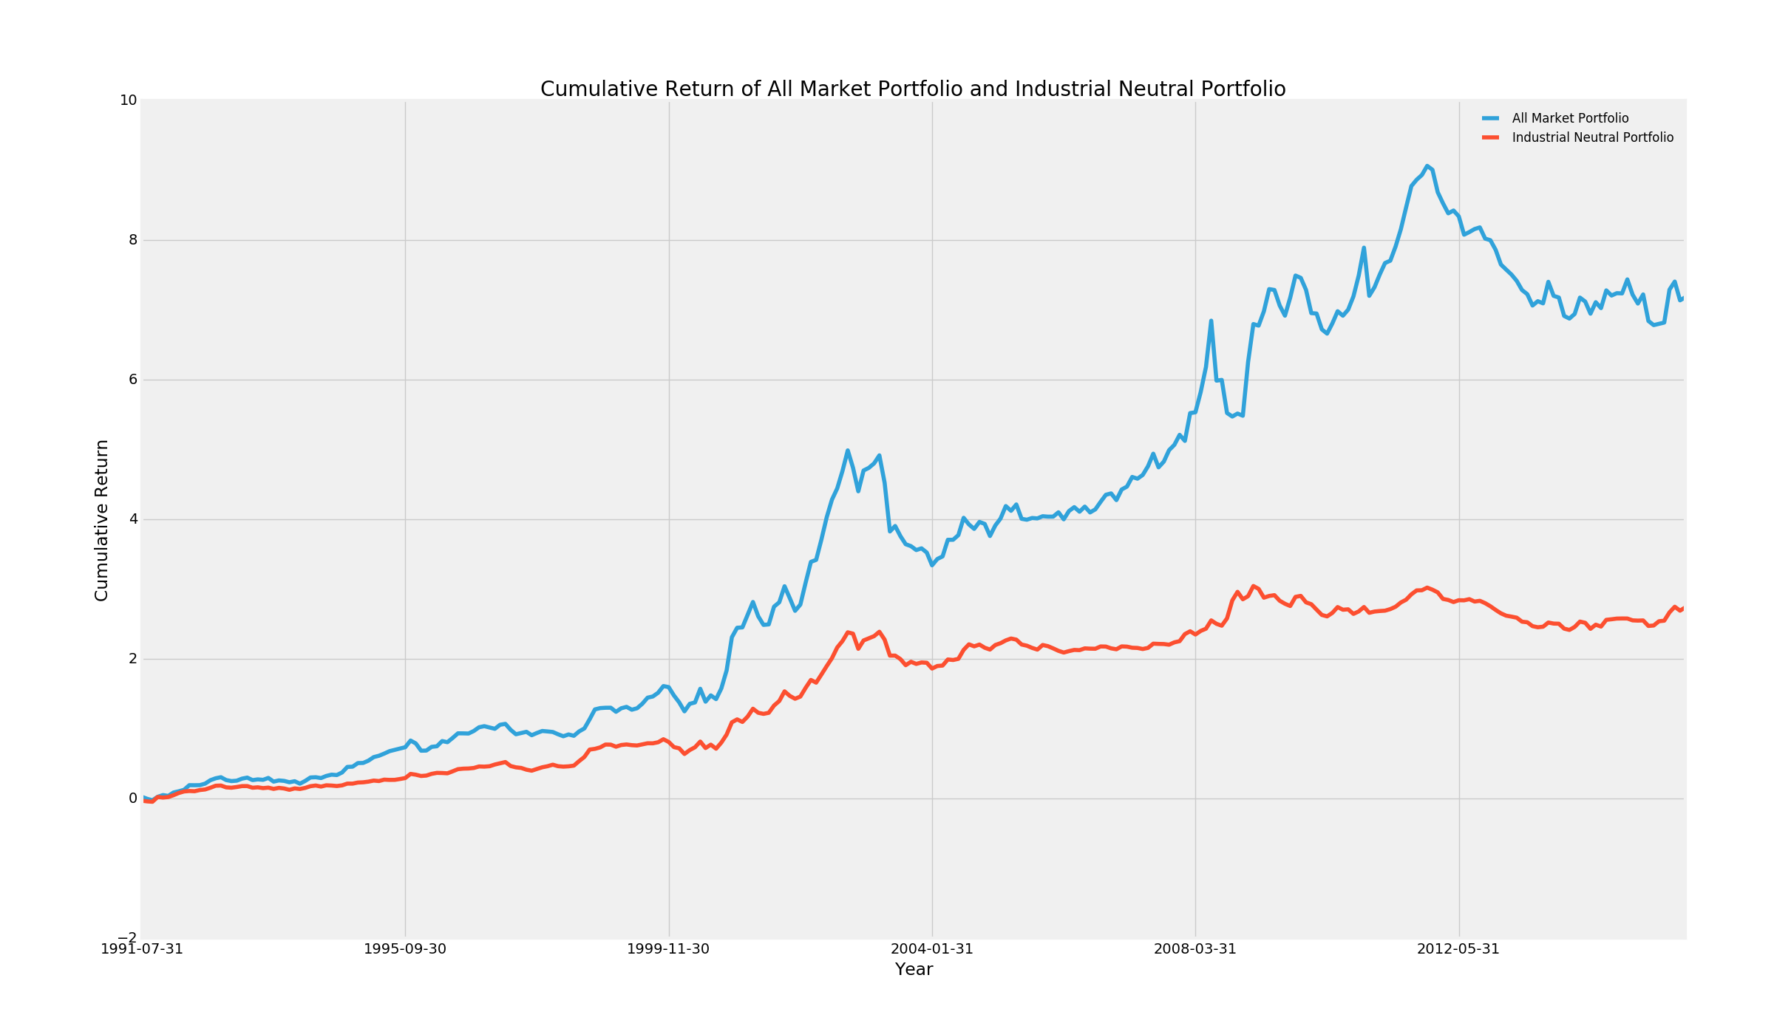

Figure 4 - Cumulative Return of Market Portfolio and SP500

The new IR is -0.0677.

After working on the industry neutrality, the portfolio return becomes even lower as well as the information ratio. As I learned from the original data, there exist a significant unbalance of ROA value among different industries. The average ROA values of each industry are graphed below.

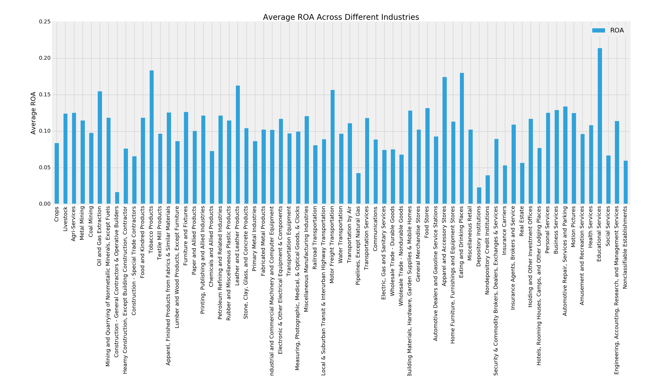

Figure 5 - Average ROA Across Different Industries

As we can tell, before the industry-neutrality, we are almost always picking stocks from the industries with high average ROA value. However, after industry neutrality, we choose stocks from all the industries and the ROA value of our new portfolio becomes lower than before. That weaken the efficiency of the ROA factor and result in a lower return. Though, industrial neutral could decrease the IR, it may potential decrease the risk, especially the fat-tail risk, at the same time. The reason is that when our portfolio is crowed in several industries, the portfolio is much more vulnerable and can be affected by industrial news.

**b. *Hedging :* Assume we hedge dynamically using an ETF that tracks the SP500. Specifically, for each month t, we regress the past 24 months of the strategy’s returns on SPY. This gives us a *beta(t)*, which we use to eliminate the market exposure of the strategy portfolio during that month. Compute *beta(t).* Draw our portfolio position in the ETF** (per dollar of the pre-hedging long-market value). **Compute the Information ratio of the hedged strategy** (per dollar long, including the positions coming from hedging) and compare to the non-hedged original strategy. (Explain what first date you use for the comparison)**.**

First, I take the SPY data using Yahoo Finance Database. **We calculated all the beta and hedge ratio based on our industrial neutralized return.**

Using the regression technique, we computed the beta(t) and graphed it as below.

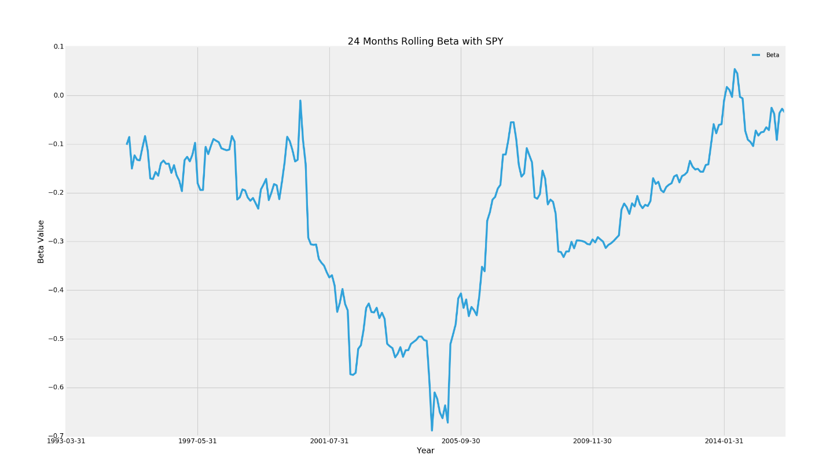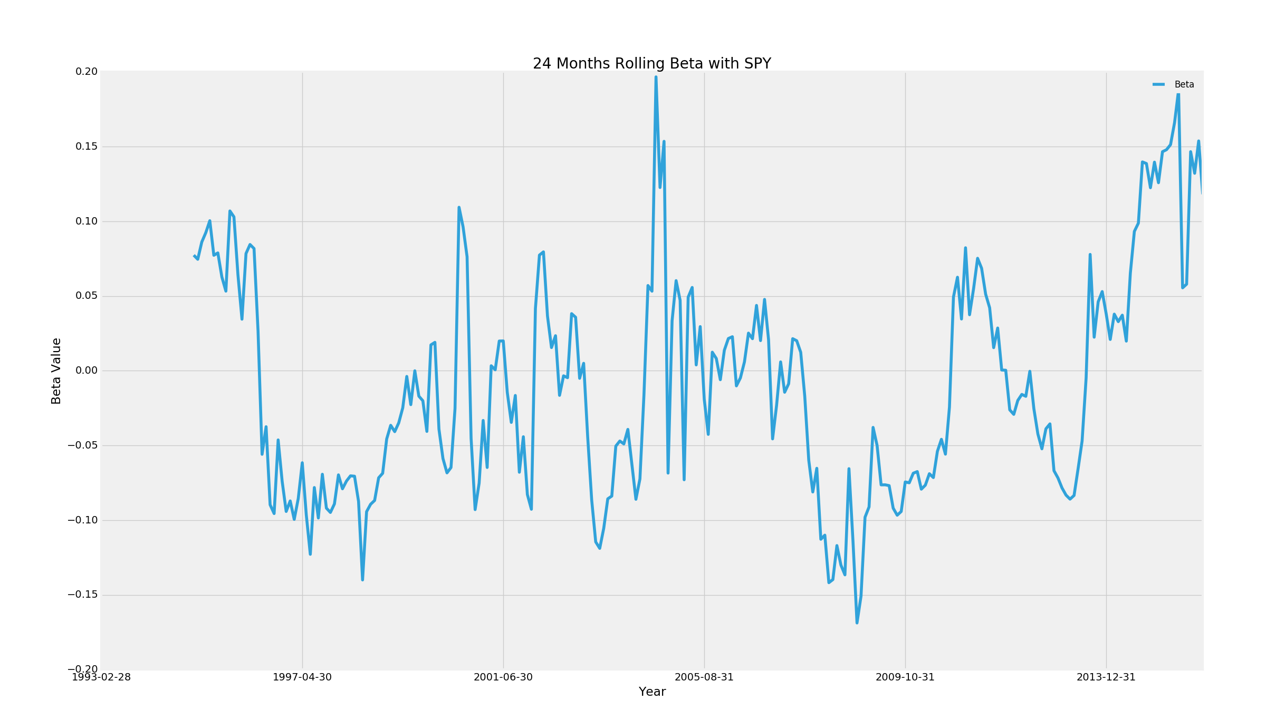

Figure 6 - 24 Months Rolling Beta with SPY

Choosing the beta values as hedging ratios for each month, we do monthly re-balance to complete the dynamic hedge.

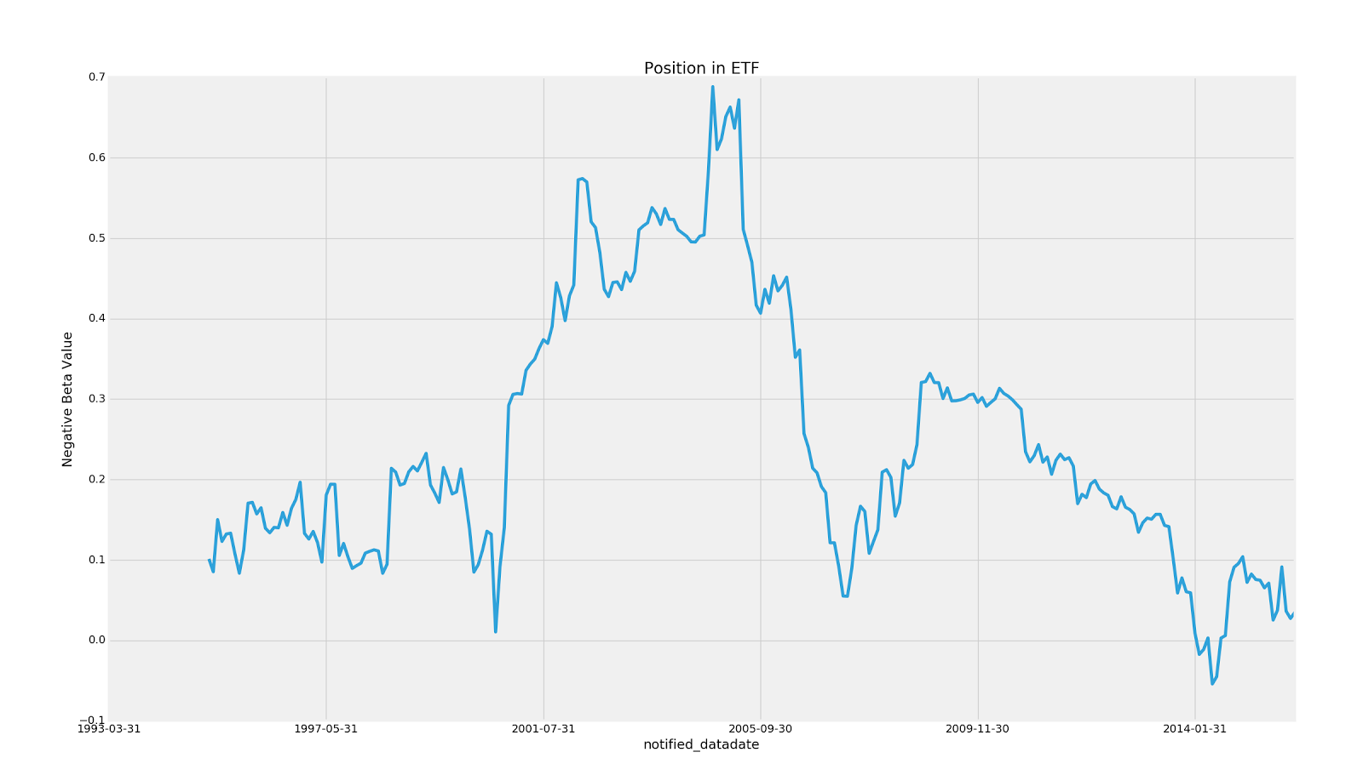

Figure 7 – Position in ETF

The ETF hedging position are shown in the graph above. As the beta coefficient is almost all negative along the time period, we would need to long the S&P500 ETF according to the positions calculated.

After hedging, the new IR is -0.0563, which is little bigger than the non-hedged original strategy. Due to the limitation of SPY data, which starts from 02/1993, the first day for comparison is 02/1995 (24 months later than the SPY starting date).

Besides, if we try to implement the same method on the strategy without industrial neutral, the new IR is 0.0086 and it is significantly higher than the previous IR.

**c. Think about ways to improve hedging (test them if feasible), we will discuss about it !**

To improve hedging, we might think from the perspectives listed below:

1. Instead of using S&P500 ETF (Short/Long ETF), we could long the according S&P500 ETF option to complete the hedge

2. Instead of using S&P500 ETF to hedge the portfolio as a whole, we could use the ETF of different industry sectors to hedge according to the industries.

3. Smooth the Beta curve and get rid of the sharpest swings.