1.      rank stocks by ROA (using the latest available information at that time); We get long the top 20% and short the bottom 20% of the ROA distribution, using equal weighting on the selected stocks. We keep the same portfolio until the end of the next month. Etc.

**a.      Compute the time-series of returns of the portfolio (per dollar long). Draw the graph of the cumulative returns.**

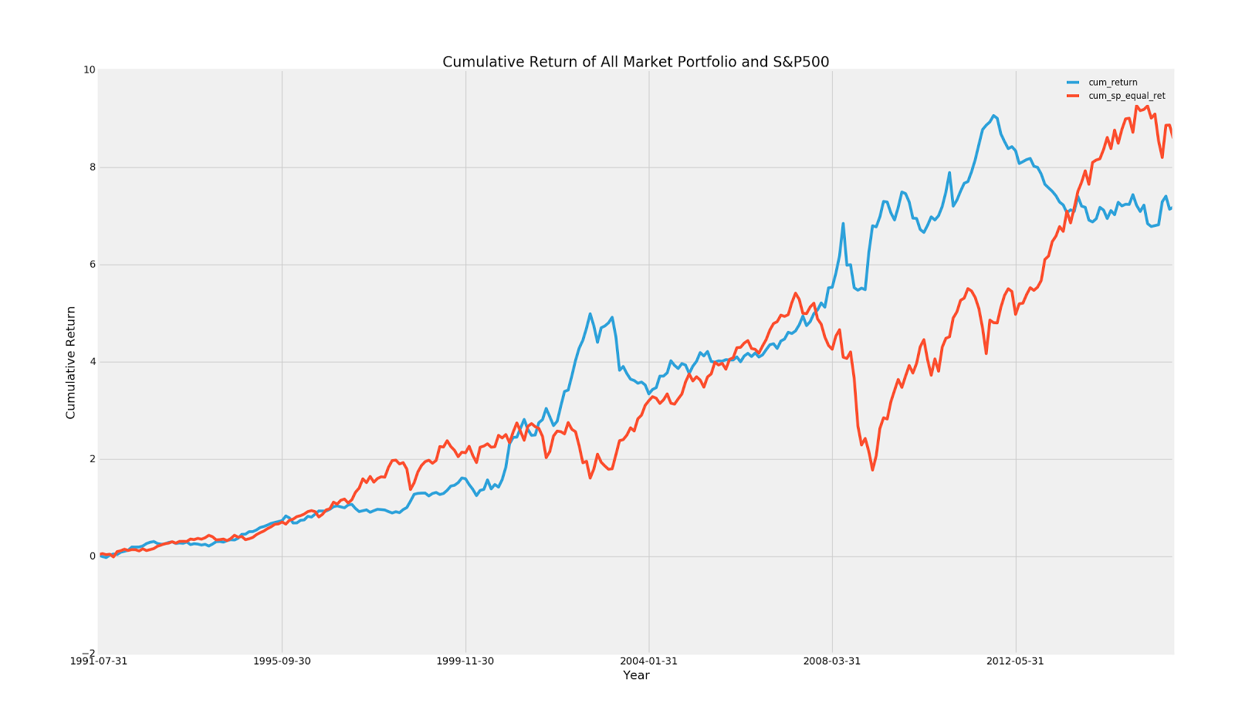

According to the graph above, we can tell that the cumulative return of the portfolio is actually below the index return over the testing period. The main reason resulting in this could be as below:

1. The ROA factor itself did not work well as a portfolio construction signal

2. The single factor model could be relatively weak explaining the market return

3. The ROA data only came out once a year, and most of the companies publish their ROA annual data on December. Though we repeatedly working on monthly-ranking and monthly-rebalance, the actual rebalance frequency is more close to annually due to the data.

**b.      What is the Information ratio?**

Information ratio could be calculated using the formula below:

【IR formula】

According to the data, we calculated the information ratio of ROA to be **-0.73307372650356972**

The information ratio is negative as the portfolio return is lower than the S&P 500 index, which suggests that the ROA might not be an effective factor.

**c.       Draw 12 months rolling volatility of the returns and compare to the volatility of the SP500.**

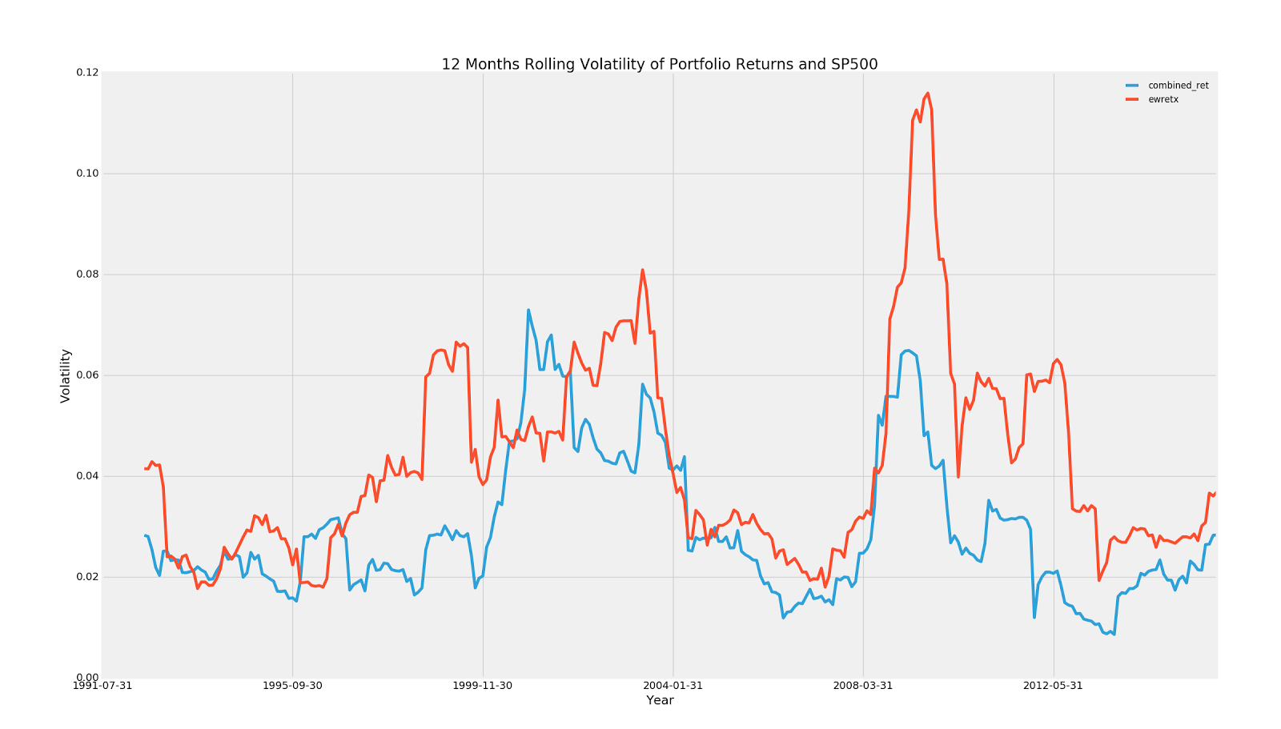

As it shown above, the portfolio rolling volatility is lower than the S&P 500 volatility.

**d.**      **Assume this is the unique strategy of a fund: what leverage do you suggest to use if the fund is targeting same volatility as the SP500 index.**

2.      Now, we consider some possible improvements to the basic strategy:

**a.      *Industry Neutrality :* we change the signal by sorting stocks within their industry. We select the top 20% and short the bottom 20% of the ROA distribution *within each industry*. Does that improve the Information ratio computed in question 1? Draw the two cumulative returns lines on a same graph.**

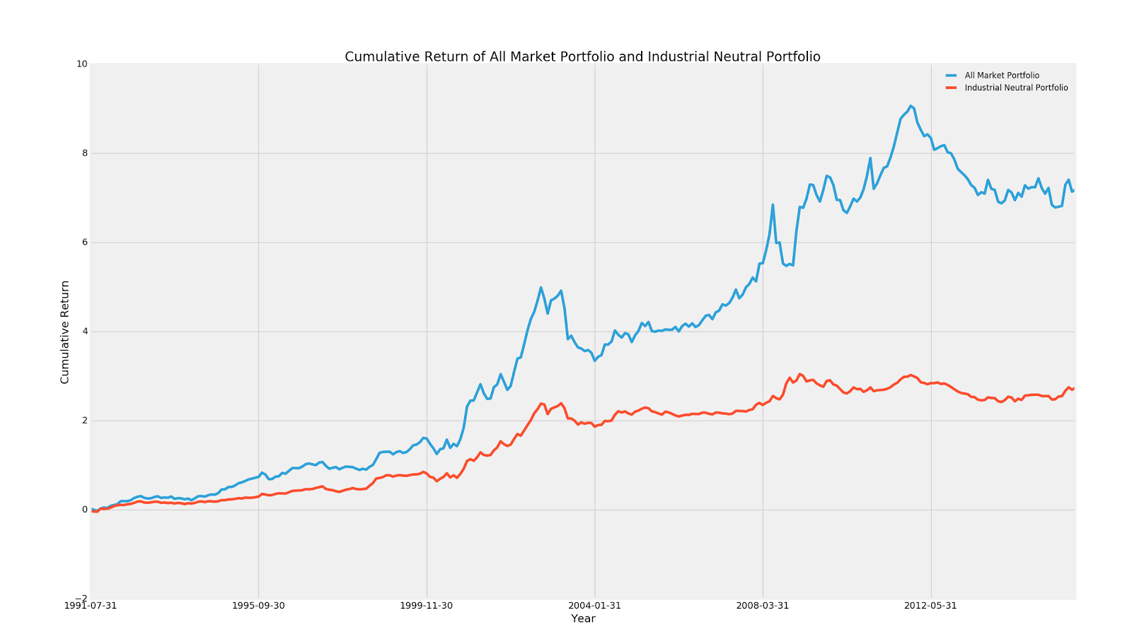

The new IR is -0.067748929919026993

After working on the industry neutrality, the portfolio return becomes even lower as well as the information ratio. The change becomes significant after 2004.

**b.      *Hedging :* Assume we hedge dynamically using an ETF that tracks the SP500. Specifically, for each month t, we regress the past 24 months of the strategy’s returns on SPY. This gives us a *beta(t)*, which we use to eliminate the market exposure of the strategy portfolio during that month. Compute *beta(t).* Draw our portfolio position in the ETF (per dollar of the pre-hedging long-market value). Compute the Information ratio of the hedged strategy (per dollar long, including the positions coming from hedging) and compare to the non-hedged original strategy. (Explain what first date you use for the comparison).**

Using the regression technique, we computed the beta(t) and graphed it as below.

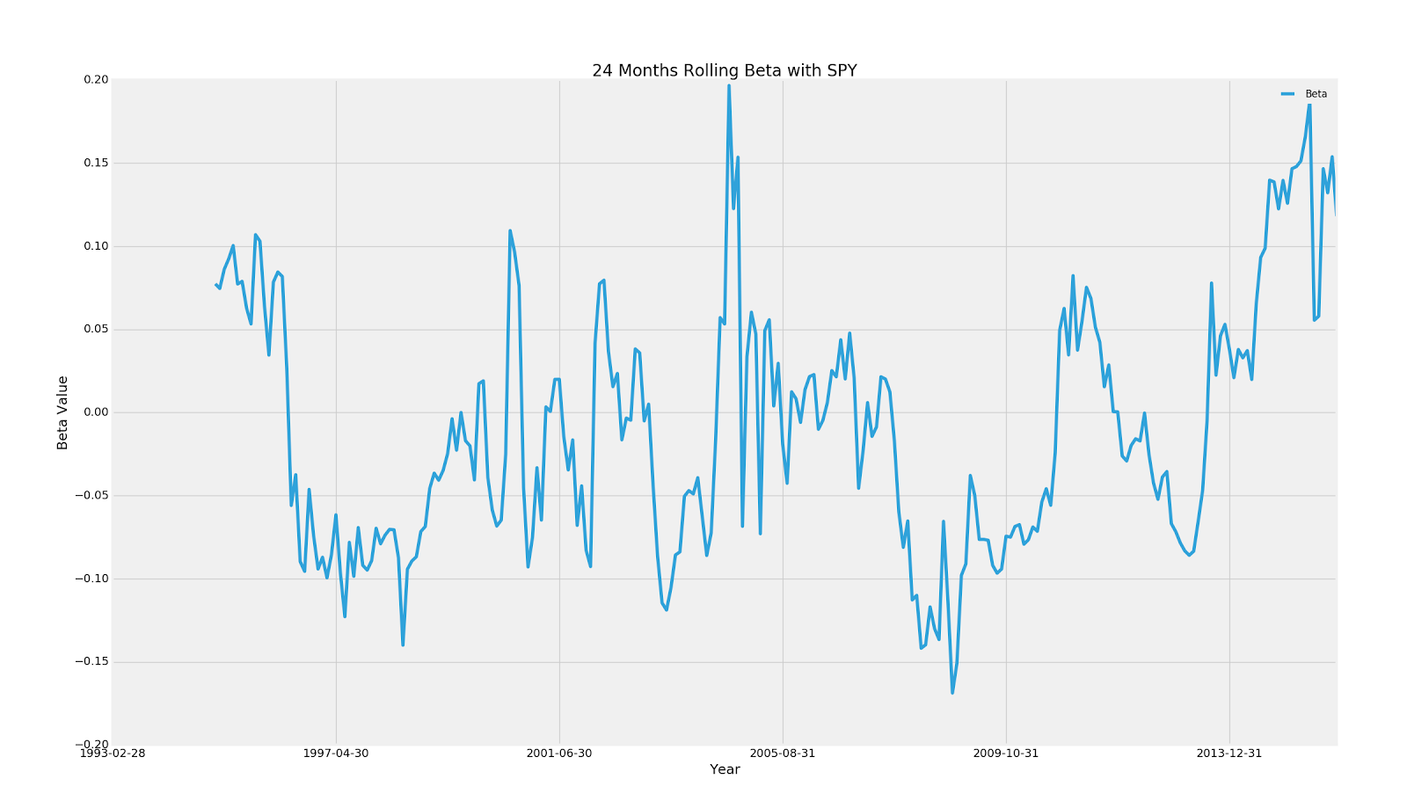

Using the beta values as hedging ratios, we dynamically ...

**c.       Think about ways to improve hedging (test them if feasible), we will discuss about it !**

To improve hedging, we might think from the perspectives listed below:

1.      Instead of using S&P 500 ETF (Shorting ETF), we could long the according S&P 500 ETF option to complete the hedge

2.      Instead of using S&P 500 ETF to hedge the portfolio as a whole, we could using the ETF of different industry sectors to hedge according to the industries.

3.