**GAGAN KUMAR SONI  
ROLL :- 21  
MSC Computer Science (2nd Year)**

______________________________________________________________

**1. `ifconfig` (or `ipconfig` on Windows):**

- Description: Displays network interface configuration information, including IP addresses, MAC addresses, subnet masks, and more.

- Working: On Linux and macOS, simply enter `ifconfig` in the terminal. On Windows, use `ipconfig` in the command prompt.

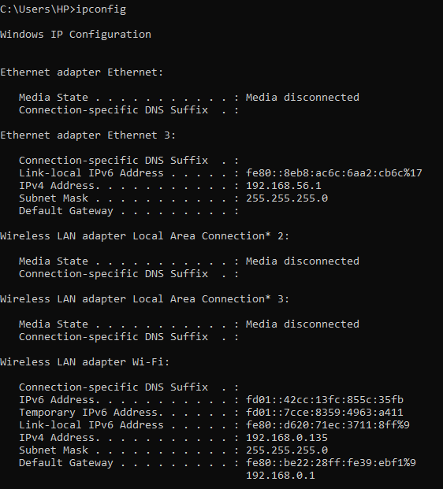

**2. `traceroute` (or `tracert` on Windows):**

- Description: Traces the route that packets take to reach a destination by sending packets with increasing Time-to-Live (TTL) values. It displays the IP addresses of routers along the way.

- Working: In the terminal or command prompt, enter `traceroute` followed by the destination address. On Windows, you can use `tracert` with the same syntax.

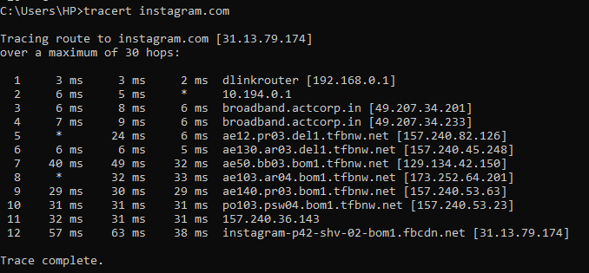

**3. `tracepath`:**

- Description: Similar to `traceroute`, but it may provide different options and features depending on the specific distribution or system. Not available on all systems.

- Working: Use `tracepath` followed by the destination address, similar to `traceroute`.

**4. `ping`:**

- Description: Tests network connectivity by sending Internet Control Message Protocol (ICMP) echo requests to a target host and receiving ICMP echo replies. It's a basic network troubleshooting tool.

- Working: Enter `ping` followed by the target hostname or IP address. It continuously sends echo requests until manually stopped with Ctrl+C.

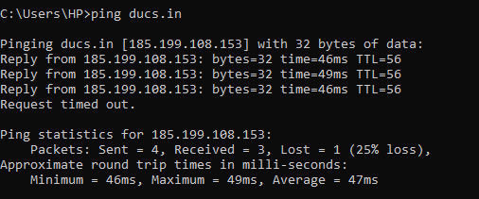

**5. `netstat`:**

- Description: Displays network statistics, active network connections, routing tables, and listening sockets. It helps investigate network-related information.

- Working: Use `netstat` followed by various options and parameters to display specific network information. Common options include `-t` for TCP, `-u` for UDP, and `-r` for routing tables.

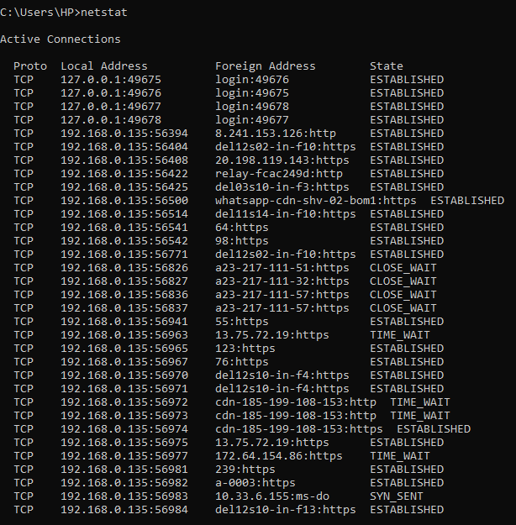

**6. `nslookup`:**

- Description: Performs DNS (Domain Name System) lookups to resolve domain names to IP addresses and vice versa.

- Working: Enter `nslookup` followed by the domain name or IP address to perform DNS lookups.

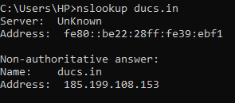

**7. `arp`:**

- Description: Displays the Address Resolution Protocol (ARP) cache, which maps IP addresses to MAC addresses on a local network.

- Working: Simply enter `arp` to display the ARP cache on your local network.

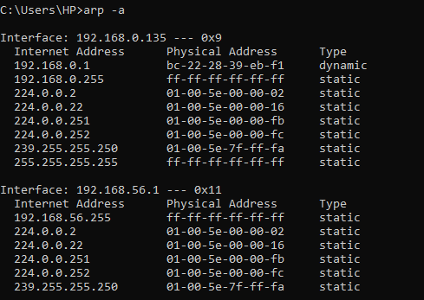

**8. `route`:**

- Description: Manages the IP routing table on your system. It allows you to view and modify routing information.

- Working: Use `route` followed by specific options and parameters to display and manipulate the routing table.

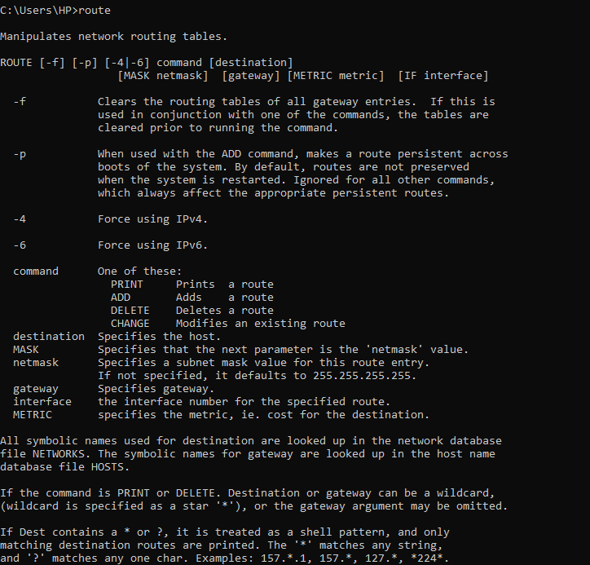

**9. `tcpdump`:**

- Description: A packet analyzer that captures and displays network traffic. It's useful for network troubleshooting and monitoring.

- Working: Enter `tcpdump` followed by various options to capture and analyze network traffic. This command is often used by network administrators and security professionals.

**10. `whois`:**

- Description: Retrieves information about a domain or IP address, including registration details, owner, and more.

- Working: Use `whois` followed by the domain name or IP address to query the WHOIS database and retrieve information about the entity that owns the domain or IP.

**11. `dig`:**

- Description: A DNS query tool used to retrieve information from DNS servers, such as IP addresses and other DNS records.

- Working: Enter `dig` followed by the specific query and domain name to retrieve DNS-related information.

**12. `host`:**

- Description: Performs DNS lookups to resolve domain names to IP addresses or vice versa, similar to `nslookup`.

- Working: Use `host` followed by the domain name or IP address to perform DNS lookups.

**13. `pathping`:**

- Description: Combines the functionality of `ping` and `tracert` on Windows to provide a more comprehensive network diagnosis by sending ICMP echo requests and tracing the route to a destination host.

- Working: Enter `pathping` followed by the destination address, similar to `ping` or `tracert`.

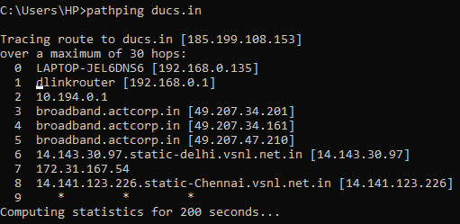

**14. `tracert` (Windows):**

- Description: Similar to `traceroute`, it traces the route to a destination host and displays information about the routers along the path.

- Working: In the Windows command prompt, use `tracert` followed by the destination address to trace the route.

Each of these commands serves a specific purpose in network troubleshooting, diagnostics, and management, helping users to better understand and maintain their network connections and configurations.