CS 499 COMPUTER SCIENCE CAPSTONE
Algorithms and Data Structures
Enhancement Narrative
Internal Computer Science Course Plan Manager
____________________________
Milestone Three Artifact Narrative
Gina Aviles

Artifact Description
The artifact I selected is a course-planning application originally created in for CS 300: Data Structures and Algorithms. The original artifact was a C++ command-line program that loaded course information from a CSV file into a binary search tree. A user could load the data, print an alphanumeric course list, or search for an individual course and view its prerequisites. I enhanced the artifact in by transforming it into an internal Angular web application for a Computer Science advising department. The enhanced application allows an advisor to select a named course plan, search for an individual course, examine its prerequisites, and identify the courses that follow it in the curriculum. It also provides a visual course-pathway display, a searchable course catalog, course-plan version information, CSV export, and CSV or Excel import with a comparison preview.
The import process classifies course records as added, modified, unchanged, missing, or invalid before changes are applied. Missing courses are retained and labeled inactive instead of being deleted without confirmation. The current prototype persists plan versions in browser storage through a dedicated data service. This service can later be replaced by an HTTPS-based repository connected to the department's protected backend database without changing the course-indexing and graph algorithms.

Justification for Inclusion in My ePortfolio
I selected this artifact because it demonstrates the progression of my abilities from analyzing data structures in an academic program to applying them in a practical software solution. The original project successfully met its basic requirements, but its scope was limited to a command-line interface, an unbalanced binary search tree, exact course-number searches, and a static CSV input file. Enhancing the artifact gave me an opportunity to reconsider the original design based on the actual operations an academic advisor needs to perform.
The most important improvement is the use of a hash map to index courses by their normalized course numbers. The original binary search tree offered an average lookup time of O(log n), but its performance could degrade to O(n) if the tree became unbalanced. The enhanced application uses a Map<string, Course> to provide average O(1) lookup for an individual course. This structure is appropriate because advisors primarily need to retrieve one course at a time by a unique identifier.
The enhanced artifact also models prerequisite relationships as a directed graph. A forward adjacency list maps each course to its prerequisite courses, while a reverse adjacency list maps each prerequisite to the courses it unlocks. The forward index allows the application to retrieve direct prerequisites in O(p), where p is the number of prerequisites for the selected course. The reverse index retrieves the next courses in O(d), where d is the number of dependent courses. These structures support navigation in both directions without repeatedly scanning the entire course plan.
I implemented depth-first search to detect circular prerequisite relationships. Cycle detection runs in O(V + E), where V represents courses and E represents prerequisite relationships. This validation prevents invalid plans such as one in which CSCI 200 indirectly requires itself. The visual pathway panel makes the graph structure visible by displaying prerequisite nodes above the selected course and subsequent-course nodes below it.
The spreadsheet comparison process further expands the complexity of the artifact. The application constructs one hash map for the current plan and another for the imported plan. It then compares the two maps in O(n + m) time, where n is the number of existing courses and m is the number of imported courses. A nested-loop comparison would require O(n × m) time. The hash-based approach produces clear change labels while remaining efficient as the size of the course plan grows.
Additional improvements include normalizing course numbers, removing duplicate prerequisite entries with sets, validating missing prerequisite references, sorting the displayed catalog alphanumerically, accepting both CSV and Excel input, preserving named plan versions, and exporting the currently selected plan. Together, these changes demonstrate that I can select data structures according to a program's access patterns instead of applying one structure to every requirement.

Functional Evidence
The following application views demonstrate how the enhanced artifact turns its data structures and algorithms into advisor-facing functions.
The overview loads the selected plan into a hash-based course index. An advisor can retrieve one course, its direct prerequisites, and the next courses that depend on it. The pathway panel displays the same relationships as a directed graph.
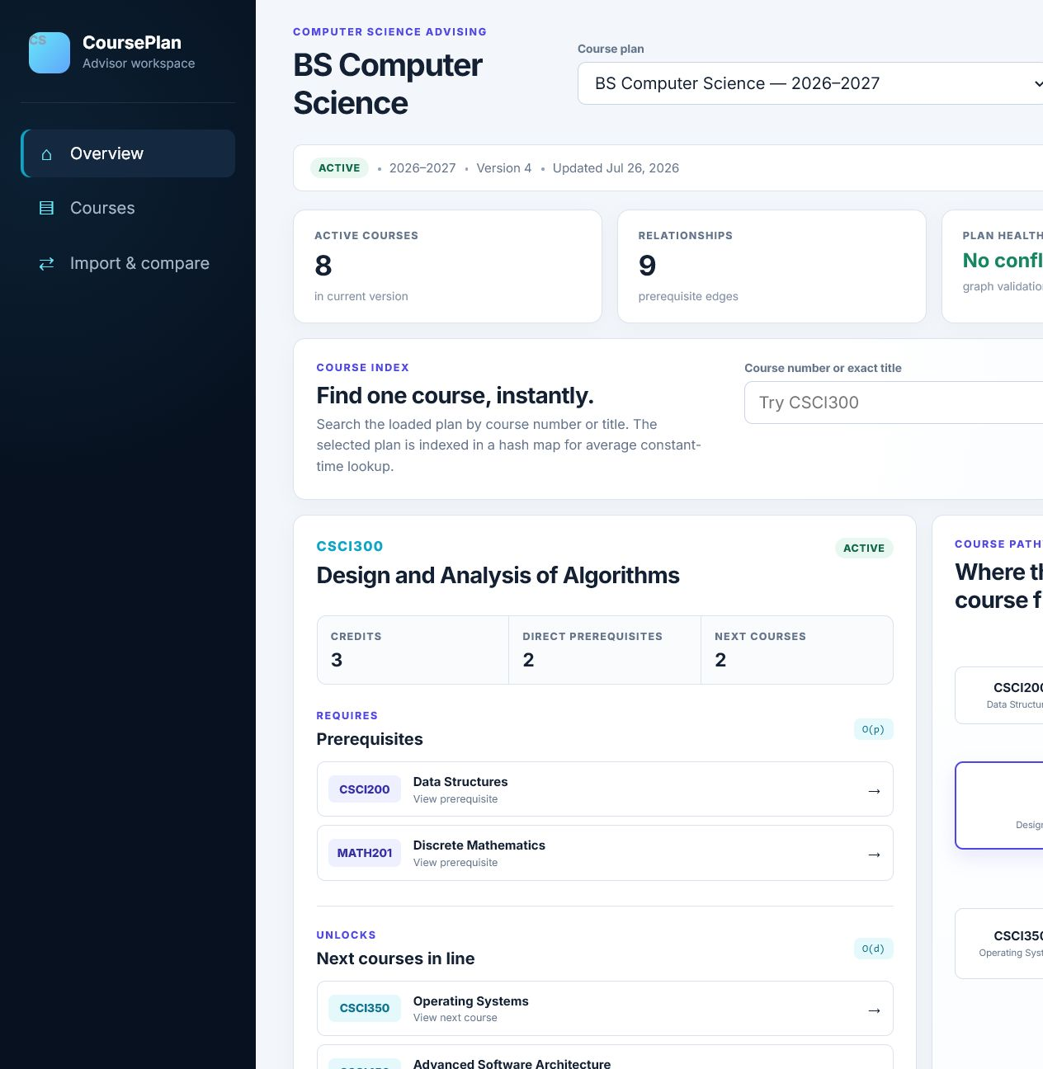
Figure 1. Course lookup, direct prerequisite retrieval, reverse-index lookup, and the visual course pathway for CSCI300.
The catalog presents the indexed courses in alphanumeric order and provides filtering, prerequisite labels, status labels, and access to each course relationship record.
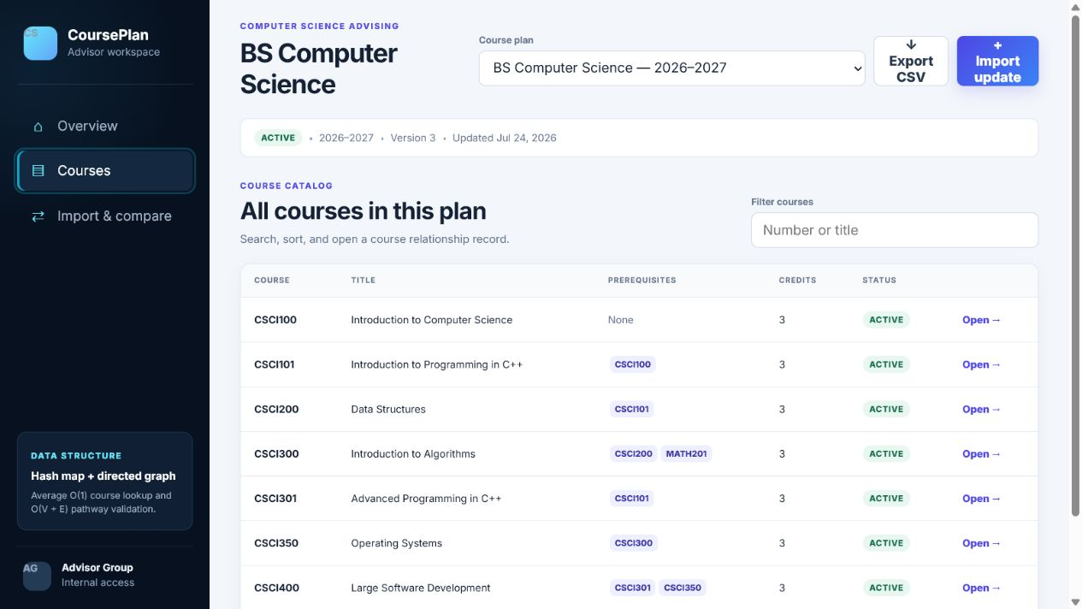
Figure 2. Searchable course catalog showing course numbers, titles, prerequisites, credits, and active status.
The import workflow accepts CSV and Excel files and explains the linear-time comparison and graph-validation steps before a plan is changed.
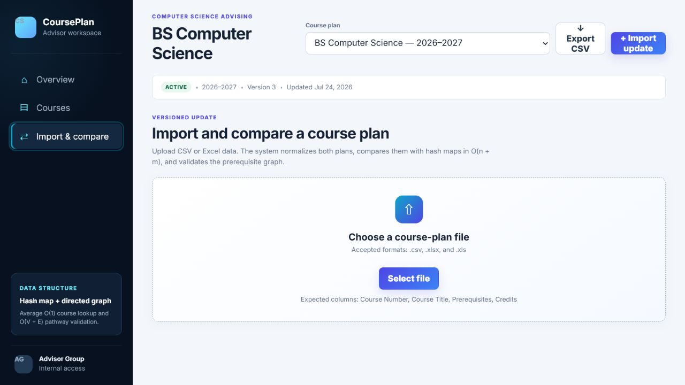
Figure 3. Versioned CSV or Excel import interface with required-column guidance.
After parsing and normalization, two hash maps compare the current and incoming plans. The preview labels each course as added, modified, unchanged, missing, or invalid and allows the advisor to review the results before creating a new plan version.
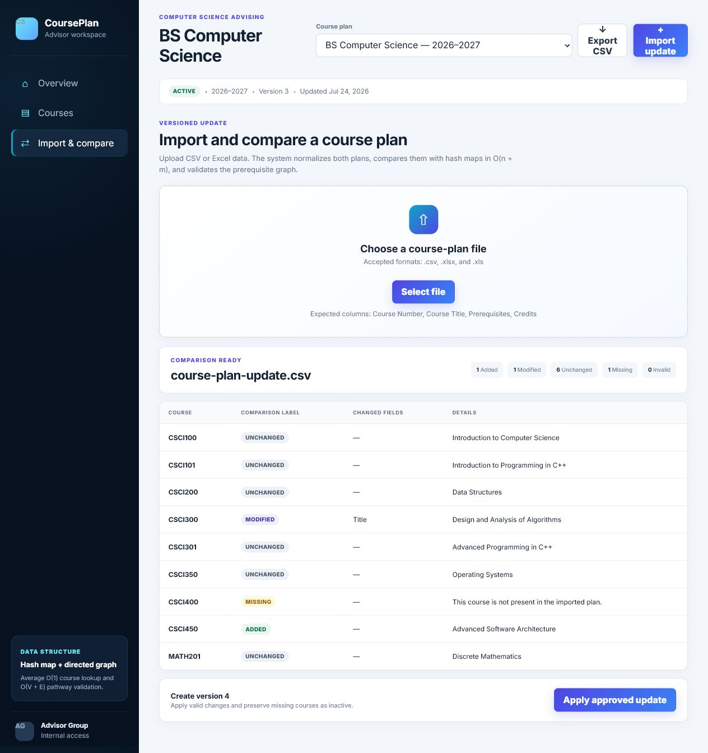
Figure 4. O(n + m) plan comparison showing one added course, one modified course, six unchanged courses, and one missing course.

Course Outcome Coverage
The enhancement met the primary course outcome I planned to address: designing and evaluating computing solutions by applying algorithmic principles and computer science practices. I evaluated the strengths and limitations of the original binary search tree, identified the operations most important to the user, and selected hash maps, sets, and graph adjacency lists to support those operations. I also documented the expected runtime complexity of loading, searching, comparing, sorting, and traversing the course data. The enhancement also supports the outcome related to using well-founded and innovative techniques, skills, and tools to create computing solutions that deliver value. Moving the artifact from a command-line program to an Angular application makes its algorithms part of a usable advising workflow. The search interface, comparison labels, visual pathway, and import preview turn abstract data-structure concepts into features that solve recognizable problems.
I have not changed my primary outcome-coverage plan, but I have refined its scope. Initially, I focused mainly on improving lookup and sorting efficiency. During development, I expanded the enhancement to include bidirectional graph relationships, cycle detection, and linear-time plan comparison. These additions provide stronger evidence of algorithm selection and analysis than searching and sorting alone.
Security is not the primary outcome demonstrated by this artifact. The prototype is intentionally limited to an internal advisor workflow and does not store student records. Before production use, the persistence service would need to be replaced by a protected backend with authentication, authorization, server-side validation, audit logging, and secure file-upload controls. I will address security more directly in the artifact selected for that outcome while still acknowledging these requirements in this project's design.

Reflection on the Enhancement Process
The most significant lesson I learned was that selecting an efficient data structure begins with understanding how users need to access the data. The binary search tree in the original artifact supported searching and ordered traversal, but the enhanced requirements involved several different access patterns. A hash map was better for finding one course, an array was appropriate for sorted presentation, sets prevented duplicate relationships, and adjacency lists were better for navigating prerequisite connections. No single data structure was the best solution for every operation.
I also learned the importance of maintaining complementary indexes. The forward prerequisite graph answers the question, "What must be completed before this course?" The reverse graph answers, "What courses become available after this course?" Building the reverse index required additional memory, but it avoided scanning every course each time an advisor requested the next class in a pathway. This was a practical example of trading memory for faster retrieval.
One challenge was defining what "next course" means. A course may directly depend on the selected course but still require another prerequisite. I learned to distinguish a direct dependent course from a course for which a student is fully eligible. Because this artifact does not maintain student records, it shows direct next courses in the curriculum rather than claiming that a specific student is eligible to enroll. Spreadsheet imports created another challenge because real input is not always consistent. Column names may differ, course numbers may contain spaces or lowercase letters, prerequisite lists may use different separators, and an import may omit an existing course. I addressed these problems by normalizing headers and course identifiers, accepting common header aliases, converting prerequisite lists to sets, validating references, and presenting a preview instead of changing the plan immediately. This reinforced the importance of validating and normalizing data before inserting it into an efficient structure.
Another important design decision involved missing records. Treating every course absent from an imported file as deleted would be risky. The application therefore identifies those records as missing and retains them as inactive in the next version. This approach preserves information and gives the department an opportunity to review curriculum changes instead of allowing an import to silently remove data. The enhancement also helped me separate persistent data from runtime data structures. The saved course plan is the source of the application's data, while the hash maps and adjacency lists are efficient in-memory representations built from the selected plan. When a plan changes, the indexes must be rebuilt so they remain consistent. This separation will make it easier to replace browser persistence with a database-backed API during a future production phase.
Overall, enhancing this artifact strengthened my understanding of how runtime analysis, data validation, user requirements, and interface design influence one another. I moved beyond implementing a data structure because it was an assignment requirement and instead selected several structures because each one supported a specific operation. The finished enhancement more clearly demonstrates my ability to evaluate trade-offs, apply graph and hash-based algorithms, communicate complexity, and transform an academic artifact into a solution with practical value.

