DAD 220 Project One Template

Complete these steps as you work through the directions for Project One. Replace the bracketed text with your screenshots and brief explanations of the work they capture. Each screenshot and its explanation should be sized to approximately one-quarter of the page with the description written below the screenshot. Follow these rules for each of the prompts and questions below. Review the example document in the Supporting Materials section of the Project One Guidelines and Rubric for assistance.

Step One: Create a Database

- In your online IDE (Codio), create a database schema called QuantigrationUpdates that will hold tables by using SQL commands.
  - List out the database name on the screen.
  - Provide the SQL commands you ran against MySQL to complete this step.
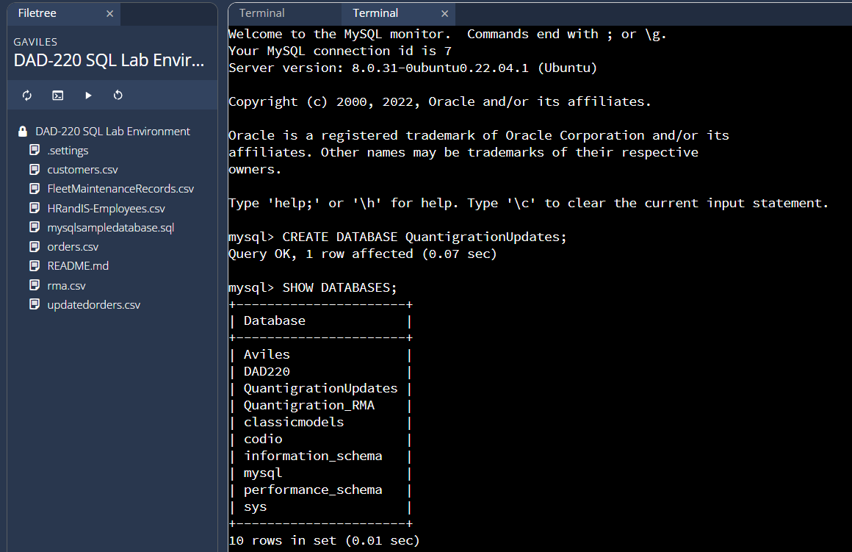
COMMAND: CREATE DATABASE QuantigrationUpdates;
SHOW DATABASES;

The screenshot above shows I created a database called QuantigrationUpdates, and used the SHOW DATABASES command to output a list the available databases.

- Connect to the QuantigrationUpdates schema. Using the ERD as a reference, write SQL commands to create the following tables with the appropriate attributes and keys to demonstrate relationships based on the ERD.
  - A table named Customers to store customer information with a primary key of Customer ID. Provide the SQL commands you ran against MySQL to complete this step.

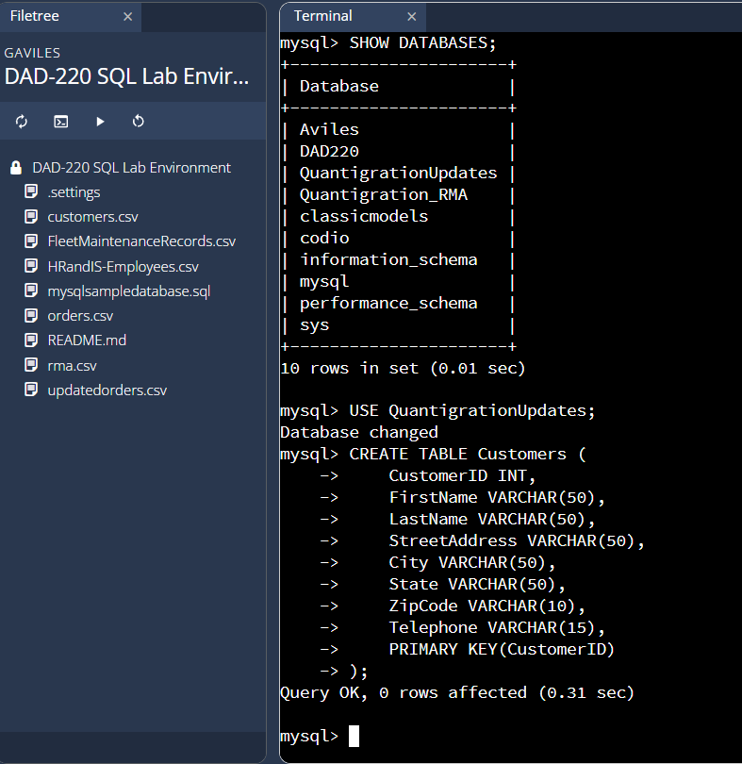
This screenshot shows the commands to switch to the QuantigrationUpdates database and create a table called Customers with the customerID as the primary key and the customers name and contact information.

COMMAND:
USE QuantigrationUpdates;
CREATE TABLE Customers (
CustomerID INT,
FirstName VARCHAR(50),
LastName VARCHAR(50),
StreetAddress VARCHAR(50),
City VARCHAR(50),
State VARCHAR(50),
ZipCode VARCHAR(10),
Telephone VARCHAR(15),
PRIMARY KEY(CustomerID)
);
  - A table named Orders to store order information with a primary key of Order ID and a foreign key of Customer ID. Provide the SQL commands you ran against MySQL to complete this step.

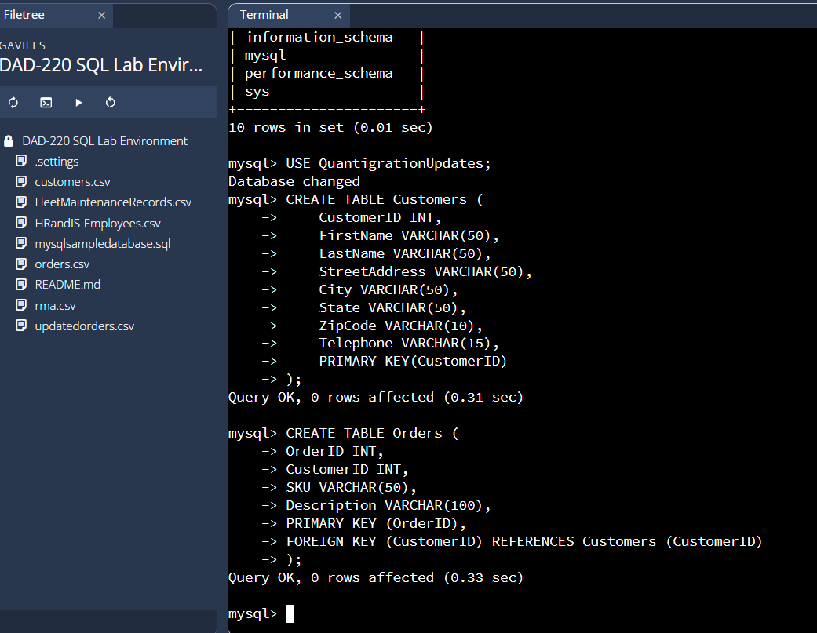
This screenshot shows the commands inputted to create the orders table with the primary key orderID, a foreign key which references the customers table, Customer ID, the item SKU, and description.

COMMAND:
CREATE TABLE Orders (
OrderID INT,
CustomerID INT,
SKU VARCHAR(50),
Description VARCHAR(100),
PRIMARY KEY (OrderID),
FOREIGN KEY (CustomerID) REFERENCES Customers (CustomerID)
);

  - A table named RMA to store RMA information with a primary key of RMA ID and a foreign key of Order ID. Provide the SQL commands you ran against MySQL to complete this step.

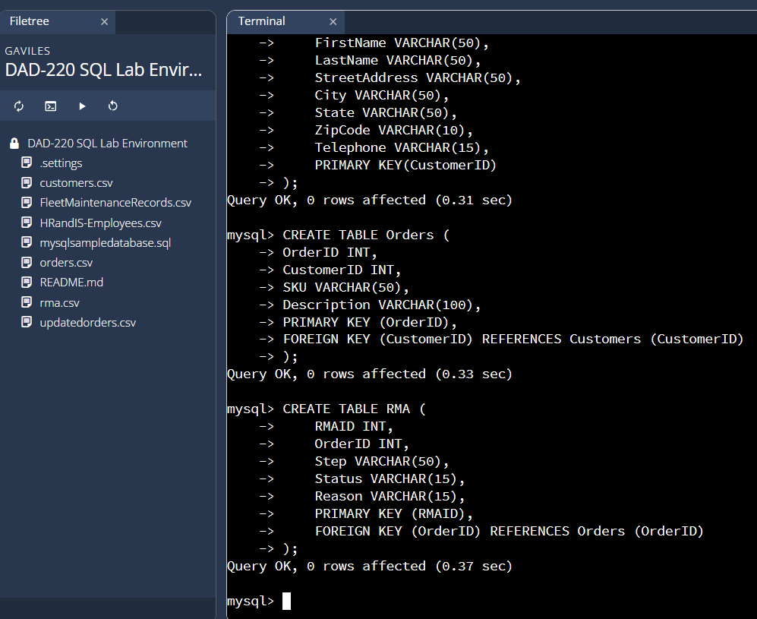
This screenshot shows the creation of the RMA table, with RMA ID as the primary key, Order ID as the foreign key which references the Orders table, step, status, and reason.

COMMAND:
CREATE TABLE RMA (
RMAID INT,
OrderID INT,
Step VARCHAR(50),
Status VARCHAR(15),
Reason VARCHAR(15),
PRIMARY KEY (RMAID),
FOREIGN KEY (OrderID) REFERENCES Orders (OrderID)
);

Step Two: Load and Query the Data

- Import the data from each file into tables.
  - Use the QuantigrationUpdates database, the three tables you created, and the three CSV files preloaded into Codio.
  - Use the import utility of your database program to load the data from each file into the table of the same name. Perform this step three times, once for each table.
  - Provide the SQL commands you ran against MySQL to complete this step.

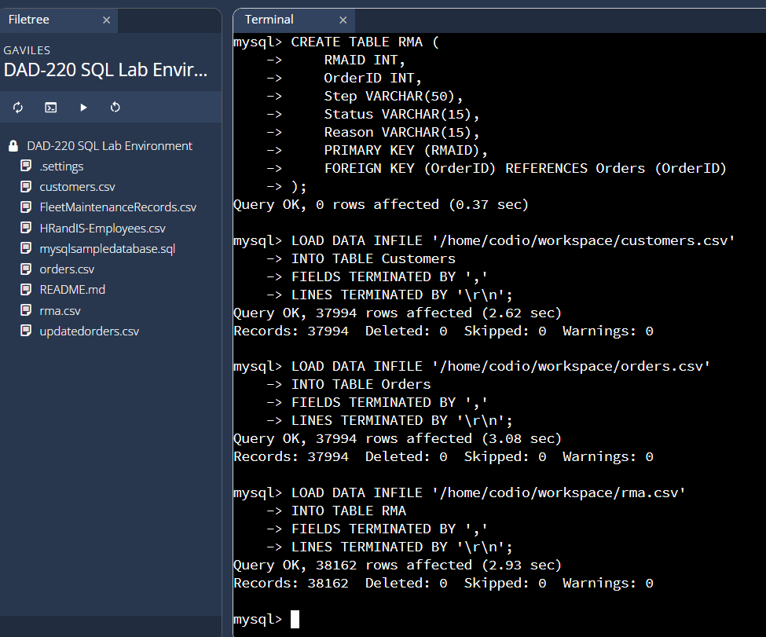

This screenshot shows the commands use to load data from three CSV files, customers.csv, orders.csv, and rma.csv, into their respective tables that I created in the QuantigrationUpdates database, called Customers, Orders, and RMA.

COMMAND:
LOAD DATA INFILE '/home/codio/workspace/customers.csv'
INTO TABLE Customers
FIELDS TERMINATED BY ','
LINES TERMINATED BY '\r\n';
LOAD DATA INFILE '/home/codio/workspace/orders.csv'
INTO TABLE Orders
FIELDS TERMINATED BY ','
LINES TERMINATED BY '\r\n';
LOAD DATA INFILE '/home/codio/workspace/rma.csv'
INTO TABLE RMA
FIELDS TERMINATED BY ','
LINES TERMINATED BY '\r\n';

- Write basic queries against the imported tables to organize and analyze the targeted data. For each query, replace the bracketed text with a screenshot of the query and its output. Also, include a one- to three-sentence description of the output.
  - Write a SQL query that returns the count of orders for customers located only in Framingham, Massachusetts.
    - This query will use a table join between the Customers and Orders tables. The query will also use a WHERE clause.
    - How many records were returned?

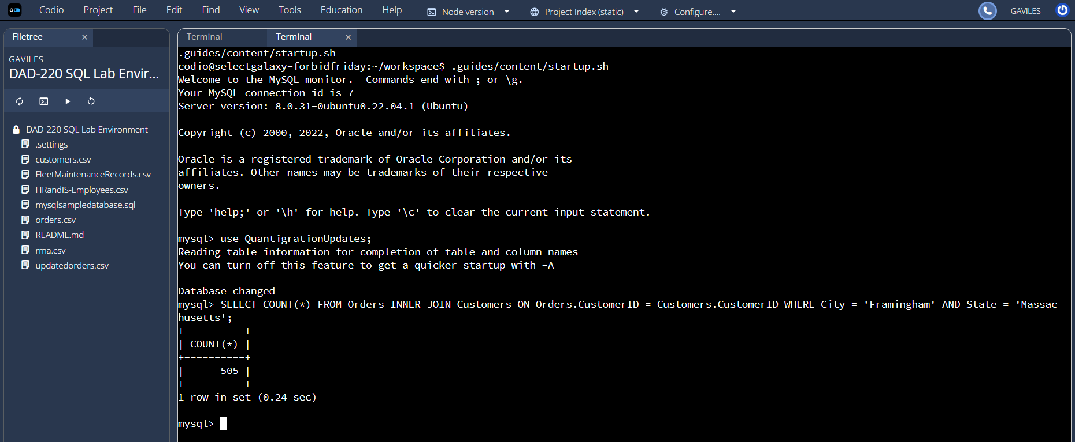
This screenshot shows the COUNT(*) command used to retrieve the number of orders placed by customers who live in Framingham, Massachusetts. The Customers table is connected to the Orders table using an inner join with the foreign key CustomerID. The output returns 1 row depicting the count of 505 orders placed by customers who live in Framingham, Massachusetts.

COMMAND:
SELECT COUNT(*) FROM Orders INNER JOIN Customers ON Orders.CustomerID = Customers.CustomerID WHERE City = 'Framingham' AND State = 'Massachusetts';

  - Write a SQL query to select all of the customers located in Massachusetts.
    - Use a WHERE clause to limit the number of records in the Customers table to only those who are located in Massachusetts.
    - How many records were returned?

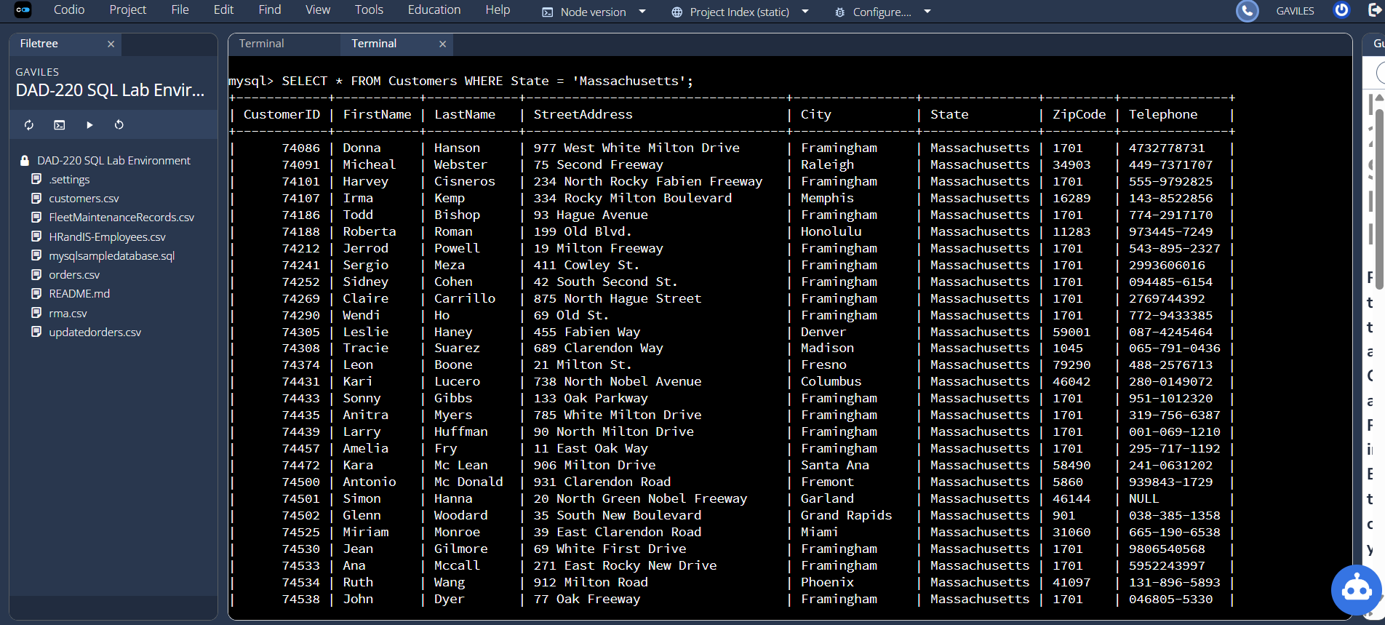
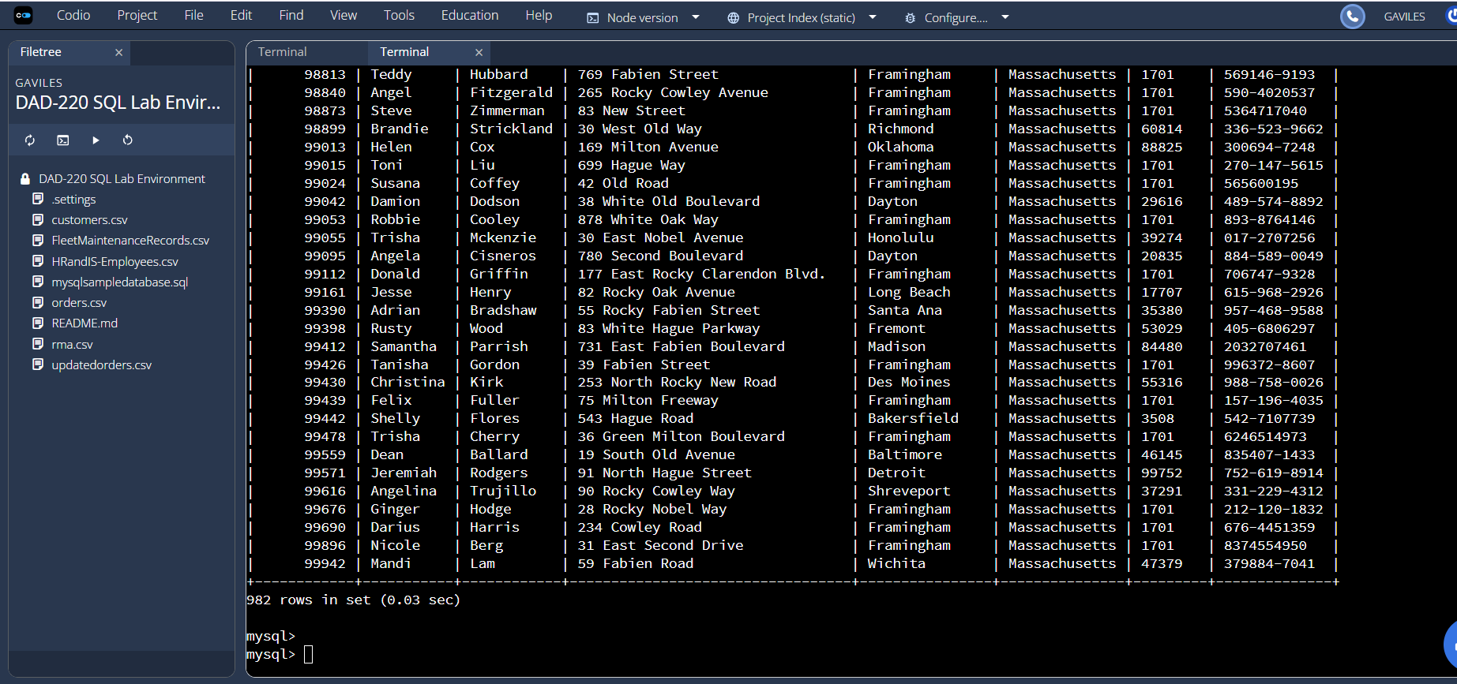
This screenshot shows the command used and the output when selecting all customers who live in the state of Massachusetts. The query returns 982 records.

COMMAND:
SELECT * FROM Customers WHERE State = 'Massachusetts';

  - Write a SQL query to insert four new records into the Orders and Customers tables using the data below:

Customers Table
CustomerID | FirstName | LastName | StreetAddress | City | State | ZipCode | Telephone
100004 | Luke | Skywalker | 15 Maiden Lane | New York | NY | 10222 | 212-555-1234
100005 | Winston | Smith | 123 Sycamore Street | Greensboro | NC | 27401 | 919-555-6623
100006 | MaryAnne | Jenkins | 1 Coconut Way | Jupiter | FL | 33458 | 321-555-8907
100007 | Janet | Williams | 55 Redondo Beach Blvd | Torrence | CA | 90501 | 310-555-5678

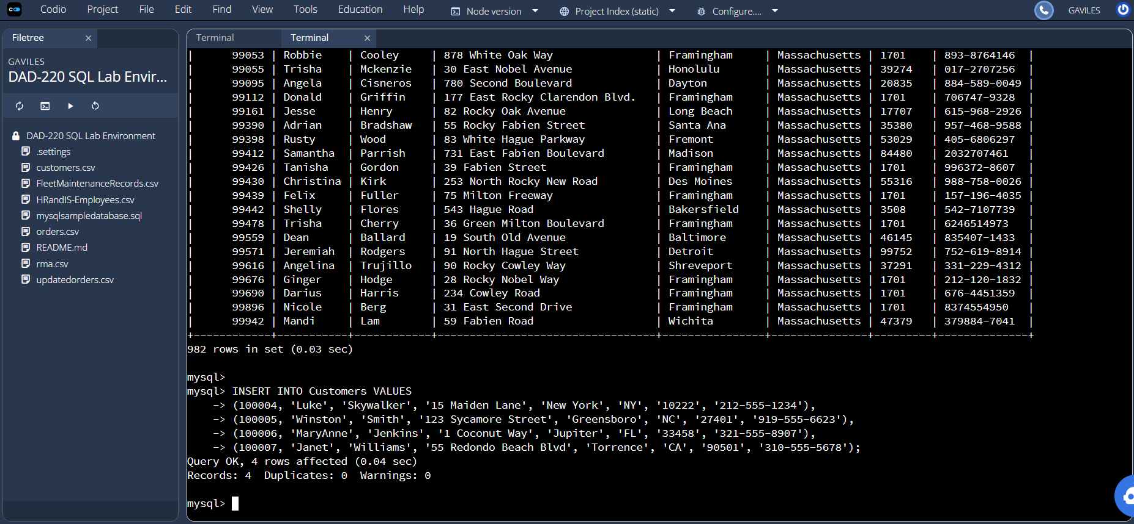
This screenshot shows the query to insert four new records into the customers table using the INSERT INTO command.

COMMAND:
INSERT INTO Customers VALUES
(100004, 'Luke', 'Skywalker', '15 Maiden Lane', 'New York', 'NY', '10222', '212-555-1234'),
(100005, 'Winston', 'Smith', '123 Sycamore Street', 'Greensboro', 'NC', '27401', '919-555-6623'),
(100006, 'MaryAnne', 'Jenkins', '1 Coconut Way', 'Jupiter', 'FL', '33458', '321-555-8907'),
(100007, 'Janet', 'Williams', '55 Redondo Beach Blvd', 'Torrence', 'CA', '90501', '310-555-5678');

Orders Table
OrderID | CustomerID | SKU | Description
1204305 | 100004 | ADV-24-10C | Advanced Switch 10GigE Copper 24 port
1204306 | 100005 | ADV-48-10F | Advanced Switch 10 GigE Copper/Fiber 44 port copper 4 port fiber
1204307 | 100006 | ENT-24-10F | Enterprise Switch 10GigE SFP+ 24 Port
1204308 | 100007 | ENT-48-10F | Enterprise Switch 10GigE SFP+ 48 port

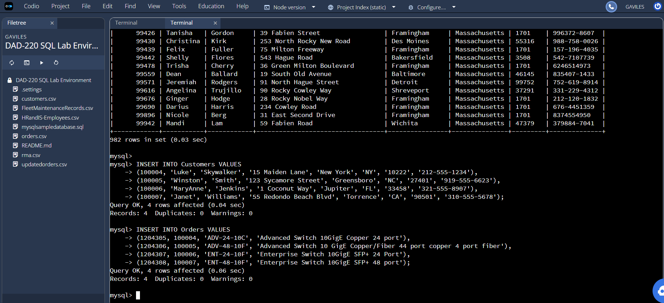
This screenshot shows the query to insert four new records into the orders table using the INSERT INTO command.

COMMAND:
INSERT INTO Orders VALUES
(1204305, 100004, 'ADV-24-10C', 'Advanced Switch 10GigE Copper 24 port'),
(1204306, 100005, 'ADV-48-10F', 'Advanced Switch 10 GigE Copper/Fiber 44 port copper 4 port fiber'),
(1204307, 100006, 'ENT-24-10F', 'Enterprise Switch 10GigE SFP+ 24 Port'),
(1204308, 100007, 'ENT-48-10F', 'Enterprise Switch 10GigE SFP+ 48 port');

  - In the Customers table, perform a query to count all records where the city is Woonsocket and the state is Rhode Island.
    - How many records are in the Customers table where the field "city" equals "Woonsocket"?

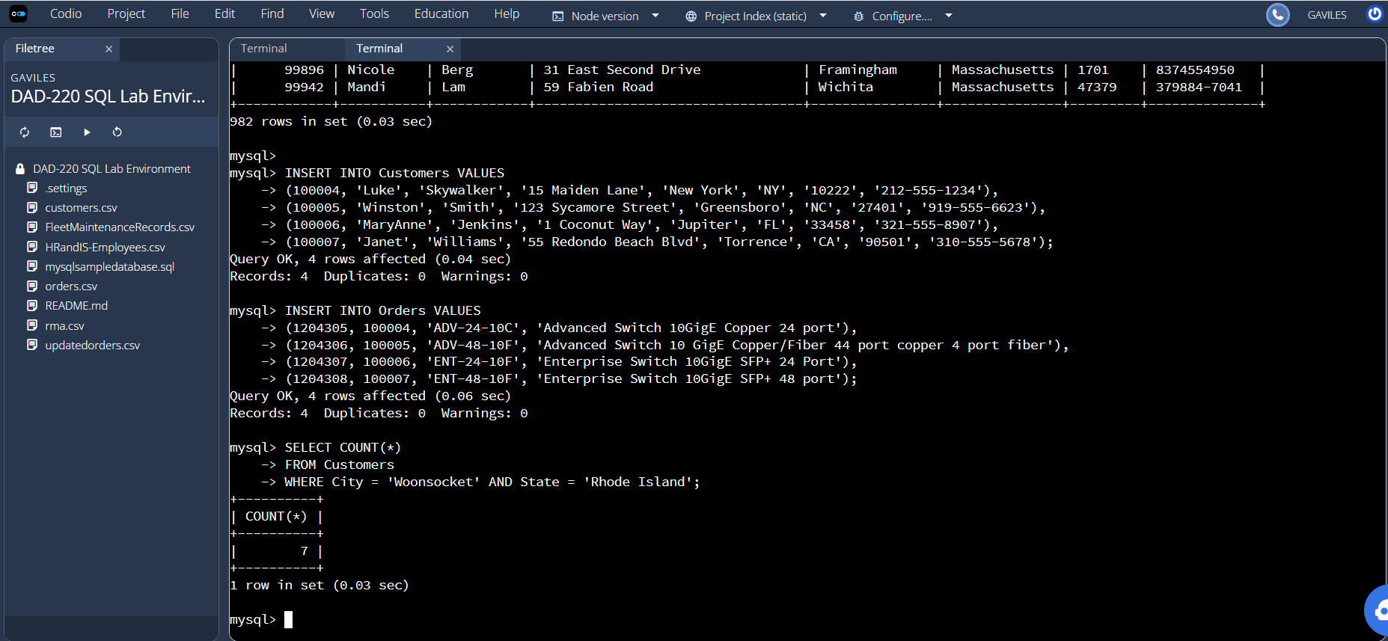
This screenshot shows the query to select the count of customers where the city is ‘Woonsocket’ and the state is ‘Rhode Island’. One record is returned stating the count of customers in Woonsocket, Rhode Island is 7.

COMMAND:
SELECT COUNT(*) FROM Customers WHERE City = 'Woonsocket' AND State = 'Rhode Island';

  - In the RMA database, update a customer's records.
    - Write a SQL statement to select the current fields of status and step for the record in the RMA table with an OrderID value of "5175".
      - What are the current status and step?

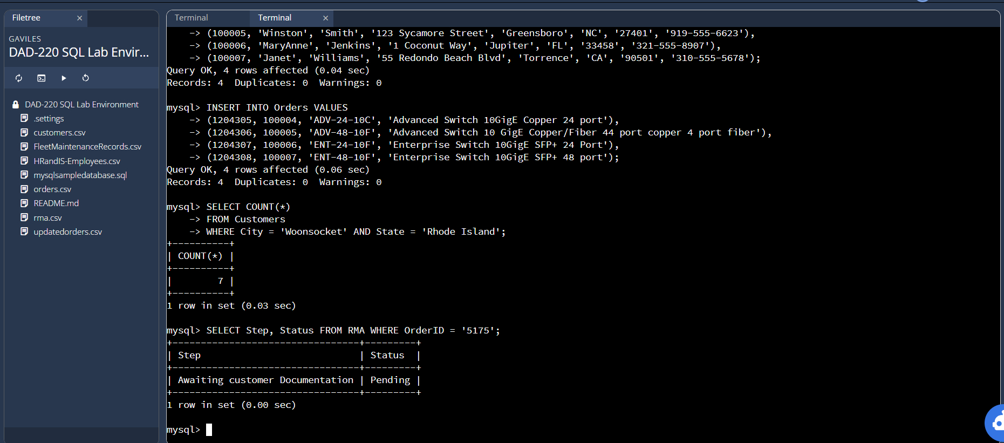
This screenshot shows a query that returns the status and step of OrderID 5175 from the RMA table. The current step is “Awaiting customer documentation’ and the current status is ‘Pending’.
COMMAND:
SELECT Step, Status FROM RMA WHERE OrderID = '5175';

    - Write a SQL statement to update the status and step for the OrderID, 5175 to status = "Complete" and step = "Credit Customer Account".
      - What are the updated status and step values for this record?

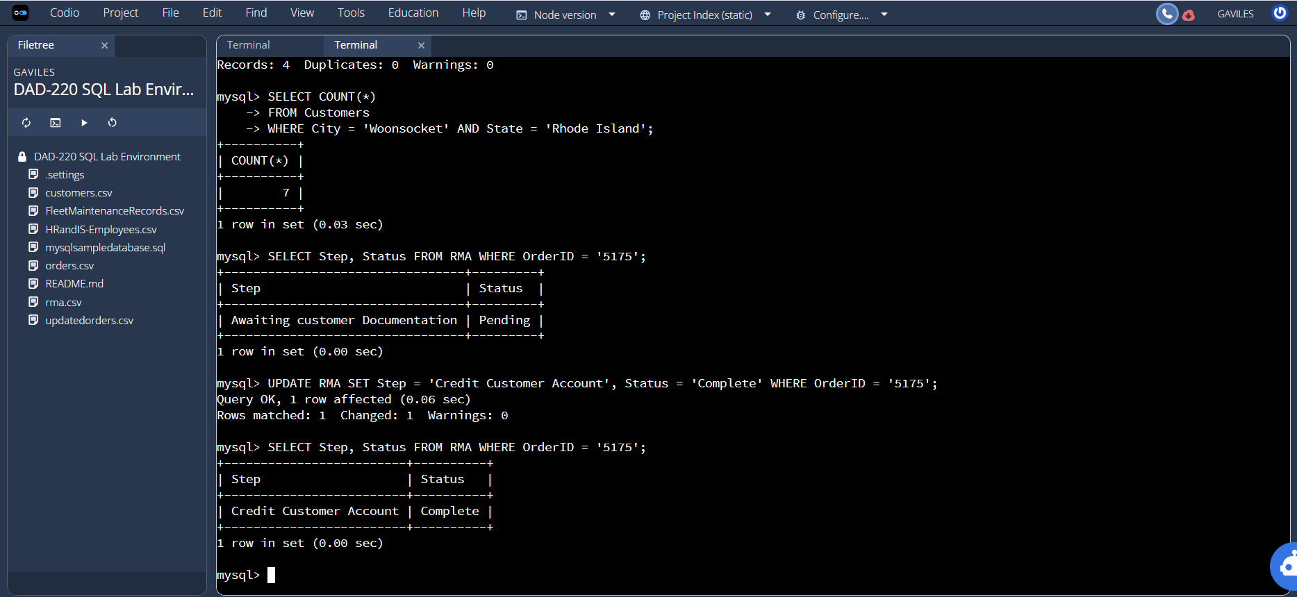
This screenshot shows the query to update the status and step fields of OrderID 5175 in the RMA table. The updates status is ‘Credit Customer Account’ and the updated step is ‘Complete’.

COMMAND:
UPDATE RMA SET Step = 'Credit Customer Account', Status = 'Complete' WHERE OrderID = '5175';

  - Delete RMA records.
    - Write a SQL statement to delete all records with a reason of "Rejected".
      - How many records were deleted?

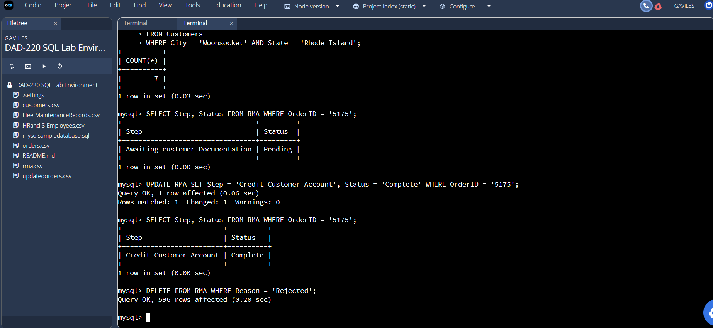
This screenshot shows the query to delete the records from the RMA table where the reason is rejected. 596 records were deleted.

COMMAND:
DELETE FROM RMA WHERE Reason = 'Rejected';

- Update your existing tables from "Customer" to "Collaborator" using SQL based on this change in requirements. Copy and paste the SQL you write to do the following action:
  - Rename all instances of "Customer" to "Collaborator".
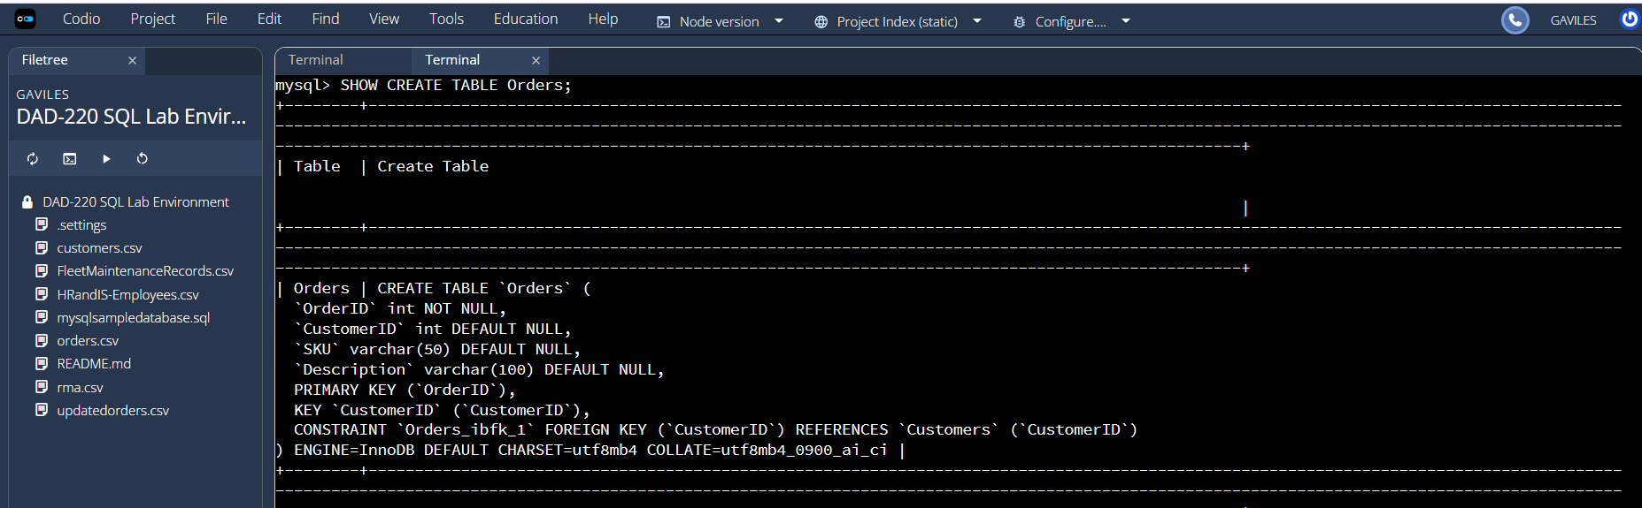
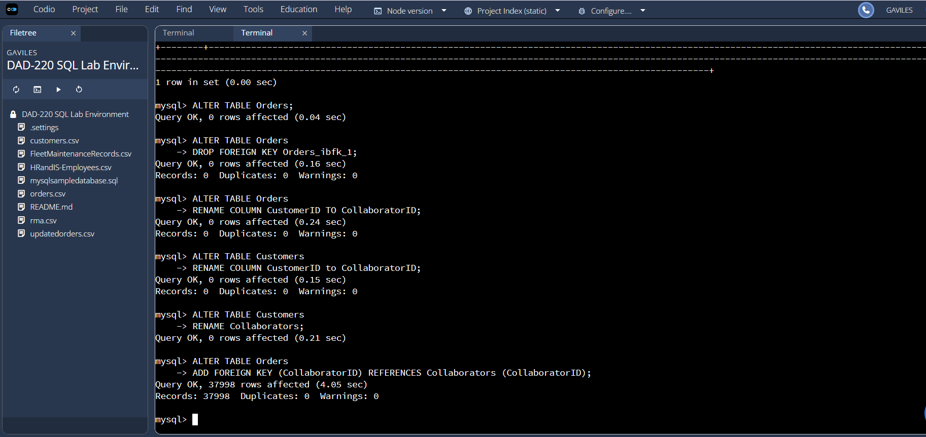

This screenshot shows all the commands required to update all instances of Customer to instead say Collaborator. The first step I took was to use the SHOW CREATE TABLE Orders to view the internal name of the foreign key restraint in the Orders table. I then removed the foreign key constraint from the Orders table and renamed the column CustomerID to CollaboratorID. Next, I renamed the CustomerID column in the Customers table to CollaboratorID. Then I renamed the Customers table to Collaborators. Finally, I added the foreign key restraint back to the Orders table where CollaboratorID in the Orders table references the CollaboratorID in the Collaborators table.

COMMAND:
mysql> SHOW CREATE TABLE Orders;
mysql> ALTER TABLE Orders
-> DROP FOREIGN KEY Orders_ibfk_1;
mysql> ALTER TABLE Orders
-> RENAME COLUMN CustomerID TO CollaboratorID;
mysql> ALTER TABLE Customers
-> RENAME COLUMN CustomerID to CollaboratorID;
mysql> ALTER TABLE Customers
-> RENAME Collaborators;
mysql> ALTER TABLE Orders
-> ADD FOREIGN KEY (CollaboratorID) REFERENCES Collaborators (CollaboratorID);

- Create an output file of the required query results. Write a SQL statement to list the contents of the Orders table and send the output to a file that has a CSV extension.

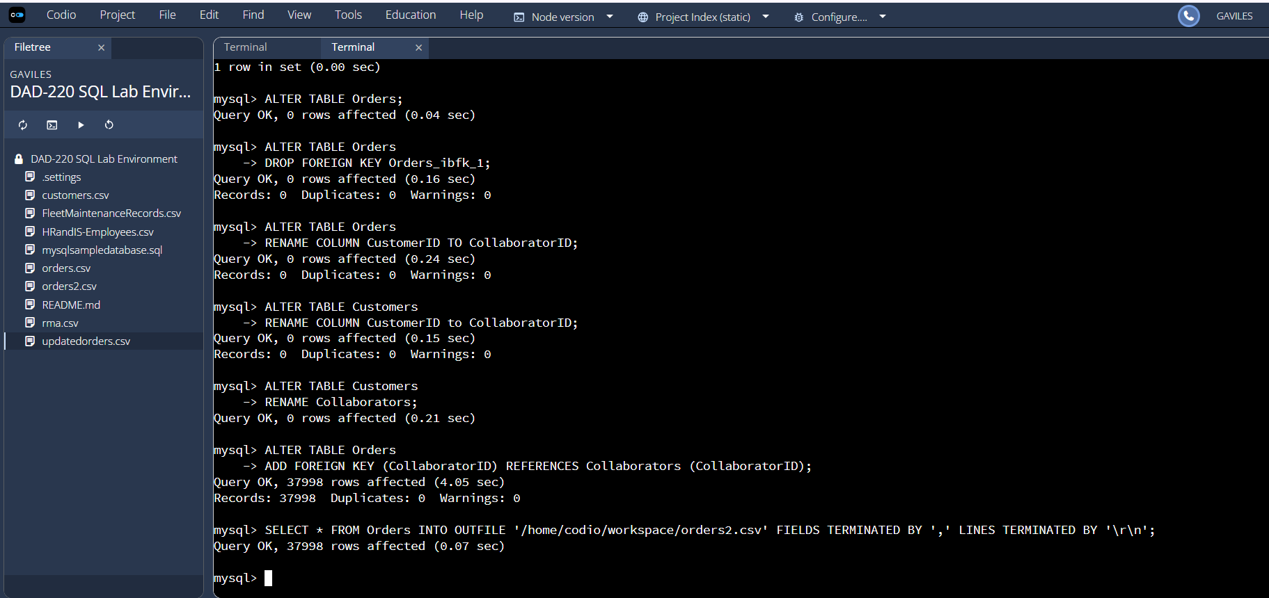
This screenshot shows the query to select the Orders table and sends the output to a csv file called orders2.csv. The output indicates 37998 rows were affected meaning 37998 rows were sent to the outfile which is the size of the Orders table. The new csv file is now listed in the files under the DAD-220 SQL Lab Environment file tree.

COMMAND:
SELECT * FROM Orders INTO OUTFILE '/home/codio/workspace/orders2.csv' FIELDS TERMINATED BY ',' LINES TERMINATED BY '\r\n';

