Database Enhancement Narrative
Enhancement Three: Interactive Customer Order and RMA Dashboard
Gina Aviles

The artifact I selected for the database category is a regional sales and returns analysis that I originally created during DAD 220: Introduction to Structured Database Environments. The original project used customer, order, and return merchandise authorization (RMA) data stored in related tables. I used SQL queries to join the tables and examine customer locations, product orders, and return patterns. The original artifact demonstrated my understanding of relational database structures and SQL, but its findings were primarily communicated through individual queries and static results.
For this enhancement, I transformed the original analysis into a complete Python and SQLite application with an interactive Streamlit dashboard. The enhanced artifact imports three headerless CSV files, validates their structure, and stores 37,994 customer records, 37,994 order records, and 38,162 RMA records in a relational SQLite database. The application connects the tables through primary and foreign keys and allows users to filter the combined data by state, product SKU, RMA status, and RMA reason. It also displays summary metrics, interactive charts, a detailed results table, and an option to download filtered results.
I selected this artifact because it represents an important progression in my database and software development abilities. The original project established a strong foundation in relational database design, SQL joins, grouping, and aggregation. The enhancement demonstrates that I can extend those concepts into a maintainable application that makes database information useful to other people. This is relevant to my professional goals because software engineers and data professionals must do more than store data; they must create reliable ways for users and stakeholders to access, understand, and act on it.
Several components showcase my technical abilities. The import module assigns explicit column names to headerless source files, validates the number of fields in each record, and loads the data in the correct parent-child order. The SQLite schema uses primary keys, foreign keys, and indexes to support data integrity and query performance. I also created a reusable CRUD class that centralizes database connections and provides standardized create, read, update, delete, and custom query operations. The class validates permitted table and column names, uses parameterized values, manages transactions, and prevents update or delete operations without filters. The dashboard further improved the artifact by replacing static query results with an interactive experience. Streamlit provides the interface, Plotly presents the visualizations, and pandas calculates filtered summaries. The dashboard joins customers, orders, and RMA records and then presents the information through clear metrics, charts, and a searchable table. This modular design separates data loading, database operations, and presentation logic, making the application easier to understand, troubleshoot, test, and expand.
I met the course outcomes that I planned to address in Module One. Course Outcome 1 was achieved by creating a centralized dashboard where users with different technical and business backgrounds can explore the same data and use consistent filters to support decision-making. Course Outcome 2 was achieved through the use of clear labels, summary metrics, interactive charts, a detailed table, code comments, and written documentation that communicate the findings to both technical and nontechnical audiences. Course Outcome 3 was addressed through the design and evaluation of a computing solution that uses relational structures, SQL joins, parameterized filtering, and Python aggregations while balancing accuracy, query performance, usability, scalability, and maintainability. Course Outcome 4 was achieved by combining Python, SQLite, SQL, reusable CRUD operations, Streamlit, pandas, and Plotly to turn raw files into a functional database application that provides practical analytical value. Course Outcome 5 was achieved through parameterized queries, table and column allowlists, foreign-key enforcement, transaction rollback, input validation, and safeguards against unfiltered updates and deletions. My only update to the original outcome plan involved credential protection and least-privilege access. Because the completed application uses a local SQLite database rather than a remote database server, it does not require stored database credentials. I therefore focused the security enhancement on preventing injection, protecting data integrity, limiting custom dashboard queries to SELECT operations, and reducing the risk of unintended data modification.
The enhancement process taught me how database design, application logic, and user-interface decisions affect one another. I learned that a successful database application requires more than writing a correct query. The source data must be validated, relationships must be represented accurately, database operations must be reusable and secure, and the final results must be presented in a way that is useful to the intended audience. Separating the application into a database import module, a CRUD module, and a dashboard helped me understand the value of modularity and separation of concerns. One challenge I ran into was determining the correct schema because the CSV files did not contain headers. I had to identify each field, validate row widths, and confirm the relationships between the files before importing them. I also discovered that the RMA file contained more records than the orders file because some orders were associated with multiple RMA records. This confirmed that rma_id, rather than order_id, needed to serve as the RMA table's primary key. That process reinforced the importance of examining the actual data instead of making assumptions about its structure. Another challenge involved connecting the dashboard to the reusable database class and managing Streamlit's execution order. An early version attempted to call database.query() before the SQLiteCRUD object had been created, which caused a NameError. I corrected the issue by creating the database object before defining and calling the filter queries. I also corrected a mismatch between the lowercase SQL column name state and the dictionary key used by the dashboard. Troubleshooting these problems improved my understanding of object initialization, scope, naming consistency, and how Streamlit reruns a script when the application state changes. Additionally, I had to make responsible choices about what conclusions the dashboard could support. Because the dataset does not include prices or dates, it would not be accurate to calculate revenue or present time-based sales trends. I instead focused on measurable patterns involving orders, products, locations, RMA statuses, and return reasons. Overall, the enhancement strengthened my database, Python, security, debugging, and data-visualization skills. It transformed the original artifact into a more professional and reusable solution while showing me how thoughtful technical decisions can make data more accessible and valuable.
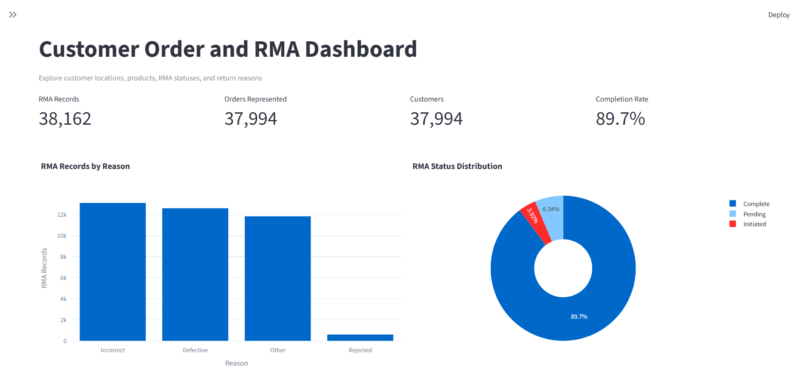
Screenshot of dashboard main screen with graphs for data visualization.

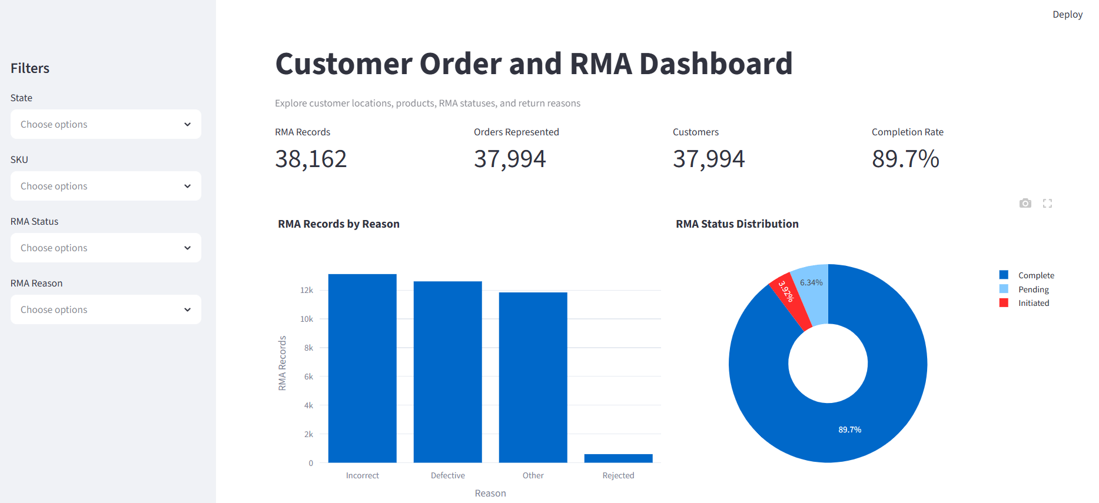
Screenshot displaying interactive filter options.

