Gina Aviles
Enhancement One: Software Design/Engineering Narrative

The artifact I selected for Category One: Software Engineering and Design is a mobile application called Timely. I originally created the application in Android Studio using Java during my CS 360: Mobile Architecture and Programming course. The purpose of the application is to help professionals, students, and other users organize and track events, meetings, and appointments. The original application included account registration and login functionality, an event-management interface, and two SQLite databases: one for storing user account information and another for storing event information.
I selected this artifact for my ePortfolio because it demonstrates my ability to design and develop a functional mobile application from the initial planning stages through implementation and testing. The application showcases my skills in user interface design, mobile application development, database integration, data validation, software security, and modular programming. It also demonstrates my ability to translate user requirements into working features, including account creation, authentication, event storage, event updates, and reminder functionality.
I improved the artifact in several significant ways. I added password hashing so that passwords are not stored in plain text, implemented account-specific event storage to ensure users can access only their own event data, and improved input validation to prevent incomplete or invalid information from being submitted. I also incorporated more reliable database migrations to preserve data when the database structure changes. To improve the reliability of the application, I added unit tests and database instrumentation tests that verify important functionality, including account creation, authentication, event management, and database operations. The most substantial enhancement was rewriting the application using Flutter and Dart. The original version was designed only for Android devices, while the Flutter version can support both Android and iOS from a shared codebase. This enhancement expanded the application’s potential audience while also improving the organization, maintainability, and reusability of the code. Rebuilding the application in Flutter required me to evaluate the original structure, determine which components could be improved, and recreate the application using a different framework and programming language.
I met the course outcomes I originally planned to address through this enhancement. Course Outcome Three required the design and evaluation of computing solutions using algorithmic principles, computer science practices, and appropriate standards while managing the trade-offs involved in design decisions. I achieved this outcome by evaluating the limitations of the original Android application and redesigning it as a cross-platform solution. I considered trade-offs between maintaining separate native applications and using a shared Flutter codebase. Flutter allowed me to reduce duplicated development work and reach users on multiple platforms, although it also required me to learn a new language, framework, and application structure. I also applied software engineering practices such as modular design, separation of concerns, validation, secure credential storage, database management, and automated testing. Course Outcome Four required the use of well-founded and innovative techniques, skills, and tools to implement computing solutions that deliver value and accomplish industry-specific goals. I achieved this outcome by using Flutter, Dart, database migration techniques, password hashing, and automated testing to create a more secure, maintainable, and accessible application. These enhancements provide value by allowing users to manage important events across different mobile platforms while protecting account information and improving the reliability of stored data. The enhanced application demonstrates my ability to learn and apply modern technologies to improve an existing software solution. At this time, I do not plan to change my outcome-coverage plan because the enhancement successfully demonstrates both Course Outcomes Three and Four. However, I plan to continue improving the application by refining the user interface, expanding the reminder and notification features, conducting additional testing, and preparing the application for possible publication in the Apple App Store and Google Play Store.
I learned a lot throughout the process of reviewing, modifying, and enhancing this artifact. One of the most important lessons was the value of conducting a thorough code review. After spending time away from the original project, I was able to identify inefficient code, limited security controls, and areas where the application structure could be improved. This experience helped me understand why peer and professional code reviews are beneficial. A fresh perspective can reveal problems or opportunities for improvement that may be overlooked by the original developer. I also strengthened my understanding of secure coding practices. Implementing password hashing helped me recognize the importance of protecting authentication data rather than storing sensitive information in plain text. Adding validation methods also demonstrated how applications can prevent invalid, incomplete, or unexpected data from entering the system. The testing process reinforced the importance of verifying individual components and database operations before an application is released to users.
One of the primary challenges I faced was converting the application from Java and Android Studio to Flutter and Dart. Although the functionality remained similar, the application structure, interface components, database interactions, and state-management approaches were different. I had to learn how Flutter organizes widgets, manages application state, and supports platform-independent development. Another challenge involved updating the database structure without losing existing user or event information. Implementing database migrations required careful planning and testing to ensure changes could be applied reliably.
Overall, enhancing Timely allowed me to improve both the technical quality of the application and my own software development abilities. The process strengthened my skills in mobile development, secure coding, testing, database management, cross-platform design, and code evaluation. It also demonstrated that an existing application can be significantly improved through careful review, modern development tools, and the application of software engineering best practices.

Enhancement Evidence
The following screens show the enhanced Timely workflow running from the Flutter build: secure local authentication, validated event creation with reminder controls, and the account-specific day view after the event is saved.
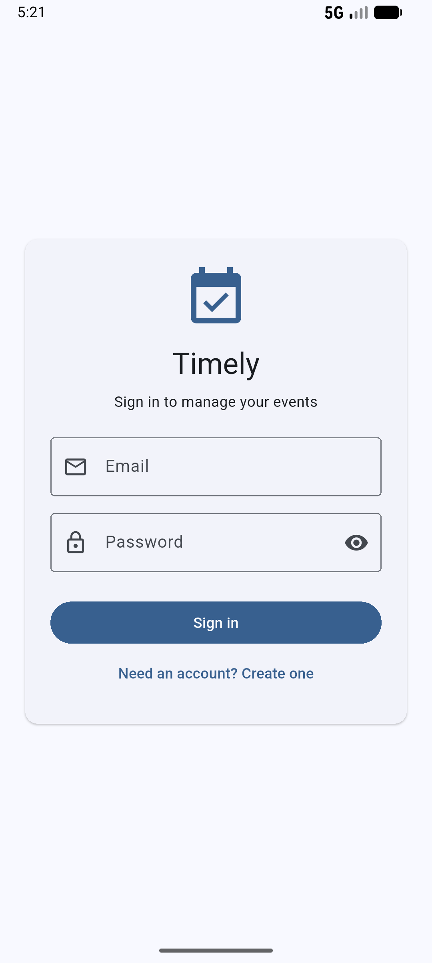 | 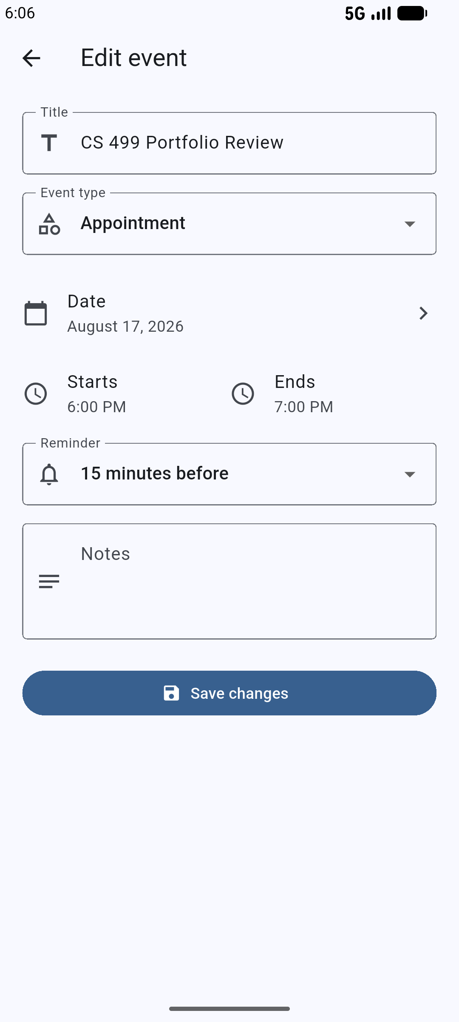 | 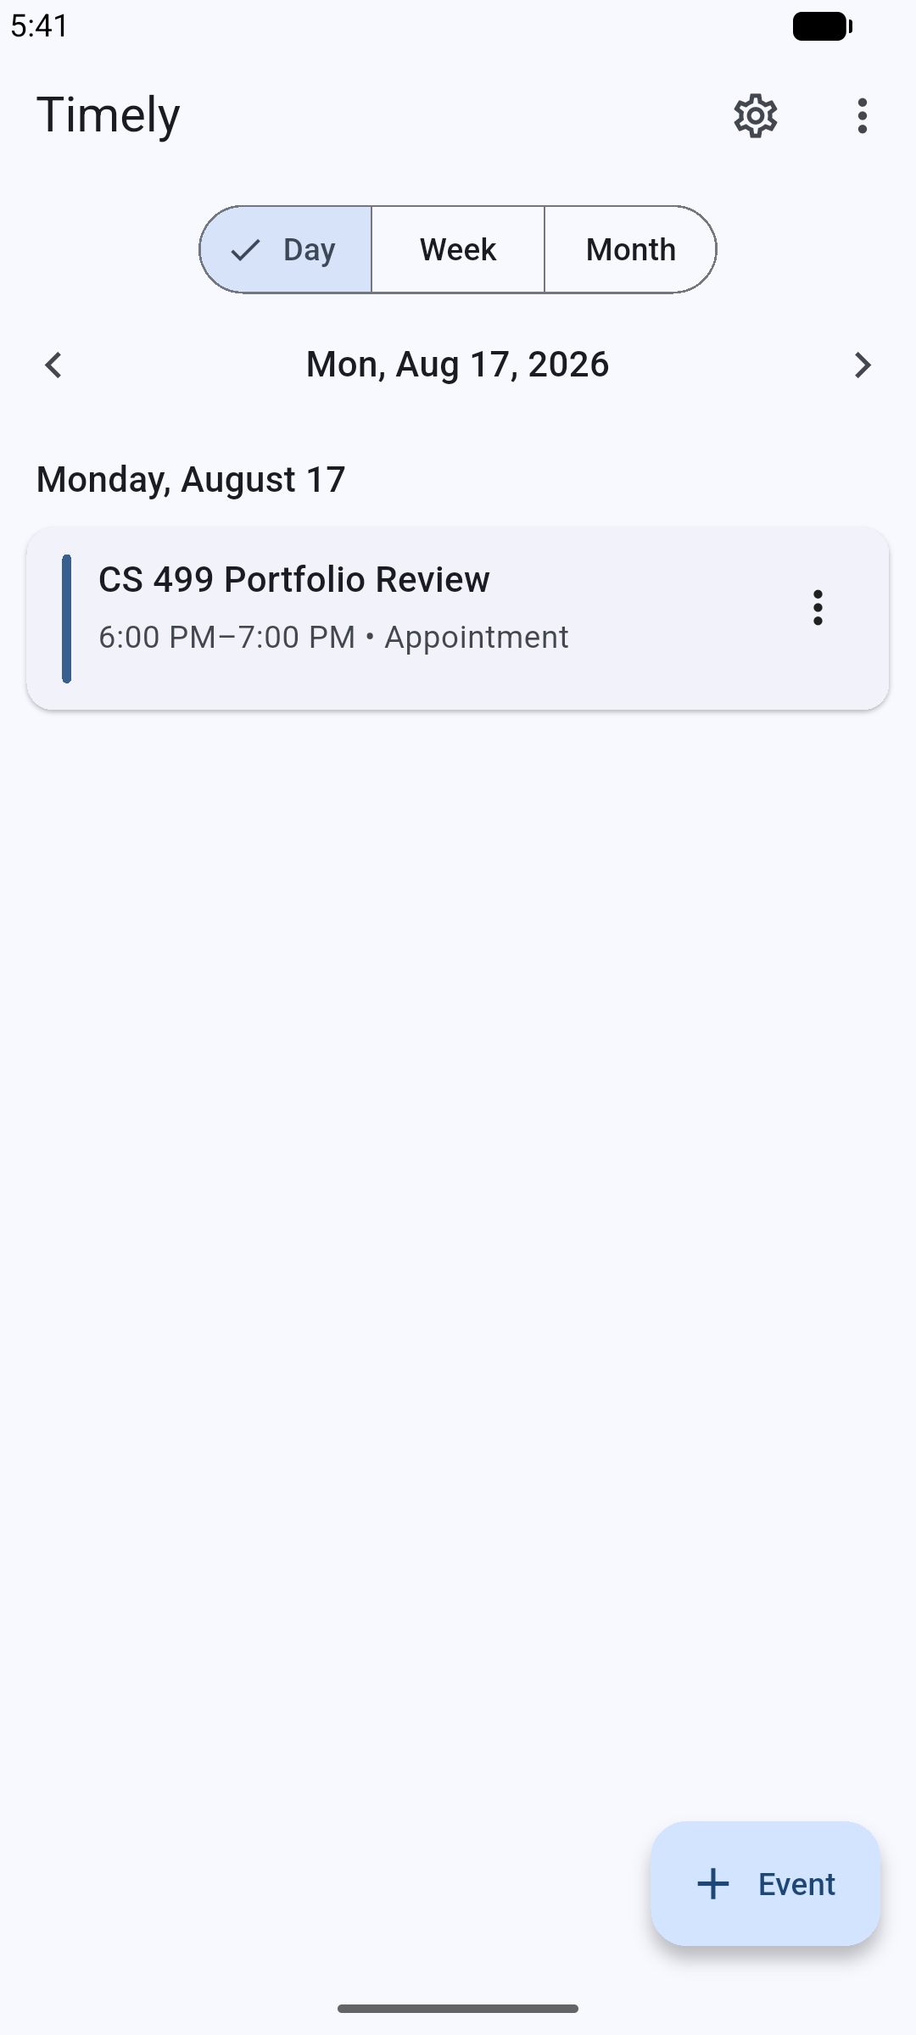
Figure 1. Secure local account sign-in in the enhanced Flutter application. | Figure 2. Event editor with type, date, time, and reminder controls. | Figure 3. Account-scoped day view displaying a saved CS 499 event.
Screens captured from the enhanced Flutter build on August 17, 2026.

