Hous

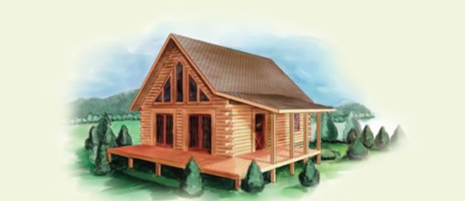

**Log Cabin Rentals**

Lake Vacations

We make lake vacations easy and fun. You bring your own powerboat, WaveRunners, or kayaks, and we provide you with lodging in a cozy log cabin! We help you prepare for your excursion, advise you on what to pack, and take care of all the little details we have already thought out for you so that you and your guests can have the most fun while making the best memories.

The fun never ends when you relax by the lake in a cabin! You can go fishing, boating, waterskiing, tubing, or hiking, and there are dozens of trails to explore. Do you prefer to simply relax? Each of our cabins comes with a big porch for sitting and enjoying the sights and sounds of nature.

# Living and Dining Areas

* Living area with a couch and chairs
* Modern dining setting that seats 6
* Plasma TV, DVD, and CD player
* Dishwasher & Microwave
* Large Gourmet BBQ on rear deck
* All crockery, cutlery, glasses, & cooking utensils
* Fireplace
* Washing machine & dryer

# Sleeping Areas

* Full bathroom with shower and tub
* 1 or 2 king bedroom(s) + loft with twins
* 1 or 2 Sofa bed(s) in living room
* Quality pillows, sheets, and towels all provided
* Air conditioning to all rooms

Figure 1 Floorplan varies with Cabin

* TV/DVD in bedroom and loft

# Outdoor Facilities

* Porch with rocking chairs and table
* Hot tub
* Volleyball Court
* Outdoor firepit & benches
* BBQ
* 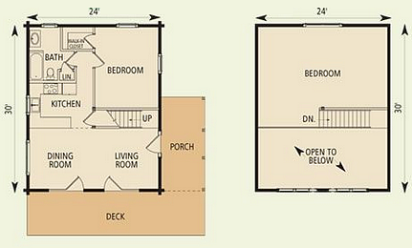Wooden picnic table

# Affordable Pricing

The weather is different yet beautiful throughout the year. Fall, summer, and spring are best for water and hiking activities. Winter offers snowshoeing, cross-country skiing, and ice fishing. So pack your bags and bring your vacation toys! We have cabins available during the entire year at affordable prices that won’t break your budget!

## Weekly Rental:

Sleeps Log Cabin Spring Summer Fall Winter

2 Aspen 3240 4320 3450 2240

4 Wasatch 3345 4460 3570 2345

6 Uintah 3625 4830 3865 2625

8 Laker 4660 6210 4970 3660

10 Family Lodge 5925 7900 6320 4925

# Contact Us

Lake Vacations.

1234 Main St.

Wasatch Mountain, UT 84040