Munson’s Pickles andPreserves Farm

Proposal Plan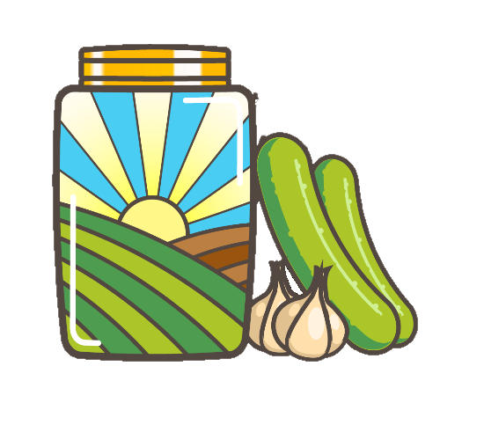

Table of Contents

Background 3

Proposal Overview 3

Identified Plants and Flowe 3

Popular Flowers by Region 4

Greenhouse Option 6

Outsourcing Option 6

Summary 7

# Background

The Munsons have been raising crops and honeybees on their farm since the mid-1800s. Twenty years ago, the family planted a few rows of sweet corn alongside the road to see how the crop would yield. The few rows flourished and produced more corn than expected. As a result, the family decided to put a sign along the road and sell the extra corn to neighbors passing by the farm. Eventually, other vegetables were added to the garden which increased community interest. As the farm grew, the family decided to try their luck at preserving. Soon, Munsons' was selling pickles and preserves prepared from the fresh produce. These quickly became a fan favorite among neighbors and the community.

Today, the farm grows over 100 acres of fresh vegetables and maintains 40 hives of honeybees. A variety of venues and markets around the community sell the produce and honey. Recently, the farm has ventured into new opportunities for selling wholesome food, as well as opening their doors to events offering farm fun.

Munsons' employs 20 field and processing employees and welcomes the help of dozens of volunteers. Volunteers help with everything from planting and harvesting to assisting customers in the Pickles and Preserves Garden Shop. Munsons' has a few veteran volunteers who manage the behind-the-scenes business details and host the popular educational farm tours and field trips.

The Munsons' Pickles and Preserves Farm is now investigating new agricultural ventures and expansion. Market research has begun based on current customer preferences and discussions with other local producers. Current data shows that plant nurseries are under-represented locally.

# Proposal Overview

Munsons' would like to expand the farm to include flowers and plants. To be successful, Munsons' will determine which flowers and plants are in the greatest demand and focus on providing enough of these plants to fulfill customer needs. The farm will explore popular flowers from around the world as well as plants that are native to the area. To maximize profit, Munsons' is examining whether to build and manage a greenhouse at their main farm in Edison, Washington, or outsource to farms across various planting zones in the United States.

## Identified Plants and Flowe

| Popular Flowers by Region | |
| --- | --- |
| Region | Flower |
| Australia | Golden Wattle |
| Singapore | Orchid |
| Cook Islands | Tiaré Flower |
| England | Tudor rose |
| Pakistan | Poet's Jasmine |
| India | Lotus |
| Iran | Persian pearl |
| Kashmiristan | Rhododendron |
| Maldives | Pink rose |
| Malaysia | Chinese hibiscus |
| Finland | Lily of the Valley |
| Estonia | Cornflower |
| Nepal | Rhododendron |
| Norway | Palestinian poppy |
| Sri Lanka | Water lily |
| South Korea | Rose of Sharon |
| Afghanistan | Tulip |
| Bangladesh | Shapla |
| Bhutan | Blue poppy |
| Cambodia | Rumduol |
| China | Peony |
| Chile | Copihue |
| Switzerland |  |
| Persian Poppy Iceland |  |
| Mountain avens |  |
| Samoa | Red ginger |
| South Africa | Protea |
| United States | Rose |

### Native Plants

* Miniature Hollyhock
* Alpine Strawberry
* Broadleaf Lupine
* Camassia
* Tuft Hairgrass
* Fireweed
* Oregon Grapeholly
* Shooting Star
* Broadleaf Sedum
* Goatsbeard

## Greenhouse Option

Munsons' does not have additional farmland to dedicate to the expansion of building a greenhouse. However, a parcel of land is available for purchase adjacent to their current farm. The seller has offered a full purchase price offer, a lease purchase offer, or a profit- sharing offer. If they choose to purchase the land, Munsons' will need to determine the initial cost of building the greenhouse as well as the ongoing cost of maintaining, operating, and staffing.

## Outsourcing Option

To minimize the initial cost of expansion, Munsons' is considering outsourcing to various farms in multiple planting zones. To fully consider this option, Munsons' needs to determine the cost to lease the land and resources from the regional farms. In addition, shipping costs will need to be calculated. The best outsourcing options for Munsons' are listed below.

Zone 3- Harlem, Montana

Zone 4- Casper, Wyoming

Zone 5- Lamar, Colorado

Zone 6- Christmas Valley, Oregon

Zone 7- Kennewick, Washington

Zone 8- Edison, Washington

Zone 9- Gold Beach, Oregon

The list consists of farms in close proximity to Munsons' farm to reduce shipping costs. Additional regions will be explored if the opportunity arises.

# Summary

Munson’s Pickles and Preserves Farm has established a respected, well-known reputation throughout many locations in the United States of America. The passion for

providing excellent customer service coupled with their love of nature has provided the farm with the opportunity to expand their business.