Winning and Attendance in the WNBA
Gabriela Eastwood
Benjamin S. Baumer
Andrew Zimbalist
2026-06-03
Abstract
A central question in the intersection between sports economics and sports analytics is how to quantify the effects of what happens on the court or field on a team’s revenue. In general, the literature expects that stronger teams will see higher live game attendance, but previous research has not found a statistically significant relationship between winning percentage and attendance in the WNBA (Agha and Berri 2023). Our study improves upon theirs by using a rolling win count from the past 44 games played rather than a seasonal winning-percentage to predict per game attendance. This avoids look-ahead bias, as fans cannot be expected to know a team’s future performance when deciding to attend a game. Using game-level data for all WNBA regular-season games from 2018–2024, we estimated an ordinary least squares model of per-game attendance with team and season fixed effects and a dummy variable for whether Caitlin Clark played. We then translated player win shares into expected attendance impacts by mapping individual contributions to team wins onto the estimated attendance–winning relationship. We chose to focus on attendance as a proxy for revenue following the research framework from Scully (1974), due to concerns about revenue data availability. We used attendance data from the “Across the Timeline: WNBA League Attendance Dashboard”, which records game-level attendance data for all WNBA games. We find a significant relationship between rolling win count and game attendance, with game attendance expected to increase by 112 people for each additional win in the 44 game window. This means that a player like Allisha Gray, for example, who we estimate contributed 10 wins to the Atlanta Dream in 2024, boosted attendance by approximately 1,100 attendees per game. These results highlight the importance of short-run performance in shaping fan demand and provide a framework for linking individual player performance to team-level revenue outcomes in women’s professional sports.
_{Source: Article Notebook}
_{Source: Article Notebook}

1 Introduction

1.1 Gabriela introduction
In the years prior to the 2020 WNBA collective bargaining agreement (CBA), NBA Commissioner Adam Silver publicly characterized the women’s league as unpopular and unprofitable (Garcia 2020). Again during the CBA renegotiations in 2025, NBA and WNBA leadership made similar negative claims about the women’s league’s long term viability. While league leadership has been ironically pessimistic about the health of the WNBA in recent years, their claims stand in tension with recent trends: the league has enjoyed a significant increase in attendance and fan interest in the past several seasons.
While this trend is encouraging for anyone interested in the success of the WNBA, breaking down further the underlying components of this trend is necessary both to explain and sustain this growth. For decades, league officials and sports economists have debated the primary drivers of game attendance, identifying game-related and market-related factors impacting fan interest and game attendance. Much of this research, beginning with foundational work in the 1970s, assumes that fans are more likely to attend games when the home team is expected to do well. This relationship is widely tested and supported in men’s professional sports, but women’s leagues and the WNBA in particular are still largely underresearched. As a relatively young league with rapid growth in viewership (WNBA 2024) but limited publicly available financial data, game attendance remains the most readily available proxy variable for public interest in the WNBA.
A key line of research in sports economics links fan demand to expectations about game outcomes. Early work such as the uncertainty-of-outcome hypothesis suggests that attendance is higher when game results are less predictable, increasing perceived excitement. In their 2014 paper, Coates et al use more recent behavioral economics models to suggest that people evaluate gains and losses relative to a reference point and tend to dislike losses more than they like equivalent gains (Coates et al. 2014). They argue that applying this idea of loss aversion may better explain why fans choose to go games than the uncertainty of outcome hypothesis. They use MLB live-game attendance data to find attendance patterns consistent with the hypothesis that fans are less likely to attend games in which they expect the home-team to lose (Coates et al. 2014). These frameworks together suggest that attendance decisions are sensitive not only to team quality, but to expectations about competitive performance and likely game outcomes.
In the first study in sports economics that sought to empirically identify the factors that affected attendance, Noll (1974) considered data from MLB, the NFL, NHL, NBA and ABA (American Basketball Association) for the 1969-70 and 1970-71 seasons and found that demand was a function of population, interactions of income with star players, team win percentage, and per capita income. Multiple subsequent studies on men’s professional team sports continued to find a statistically significant correlation between team quality and attendance. In these studies, a debate emerged about the direction of causality: did strong team performance engender higher attendance or vice versa (Baade and Tiehen 1990; Clapp and Hakes 2005; Davis 2008, 2009; Horowitz 2007; Lemke et al. 2010)? While no Granger causality tests were run, the predominant view has been causality running from team performance to attendance (Hall et al. 2002).
Finally, situating these revenue models within broader league structure, sports economists have written extensively about the relationship between winningness and team revenue, particularly about how competitive balance benefits teams across the league in generating revenue. While teams and fans want to win as many games as possible, significant imbalance in winning percentages across a professional sports league will tend to decrease viewership as spectators will only watch a game if they have some uncertainty about the outcome (Perline et al. 2018). In their study of competitive balance in NCAA basketball, Perline et al. found that the women’s game was significantly less balanced than the men’s game, looking at the standard deviation and the range of winning percentages for teams in the women’s division I conference (Perline et al. 2018). They hypothesize that the difference in the competitive balance of the men’s and women’s games could be one cause of lower revenue generation and attendance in the women’s game.
In their study of attendance determinants in the WNBA, Agha and Berri argue that a major reason why attendance is considerably lower at WNBA games than NBA games is that the women’s league is still in its early years, only beginning play in 1997 compared to the NBA’s 1946. To account for this, they compare attendance in the tenth season of the WNBA (2006) and the NBA (1955/56) (Agha and Berri, 2023, p. 36.) In their respective tenth years, the WNBA average attendance per home game exceeded the NBA’s by more than 2,000 fans per game. This comparison suggests that the current disparity in attendance between the women’s and men’s league should not be interpreted as a lack of demand, but rather a sign of the league’s maturity. Considering the league’s age as a factor in demand for attendance, it is interesting to inquire further into whether patterns of fan behavior change as the league matures. Agha and Berri attempt to establish whether different forces shape demand for attendance in the WNBA and the NBA, finding that team performance was not a statistically significant predictor of game attendance in the WNBA. As noted above, this is contrary to the virtually unanimous finding in the existing scholarship for men’s leagues. However, their study only employed data from 2004 through 2017 and thus can not capture the more recent improvements in attendance shown in figure 1.
Of course, all of this differential cannot be attributed to the age of the league. Additional important factors include: the WNBA plays during the summer months in order to promote arena use outside of the NBA season; there is less money spent on promotion, reduced media coverage, historical prejudice, arena amenities and age, and ticket prices, among others. To be sure, the sports management literature also includes several studies that find a major motivation behind fandom for women’s sports leagues to be an area’s overall support for feminist issues (Delia 2020; Guest and Luijten 2018; Leslie-Walker and Mulvenna 2022). Nonetheless, to the extent that the league’s age is a factor, it is interesting to inquire into the patterns of fan behavior and whether they might change as the league matures. Agha and Berri (2023) found that their variable on team performance was not statistically significant as an explainer of team attendance. As noted above, this is contrary to heretofore virtually unanimous finding in the existing scholarship for men’s leagues. Note, however, that Agha and Berri (2023) employed data only from 2004 through 2017 and that its performance variable was team win percentage during the previous year.
In viewing more recent attendance figures for the WNBA in the context of the league’s history, we hoped to determine whether predictors of attendance have shifted over time, due to the WNBA’s relative instability as a young league. Specifically, we find that in recent years the strength of the effect of team strength on game attendance has increased, paralleling documented trends in men’s leagues.
In this paper we build upon the literature on team performance and game attendance in the context of the WNBA and introduce a period-based model that allows us to more accurately capture the current state of league growth.

1.2 still to be incorporated in intro:
Differences in the literature over how to measure team quality (wins, wins lagged, number of championships in past years, win probability, star power), attendance (logs, lags, linear regression or censored), the inclusion of control variables and non-linear forms also emerged (Wiseman and Chatterjee 2003; Woltring et al. 2018; Kim and Chang 2023; DeSchriver and Jensen 2002; Paul et al. 2019).
The use of only last year’s win percentage to measure team performance is problematic because fans are more likely to respond to the more recent performance of the team. Thus, while a team’s win percentage in 2016 might have an appreciable impact on the team’s attendance at the beginning of the 2017 season, as the season wears on, this impact should consistently diminish.
Professional men’s team sport leagues have demonstrated a clear relationship between team quality and attendance. It is reasonable to anticipate that as women’s sports mature and are perceived increasingly as a normal sports league, rather than a political concession or oddity, they will begin to assert similar fan demand characteristics. In particular, fan demand will become more responsive to team quality. Using game attendance and team performance data from 1997 through 2025, we test these hypotheses.

1.3 Andrew other passage
The relationship between attendance and winning percentage has been examined, but such studies often look at winning percentage as causation for attendance. Davis (2008) and Horowitz (2007) both found that attendance and winning percentage were related. Horowitz concluded a bidirectional relationship between the two, while Davis suggested that causation runs from winning percentage to attendance. In a following study, Davis (2009) found winning percentage as a significant determinant of attendance for 12 National League teams; though the study did not establish causation both ways. Lemke et al. (2010) found attendance increases as home team win probability increases. There is evidence that causation may run from attendance to winning percentage, but the bulk of the literature has been researched the other way.
The present study controls for payroll and stadium capacity as both have been shown to affect attendance. Wiseman and Chatterjee (2003) found team payroll was positively correlated to team winning percentage (9). Additionally, they found that this relationship has grown stronger since the late 1990’s. Hall et al. (2002) did not find causality evidence from payroll to team winning percentage in their entire dataset, but they did note an increased correlation in the 1990’s. Additionally, they stated that an MLB team with a payroll of at least 150% of the league average could expect a winning percentage of at least .550. This is an important finding, because Vrooman (2012) identified .550 as a benchmark winning percentage for qualifying as a playoff team.

2 Data

2.1 Game logs and attendance
Our analysis is based on game-level data that spans WNBA history, beginning in 1997 and continuing through the end of the 2025 season. Our final data set contains observations from 6,164 games.
First, we collected game-level attendance data from (Across the Timeline, n.d.). We supplemented these data with arena capacities that we collected manually. Attendance data was unavailable for only 152 games, while (due to the COVID-19 pandemic) 2 games (accurately) recorded attendance of 0.
Second, we collected game-level performance data from the wehoop R package (Gilani and Hutchinson 2021), which uses the official WNBA API. These data include the final score of the game. We also used the wehoop package to identify whether Caitlin Clark played more than 0 minutes in the game.
Table 1 shows a sample of the data. While many other variables are omitted from the table, we note that the attendance, the teams playing in the game, the outcome, the arena, and whether Caitlin Clark played in the game, are recorded.
Table 1
Table 1: WNBA Game Data (1997-2025)
Sample of game-level records
Game Date | Home | Away | Arena | Attendance | Plus Minus | Clark
2004-06-15 | CHA | SAN | Time Warner Cable Arena | 5,004 | 2 | 0
2015-06-21 | SEA | PHO | KeyArena | 5,947 | -12 | 0
2022-07-14 | NYL | LVA | Barclays Center | 9,896 | -34 | 0
2016-06-24 | SEA | CON | KeyArena | 6,568 | 17 | 0
2021-06-06 | MIN | ATL | Target Center | 2,021 | 20 | 0
2025-09-03 | CHI | CON | Wintrust Arena | 7,195 | 24 | 0
2023-07-12 | IND | NYL | Gainbridge Fieldhouse | 6,123 | -8 | 0
2021-08-17 | PHO | IND | Footprint Center | 4,089 | 4 | 0
2019-07-05 | SEA | ATL | Alaska Airlines Arena | 8,111 | -11 | 0
1999-07-08 | SAC | HOU | ARCO Arena | 9,505 | 11 | 0
Sample of Game-level WNBA data. The data indicates (among other things) which teams were playing, who won, the arena, the attendance, and whether Caitlin Clark played in the game.
_{Source: Article Notebook}
Figure 1 shows the distribution of attendance across all seasons, with a logarithmic scale on the vertical axis. There is no attendance data from 2020, because all games that year were played in the WNBA bubble due to the COVID-19 pandemic, and some games in 2021 continued to be played with artificially low attendance.
_{Source: Article Notebook}
Several broad observations can be made from Figure 1. First, after some initial enthusiasm during the first three years of the league, attendance largely plateaued or steadily but slightly declined from 2000 to 2017. The two years preceding the pandemic (2018-2019) had notably lower attendance. Since the pandemic, attendance has rebounded, exceeding its initial levels in 2024 and reaching new heights in 2025. In fact, average WNBA attendance in 2025 was 10,986, which was 1.1% higher than the previous high in 1998.
These last two years coincide with the arrival of Caitlin Clark, the 2024 Rookie of the Year Award winner who is widely regarded as a generational talent. Disentangling the “Caitlin Clark effect” from the league’s overall attendance trends is one of our goals.
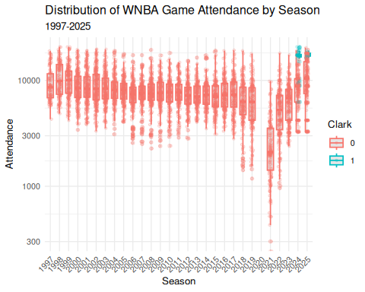
Figure 1: Distribution of WNBA game attendance by season. Note that the vertical axis has a logarithmic scale. Caitlin Clark’s games in 2024-2025 are separated by color.
_{Source: Article Notebook}

2.2 Estimating team strength
We used the game-level results data to model the strength of each WNBA team as a time series. Measuring team strength is necessary to test our hypothesis that attendance is in part driven by the desire of fans to see quality basketball. We considered season-to-date winning percentage and a rolling 44-game (the length of a typical WNBA season) winning percentage before settling on Elo rating (Elo 1978). Originally developed for rating chess players, Elo rating is well-understood in sports analytics as a measure of team strength that updates after each game, and—unlike winning percentage and rolling winning percentage—takes into account not only the outcome but also the estimated team strength of both teams.
Let $θ_{i}(t)$ be the strength of team $i$ at time $t$, where Elo rating are typically centered at 1500. Then if the probability that team $i$ beats team $j$ is modeled by a logistic curve with base 10 and scale factor 400, the win probability is given by:
$$Pr(i\text{ beats }j\text{ at time }t)=\frac{1}{1+{10}^{\frac{θ_{j}(t)−θ_{i}(t)}{400}}} .$$
Each team starts the 1997 season with ${\hat{θ}}_{i}(0)=1500$, and following each game, team $i$’s rating is updated via the formula
$${\hat{θ}}_{i}(t+1)={\hat{θ}}_{i}(t)+K⋅I(i\text{ beats }j) ,$$
where $I(i\text{ beats }j)$ is an indicator variable that is 1 if $i$ beats $j$ and $−1$ if $j$ beats $i$, and $K=32$ is a constant that controls how sensitive the ratings are to each game. Figure 2 shows the evolution of Elo rating ${\hat{θ}}_{i}(t)$ by franchise for the 12 teams who were active during the 2024 season. The recent poor performance of the Los Angeles Sparks, the 2010 dominance of the Seattle Storm, and the recent rise of the New York Liberty and Indiana Fever are easily visible.
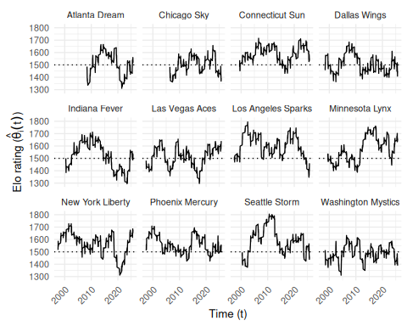
Figure 2: Evolution of team Elo ratings in the WNBA (1997-2025). Only franchises active in 2024 are shown. The recent poor performance of the Los Angeles Sparks, the 2010 dominance of the Seattle Storm, and the recent rise of the New York Liberty and Indiana Fever are easily visible. Note that all franchises begin with a 1500 rating.
_{Source: Article Notebook}

2.3 Estimating home win probability
The Elo ratings estimated above can then be plugged back into the win probability formula to estimate the home teams’s chances of winning. We also added a 12-point home court advantage to our home win probability model, so that:
$${\hat{p}}_{ij}({\hat{θ}}_{i}(t),{\hat{θ}}_{j}(t),t)=Pr(i\text{ beats }j\text{ at time }t\text{ at home})=\frac{1}{1+{10}^{\frac{{\hat{θ}}_{j}(t)−\left(θ_{i}(t)+12\right)}{400}}} .$$
We arrived at 12 points by manually calibrating the win probabilities to match the observed frequencies. While the model was less accurate at the extremes (it was consistently reluctant to predict nearly certain home wins and losses), it fit very well in the middle where most of the games occur (see Table 2).
Table 2: Calibration of home win probability model, based on Elo ratings. We note that in the most frequent situations, where the home team was a slight favorite, the observed home win probability is within 3 percentage points of the predicted home probability. However, in those rarer occasions where a home win was extremely likely or unlikely, the model was less accurate.
Table 1: WNBA Home Win Probability Model Calibration (1997-2025)
10 Equally-spaced Bins
Wpct Bin | Games | Bin Midpoint | Obs Home Wpct | Diff
(0.153,0.233] | 51 | 0.212 | 0.059 | -0.153
(0.233,0.311] | 170 | 0.284 | 0.188 | -0.096
(0.311,0.39] | 441 | 0.360 | 0.211 | -0.149
(0.39,0.468] | 744 | 0.432 | 0.349 | -0.083
(0.468,0.547] | 971 | 0.508 | 0.485 | -0.023
(0.547,0.625] | 1,136 | 0.586 | 0.601 | 0.016
(0.625,0.704] | 1,150 | 0.664 | 0.697 | 0.033
(0.704,0.782] | 910 | 0.737 | 0.815 | 0.078
(0.782,0.861] | 490 | 0.810 | 0.894 | 0.084
(0.861,0.94] | 101 | 0.884 | 0.950 | 0.066
_{Source: Article Notebook}

3 Methods
Our goal is to model the attendance ($y$) at a given WNBA game, as a function of several different measures of fan engagement detailed in Section 3.2. We also include several control variables to account for time and city-related effects (see Section 3.3).
We also know the arena in which the game took place and the capacity of that arena. Thus, and alternative response variable is percentage of arena capacity filled ($γ$).

3.1 Response variables
In Figure 3, we observe the relationship between attendance and estimated home win probability. In most years, the slope appears to be positive.
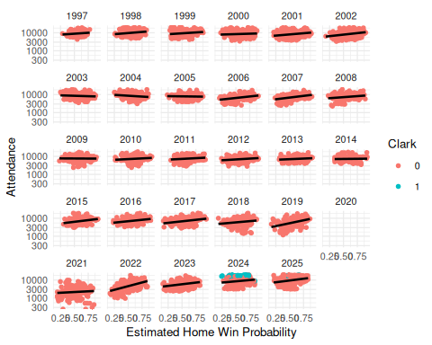
Figure 3: WNBA attendance by season, against estimated home win probability. We note that in most years, the slope of the association appears to be positive.
_{Source: Article Notebook}
In Figure 4, we note similar trends in the relationship between the percentage of the arena capacity filled and the estimated home win probability. We also note that since arena capacity cannot exceed 1, there are edge effects created by sellouts. Those sellouts are much more frequent in the last two years of data, and many of the sellouts involve Caitlin Clark.
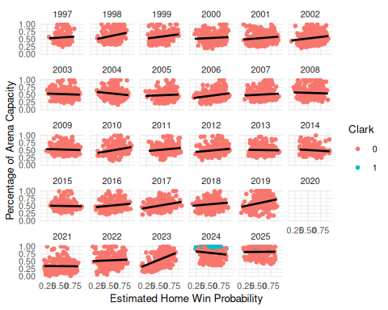
Figure 4: WNBA percentage of arena capacity filled by season, against estimated home win probability. We note the edge effects caused by sellouts, which occur much more frequently in 2024 and 2025.
_{Source: Article Notebook}
Because the raw attendance figures are not normally distributed, we model the logarithm of attendance. Similarly, because the percentage of arena capacity are bound above by 1 and below by 0, we employ a Tobit regression model.

3.2 Modeling fan engagement
In Section 2.2, we described our use of Elo rating to estimate the strength of the home team (${\hat{θ}}_{i}(t)$), the strength of the visiting team (${\hat{θ}}_{j}(t)$) and the home win probability (${\hat{p}}_{ij}(t)$) (which is itself a function of the estimated team strengths).
As noted in Section 1, there are multiple notions of what drives fan engagement relevant to the WNBA. Each of these notions can be captured by a simple bivariate function of the corresponding strengths of the teams ($f_{k}({\hat{θ}}_{i}(t),{\hat{θ}}_{i}(t))$).
- Quality of play: fans may wish to attend a game in person if the quality of play is high. We model this as the sum of the Elo rating of the two teams ($f_{1}({\hat{θ}}_{i}(t),{\hat{θ}}_{i}(t))={\hat{θ}}_{i}(t)+{\hat{θ}}_{j}(t)$)
- Loss aversion: fans may wish to attend a game to see their team (the home team) win. We model this using the estimated home win probability function above ($f_{2}({\hat{θ}}_{i}(t),{\hat{θ}}_{i}(t))={\hat{p}}_{ij}(t)$)
- Uncertainty outcome hypothesis: fans may wish to attend a game for which the outcome is unclear. We model this as ($f_{3}({\hat{θ}}_{i}(t),{\hat{θ}}_{i}(t))=|{\hat{θ}}_{i}(t)−{\hat{θ}}_{j}(t)|$)

3.3 Control variables
As time-related control variables, we include the the season ($τ_{1}$), the month of the year ($τ_{2}$), and day of the week ($τ_{3}$) as fixed effects. To control for city-related effects, we also include the team name ($ϕ_{1}$), as well as the median income ($ϕ_{2}$, in thousands of USD) and population ($ϕ_{3}$, in millions) of the home city. Finally, we include an indicator based on whether Caitlin Clark played more than 0 minutes in the game ($χ$).

3.4 Interaction
Testing our primary hypotheses requires analyzing how the relationship between attendance and fan engagement has changed over time. To capture this, we include an interaction term between our measures of fan engagement ($f_{k}$) and season ($τ_{1}$).

3.5 Model formulation for attendance
Like Coates et al. (2014), we model the natural logarithm of attendance.
Our general regression model for attendance is:
$$lny=β_{0}^{(k)}+β_{1}^{(k)}f_{k}+\underset{\text{time-related}}{\underset{⏟}{β_{2}^{(k)}τ_{1}+β_{3}^{(k)}τ_{2}+β_{4}^{(k)}τ_{3}}}+\underset{\text{ city-related }}{\underset{⏟}{β_{5}^{(k)}ϕ_{1}+β_{6}^{(k)}ϕ_{2}+β_{7}^{(k)}ϕ_{3}}}+β_{8}^{(k)}χ+\underset{\text{interaction}}{\underset{⏟}{β_{9}^{(k)}f_{k}τ_{1}}}+ϵ ,$$
where $k∈\{1,2,3\}$, and $β_{j}^{(k)}∈R$ for $j=\{0,1,6,7,8\}$, while the other $β_{j}^{(k)}$ coefficients are vectors of length equal to the number of factor levels in their corresponding categorical explanatory variable. Most notably $β_{2}^{(k)}$ and $β_{9}^{(k)}$ have 29 values (corresponding to each season after 1997) and $β_{5}^{(k)}$ has 19 values (corresponding to each team). Only current WNBA franchises are included in the regression model. We also excluded all data from the 2020 and 2021 seasons, since there were no fans allowed in all or parts of both seasons.

3.6 Model formulation for percentage of arena capacity
We fit the same set of models with $γ$ as the response, but the in Tobit framework.

4 Results
_{Source: Article Notebook}

4.1 Attendance
In keeping with recent guidance from Wasserstein and Lazar (2016) and Wasserstein et al. (2019), and with a sample size of over 5000 observations and dozens of coefficients, we are less interested in the p-values shown in Table 3, and focus our attention on the magnitude and practical impact of the fitted coefficients. (All variables except for population achieve “statistical significance” at the 5%-level, as shown in Table 4). Residual analysis for the attendance models are shown in Section 6.1.
Table 3: Fitted coefficients for scalar terms in models for the natural logarithm of attendance.
Model | Term | Estimate | Std Error | Statistic | P Value
f1 | (Intercept) | 9.027 | 0.129 | 69.908 | 0.000
f2 | (Intercept) | 8.968 | 0.155 | 58.003 | 0.000
f3 | (Intercept) | 9.078 | 0.132 | 68.750 | 0.000
f2 | I(abs(elo.A - elo.B)) | 0.001 | 0.001 | 0.524 | 0.600
f1 | I(elo.A + elo.B - 3000) | 0.002 | 0.001 | 3.320 | 0.001
f3 | I(home_win_prob - 0.5) | 0.422 | 0.402 | 1.050 | 0.294
f1 | is_cc | 0.705 | 0.049 | 14.514 | 0.000
f2 | is_cc | 0.699 | 0.050 | 14.089 | 0.000
f3 | is_cc | 0.653 | 0.048 | 13.627 | 0.000
f1 | median_income | -0.007 | 0.002 | -3.687 | 0.000
f2 | median_income | -0.006 | 0.002 | -3.144 | 0.002
f3 | median_income | -0.008 | 0.002 | -4.003 | 0.000
f1 | median_pop | 0.021 | 0.007 | 2.967 | 0.003
f2 | median_pop | 0.014 | 0.007 | 1.888 | 0.059
f3 | median_pop | 0.017 | 0.007 | 2.382 | 0.017

_{Source: Article Notebook}
Consider first the strong evidence for the Caitlin Clark effect. Even for the smallest coefficient in Table 3, the expected attendance nearly doubles (i.e., is multiplied by $exp(0.653)$ = 1.92) when Clark plays in the game, and this is after controlling for the Indiana Fever team effect, the level of fan engagement, and the season effects!
Conversely, the evidence for the quality of play and uncertainty of outcome hypotheses is weak, with those coefficients barely moving the needle. A 10 percentage point increase in the probability of the home team winning is associated with a modest 4.31% increase in the expected attendance, after controlling for our other factors.
Table 4: Analysis of variance for terms in models for the natural logarithm of attendance.
Model | Term | Df | Sumsq | Meansq | Statistic | P Value
f2 | I(abs(elo.A - elo.B)) | 1 | 10.851 | 10.851 | 99.987 | 0.000
f1 | I(elo.A + elo.B - 3000) | 1 | 40.473 | 40.473 | 401.255 | 0.000
f3 | I(home_win_prob - 0.5) | 1 | 39.923 | 39.923 | 395.845 | 0.000
f1 | is_cc | 1 | 22.763 | 22.763 | 225.675 | 0.000
f2 | is_cc | 1 | 21.472 | 21.472 | 197.854 | 0.000
f3 | is_cc | 1 | 19.936 | 19.936 | 197.668 | 0.000
f1 | median_income | 1 | 1.502 | 1.502 | 14.890 | 0.000
f2 | median_income | 1 | 1.307 | 1.307 | 12.039 | 0.001
f3 | median_income | 1 | 1.629 | 1.629 | 16.153 | 0.000
f1 | median_pop | 1 | 0.278 | 0.278 | 2.759 | 0.097
f2 | median_pop | 1 | 0.322 | 0.322 | 2.964 | 0.085
f3 | median_pop | 1 | 0.154 | 0.154 | 1.528 | 0.216
f1 | factor(month(game_date)) | 4 | 12.644 | 3.161 | 31.339 | 0.000
f2 | factor(month(game_date)) | 4 | 12.434 | 3.109 | 28.645 | 0.000
f3 | factor(month(game_date)) | 4 | 11.842 | 2.960 | 29.354 | 0.000
f1 | factor(wday(game_date)) | 6 | 14.323 | 2.387 | 23.667 | 0.000
f2 | factor(wday(game_date)) | 6 | 15.293 | 2.549 | 23.487 | 0.000
f3 | factor(wday(game_date)) | 6 | 14.704 | 2.451 | 24.300 | 0.000
f1 | name_current | 12 | 117.498 | 9.791 | 97.074 | 0.000
f2 | name_current | 12 | 132.317 | 11.026 | 101.605 | 0.000
f3 | name_current | 12 | 122.443 | 10.204 | 101.171 | 0.000
f2 | I(abs(elo.A - elo.B)):factor(season_id) | 26 | 6.526 | 0.251 | 2.313 | 0.000
f1 | I(elo.A + elo.B - 3000):factor(season_id) | 26 | 27.457 | 1.056 | 10.470 | 0.000
f3 | I(home_win_prob - 0.5):factor(season_id) | 26 | 31.440 | 1.209 | 11.990 | 0.000
f1 | factor(season_id) | 26 | 152.181 | 5.853 | 58.029 | 0.000
f2 | factor(season_id) | 26 | 150.433 | 5.786 | 53.315 | 0.000
f3 | factor(season_id) | 26 | 147.101 | 5.658 | 56.098 | 0.000

_{Source: Article Notebook}
Table 5 characterizes the model fits. We can see that while all models achieve a similar fit, models $f_{1}$ (corresponding to the quality of play hypothesis) and $f_{3}$ (corresponding to the home win probability) are slightly superior by most metrics.
Table 5: Comparison of models.
model | r.squared | adj.r.squared | sigma | statistic | p.value | df | logLik | AIC | BIC | deviance | df.residual | nobs
f1 | 0.436 | 0.427 | 0.318 | 49.459 | 0 | 78 | -1337.102 | 2834.204 | 3356.582 | 502.715 | 4984 | 5063
f2 | 0.394 | 0.384 | 0.329 | 41.460 | 0 | 78 | -1522.340 | 3204.680 | 3727.057 | 540.879 | 4984 | 5063
f3 | 0.436 | 0.428 | 0.318 | 49.471 | 0 | 78 | -1336.828 | 2833.656 | 3356.033 | 502.660 | 4984 | 5063

_{Source: Article Notebook}
Figure 5 shows that after controlling for the Caitlin Clark effect, expected attendance is only just returning its 1997 baseline in the most recent season. This is a mixed blessing. On the one hand, even after controlling for Clark, league expected attendance has fully recovered from the COVID-19 pandemic and the malaise of the early 2000s and 2010s. On the other hand, it seems unlikely that the league would have achieved record high attendance without Clark.
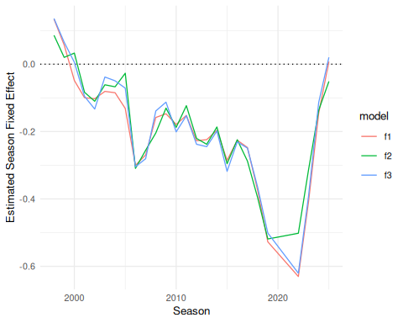
Figure 5: Estimated season-level fixed effects for natural logarithm of attendance models.
_{Source: Article Notebook}
Figure 6 shows a general increase in the slope of the interaction terms in all three models in recent years. For all three models, these change in slope coefficients were decidedly negative until around 2015. This suggests that the relationship between attendance and fan engagement was more moderate during those years. (Note that for all three models, the main effect of the fan engagement term in Table 3 is positive.) While the change in slope associated with model $f_{1}$ is still negative, it is closer to zero than it has been in the past. The changes in slope associated with models $f_{2}$ and $f_{3}$ are now positive, although it is difficult to assess the long-term trend due to the pandemic being only a few years past.
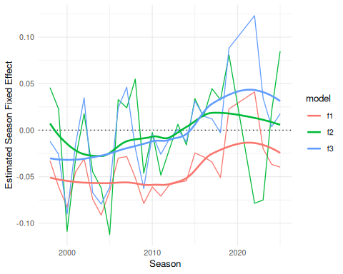
Figure 6: Estimated season-level changes in slopes for natural logarithm of attendance models.
_{Source: Article Notebook}

4.2 Percentage of Arena Capacity
Because our response variable $γ$ is constrained between 0 and 1, but has significant mass at 1 exactly, we fit a Papke-Wooldridge fractional response model (Papke and Wooldridge 1996) with HC1 sandwich estimators for the covariance matrix.
_{Source: Article Notebook}
Table 6 reports the coefficients from the percentage of arena capacity models.
Table 6: Table of coefficients from percentage of arena capacity models.
model | term | estimate | std.error | statistic | p.value
f1 | (Intercept) | 0.0420351 | 0.3060837 | 0.1373320 | 0.8907684
f1 | I(elo.A + elo.B - 3000) | 0.0053038 | 0.0012483 | 4.2489239 | 0.0000215
f1 | median_income | 0.0192855 | 0.0046684 | 4.1310605 | 0.0000361
f1 | median_pop | -0.0975090 | 0.0147117 | -6.6279729 | 0.0000000
f1 | is_cc | 2.8268291 | 0.2623045 | 10.7768979 | 0.0000000
f2 | (Intercept) | 0.3066991 | 0.3737256 | 0.8206531 | 0.4118439
f2 | I(abs(elo.A - elo.B)) | -0.0012487 | 0.0029263 | -0.4267265 | 0.6695786
f2 | median_income | 0.0164644 | 0.0046623 | 3.5314191 | 0.0004133
f2 | median_pop | -0.0948250 | 0.0144747 | -6.5511069 | 0.0000000
f2 | is_cc | 2.9022797 | 0.2595776 | 11.1807804 | 0.0000000
f3 | (Intercept) | 0.0502670 | 0.3202932 | 0.1569407 | 0.8752916
f3 | I(home_win_prob - 0.5) | 2.3584200 | 0.8986874 | 2.6242941 | 0.0086829
f3 | median_income | 0.0179402 | 0.0047330 | 3.7904230 | 0.0001504
f3 | median_pop | -0.1017634 | 0.0149716 | -6.7970886 | 0.0000000
f3 | is_cc | 2.8717453 | 0.2611669 | 10.9958230 | 0.0000000

_{Source: Article Notebook}
Table 7 shows the model fit metrics for the percentage of arena capacity models.
Table 7: Comparison of percentage of arena capacity models.
model | null.deviance | df.null | logLik | AIC | BIC | deviance | df.residual | nobs
f1 | 916.6665 | 5062 | -2973.023 | 6104.046 | 6619.894 | 559.5177 | 4984 | 5063
f2 | 916.6665 | 5062 | -2999.275 | 6156.550 | 6672.398 | 574.1421 | 4984 | 5063
f3 | 916.6665 | 5062 | -2986.255 | 6130.510 | 6646.358 | 564.3610 | 4984 | 5063

_{Source: Article Notebook}
Table 8 shows the analysis of variance for the percentage of arena capacity models.
Table 8: Analysis of variance for terms in models for percentage of arena capacity.
Model | Term | Df | Deviance | Df Residual | Residual Deviance | P Value
f2 | I(abs(elo.A - elo.B)) | 1 | 0.032 | 5061 | 916.634 | 0.858
f1 | I(elo.A + elo.B - 3000) | 1 | 8.035 | 5061 | 908.631 | 0.005
f3 | I(home_win_prob - 0.5) | 1 | 0.906 | 5061 | 915.760 | 0.341
f1 | is_cc | 1 | 24.002 | 5010 | 573.411 | 0.000
f2 | is_cc | 1 | 23.389 | 5010 | 581.441 | 0.000
f3 | is_cc | 1 | 22.520 | 5010 | 579.403 | 0.000
f1 | median_income | 1 | 0.977 | 5012 | 601.451 | 0.323
f2 | median_income | 1 | 1.038 | 5012 | 608.706 | 0.308
f3 | median_income | 1 | 0.972 | 5012 | 606.342 | 0.324
f1 | median_pop | 1 | 4.038 | 5011 | 597.414 | 0.044
f2 | median_pop | 1 | 3.876 | 5011 | 604.830 | 0.049
f3 | median_pop | 1 | 4.419 | 5011 | 601.923 | 0.036
f1 | factor(month(game_date)) | 4 | 13.370 | 5025 | 696.118 | 0.010
f2 | factor(month(game_date)) | 4 | 13.218 | 5025 | 706.988 | 0.010
f3 | factor(month(game_date)) | 4 | 12.953 | 5025 | 701.429 | 0.012
f1 | factor(wday(game_date)) | 6 | 18.624 | 5029 | 709.487 | 0.005
f2 | factor(wday(game_date)) | 6 | 18.719 | 5029 | 720.205 | 0.005
f3 | factor(wday(game_date)) | 6 | 19.034 | 5029 | 714.381 | 0.004
f1 | name_current | 12 | 93.689 | 5013 | 602.429 | 0.000
f2 | name_current | 12 | 97.243 | 5013 | 609.745 | 0.000
f3 | name_current | 12 | 94.115 | 5013 | 607.314 | 0.000
f2 | I(abs(elo.A - elo.B)):factor(season_id) | 26 | 7.299 | 4984 | 574.142 | 1.000
f1 | I(elo.A + elo.B - 3000):factor(season_id) | 26 | 13.894 | 4984 | 559.518 | 0.974
f3 | I(home_win_prob - 0.5):factor(season_id) | 26 | 15.042 | 4984 | 564.361 | 0.957
f1 | factor(season_id) | 26 | 180.519 | 5035 | 728.112 | 0.000
f2 | factor(season_id) | 26 | 177.710 | 5035 | 738.924 | 0.000
f3 | factor(season_id) | 26 | 182.345 | 5035 | 733.416 | 0.000

_{Source: Article Notebook}
Figure 7 shows that…
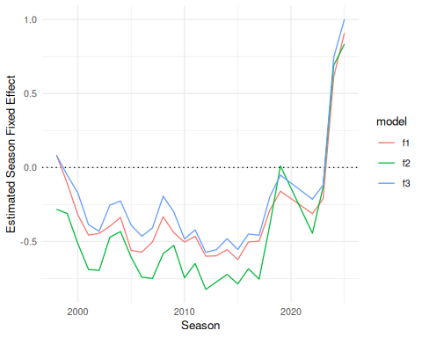
Figure 7: Estimated season-level fixed effects for percentage of arena capacity models.
_{Source: Article Notebook}
Figure 8 shows that…
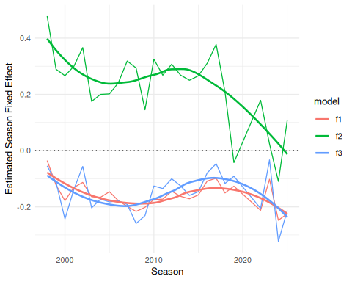
Figure 8: Estimated season-level changes in slopes for percentage of arena capacity models.
_{Source: Article Notebook}

5 Conclusion

5.1 Limitations
Because the percentage of arena capacity data is right-censored, we considered a Tobit regression model (McDonald and Moffitt 1980), but our residuals violated the normality and homoskedasticity conditions. We also considered fitting a Beta regression model with a logit link function, and converting the fixed effects for seasons to random effects, but those models didn’t converge.

5.2 Future work

5.3 Discussion

References
Across the Timeline. n.d. WNBA Attendance — Across the Timeline. Across the Timeline; https://www.acrossthetimeline.com/wnba/attendance.html. https://www.acrossthetimeline.com/wnba/attendance.html.
Agha, Nola, and David Berri. 2023. “Demand for Basketball: A Comparison of the WNBA and NBA.” International Journal of Sport Finance 18 (1): 35–44. https://doi.org/10.32731/IJSF/181.022023.03.
Baade, Robert A, and Laura J Tiehen. 1990. “An Analysis of Major League Baseball Attendance, 1969-1987.” Journal of Sport and Social Issues 14 (1): 14–32. https://doi.org/10.1177/019372359001400102.
Clapp, Christopher M, and Jahn K Hakes. 2005. “How Long a Honeymoon? The Effect of New Stadiums on Attendance in Major League Baseball.” Journal of Sports Economics 6 (3): 237–63. https://doi.org/10.1177/1527002504265957.
Coates, Dennis, Brad R. Humphreys, and Li Zhou. 2014. “Reference-Dependent Preferences, Loss Aversion, and Live Game Attendance.” Economic Inquiry 52 (3): 959–73. https://doi.org/10.1111/ecin.12061.
Davis, Michael C. 2008. “The Interaction Between Baseball Attendance and Winning Percentage: A VAR Analysis.” International Journal of Sport Finance 3 (1): 58–73. https://doi.org/10.1177/155862350800300105.
Davis, Michael C. 2009. “Analyzing the Relationship Between Team Success and MLB Attendance with GARCH Effects.” Journal of Sports Economics 10 (1): 44–58. https://doi.org/10.1177/1527002508327387.
Delia, Elizabeth B. 2020. “The Psychological Meaning of Team Among Fans of Women’s Sport.” Journal of Sport Management 34 (6): 579–90. https://doi.org/10.1123/jsm.2019-0404.
DeSchriver, Timothy D, and Paul E Jensen. 2002. “Determinants of Spectator Attendance at NCAA Division II Football Contests.” Journal of Sport Management 16 (4): 311–30. https://doi.org/10.1123/jsm.16.4.311.
Elo, A. E. 1978. The Rating of Chessplayers, Past and Present. New York: Arco Publishing.
Garcia, Christopher. 2020. “"Betting on Women": A Feminist Political Economic Critique of Ideological Sports Narratives Surrounding the WNBA.” The Political Economy of Communication 8 (1). https://polecom.org/index.php/polecom/article/view/119.
Gilani, Saiem, and Geoffery Hutchinson. 2021. “Wehoop: Access Women’s Basketball Play by Play Data.” In CRAN: Contributed Packages. The R Foundation. https://doi.org/10.32614/cran.package.wehoop.
Guest, Andrew M, and Anne Luijten. 2018. “Fan Culture and Motivation in the Context of Successful Women’s Professional Team Sports: A Mixed-Methods Case Study of Portland Thorns Fandom.” Sport in Society 21 (7): 1013–30. https://doi.org/10.1080/17430437.2017.1346620.
Hall, Stephen, Stefan Szymanski, and Andrew S Zimbalist. 2002. “Testing Causality Between Team Performance and Payroll: The Cases of Major League Baseball and English Soccer.” Journal of Sports Economics 3 (2): 149–68. https://doi.org/10.1177/152700250200300204.
Horowitz, Ira. 2007. “If You Play Well They Will Come-and Vice Versa: Bidirectional Causality in Major-League Baseball.” Managerial and Decision Economics 28 (2): 93–105. https://doi.org/10.1002/mde.1308.
Kim, Rhino, and Sue Ryung Chang. 2023. “Winning Back Attendance: Effects of Winning Performance, Online Search, and the MLB Rule Changes for More Dynamic Games.” Asia Marketing Journal 25 (3): 148–59. https://doi.org/10.53728/2765-6500.1616.
Lemke, Robert J, Matthew Leonard, and Kelebogile Tlhokwane. 2010. “Estimating Attendance at Major League Baseball Games for the 2007 Season.” Journal of Sports Economics 11 (3): 316–48. https://doi.org/10.1177/1527002509337212.
Leslie-Walker, Anika, and Claire Mulvenna. 2022. “The Football Association’s Women’s Super League and Female Soccer Fans: Fan Engagement and the Importance of Supporter Clubs.” Soccer & Society 23 (3): 314–27. https://doi.org/10.1080/14660970.2022.2037218.
McDonald, John F, and Robert A Moffitt. 1980. “The Uses of Tobit Analysis.” The Review of Economics and Statistics, 318–21. https://www.jstor.org/stable/1924766.
Noll, Roger G. 1974. Attendance and Price Setting. The Brookings Institution.
Papke, Leslie E, and Jeffrey M Wooldridge. 1996. “Econometric Methods for Fractional Response Variables with an Application to 401 (k) Plan Participation Rates.” Journal of Applied Econometrics 11 (6): 619–32. https://doi.org/10.1002/(SICI)1099-1255(199611)11:6<619::AID-JAE418>3.0.CO;2-1.
Paul, Rodney, Andrew Weinbach, and Nick Riccardi. 2019. “Attendance in the Canadian Hockey League: The Impact of Winning, Fighting, Uncertainty of Outcome, and Weather on Junior Hockey Attendance.” International Journal of Financial Studies 7 (1): 12. https://doi.org/10.3390/ijfs7010012.
Perline, Martin M., Jeffrey S. Noble, and G. Clayton Stoldt. 2018. “Competitive Balance in NCAA ‘Power Conferences:’ The Case of Men’s and Women’s Basketball.” The Sport Journal 21.
Vrooman, John. 2012. Theory of the Big Dance: The Playoff Pay-Off in Pro Sports Leagues. New York, NY: Oxford University Press.
Wasserstein, Ronald L, and Nicole A Lazar. 2016. “The ASA Statement on p-Values: Context, Process, and Purpose.” In The American Statistician, No. 2, vol. 70. Taylor & Francis. https://doi.org/10.1080/00031305.2016.1154108.
Wasserstein, Ronald L, Allen L Schirm, and Nicole A Lazar. 2019. “Moving to a World Beyond ‘p< 0.05’.” In The American Statistician, No. sup1, vol. 73. Taylor & Francis. https://doi.org/10.1080/00031305.2019.1583913.
Wiseman, Frederick, and Sangit Chatterjee. 2003. “Team Payroll and Team Performance in Major League Baseball: 1985–2002.” Economics Bulletin 1 (2): 1–10. https://accessecon.com/pubs/eb/2003/volume1/eb-03a10003a.pdf.
WNBA. 2024. “WNBA Delivers Record‑setting 2024 Season.” https://www.wnba.com/news/wnba-delivers-record-setting-2024-season.
Woltring, Mitchell T et al. 2018. “Attendance Still Matters in MLB: The Relationship with Winning Percentage.” The Sport Journal.

6 Appendix

6.1 Residual analysis of attendance models
$f1  NULL  $f2  NULL  $f3  NULL | 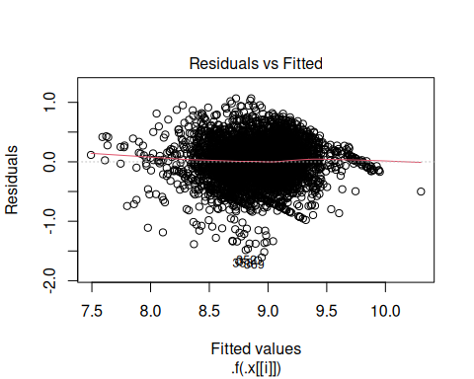  Figure 9: Residual plots for models.

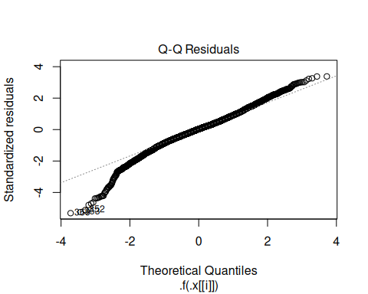  Figure 10: Residual plots for models. | 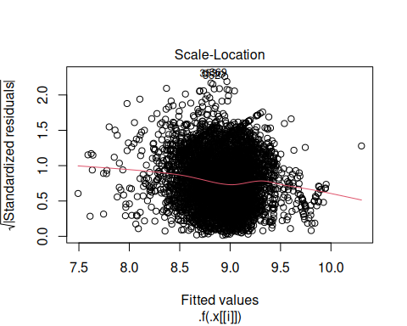  Figure 11: Residual plots for models.

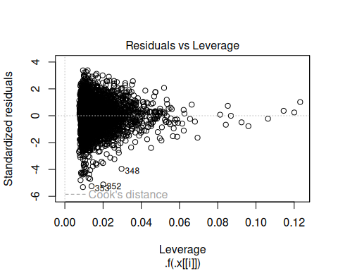  Figure 12: Residual plots for models. | 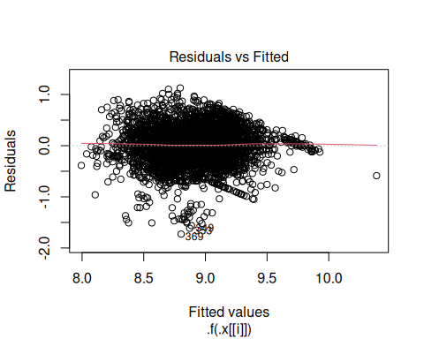  Figure 13: Residual plots for models.

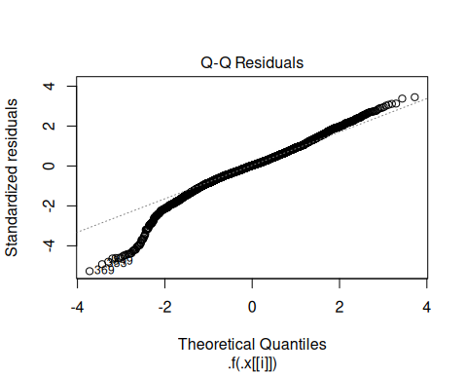  Figure 14: Residual plots for models. | 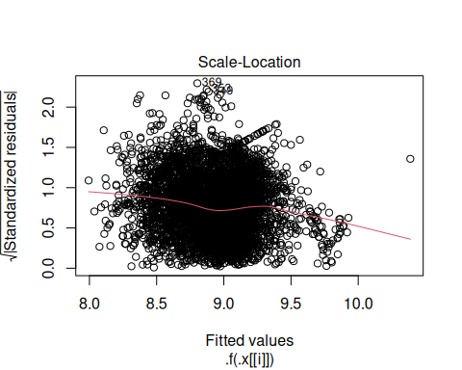  Figure 15: Residual plots for models.

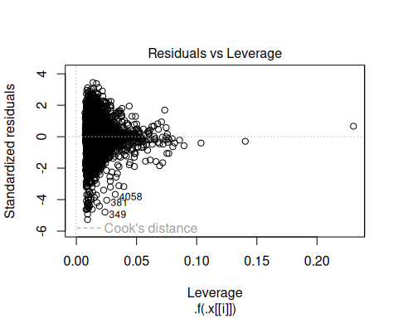  Figure 16: Residual plots for models. | 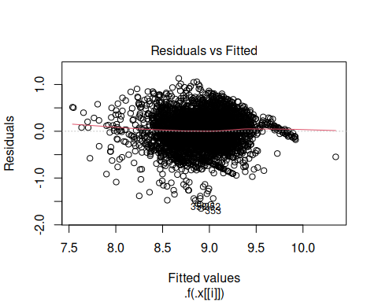  Figure 17: Residual plots for models.

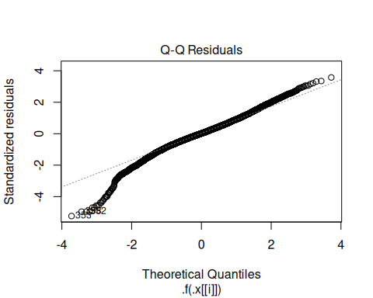  Figure 18: Residual plots for models. | 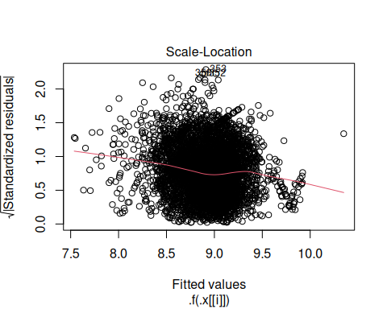  Figure 19: Residual plots for models.

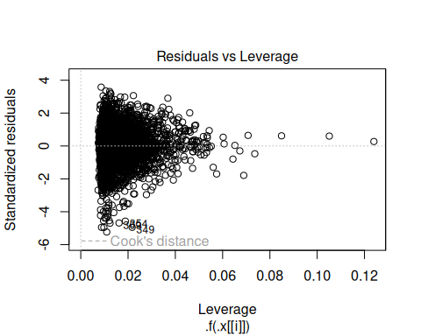  Figure 20: Residual plots for models. | _{Source: Article Notebook}

Note that, as in most sports leagues, there is always the possibility finagling with game attendance figures. The WNBA appears to give attendance counting instructions to teams that define attendance as turnstile count, plus season ticket sales, plus complimentary tickets and promotions. There is considerable for these factors to be manipulated, rendering the possibility of noise in the attendance figures we use.
We were only able to collect an estimate for the current arena capacity, which is not necessarily the same as the arena capacity on the day of the game.
Because the population and median income statistics were available at irregular time periods (due to the COVID-19 pandemic and other factors), we chose to use the median of the population and median income across all of the available years of data as a constant value. While this does mean that the growth in cities like Phoenix or Las Vegas is ignored, we doubt this will meaningfully affect our results, especially since the team fixed effect should capture some of that variability.

