Table Boot
I have a very unequal floor in my cellar so placing a table is always challing because it is dancing between the 4 legs.
So that’s why I created this compensation boot than can be applyed to one leg to make the table stable.
Compensation height: 13 mm
Size: 50 x 25

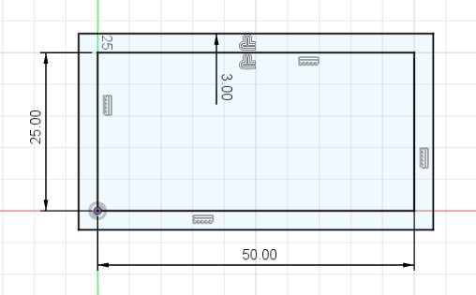

3D Descripton
I have extruded the shape 13 mm from the bottom and 10 mm in the top direction
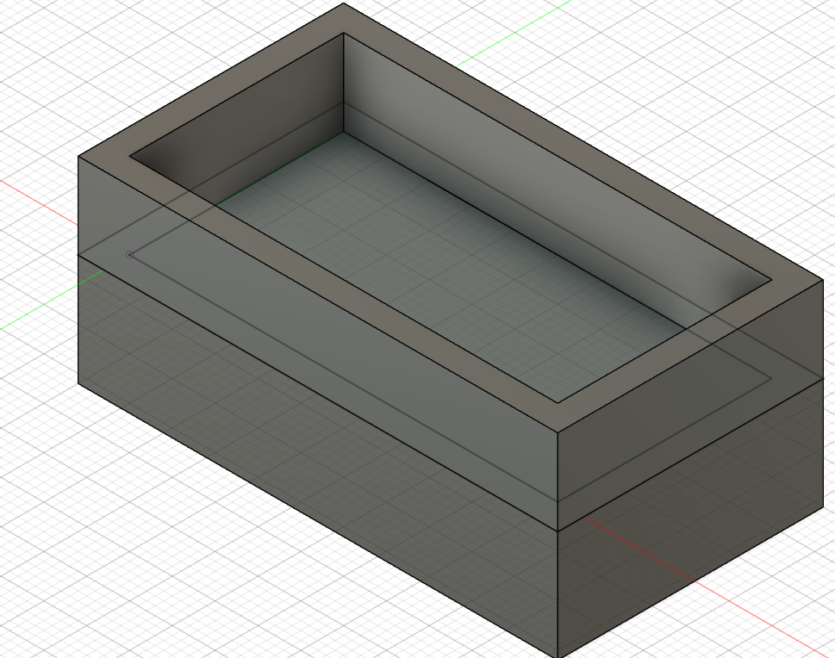

Table boot In use
