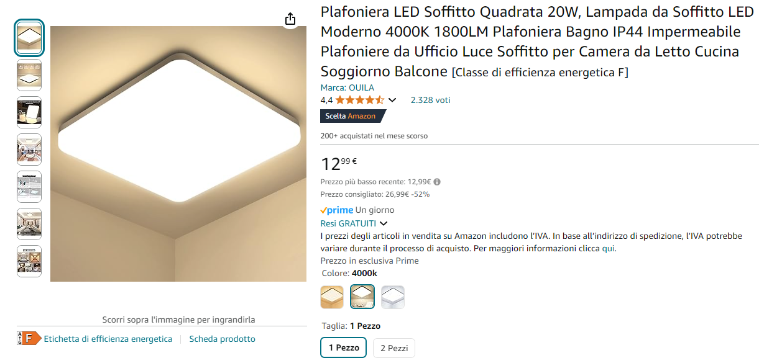

https://amzn.eu/d/2L3FwE9

