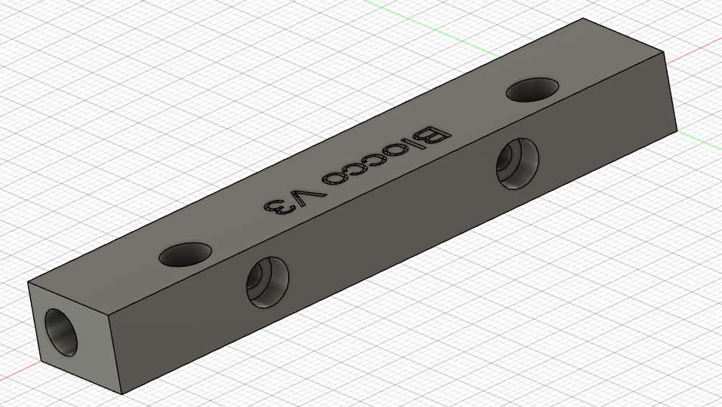

Kaiser Stand Bracket Side
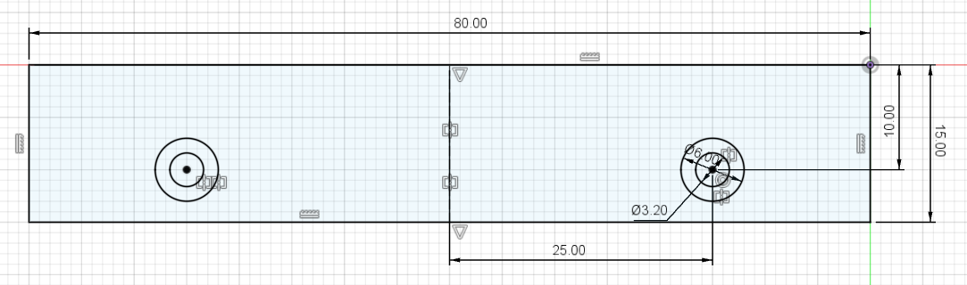

Plate side
