Ceiling Light

https://amzn.eu/d/hiAGEYF
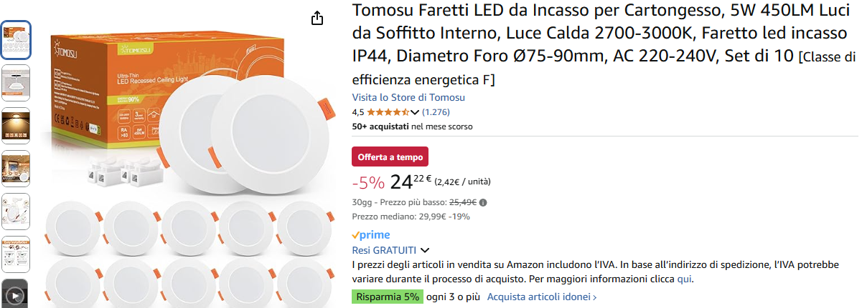

Size

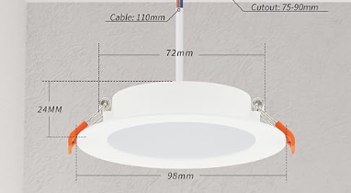

Diameter: 75 mm

