Test SLIC superpixel
The speed is really an issue
40 Seconds to process a f
[INFO]: Segmentation 10 Elapsed time 21204.5277 [ms]
[INFO]: Segmentation 100 Elapsed time 46735.102600000006 [ms]
[INFO]: Segmentation 200 Elapsed time 72269.78460000001 [ms]
[INFO]: Segmentation 300 Elapsed time 98268.2434 [ms]

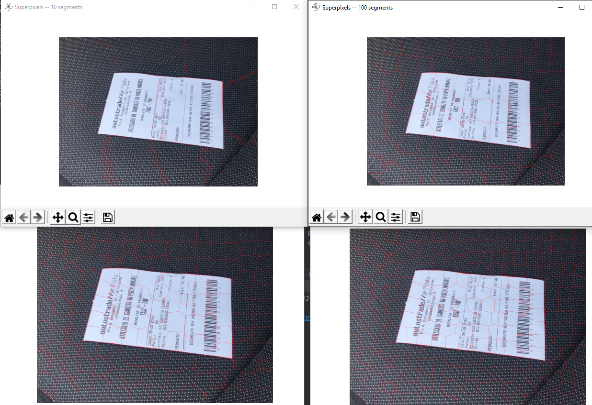

Hugh is not the way …

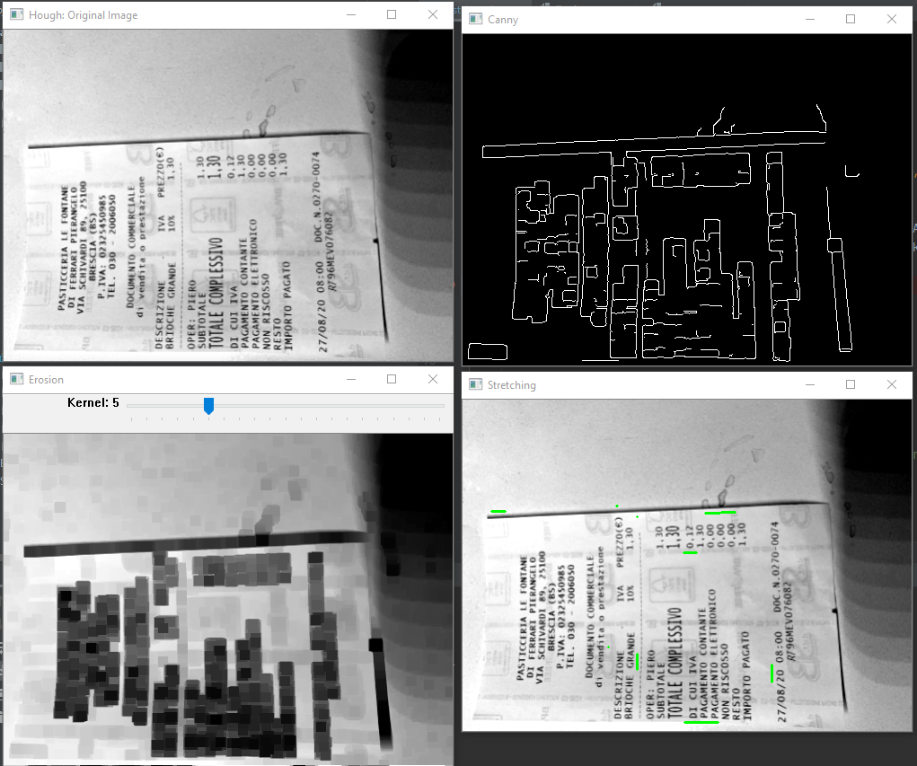

Auto text orientation
1. Use Hugh to rotate the lines in the correct way
2. How we can use the information that the text start from left?
We need a good binarization and then maybe a couple of tools taking care that there are more black pixels on one side. Examples:
- projection: interesting but try to average the signal
- vertical slicing and area counting: split the receipt in two side, the darker one (more black pixels) is the left
- Erosion and blob: should work for receipt because test on the left is bigger than numbers on the right
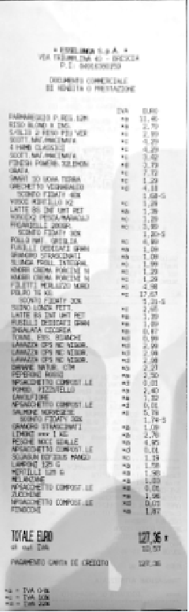

Skew correction using python
https://www.pyimagesearch.com/2017/02/20/text-skew-correction-opencv-python/
same as the other, just in python
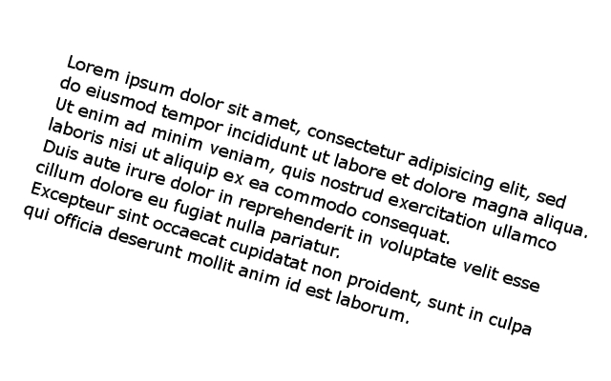
Detecting text orientation using Hough transform
http://felix.abecassis.me/2011/09/opencv-detect-skew-angle/

Here they use hough but the problem is that we don’t know if it is upsidedown

