Whitepaper: Intelligence-Led SIEM for Healthcare
Author: AI/ML Systems Engineer
Framework: Open-Source (Gradio, Scikit-Learn, KaggleHub)
Compliance Target: HIPAA Technical Safeguards

1. Abstract
As hospitals transition to fully digital environments, the attack surface has expanded to include Electronic Health Records (EHR) and Internet of Medical Things (IoMT) devices. Traditional SIEMs rely on static signatures that fail to detect novel "Zero-Day" threats. This paper introduces an AI-Driven SIEM prototype that utilizes Unsupervised Machine Learning (Isolation Forests) to identify behavioral anomalies in real-time, coupled with an Explainable AI (XAI) layer to provide clinical staff with natural language security reports.

2. System Architecture & Component Mapping
The system is built on a modular five-layer architecture to ensure data integrity and operational reliability.
Block-by-Block Specification
- Data Ingestion Layer: Uses kagglehub to programmatically pull healthcare-specific telemetry. It handles multi-source streams including EHR audit logs, network traffic, and device heartbeats.
- Pre-Processing & Anonymization: A critical HIPAA-compliance gate. This block performs PII Scrubbing (removing identifiers) and feature scaling before the data enters the ML pipeline.
- ML Detection Engine: Powered by the Isolation Forest algorithm. Unlike supervised models, this does not require labelled "attack" data; it identifies threats by calculating the "susceptibility to isolation" of each log entry.
- XAI (Explainable AI) Layer: Translates high-dimensional mathematical anomalies into Feature Attribution. It identifies the "Why" behind the "What" (e.g., "Alert triggered by 4:00 AM access time").
- UI/Action Layer: A Gradio-based dashboard that provides dual views: a technical heatmap for IT and a Natural Language Report for medical staff.
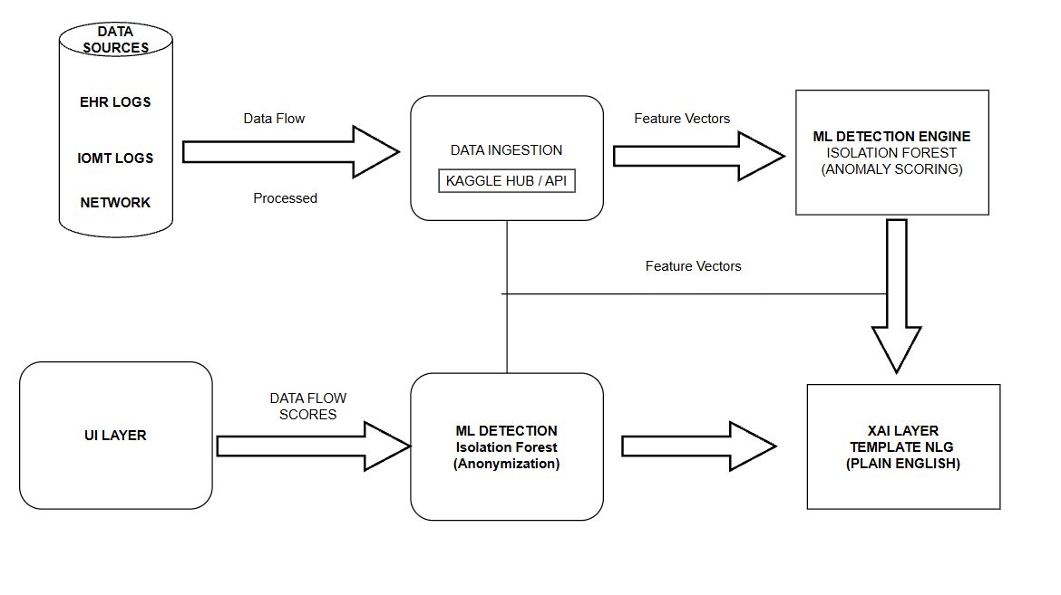
Figure 1: INTELLIGENT SIEM

3. The Detection Methodology
The core engine treats security as a geometry problem. In a high-dimensional space where features like data_volume and access_frequency are axes, normal behavior forms a dense cluster.
- Isolation Forest Equation: The anomaly score $s(x, n)$ is calculated as:
$$s(x, n) = 2^{-\frac{E(h(x))}{c(n)}}$$
Where $h(x)$ is the path length to isolate a point. Shorter paths indicate anomalies.
- Contamination Parameter: Set at $3\%$, ensuring the system ignores minor "noise" while flagging significant deviations like brute-force attacks or massive data exfiltration.

4. Clinical Use Cases
- EHR Snooping: Detection of a staff member accessing a high-volume of records outside of their shift hours.
- IoMT Hijacking: Identifying a life-support device (e.g., infusion pump) communicating with a foreign IP address or sending non-standard packet sizes.
- Ransomware Prevention: Early detection of rapid file-system changes or unusual encryption-like entropy in data logs.

5. Staff-Centric Reporting (XAI)
To solve "Alert Fatigue," the SIEM includes a Template-based Natural Language Generator. This converts technical outliers into actionable intelligence:
“🚩 ALARM: User Admin_01 flagged due to 25 failed login attempts within 1 minute. Potential brute-force attack in progress.”

6. Deployment & Future Roadmap
The prototype is designed for deployment on Hugging Face Spaces, ensuring it is open-source and accessible for stakeholder review.
- Phase 1: Unsupervised anomaly detection (Current).
- Phase 2: Integration of a Human-in-the-Loop (HITL) feedback system to retrain the model on false positives.
- Phase 3: Integration with HL7/FHIR standards for native medical data compatibility.

