Name: Ngari Kelvin Gauki.
Reg No: P15/30614/2015.
Introduction.
Have implemented three deferents codes namely perceptron , Adaline and Q learning. I have used python programming language the implement all the codes. To start with perceptron, I have created a Class called perceptron(): and only one function called getPerceptron() where all the computation of the new weights is undertaken. The perceptron code stop/terminate to execute when the error becomes constants ( the error do not change ). Secondly, Adaline code works similar to perceptron though the different occurs in the output of the both codes. Adaline give any number as the output while perceptron output ranges from 0 (zero) to 1 (one). Lastly, in Q learning code have created a class called Qlearning() , then have created different functions , like def episode() which determines randomly which room one starts with (current room) and the room to go until someone gets to the goals room which is F in our situation ( F the targeted , solution or goal room ). after every episode the code (when the goal is reached which is room f) prints end of episode. The code also ask the user to enter the room he needs to see the path of(from the room you are at, where you need the code to show you the path from that current room to the goal room. Example when you enter room, the program will print A-E-F, which is the path from A to F). the code loops hundred times till it terminate. The algorithm of three codes appear below:
Q LEARNING ALGORITHM.
Step 0. start.
Step 1. From random have imported randint to randomize rooms.
Step 2. Created class Qlearning():.
Step 3. declared and initialized the following variables and arrays.
Step 4. assign the first array zeros (0).
step 4. assign the second array R values (100 and 0)
step 5. print the two arrays Q and R.
step 6. create function episode(): that select any room randomly and decide the right path to goal room.
Step 7. first get the current room ( the room you are at the moment).
Step 8. get the rooms that you can access at the current room (where you are).
Step 9. randomly select any other room from the rooms which you can access while at the current room.
Step 10. repeat the process 9 until you get to the goal room. Keep track of all rooms you have visited so as to be able to generates paths from different room to goal room.
Step 11. ask the user to enter the path he/she wants the code to generate (example A).
Step 12. print the path from the room the user has typed to the goal room (example A-E-F).
step 13. terminate

Code screen shots (real code is attached in the zipped file qlearning.py).
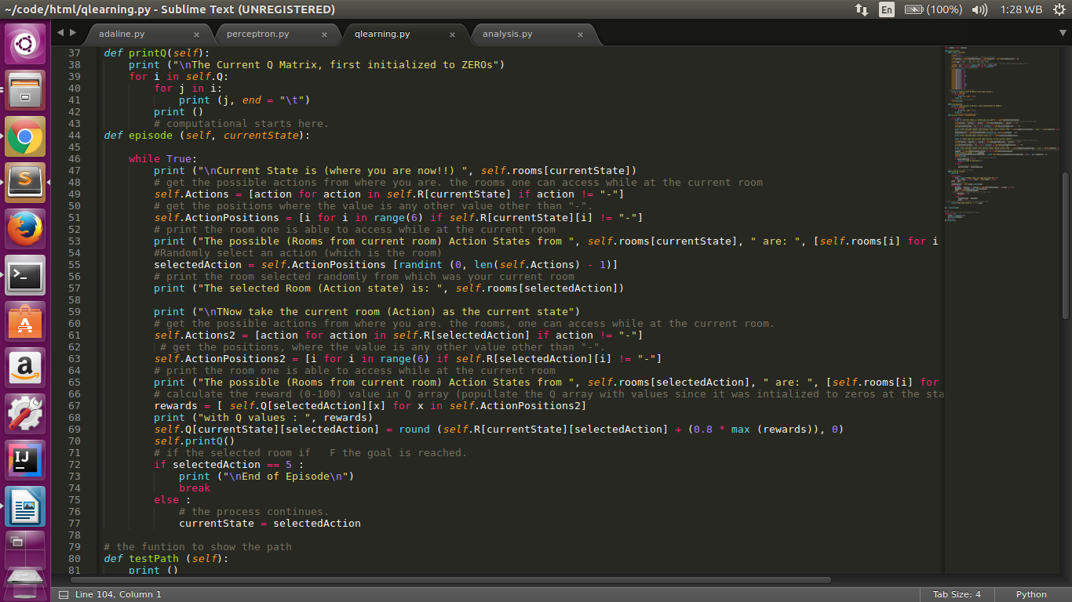

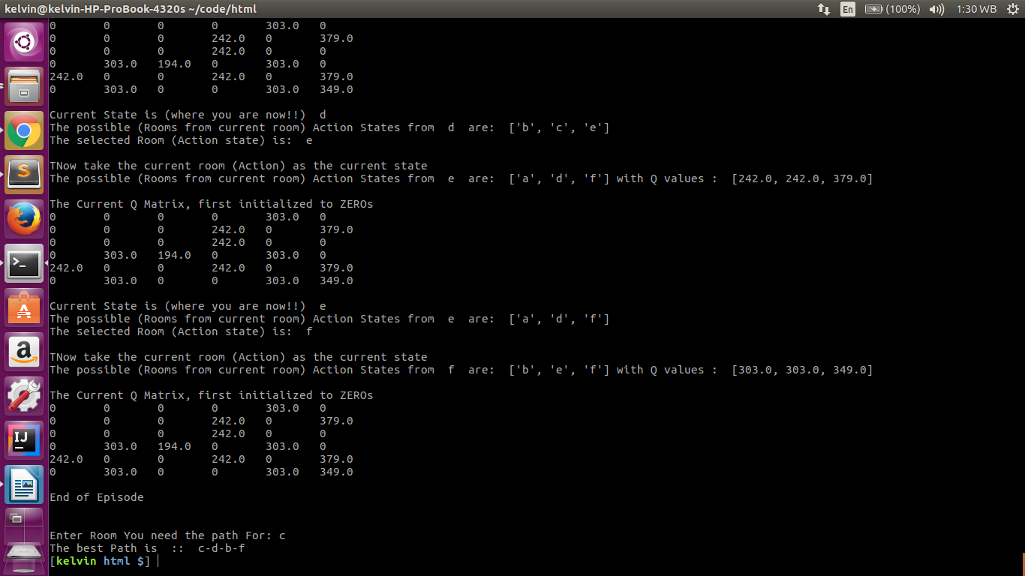
screen shot for the result.

PERCEPTRON ALGORITHM.
Step 1. start.
Step 2. create a class.
Step 3. declare and initialize variables and arrays.
Step 3. create function getPerceptron(): that computes the new weights.
Step 4. multiply each initial weight with the sensor values.
Step 5. sum all the product and store the to variable SUM (S).
step 6. round off the results (sum) to one decimal point.
Step 7. given the threshold which is constant 1, use if loop to compare it with sum, if sum is greater than threshold(t) return 1 else return 0.
step 8. store the value into the network (n).
step 9. calculate the error where you take the desired output minus the network (n).
step 10. correct the error (d) by multiplying learning rate(r) with error (e).
step 11. calculate the new weights.
Step 12. make the new weights the initial weights to the next loop.
Step 13. repeat step 12 until there is no change in error.
Step 14. terminate.
Code screen shots (real code is attached in the zipped file perceptron.py).
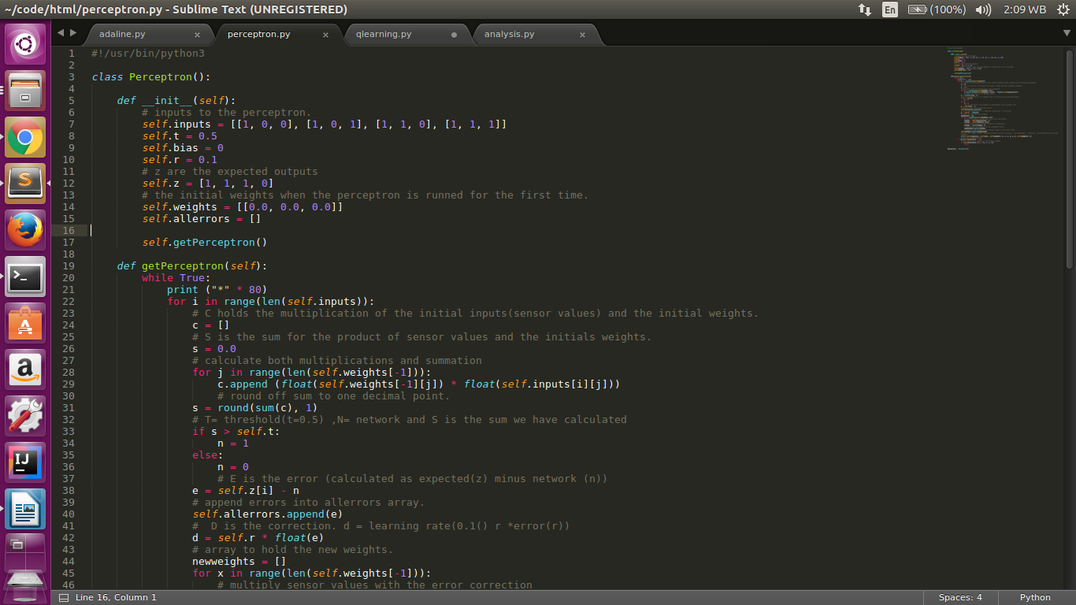

screen shot for the result.
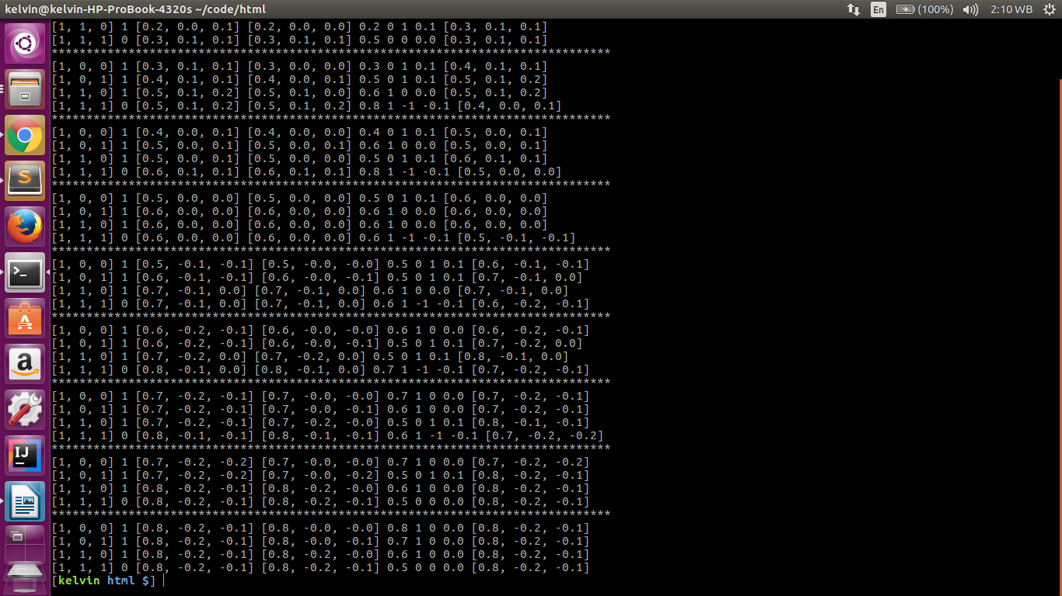
ADALINE ALGORITHM.
Step 1. start.
Step 2. import random.
Step 3. declare and initialize the variables to be used.
Step 4. the variable synapses is initialized with random values.
Step 5. calculate the output.
Step 6. calculate the error.
Step 7. update the synapses values.
Step 8. print the titles itemset , error and synapses.
Step 9 print the values of the titles which are itemset , error and synapses.
Step 10. calculate the average error.
Step 11. print the synapses and average error.
Step 12. terminate.
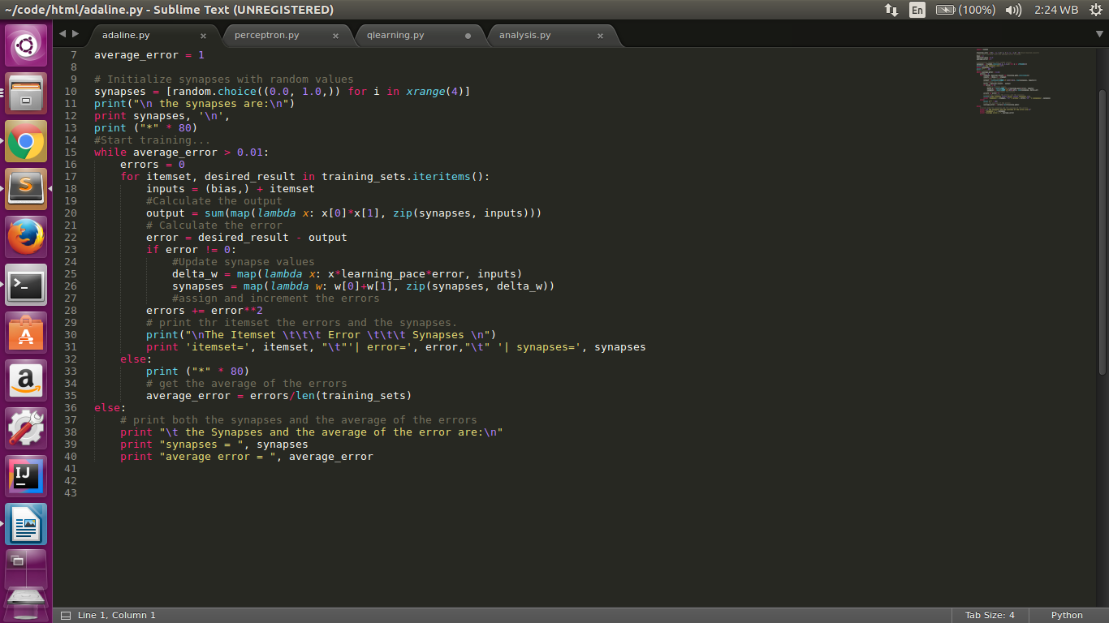
Code screen shots (real code is attached in the zipped file Adaline.py).

screen shot for the result.
