1.读入文件“01.plot.txt”，第一列为基因功能类别，之后四列为各功能类在G1，S，G2，M时期表达值，绘制折现图，并输出pdf图形文件。要求：显示图例，y轴名称，x轴名称（任意名或参考示例）。
程序：
data=read.table("D:/诺禾致源/R/01.plot.txt",sep="\t",header=T)
jpeg("D:/诺禾致源/R/01.plot.jpeg")
x=c(1:dim(data)[1])
y=data[,2]
plot(x,y,type="b",pch=18,col="black",xaxt="n",ylim=c(-1,1),ylab="EXPRESSION",xlab="SORT",cex=1.5)
axis(1,at=(1:19),labels=c("A","B","C","D","E","F","G","H","I","J","K","L","O","P","Q","R","T","U","Z"))
y=data[,3]
lines(y~x,type="b",pch=18,col="blue",cex=1.5)
y=data[,4]
lines(y~x,type="b",pch=18,col="red",cex=1.5)
y=data[,5]
lines(y~x,type="b",pch=18,col="green",cex=1.5)
legend("topright",inset=.05,c("G1表达均值","S表达均值","G2表达均值","M表达均值"),col=c("black","blue","red","green"),lty=1,pch=18)
dev.off()
图形示例：
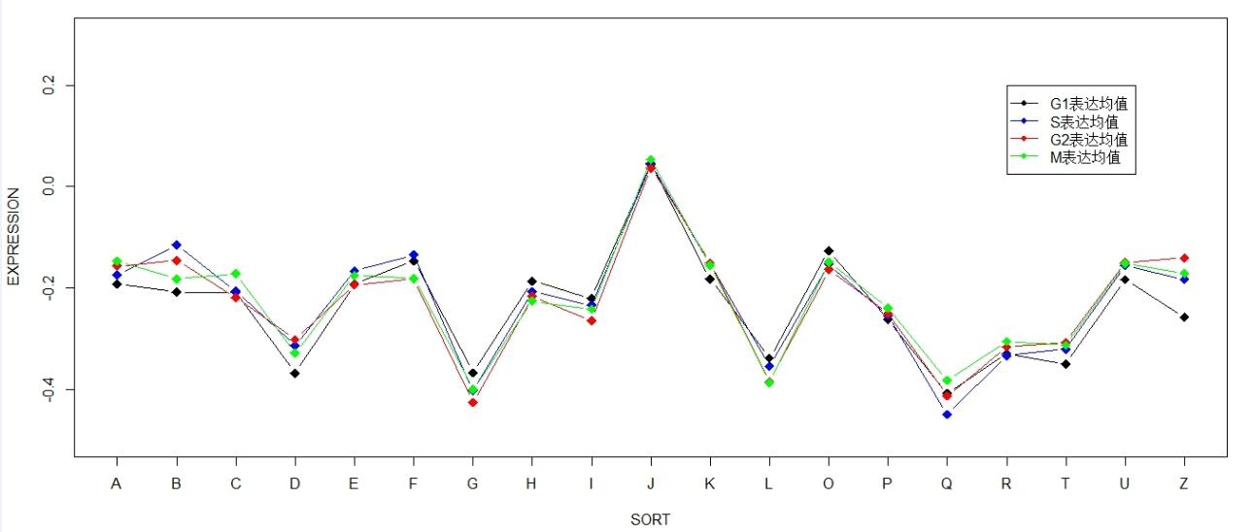

5.读入文件“02.plot.txt”， 弗吉尼亚各年龄段死亡率数据条形图，并输出pdf图形文件。要求：显示标题，y轴名称，x轴名称（任意名或参考示例）。
程序：
data=read.table("D:/诺禾致源/R/02.plot.txt",sep="\t",header=T)
pdf("D:/诺禾致源/R/02.plot.pdf")
data=data[,2:6]
GSE <- as.matrix(data)
name=c("70-74","65-69","60-64","55-59","50-54")
colnames(GSE)=name
barplot(GSE,beside=T,col=c(2:6))
legend("topright",inset=.05,c("Rural Male","Rural Female","Urban Male","Urban Female"),col=c("black","blue","red","green"),lty=1,pch=18)
dev.off()
图形示例：
