Information for setting up SDRuHRD

Background:
In 2015 I purchased an RTL dongle and converter for my first experience with Software Defined Radio. Several software packages were available, SDR Sharp and HDSDR among them. I liked HDSDR best as it was compact and it controlled my radio thru its DDE conection to Ham Radio Deluxe (HRD).
When I saw the ad for SDRPlay’s RSP1, I decided to try one as a step up from the RTL dongle. The RSP1 worked great and I was really happy with it running with HDSDR. When SDRPlay came out with SDRuno, I tried it, but the early releases were not as good as HDSDR, and SDRuno couldn't control my radio thru HRD (or any other way).
In early 2020 I saw SDRuno now had a way to connect to my radio and HRD. I tested recent versions of SDRuno and I could see it had evolved into really outstanding SDR software. Now, with a way to connect HRD, it really answered all my objections.
I followed SDRuno’s instructions for the HRD interface. It worked OK, but now I couldn’t control anything on my radio except frequency and mode.
I had been using HRD to control nearly everything on my radio. I liked using the mouse and directly changing radio settings. Navigating thru numerous menus on my radio was a pain, I didn’t like having to give up my HRD radio control.

Solution:
I decided to try writing my own solution to get the best of both: SDRuno and HRD with full HDR control of my radio. SDRuHRD is the result.
SDRuHRD connects to SDRuno thru the CAT RX settings (SDRuno: RXCONTROL / SETT. / CAT (see the port setup drawing Fig. 1 COM10/COM11).
It also connects to HRD thru the HRD 3rd-party Serial Port (HRD: Tools/Hardware/3rd-party Serial Port (see Fig. 1 COM12/COM13).
HRD connects to my radio in the conventional manner thru COM5 (Fig. 1)
SDRuHRD polls SDRuno to see if there is any change in SDRuno status since the last poll. If nothing has changed, it polls HRD to see if there is any change in HRD status since the last poll.
If either has changed, SDRuHRD sends the changed status to the other, then waits until the status is updated before polling again. If no status changes have occurred, SDRuHRD waits a nominal 200ms, then polls again.
You will need to setup two virtual serial port pairs, in the same way you would setup one pair in the SDRuno to HDR (See: https://www.sdrplay.com/docs/HRDandSDRuno.pdf)
NOTE: SDRuHRD V1.0.1.1 has been tested with the last free version of HRD (5.24.0.36), and the latest version of HRD (6.7.0.301 released 2020-08-03)

Setup:

Assuming you have already installed HRD and SDRuno and your radio is connected to HRD:
- Create two Virtual Loop Back port pairs, one pair for the HRO 3rd-party Serial Port to SDRuHRD connection (like COM12-COM13 Fig. 1), and the other pair for the SDRuHRD to SDRuno connection (like COM10-COM11 Fig. 1) Use Device Manager to find unused space for the port pairs. After you create them, you should be able to see the new ports in Device Manager. I found it helped me to make a list of intended port connections as a reference for the next steps.
- In HRD, go to Menu: “Tools/Hardware/3rd-party Serial Port”. Select the port that you setup for HRD in step 1. Set the baud rate to 57600. Set Mode to “Default” or “None”. Check “Enable” and “Connect when Ham Radio Deluxe starts”. You should see “Status: … Connected” at the bottom of the dialog.
(NOTE: the Baud rate really serves no purpose for Virtual Serial Ports as long as you don’t select “Enable strict baud rate emulation”. The baud rate in SDRuHRD is hard coded at 57600.)
- In SDRuno, in the title bar of the “SDRuno rx control” window click on Sett. In the “RX Settings” dialog that appears, click on “CAT”. In the CAT window select your Port, 57600 Baud rate, RX Mode Control, and Enable and Connect. You should see “STATUS: CONNECTED” at the bottom of the dialog.
- Start SDRuHRD, and select the paired COM ports for HRD and SDRuno. After a few seconds, the Port combo boxes should gray out and you should see something like “IF00014325000 +00000000002000000 “ in the “Last Rcvd” textboxes. You should now be able to change frequency and/or mode in either program and the other should follow.
Note:
- There is no way that HRD can change the “LO” value in SDRuno, so you won’t be able to change bands in HRD and have SDRuno follow. SDRuno just ignores the band change. You will need to manually select the correct band in the SDRuno VRX, then you will be able to have SDRuno follow your changes from HRD (or your connected radio). Going the other way, my radio (an Icom 7100) will follow band changes made in SDRuno.
- The Com port settings are stored in the registry at: HKEY_CURRENT_USER\Software\AF5LA\SDRuHDR
- There is a start menu shortcut to “Reset Default Com Ports” script that will clear the com port settings.
Issues:
- If you change frequencies faster than SDRuHRD can update, you might run into a situation where it updates and then rolls back to a previous value. I have also seen an oscillatory condition where it continues to change back and forth between the last two frequencies. This is likely to occur if I slowly turn the tuning knob on my radio.
George AF5LA
73
10/28/2020

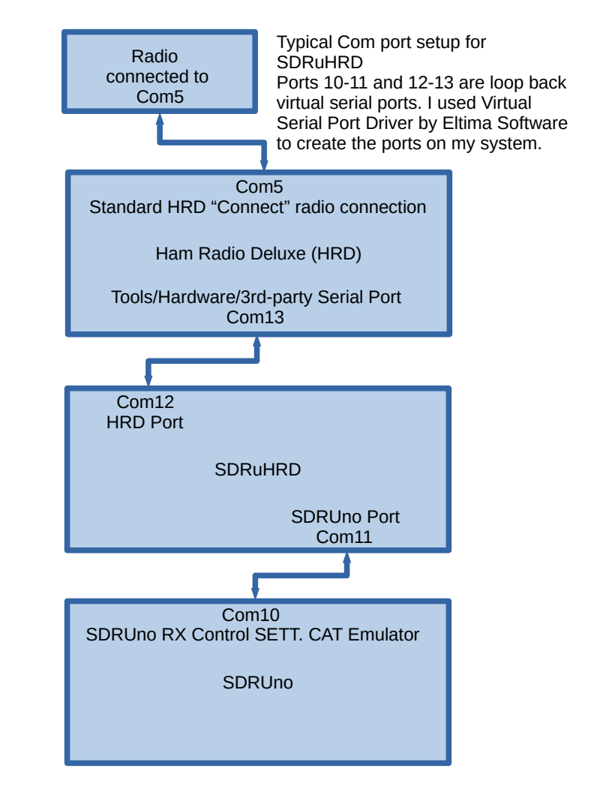Fig. 1 Typical Port Setup for SDRuHRD

