**Class:** Final Year (Computer Science and Engineering)

**Year:** 2021-22 **Semester:** 1

**Course:** High Performance Computing Lab

**Practical No. 3**

**Exam Seat No: 2018BTECS00033**

1. 2018BTECS00033- Mahendra Bhimrao Gharge

**Problem Statement 1:**

1. **Estimation of value of PI using OpenMP**
2. **Matrix Vector multiplication using OpenMP**
3. **Matrix Matrix addition using OpenMP**

**Screenshot 1:**

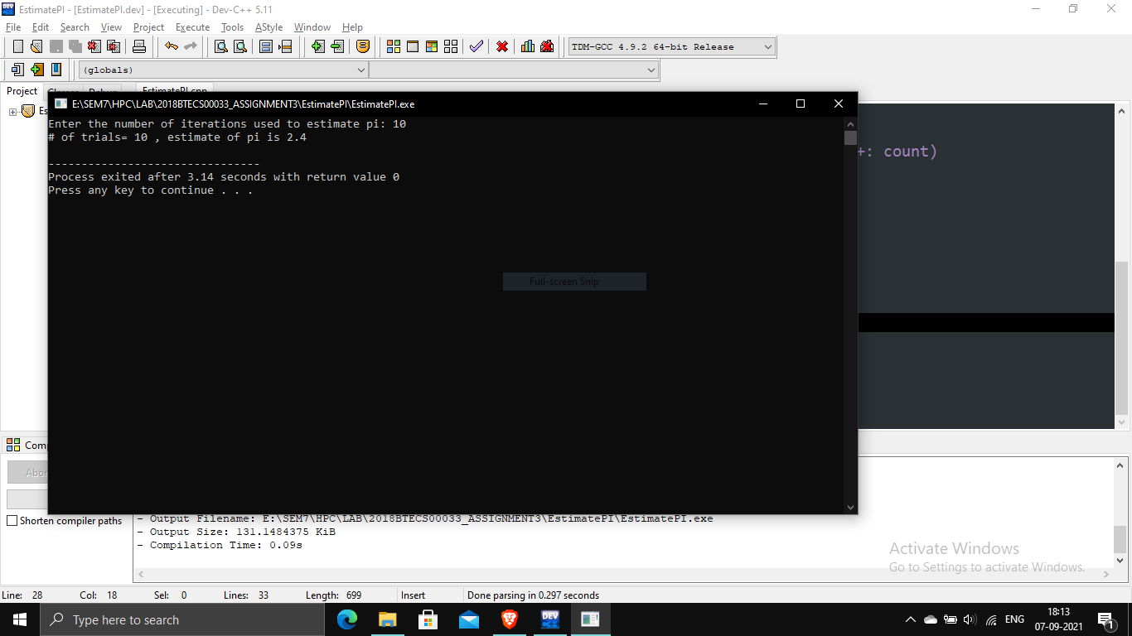

**Information 1: Calculated the PI using 10 iterations as was found to be 2.4**

**Screenshot 2:**

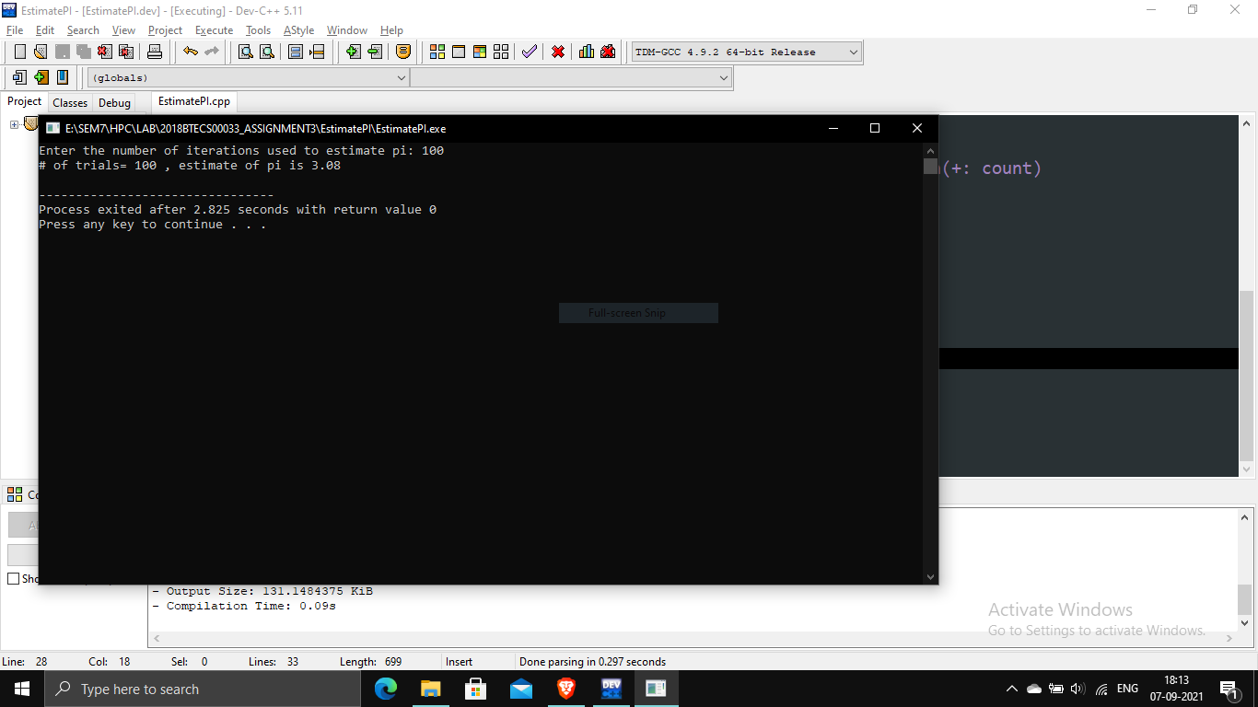

**Information 2: Calculated the PI using 100 iterations as was found to be 3.08**

**Screenshot 3:**

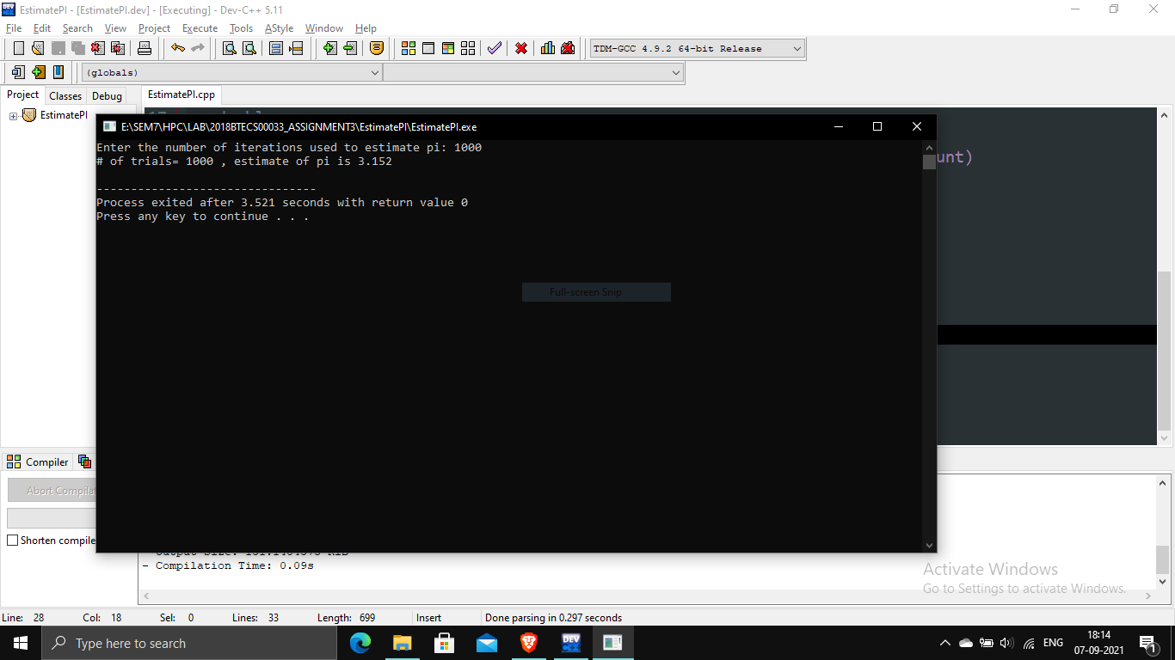

**Information 3: Calculated the PI using 1000 iterations as was found to be 3.15**

**Screenshot 4:**

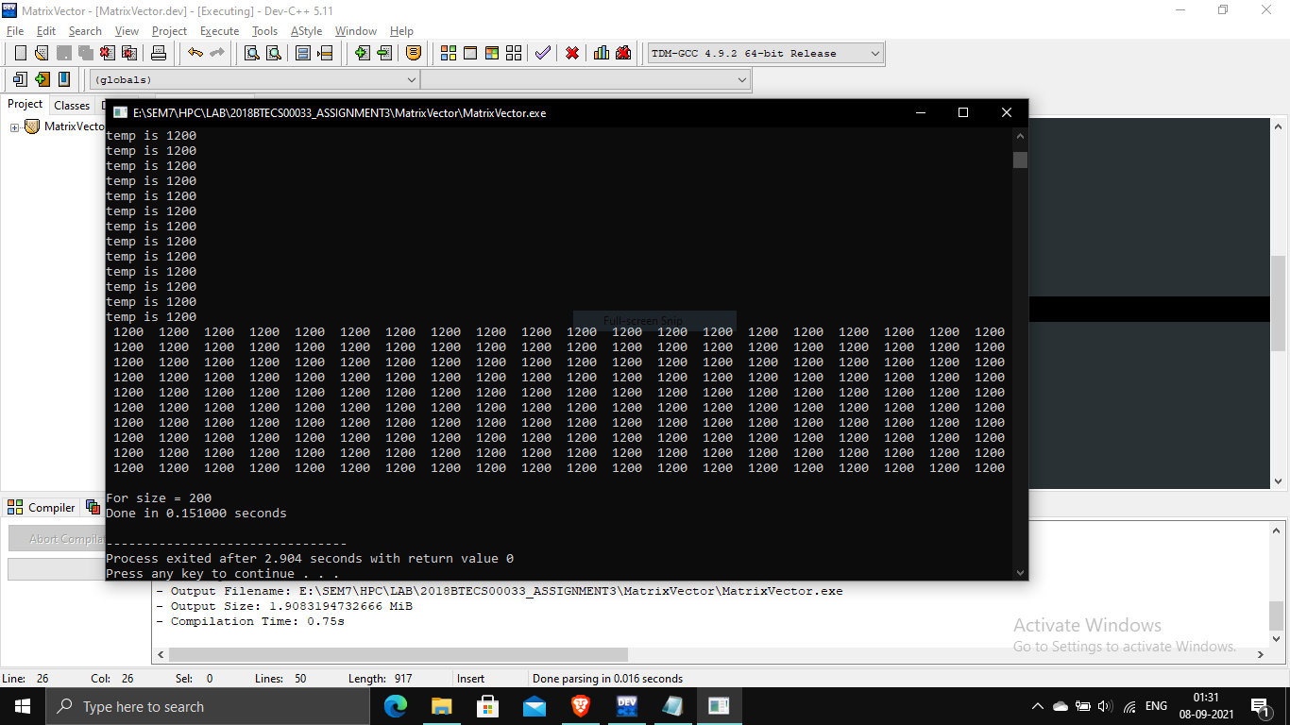

**Information 4 Calculated matrix vector multiplication using 200 as size and 1 thread**

**Screenshot 5:**

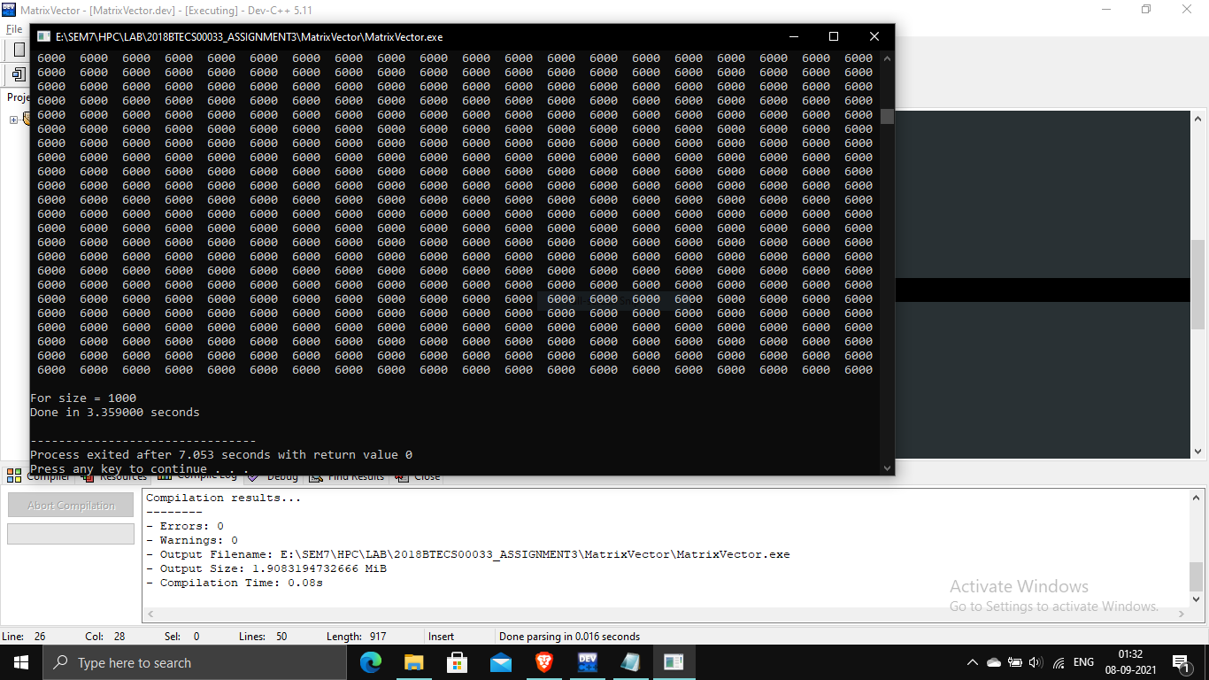

**Information 5 Calculated matrix vector multiplication using 1000 as size and 1 thread**

**Screenshot 6:**

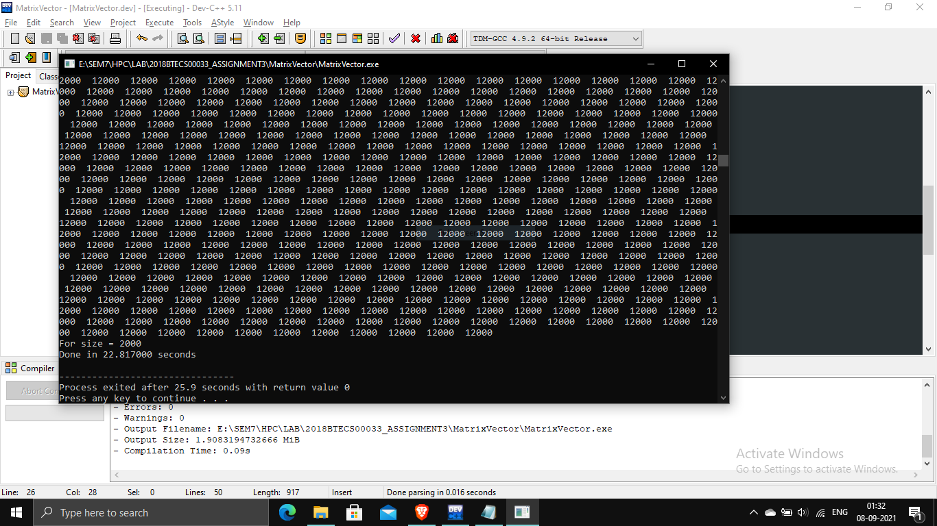

**Information 6 Calculated matrix vector multiplication using 2000 as size and 1 thread**

**Screenshot 7:**

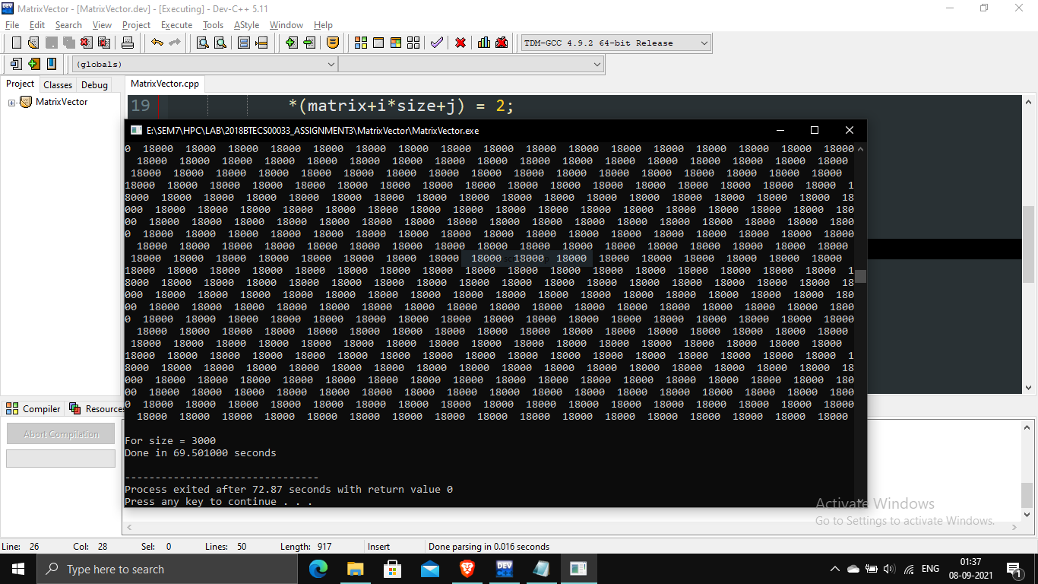

**Information 7 Calculated matrix vector multiplication using 3000 as size and 1 thread It was found that as we increase the size, the time also increases. for a single thread.**

**Screenshot 8 :**

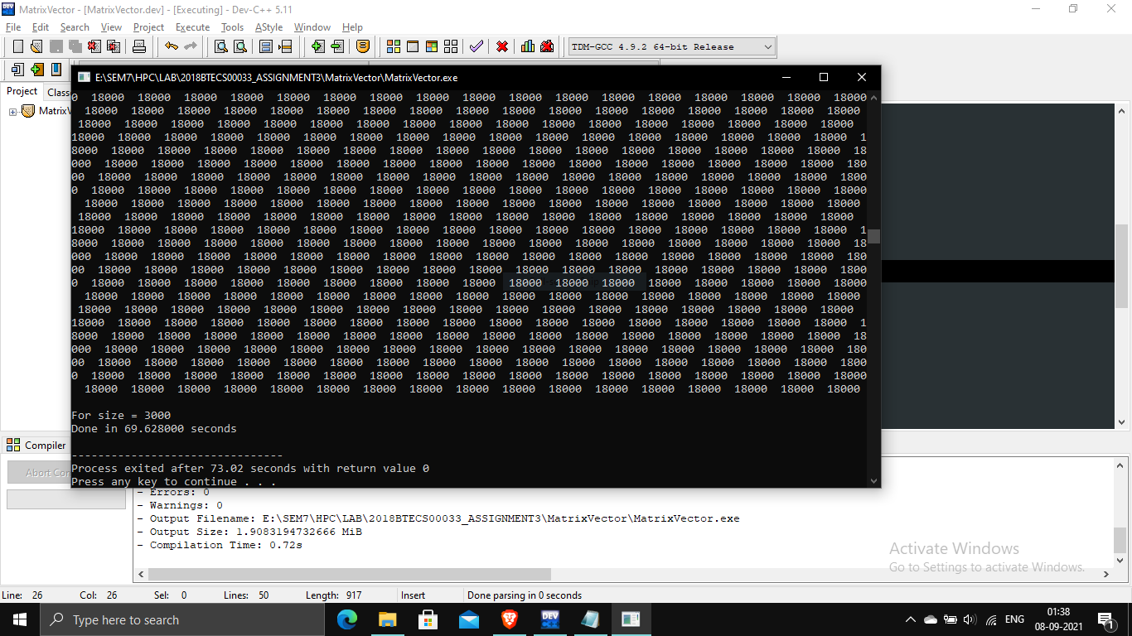

**Information 8 Calculated matrix vector multiplication using 3000 as size and 2 thread**

**Screenshot 9:**

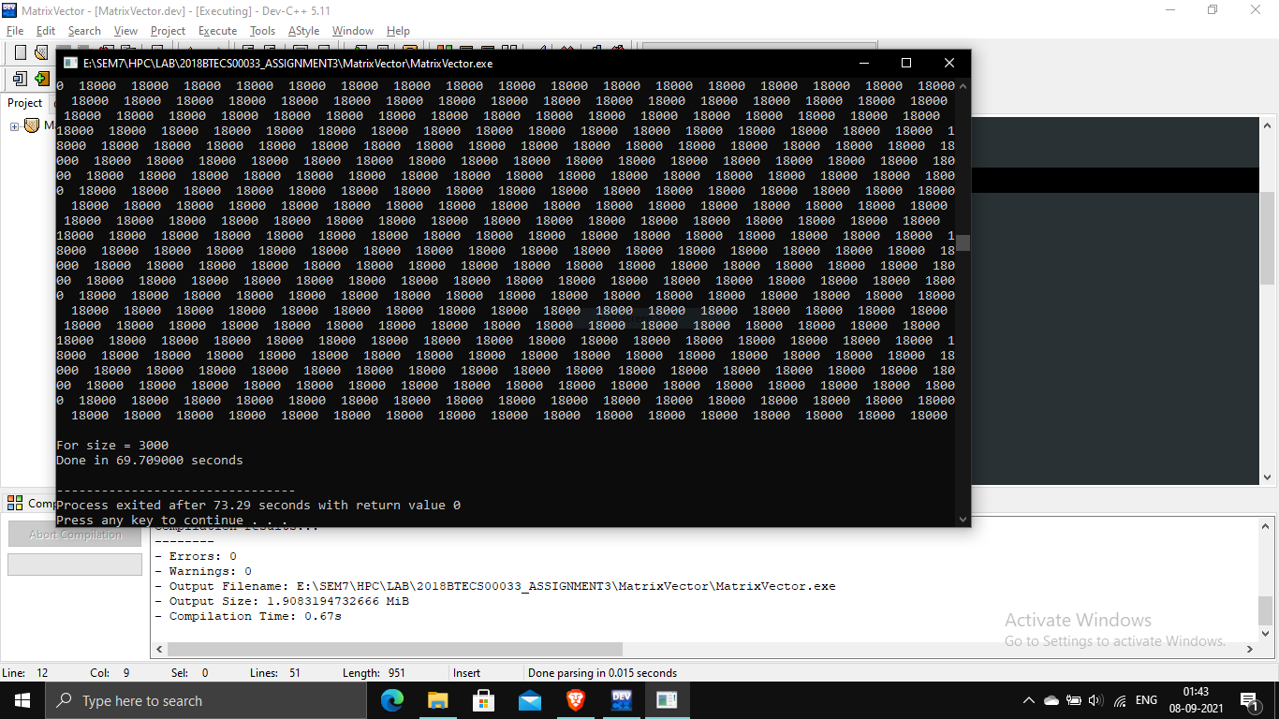

**Information 9 Calculated matrix vector multiplication using 3000 as size and 4 thread**

**Screenshot 10:**

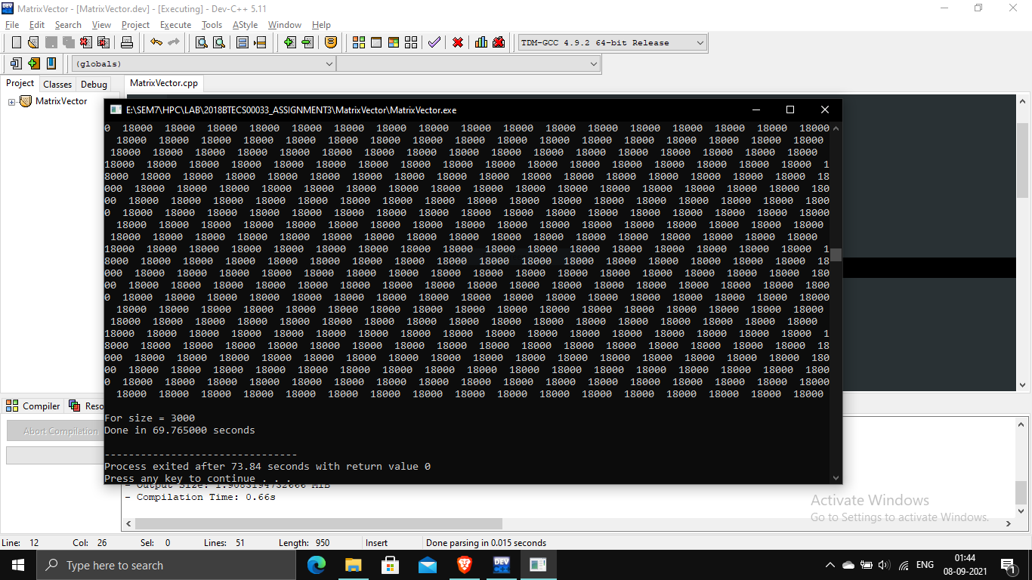

**Information 10 Calculated matrix vector multiplication using 3000 as size and 8 thread It was found that speed slightly increases and then decreases.**

**Screenshot 11:**

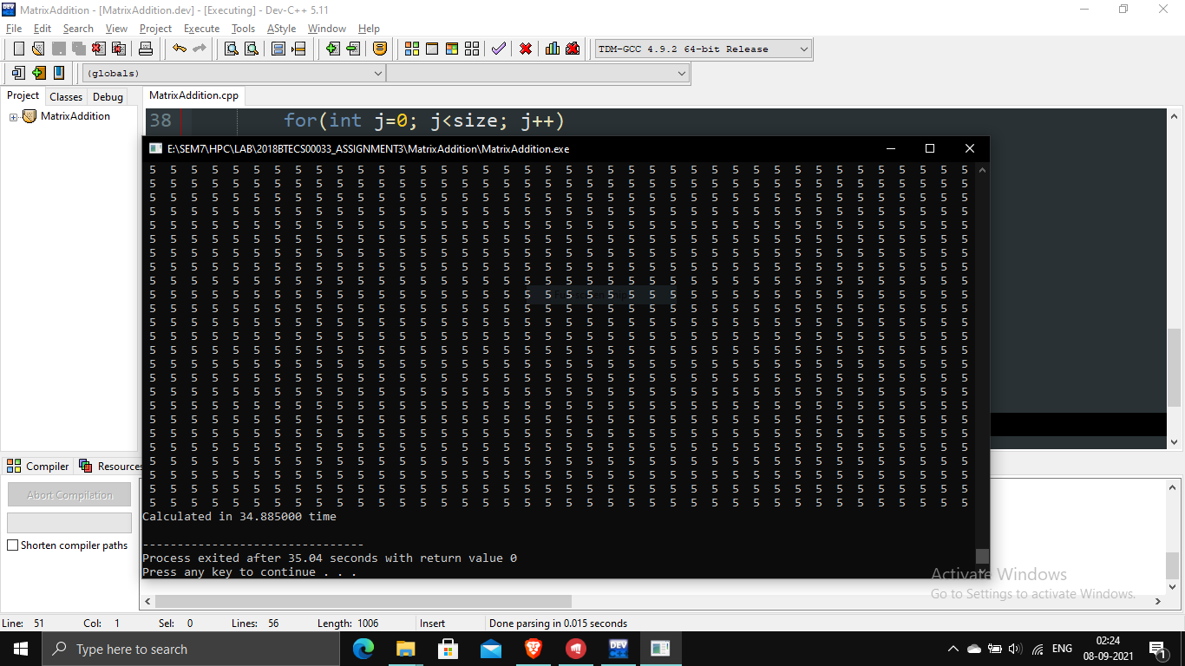

**Information 11 Calculated addition of two matrices using static schedule with chunk of 500**

**Screenshot 12:**

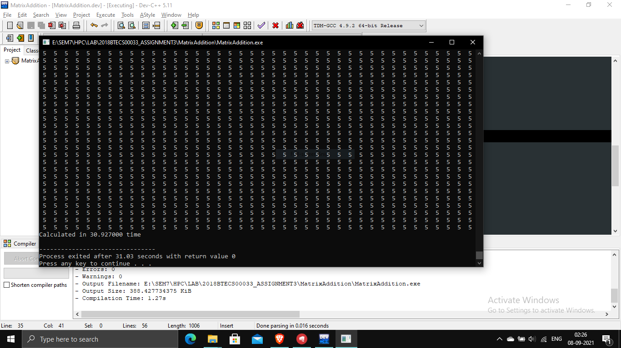

**Information 12 Calculated addition of two matrices using static schedule with chunk of 200**

**Screenshot 13 :**

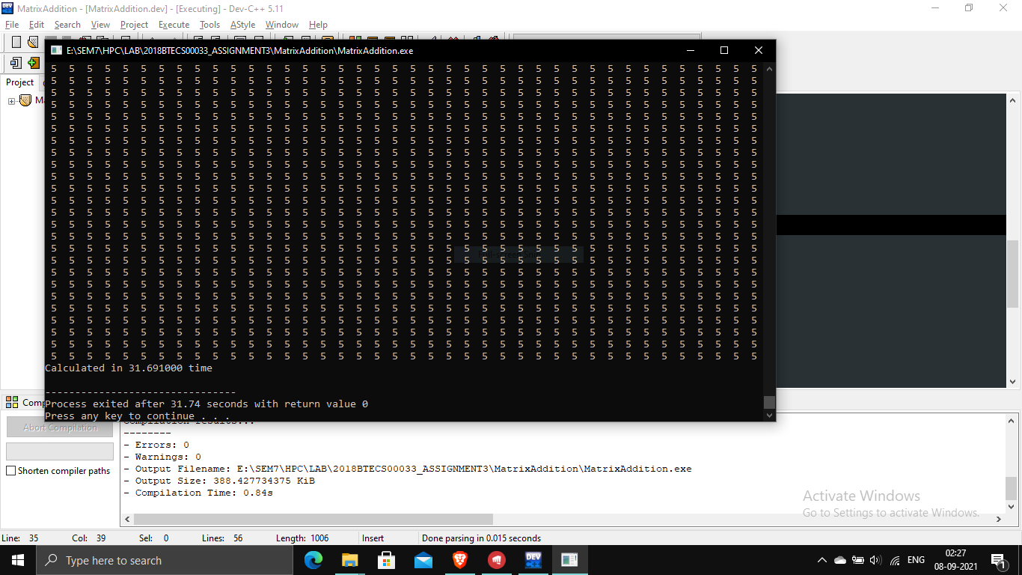

**Information 13 Calculated addition of two matrices using a static schedule with a chunk of 100. For a static schedule it was found that as I decrease the chunk size for 4 threads, the time decreases.**

**Screenshot 14:**

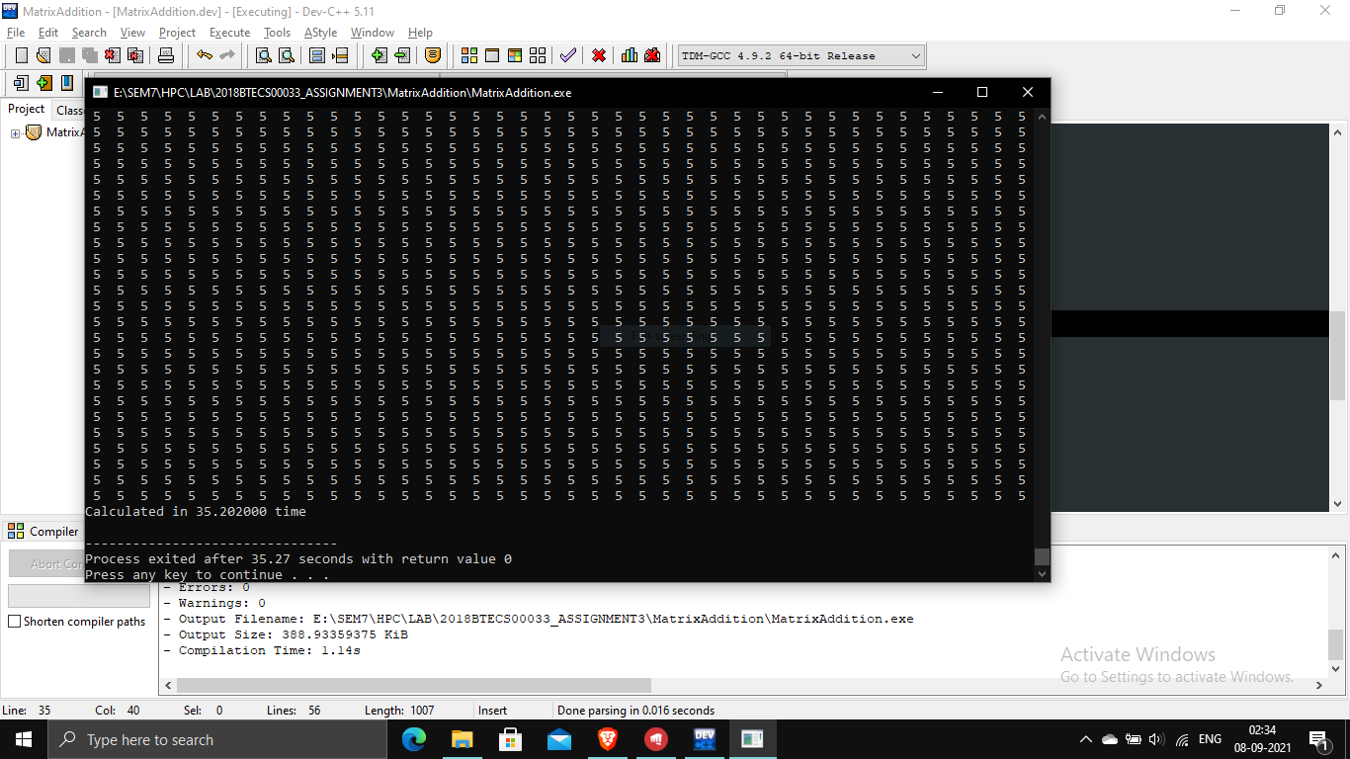

**Information 14 Calculated addition of two matrices using a dynamic schedule with a chunk of 500**

**Screenshot 15:**

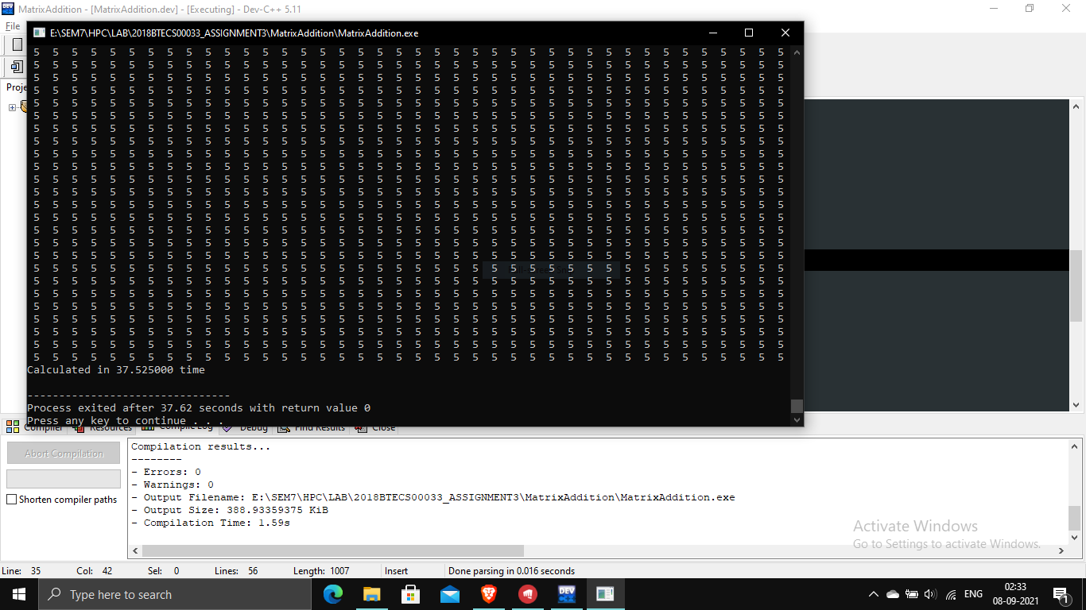

**Information 15 Calculated addition of two matrices using a dynamic schedule with a chunk of 200**

**Screenshot 16:**

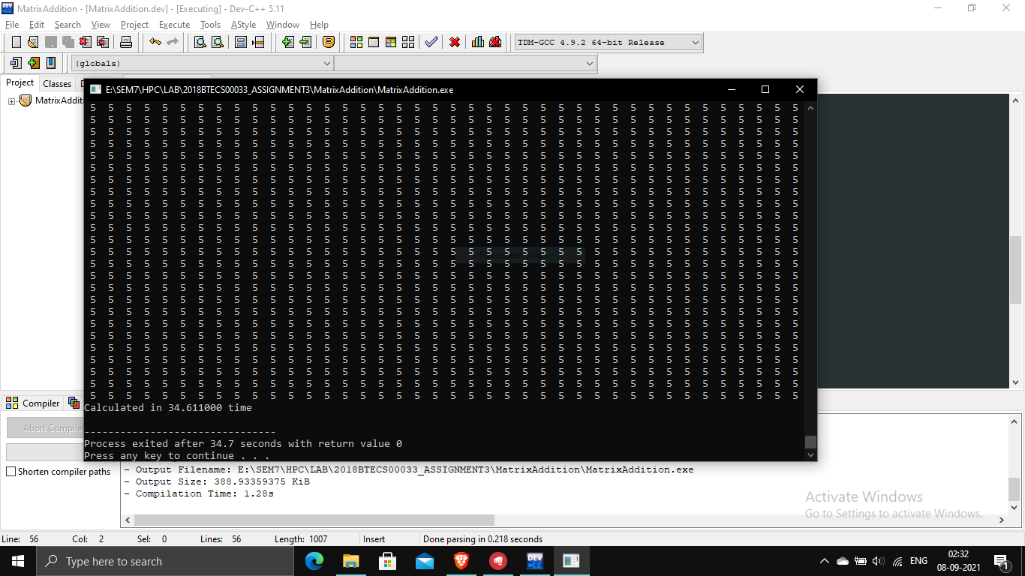

**Information 16 Calculated addition of two matrices using a dynamic schedule with a chunk of 100. There was no significant improvement found.**

**Screenshot 17:**

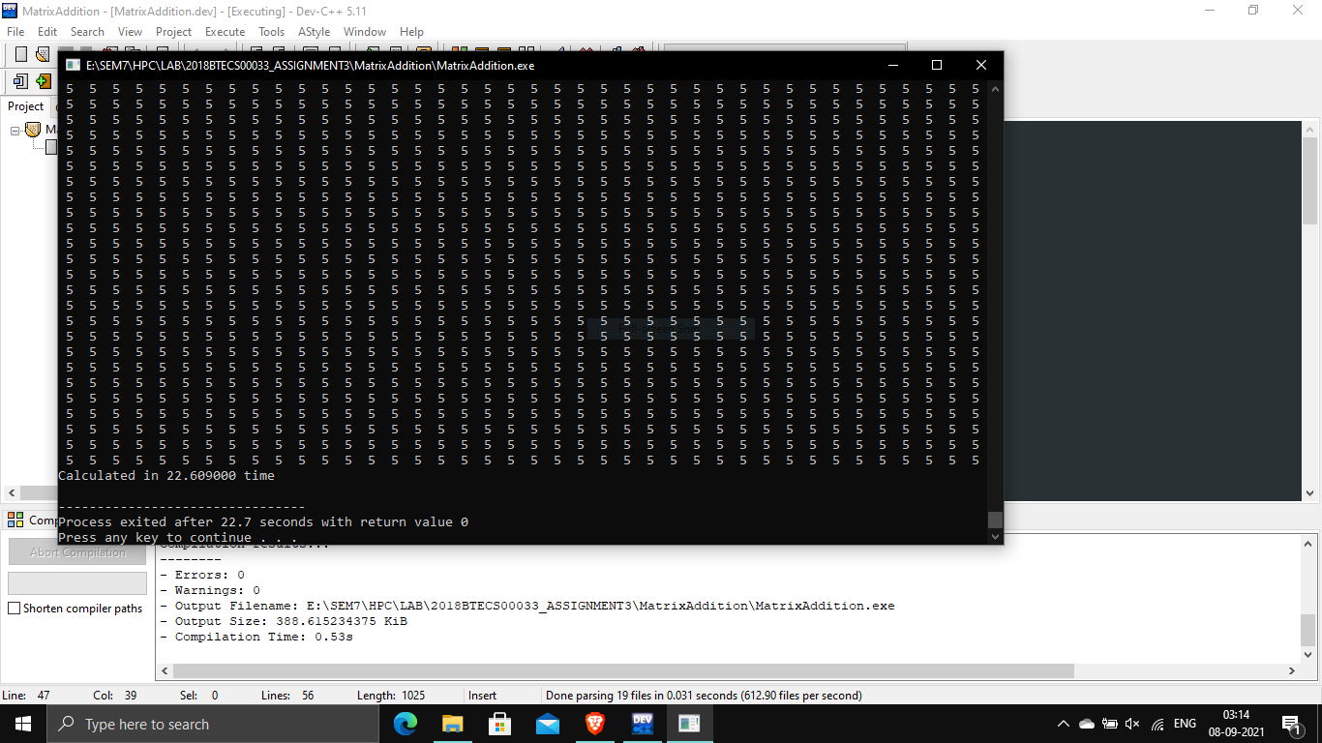

**Information 17 Calculated addition of two matrices using a dynamic schedule with a chunk of 500. After using nowait, a significant improvement was seen.**

**Github Link:** [**https://github.com/g-mahendra/HPC_LAB_ASSIGNMENTS**](https://github.com/g-mahendra/HPC_LAB_ASSIGNMENTS)