PRN: 2018BTECS00033

NAME: MAHENDRA B. GHARGE

CLASS: TYSCE

**Assignment7A**

**Problem Statement 2:**

Design a HTML web page for the any three sports teams’ information. Access it locally and in LAN using a web server.

**Output on Desktop:**

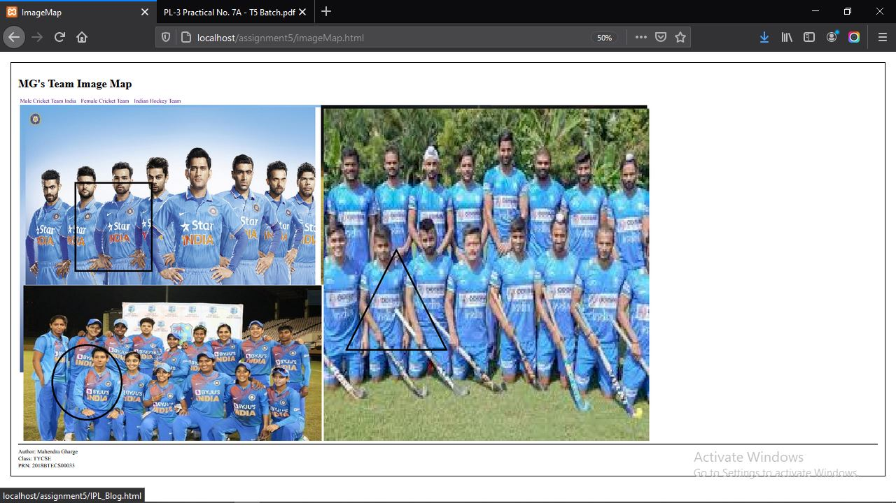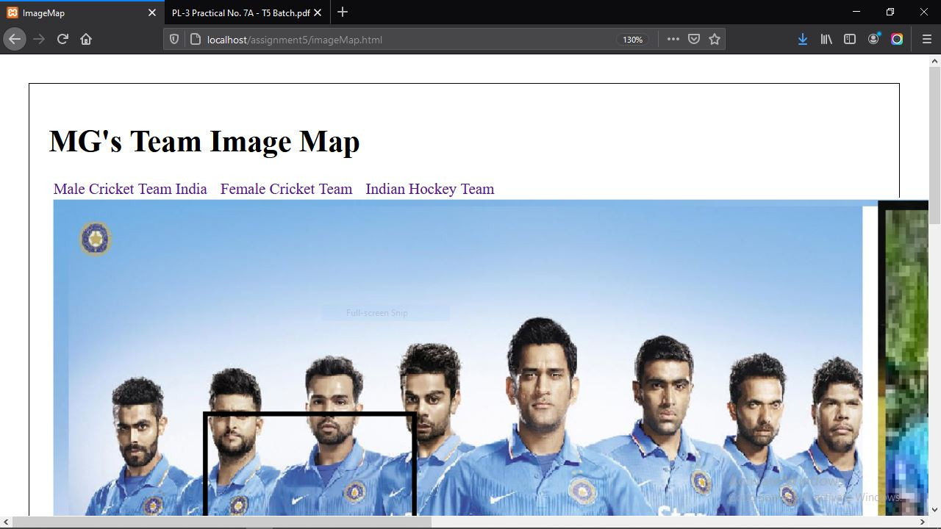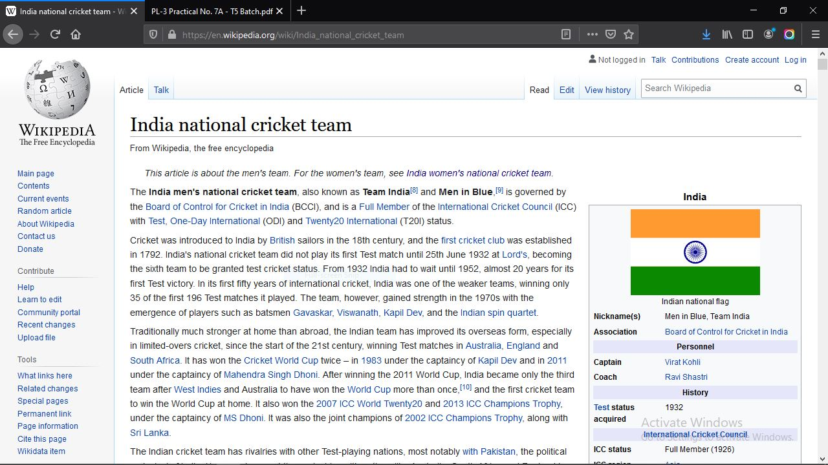

**Output on Smartphone:**

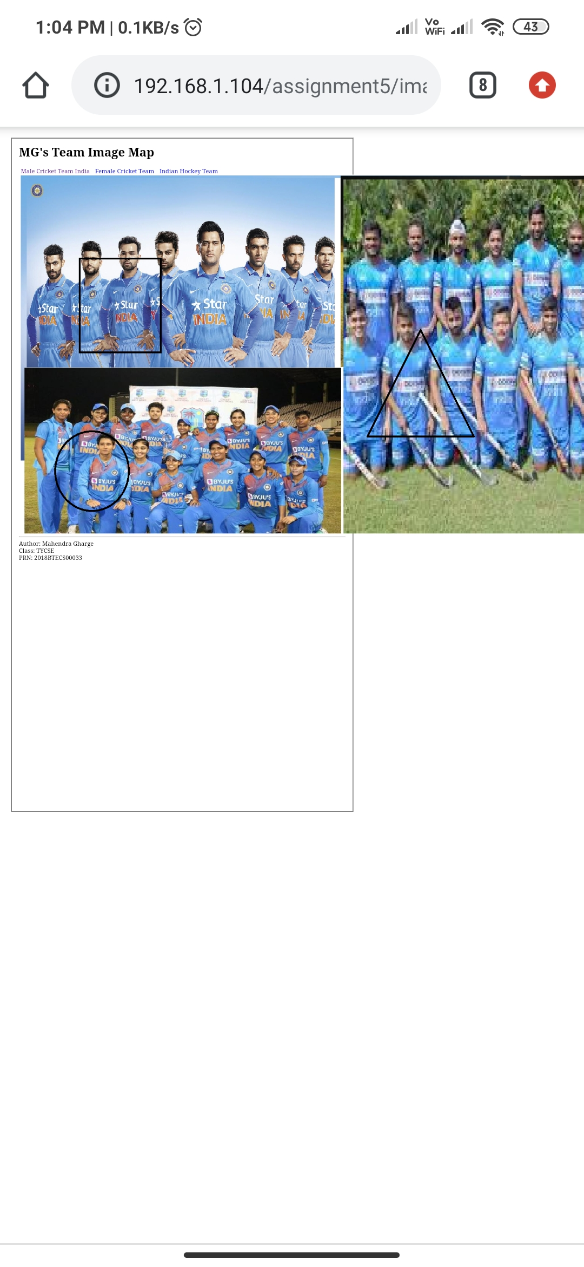

**Link to Github repo:**

<https://github.com/g-mahendra/PL3Assignments>