**Class:** Third Year (Computer Science and Engineering)

**Year:** 2020-21 **Semester:** 2

**Course:** Advanced Web and Mobile Application Development Lab (4CS381)

**LA4/ESE Exam**

**14/06/2021 01.00 PM – 04.00 PM**

**Exam Seat No:**

Name: Mahendra Bhimrao Gharge

Exam Seat Number: 2018BTECS00033

**Problem Statement 1**

**Statement:** Design and build a simple photography website using Node.js, Express.js and any database.

**Screenshot 1:**

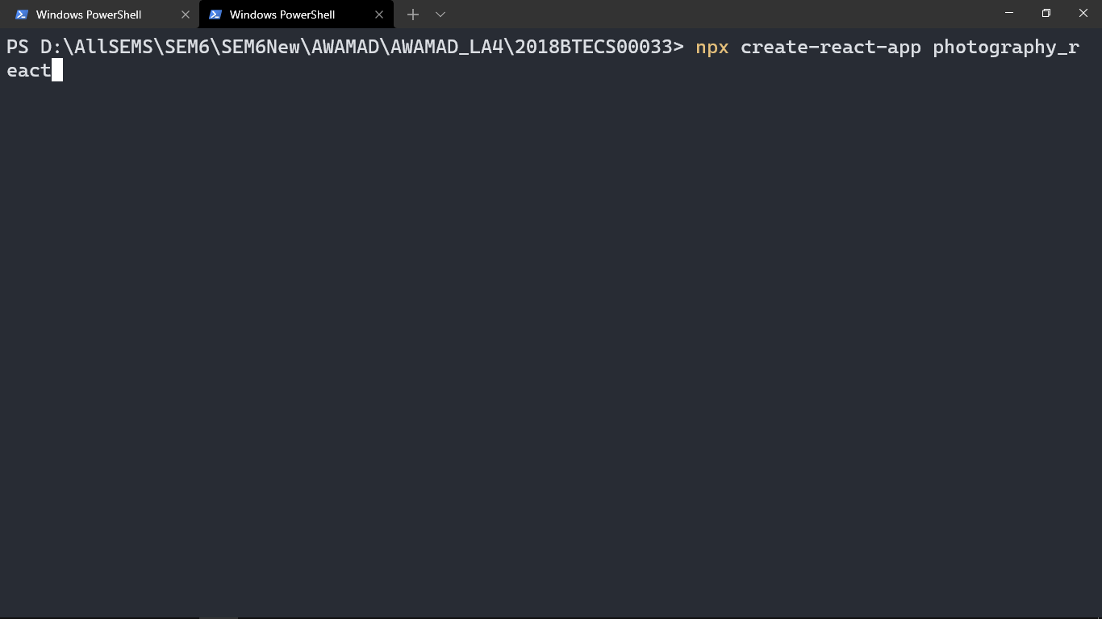

**Information 1: Created react app**

**Screenshot 2:**

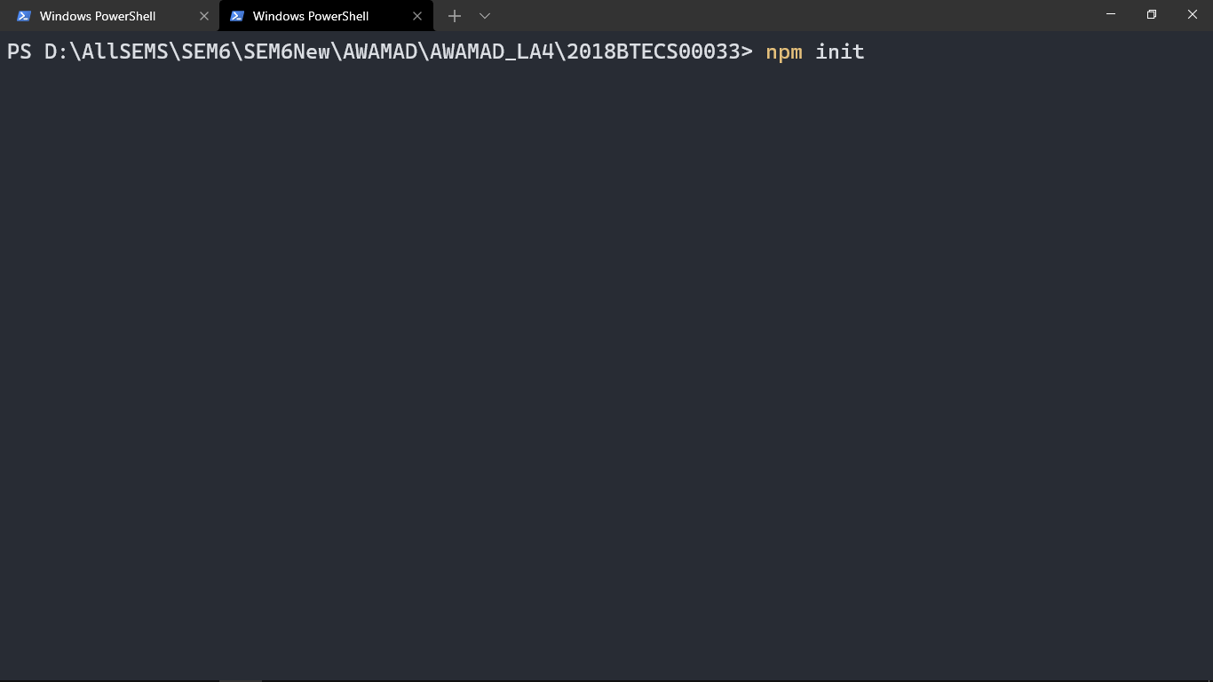

**Information 2: Created server with express**

**Screenshot 3:**

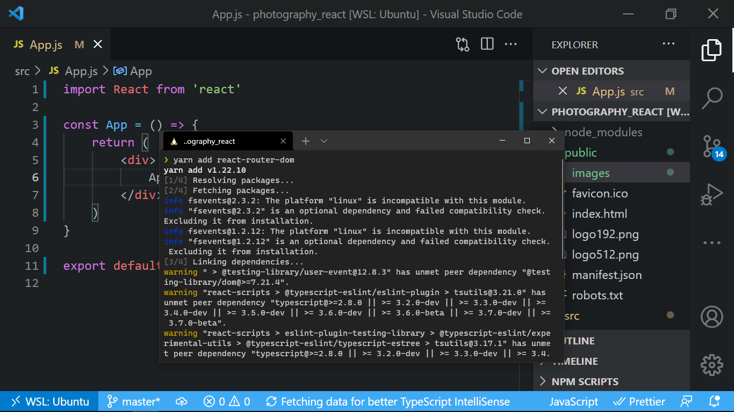

**Information3: Installed react router**

**Screenshot 4:**

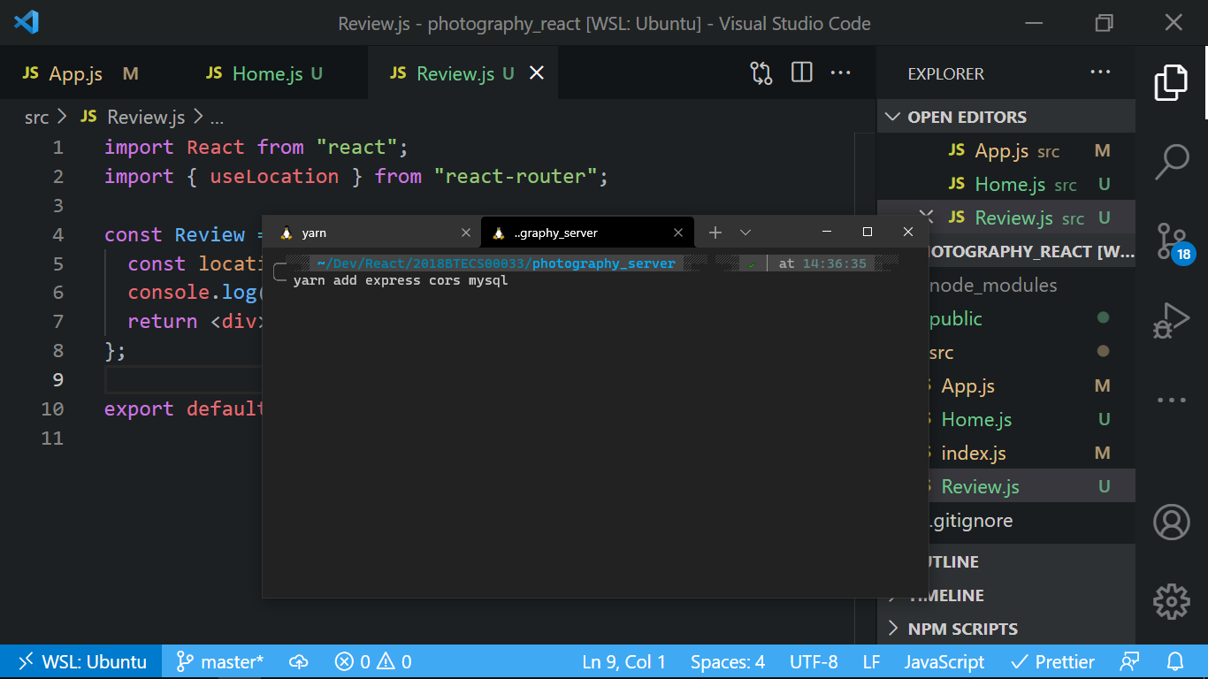

**Information4: Install serer dependencies**

**Screenshot 5:**

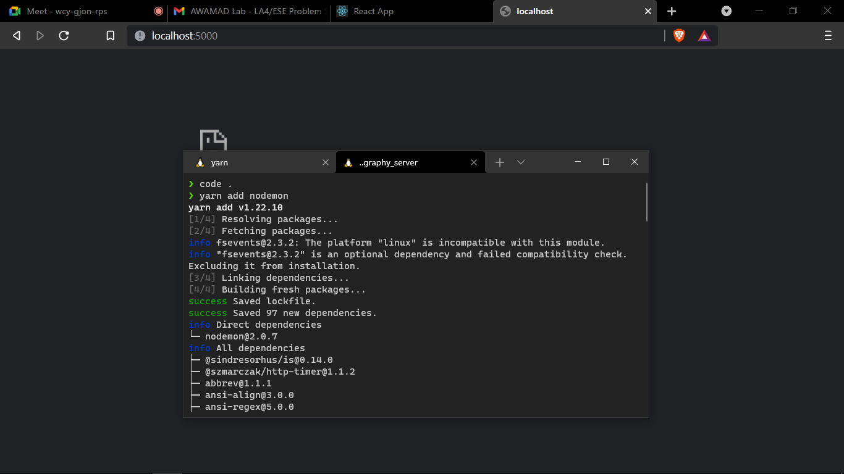

**Information: Installed nodemon in express.**

**Screenshot 6:**

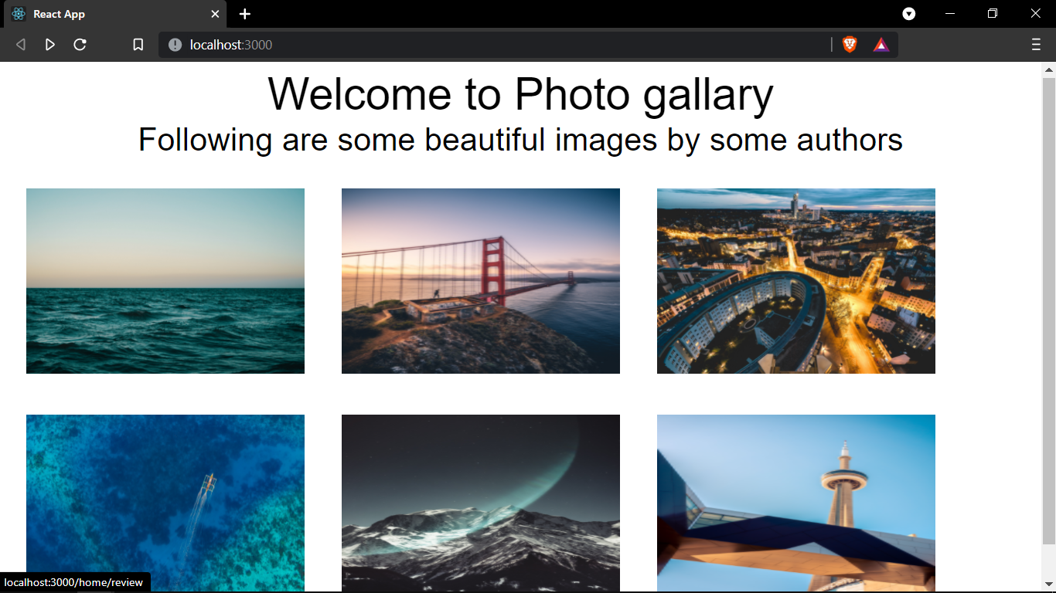

**Information 6: Home sreen of photo gallery**

**Screenshot 7:**

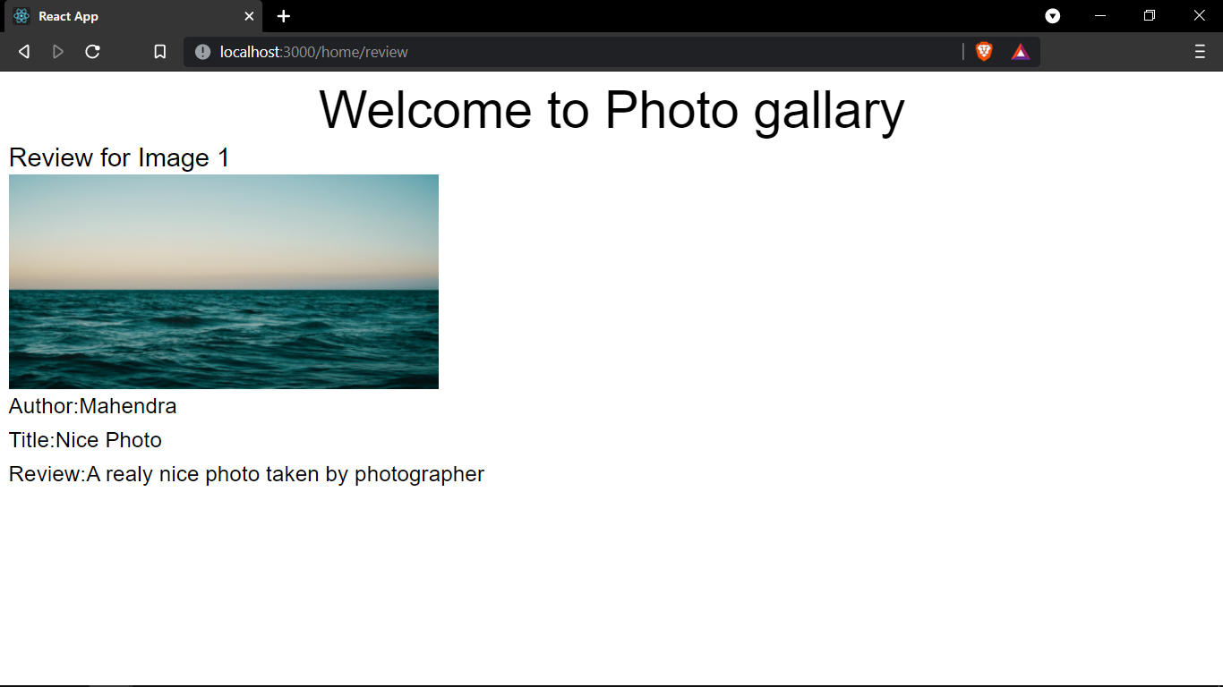

**Information7: Fetching review of particular image from database.**

**Problem Statement 2**

**Statement:** Create and run React App for photography tips using different components, props and user defined components.

**Screenshot 1:**

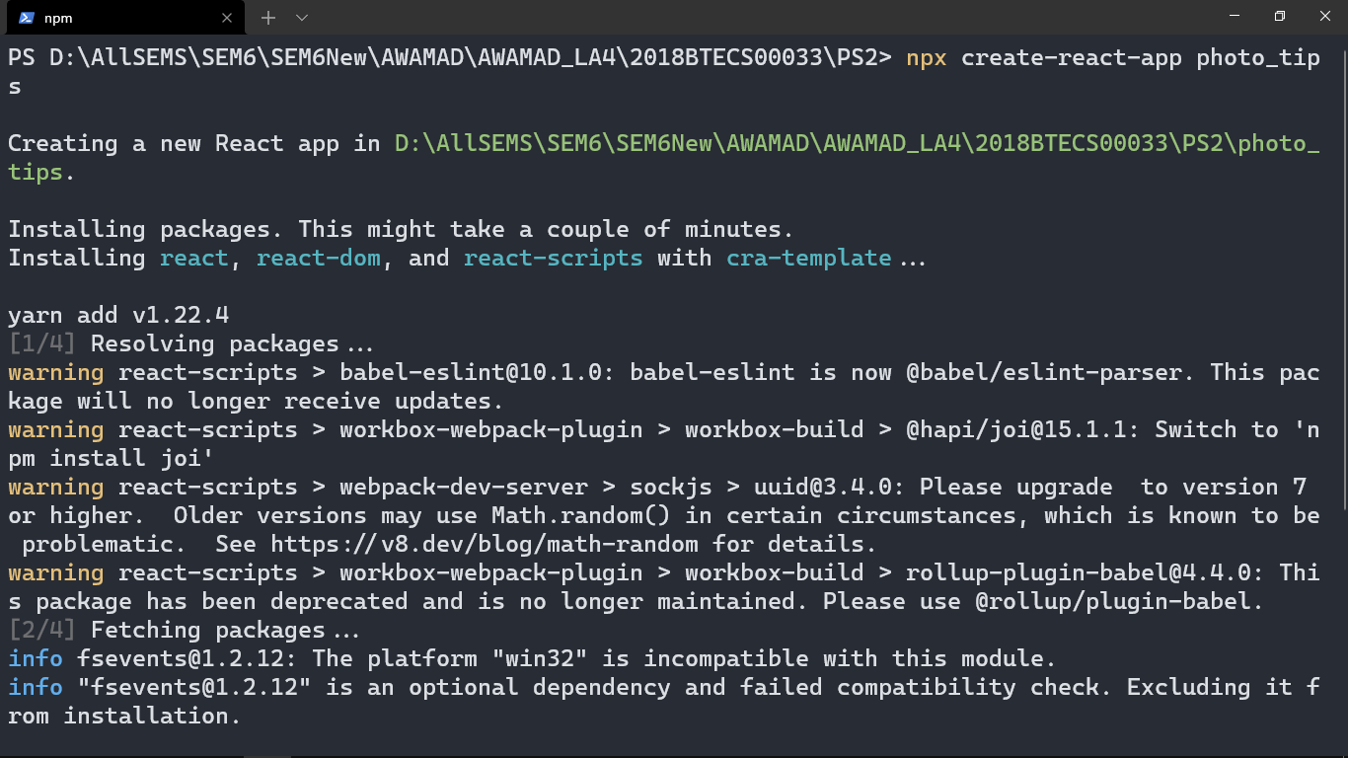

**Information 1: created creact app**

**Screenshot 2:**

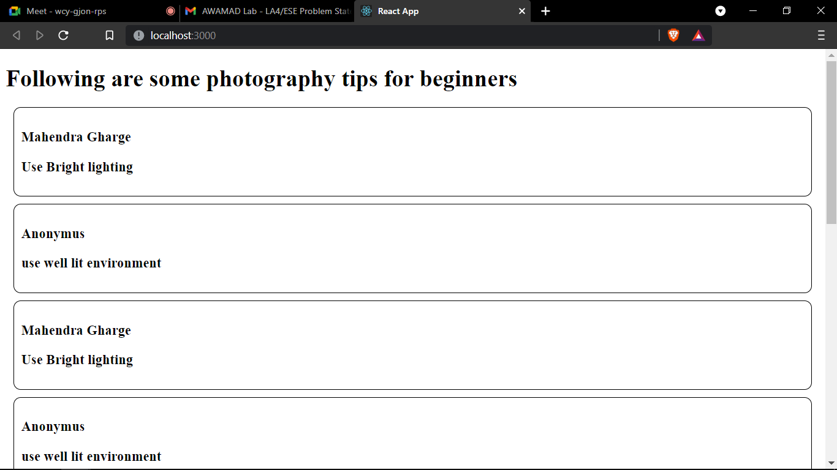

**Information2: Running react app for photography tips**

**Screenshot 3:**

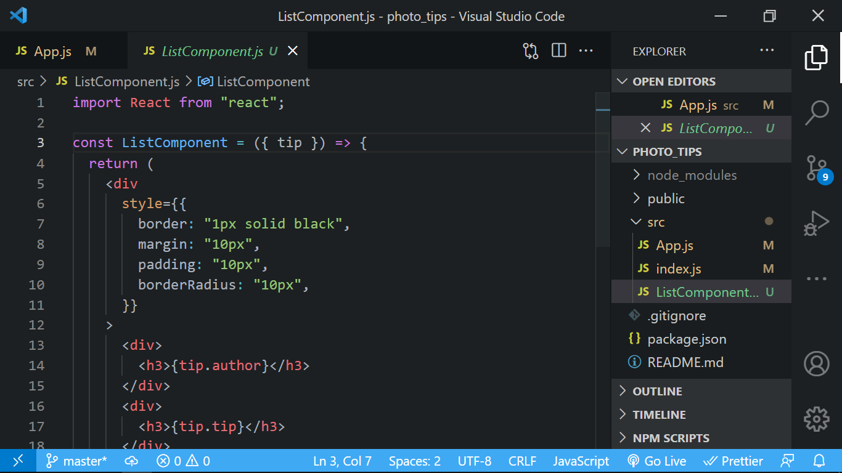

**Information 3:Created costom component**

**Technologies Used: React, express, MySQL**

**GitHub Link: http://github.com/g-mahendra/awamad**