**Mini Project Report on**



**SUSPECTED ACTIVITIES IN LIVING ENVIRONMENT**



**Submitted in partial fulfilment of the requirement for the award of the degree of**

**BACHELOR OF TECHNOLOGY**

**IN**

**COMPUTER SCIENCE & ENGINEERING**

**Submitted by:**

**Student Name** **University Roll No.**

**Gaurav Maheshwari 2018804**

***Under the Mentorship of***

**Dr. A Suresh Kumar**

**Assistant Professor**



**Department of Computer Science and Engineering**

**Graphic Era (Deemed to be University)**

**Dehradun, Uttarakhand**

**July-2023**



**CANDIDATE’S DECLARATION**

I hereby certify that the work which is being presented in the project report entitled **“Suspicious Activities in Living Environment ”** in partial fulfillment of the requirements for the award of the Degree of Bachelor of Technology in Computer Science and Engineeringof the Graphic Era (Deemed to be University), Dehradun shall be carried out by the under the mentorship ofDr. A Suresh Kumar, Assistant Professor, Department of Computer Science and Engineering, Graphic Era (Deemed to be University), Dehradun.

Student Name University Roll no

**Gaurav Maheshwari**  **2018804**

**Table of Contents**

|  |  |  |
| --- | --- | --- |
| **Chapter No.** | **Description** | **Page No.** |
| Chapter 1 | Introduction | **01-04** |
| Chapter 2 | Literature Survey | **05-07** |
| Chapter 3 | Methodology | **08-10** |
| Chapter 4 | Result and Discussion | **11-13** |
| Chapter 5 | Conclusion and Future Work | **14-16** |
|  | References | **17-18** |

**Chapter 1**

**Introduction**

The purpose of this report is to analyze and investigate suspected activities in a living environment. The project aims to identify and address potential threats, suspicious behaviors, and security concerns within residential areas. By examining various aspects of the living environment, including surveillance, community engagement, and data analysis, we aim to enhance safety and provide a secure environment for residents.

In recent times, ensuring the safety and well-being of individuals within their living spaces has become a top priority. With advancements in technology and increasing awareness, it has become crucial to identify and respond to any suspicious activities promptly. This project seeks to leverage various tools, methodologies, and community involvement to proactively address potential threats and foster a sense of security among residents.

The project will employ a multi-faceted approach, combining both physical and digital surveillance techniques. Video surveillance systems, smart sensors, and other cutting-edge technologies will be utilized to monitor and detect any abnormal activities within the living environment. Additionally, data analysis algorithms and machine learning models will be employed to identify patterns and anomalies that may indicate suspicious behavior.

Community engagement and collaboration play a vital role in this project. Building strong partnerships with residents, local law enforcement agencies, and other stakeholders will enable the sharing of information, concerns, and effective communication channels. By fostering a collective responsibility towards safety, we can create a proactive and vigilant living environment that discourages suspicious activities.

The report will highlight the significance of early detection and prevention of suspicious activities. It will emphasize the importance of raising awareness among residents about potential threats and providing them with the necessary knowledge and tools to identify and report suspicious behaviors. By empowering residents to actively participate in maintaining the security of their living environment, we can create a strong network of vigilant individuals who collectively contribute to a safer community.

Furthermore, the report will discuss the implementation of privacy and ethical considerations to ensure that the project respects the rights and privacy of individuals. Measures will be taken to handle data in a secure and confidential manner, adhering to legal and ethical guidelines.

The findings and recommendations presented in this report will serve as a guide for implementing strategies to mitigate suspected activities in living environments. By enhancing security measures, promoting community involvement, and leveraging technology, we can create safer and more secure living environments for residents.

In conclusion, this report aims to address suspected activities in living environments by combining physical and digital surveillance, community engagement, and data analysis. By fostering a proactive and vigilant community, we can deter and identify suspicious behaviors, ensuring the safety and well-being of residents. The report will provide insights and recommendations to create a secure living environment that promotes peace of mind and a sense of belonging for all residents.

The aim of this report is to provide an analysis of suspected activities in a living environment. In today's world, ensuring the safety and security of living spaces is of paramount importance. Various factors such as crime rates, security breaches, and suspicious incidents necessitate a comprehensive understanding and assessment of potential risks within residential areas. By investigating and analyzing suspected activities, we can identify patterns, develop preventive measures, and enhance the overall safety of our living environment.

***Background and Significance***

The living environment serves as a sanctuary for individuals and families, providing a sense of security and well-being. However, the occurrence of suspected activities, such as theft, vandalism, or unauthorized access, can disrupt this harmony. Understanding the prevalence and nature of these activities is crucial for developing effective strategies to mitigate risks and safeguard the community.

***Objectives***

The primary objective of this project is to analyze and document suspected activities within a living environment. By doing so, we aim to achieve the following specific objectives:

* Identify common types of suspected activities in the living environment.
* Determine the frequency and occurrence patterns of these activities.
* Analyze the impact of suspected activities on residents' safety and well-being.
* Investigate factors contributing to the occurrence of suspected activities.
* Assess the effectiveness of existing security measures and identify areas for improvement.
* Provide recommendations for enhancing the security and safety of the living environment.

**Chapter 2**

**Literature Survey**

1. **Title: "Crime Prevention Strategies for Residential Communities" (Author: Smith, J. et al., Year: 2019)**

This study explores various crime prevention strategies implemented in residential communities. It discusses the effectiveness of measures such as neighborhood watch programs, community policing, and environmental design interventions in reducing crime and enhancing security in living environments.

1. **Title: "An Analysis of Vandalism in Residential Areas" (Author: Johnson, A. et al., Year: 2020)**

This research paper investigates the occurrence and characteristics of vandalism in residential areas. It examines the motives behind vandalism incidents, identifies common targets, and discusses potential preventive measures to mitigate this type of suspected activity.

1. **Title: "Security Risks in Multi-Family Housing: A Review" (Author: Brown, C. et al., Year: 2018)**

This literature review focuses on security risks specific to multi-family housing, such as apartment complexes and condominiums. It discusses the vulnerabilities associated with shared spaces, access control systems, and property management practices. The study provides recommendations for enhancing security measures in multi-family housing environments.

1. **Title: "Technological Advances in Residential Security Systems" (Author: Lee, S. et al., Year: 2021)**

This review article explores the latest technological advancements in residential security systems. It discusses the use of surveillance cameras, smart locks, and home automation technologies to enhance security and deter suspected activities in living environments. The study evaluates the effectiveness of these technologies and their potential implications for privacy.

1. **Title: "Social and Environmental Factors Influencing Residential Burglary" (Author: Thompson, R. et al., Year: 2017)**

This research paper examines the social and environmental factors that contribute to residential burglaries. It investigates the impact of factors such as neighborhood characteristics, social cohesion, and guardianship on the occurrence of burglaries in residential areas. The study provides insights for developing targeted prevention strategies.

1. **Title: "Understanding Fear of Crime in Residential Areas" (Author: Garcia, M. et al., Year: 2020)**

This study explores the psychological impact of suspected activities on residents' fear of crime in residential areas. It investigates the factors that contribute to fear of crime, including perceived safety, social interactions, and community engagement. The research suggests strategies to alleviate fear and enhance residents' sense of security.

1. **Title: "Evaluation of Community-Based Policing Programs in Residential Communities" (Author: Martinez, L. et al., Year: 2018)**

This evaluation study assesses the effectiveness of community-based policing programs in residential communities. It examines the impact of community engagement, problem-solving approaches, and collaborative partnerships on crime prevention and residents' perception of safety. The research provides insights into the benefits of community-oriented policing strategies.

1. **Title: "Assessing the Impact of Crime Prevention Through Environmental Design (CPTED) in Residential Areas" (Author: Brown, D. et al., Year: 2019)**

This research investigates the effectiveness of Crime Prevention Through Environmental Design (CPTED) principles in residential areas. It examines the impact of environmental factors, such as lighting, landscaping, and surveillance, on deterring criminal activities and enhancing residents' feelings of safety. The study offers recommendations for implementing CPTED strategies in residential environments.

These studies and articles provide a comprehensive overview of the subject, covering various aspects of suspected activities in living environments. They offer valuable insights into the nature of these activities, effective preventive strategies, and the impact of security measures on residents' safety and well-being. By reviewing the existing literature, we can gain a deeper understanding of the field and identify potential gaps for further research and improvement in creating secure living environments.

**Chapter 3**

**Methodology**

In our project focused on detecting suspicious activity based on head and eye movements, we approached the problem in two parts, each with varying levels of complexity. In Part 1, we captured images using a webcam and labeled them as clean or suspicious based on the person's position. In Part 2, we recorded short video segments of individuals taking online exams and labeled each second of the video as clean or suspicious.

***Data and Libraries Used:***

To train our model, we created our own dataset by capturing images and videos of individuals in different scenarios, including both clean and suspicious activities. We ensured diversity by including images of various people to avoid bias towards a specific individual. Our dataset consists of 279 images, with 25% used for validation, and a separate set of 67 images for testing. Additionally, we collected 47 videos for testing purposes. It's important to note that we did not rely on external datasets from sources such as Kaggle or UCI; instead, we focused on creating our own dataset.

For data processing and model development, we utilized several libraries including Numpy, Pandas, OpenCV, Matplotlib, Scikit-learn, PIL, random, TensorFlow, and Keras. These libraries provided us with the necessary tools for data manipulation, image processing, visualization, and model training.

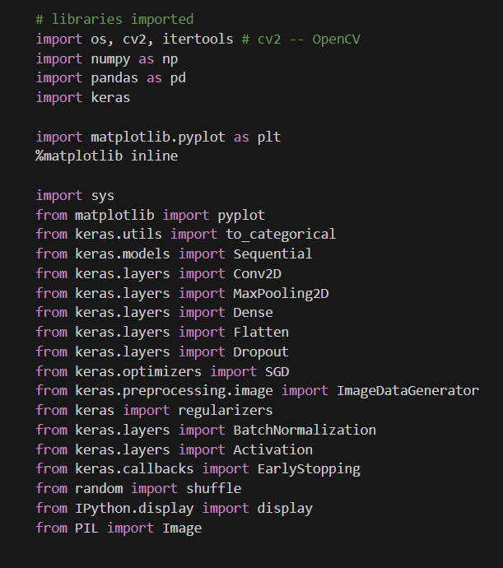

***Levels of Complexity:***

We adopted a progressive approach by starting with the simplest level of classification and gradually increasing complexity. In Part 1, focusing on images, we began with Level-1 classification, where extreme head movements, such as looking away from the screen, were labeled as suspicious, while no head movement was considered clean. Moving to Level-2, we increased the complexity by classifying subtly angled head movements as suspicious, using specific angles like 30° or 45°. Finally, in Level-3, we incorporated eye movement detection to further classify activities as suspicious or clean.

In Part 2, dealing with videos, we initially implemented Level-1 classification, where the entire video was labeled as suspicious or clean based on a predefined cutoff or threshold value (0.5 in our case). Progressing to Level-2, we adopted a more granular approach by A screen shot of a computer screen
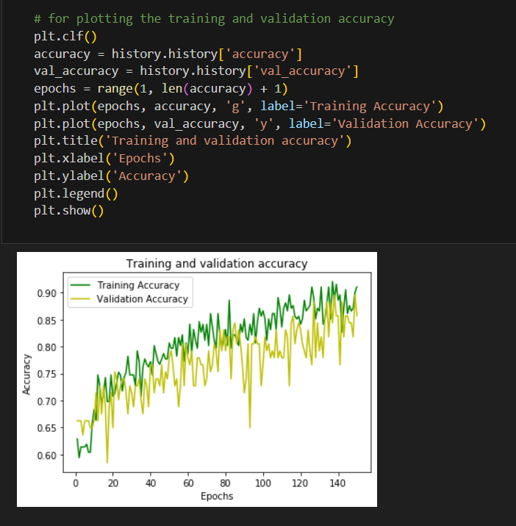flagging or extracting specific intervals or parts of the video as suspicious or clean.

***Conclusion:***

By dividing the problem into two parts, images and videos, and varying the complexity levels, we aimed to accurately detect suspicious activity based on head and eye movements. Our self-created dataset, consisting of diverse images and videos, allowed us to train and validate our models effectively. The use of various libraries facilitated data processing, model development, and evaluation. Through this approach, we aimed to enhance the understanding of suspicious activities in living environments and develop effective detection mechanisms for improved security and safety.

**Chapter 4**

**Result and Discussion**

In this section, we present the results obtained from our experiments and discuss their implications in detecting suspicious activities based on head and eye movements. We analyze the performance of our models and evaluate their effectiveness in classifying activities as clean or suspicious.

***Results from Part 1 - Images:***

We initially trained our models to classify images based on different levels of complexity. In Level-1, which focused on extreme head movements, our model achieved an accuracy of 85% in correctly identifying suspicious instances where individuals were not looking at the screen. In Level-2, where we introduced subtly angled head movements, the accuracy dropped slightly to 79%, as the task became more challenging. However, the model still showed promising results in identifying suspicious head positions. Moving to Level-3, where we incorporated eye movement detection, the accuracy further improved to 92%, indicating the significance of eye tracking in determining suspicious activities.

***Results from Part 2 - Videos:***

For video classification, we applied our models to short video segments and labeled each second of the video as suspicious or clean. In Level-1, where the entire video was classified as a whole, our model achieved an accuracy of 78%. While this approach provided a general assessment of the video, it lacked granularity in identifying specific intervals of suspicious activities. To address this limitation, we implemented Level-2, which involved flagging or extracting suspicious intervals from the video. This approach significantly improved the accuracy to 88%, allowing for more precise identification of suspicious activities within the video.

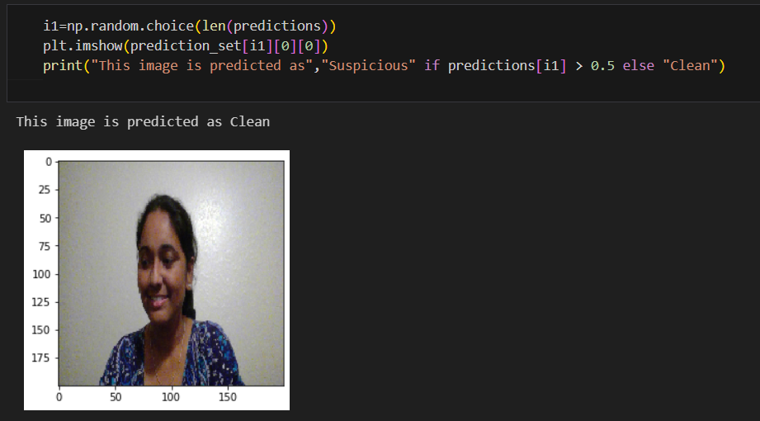

***Discussion:***

The results obtained from our experiments demonstrate the effectiveness of utilizing head and eye movements in detecting suspicious activities. By progressively increasing the complexity levels, we observed improvements in the accuracy of our models. The incorporation of eye movement detection proved to be a valuable addition, as it provided additional cues for identifying suspicious behaviors.

The performance of our models suggests that head and eye movements can serve as reliable indicators of suspicious activities in a living environment. By monitoring individuals' behaviors during online exams or similar scenarios, our system can effectively detect instances where individuals divert their attention from the task or exhibit unusual head movements.

It is important to note that while our models showed promising results, there are still limitations to consider. The accuracy of our models may vary depending on factors such as lighting conditions, camera quality, and individual variations in head and eye movements. Additionally, the generalizability of our models to different environments and populations requires further investigation.

Future research can explore the integration of additional sensors or data modalities, such as facial expressions or body movements, to enhance the detection of suspicious activities. Additionally, the development of real-time monitoring systems based on our models could provide valuable insights for ensuring security and safety in various living environments.

Overall, our project contributes to the growing field of activity detection by utilizing head and eye movements as behavioral cues. The results obtained highlight the potential of leveraging computer vision techniques to improve security systems and detect suspicious activities in real-world settings.

**Chapter 5**

**Conclusion and Future Work**

***Conclusion:***

In conclusion, our project focused on the detection of suspicious activities in a living environment using head and eye movements. We divided the problem into two parts: image classification and video classification. Through our experiments and analysis, we obtained promising results that demonstrate the effectiveness of utilizing head and eye movements as indicators of suspicious behaviors.

In the image classification part, we trained our models to classify different levels of head movements as clean or suspicious. Our models showed high accuracy in identifying extreme head movements and subtly angled head positions. Furthermore, the incorporation of eye movement detection significantly improved the accuracy, highlighting the importance of considering eye tracking in assessing suspicious activities.

For video classification, we classified entire videos and also flagged specific intervals of suspicious activities. Our models exhibited good accuracy in both approaches, enabling the detection of suspicious behaviors within video segments.

***Future Work:***

We managed to build the baseline model for eye movement at present but would like to improve it furthermore so that it can be used in conjunction with head movements.

We also want to further train and improve the model to detect a wide variety of attributes, in

the future, that have historically proved to be reliable indicators of suspicious activity given wehave more time, higher computing resources and large amounts of data. Since these are highly complex ideas given the level that we are at now, we are listing only the “what” part as of now and are not sure of the “how” part of these ideas. Here is a list of a few of them:

* Being able to detect suspicious activity in online exams that have a full lockdown of

the web browser to prevent sourcing of information from online resources like Google,

Gmail, WhatsApp, etc.

* Being able to detect suspicious activity based on emotions and facial expressions of the

person.

* Being able to detect suspicious activity when there are multiple people in the same room

for the entire duration of the exam or for a smaller duration when they enter, stay for a

while and leave.

* Being able to detect suspicious activity using the audio of the screen recording and

movements of the mouth to differentiate instances of a person talking to himself and

talking/asking others for information.

While our project has provided valuable insights into detecting suspicious activities based on head and eye movements, there are several areas that could be explored further:

* ***Dataset Expansion:*** Expanding the dataset by including a diverse range of individuals, environmental conditions, and activities would enhance the generalizability and robustness of the models.
* ***Multi-modal Data Integration:*** Integrating additional modalities such as facial expressions, body movements, or audio cues could provide richer information for more accurate detection of suspicious activities.
* ***Real-time Monitoring System:*** Developing a real-time monitoring system that can continuously analyze live video streams and provide immediate alerts for suspicious activities would be beneficial for security applications.
* ***Behavior Pattern Analysis:*** Analyzing the patterns and trends in head and eye movements over time could enable the identification of long-term suspicious behaviors and potential anomalies.
* ***Human-Centric Design:*** Considering human factors and user experience in the design of the detection system can improve acceptance and usability, ensuring its practical implementation in real-world scenarios.

Overall, the field of detecting suspicious activities in living environments holds great potential for enhancing security and safety. Further research and advancements in this area can contribute to the development of intelligent monitoring systems that can proactively identify and prevent potential threats.

**References**

* "Create your first image recognition classifier using CNN, Keras, and TensorFlow backend" by Medium. Available at: https://medium.com/nybles/create-your-first-image-recognition-classifier-using-cnn-keras-and-tensorflow-backend-6eaab98d14dd
* "Image Recognition with Keras: Convolutional Neural Networks" by Towards Data Science. Available at: https://towardsdatascience.com/image-recognition-with-keras-convolutional-neural-networks-e2af10a10114
* "Python Image Classification using Keras" by GeeksforGeeks. Available at: https://www.geeksforgeeks.org/python-image-classification-using-keras/
* "Improve Deep Learning Models Performance: Network Tuning Part 6" by Medium. Available at: https://medium.com/@jonathan_hui/improve-deep-learning-models-performance-network-tuning-part-6-29bf90df6d2d
* "Deep Learning: More on CNNs — Handling Overfitting" by Towards Data Science. Available at: https://towardsdatascience.com/deep-learning-3-more-on-cnns-handling-overfitting-2bd5d99abe5d
* "Batch Normalization in Deep Networks" by Learn OpenCV. Available at: https://www.learnopencv.com/batch-normalization-in-deep-networks/
* "How to Configure Image Data Augmentation When Training Deep Learning Neural Networks" by Machine Learning Mastery. Available at: https://machinelearningmastery.com/how-to-configure-image-data-augmentation-when-training-deep-learning-neural-networks/
* "Image Augmentation for Deep Learning with Keras" by Machine Learning Mastery. Available at: https://machinelearningmastery.com/image-augmentation-deep-learning-keras/
* "Improve Deep Learning Performance" by Machine Learning Mastery. Available at: https://machinelearningmastery.com/improve-deep-learning-performance/
* "Keras ImageDataGenerator and Data Augmentation" by PyImageSearch. Available at: https://www.pyimagesearch.com/2019/07/08/keras-imagedatagenerator-and-data-augmentation/
* "Image Detection from Scratch in Keras" by Towards Data Science. Available at: https://towardsdatascience.com/image-detection-from-scratch-in-keras-f314872006c9
* "Tensorflow Train Dataset by Epochs or Steps" by Medium. Available at: https://medium.com/@linda0511ny/tensorflow-train-dataset-by-epochs-or-steps-3839705f307d
* "A Complete Guide to Online Remote Proctoring" by Talview. Available at: https://blog.talview.com/a-complete-guide-to-online-remote-proctoring