Creating a Linux Image from Source

Prerequisites
Ensure that your system has the necessary packages installed by running the following command:
sudo apt update && sudo apt install bzip2 git vim make gcc libncurses-dev flex bison bc cpio libelf-dev libssl-dev syslinux dosfstools -y

Getting the Source Code
Clone the Linux kernel and BusyBox repositories:
git clone --depth 1 https://github.com/torvalds/linux.git
git clone --depth 1 https://git.busybox.net/busybox

Compiling the linux Kernel
cd linux
make menuconfig
make sure 64bit is ticked, save the config and exit
make -j 8
-j is the number of jobs -> use something sensible depending on your machines core count, this might take a while, we are now compiling the linux kernel
Now we can copy the kernel image
cp arch/x86/boot/bzImage ..

Building busybox
cd ../busybox
make menuconfig
hit enter on settings and make sure to tick the “Build static library” under build options
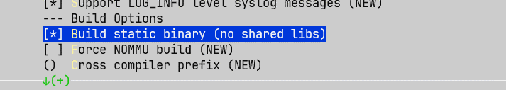
then save and exit and run make to build busybox
make
mkdir ../initramfs
make CONFIG_PREFIX=../initramfs instal
now in the initramfs folder create a new file called init, make it executable and tell it to start sh using sh on startup
cd ../initramfs
nano init
“
#!/bin/sh

/bin/sh
“
save and exit
chmod -x init

now archive it
find . | cpio -o -H newc > ../init.cpio

Creating the boot image
cd .. && ls
here you should now have a bzImage (the kernel) and a init.cpio (user space)

now create a 50mb boot volume (that’s more than enough, really, its not windows xD)
dd if=/dev/zero of=boot bs=1M count=50
lets give it a simple fat filesystem
mkfs -t fat boot

then put the syslinux loader onto it
syslinux boot

since we already have a fs on the bootvolume, we can simply mount it to copy over our kernel and userspace
mkdir m
sudo mount boot m
sudo cp bzImage init.cpio m
sudo umount m

Creating a VM in QEMU
THAT’S IT, now we can create a vm, I will just use qemu but you should get virtualbox or vmware to work aswell, just change the path accordingly
PS: qemu-system-x86_64.exe -drive format=raw,file=\\wsl.localhost\Ubuntu\home\gabriel\mylinux\boot

You should get something like this:
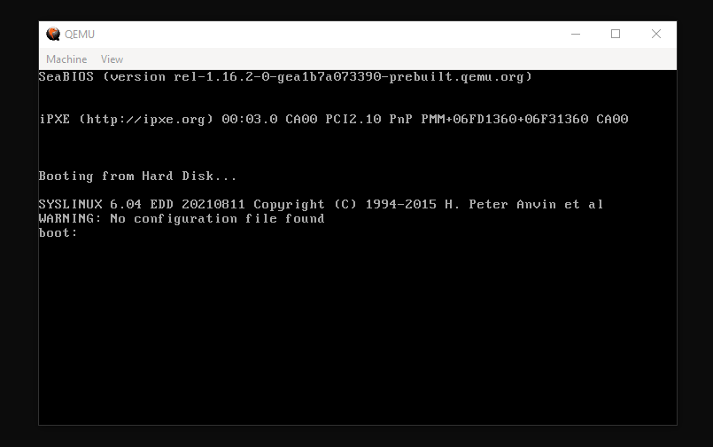
Now tell the bootloader what to load, in our case: (mind the keyboard layout xD)
/bzimage -initrd=/init.cpio

Your linux will boot right up, your console will be spammed with kernel messages but you should be able to run all the basic linux commands included with busybox, like ls or vi and so on, hope you learned something

