**Chitosan nanoparticles containing the insecticide dimethoate: a new approach in the reduction of harmful ecotoxicological effects**

José Henrique Vallim, Zaira Clemente, Rodrigo Fernandes Castanha, Anderson do Espírito Santo Pereira, Estefânia Vangelie Ramos Campos, Márcia Regina Assalin, Cláudia Vianna Maurer-Morelli, Leonardo Fernandes Fraceto, Vera Lúcia Scherholz Salgado de Castro

**Table A1.** Size (nm) and particle concentration (mL-1 nanoparticles) values for nanoparticles with dimethoate (nanoDMT) at 0 and 96 h in a zebrafish embryo medium (USEPA, 2002). The samples were analyzed in triplicate, with a pH of 4.9, at 25 ºC.

|  |  |  |  |
| --- | --- | --- | --- |
| **Group/Time (h)** | **pH** | **Size (nm)** | **Concentration**  **(nanoparticles mL-1)** |
| nanoDMT (0) | 4.9 | 296.2 ± 18.1 | 2.44 x 1010 ± 1.62 x 1010 |
| nanoDMT (96) | 4.9 | 251.8 ± 34.4 | 1.77 x 1010 ± 1.31 x 1010 |

**Table A2.** Estimate ofLC10 to LC50 (mg L-1) after the exposure of organisms to different treatments (NP, nanoDMT, NP + DMT, DMT, and cDMT) for 96 h (n = 24/concentration). Probit Analysis module of the Statgraphics Centurion XVII program, Version 1.17.04, p < 0.05.

|  |  |  |  |  |  |
| --- | --- | --- | --- | --- | --- |
| **LC96 h**  **(mg L-1)** | **NP** | **nanoDMT** | **NP + DMT** | **DMT** | **cDMT** |
| LC50 | 1744.56 (936.36-nd) | 251.81  (206.15-311.07) | 143.28  (114.35-183.60) | 155.02  (132.30-183.41) | 5.27  (4.29-6.45) |
| LC40 | 1406.19 (766.83-nd) | 207.50  (163.05-258.39) | 114.38  (86.66-147.64) | 138.74  (115.99-164.12) | 4.52  (3.50-5.57) |
| LC30 | 1044.16 (577.37-nd) | 160.10  (113.20-205.73) | 83.47  (53.99-112.22) | 121.32  (97.34-144.67) | 3.71  (2.57-4.69) |
| LC20 | 620.47  (310.29-nd) | 104.63  (49.26-149.36) | 47.286  (11.28-75.24) | 100.93  (73.89-123.546) | 2.76  (1.39-3.76) |
| LC10 | 32.88  (356.97-nd) | 27.70  (-45,83-78.45) | -2.89  (-53.81-29.81) | 72.66  (38.91-96.70) | 1.45  (-0.36-2.59) |

**DMT =** dimethoate, **NP =** nanoparticle control, **nanoDMT =** nanoencapsulated dimethoate, **cDMT =** commercial dimethoate, and **NP + DMT =** nanoparticles plus dimethoate.

nd = not determined

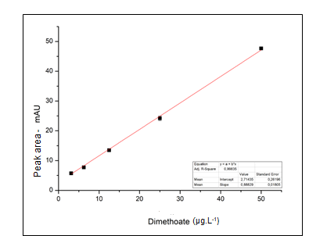

**Figure A1**. DMT calibration curve by HPLC

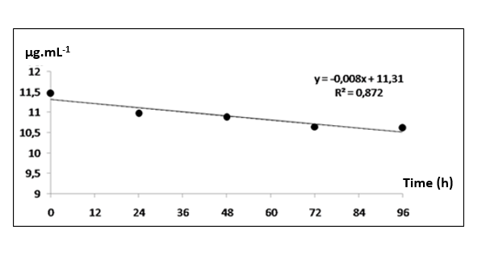

**Figure A2**. DMT stability curve in embryo/larvae medium

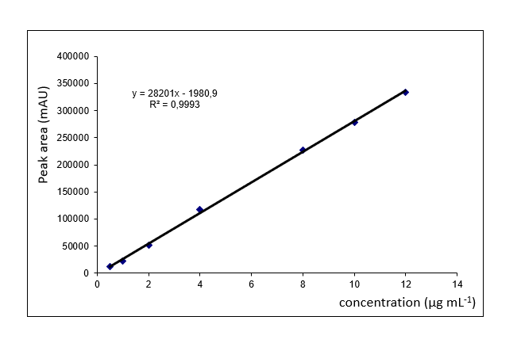

**Figure A3**. Concentration plots of DMT (technical grade) standard solutions

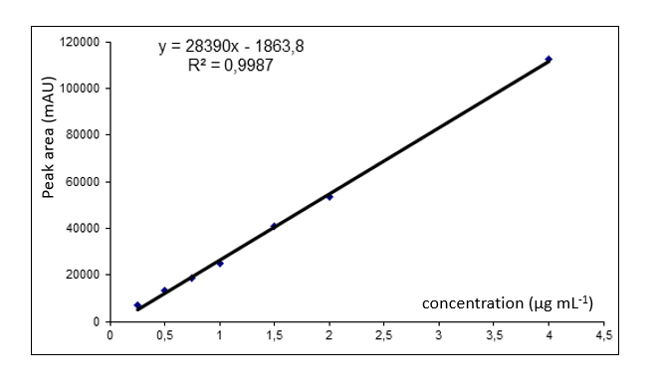

**Figure A4**. Concentration plots of cDMT standard solutions