Screen Sketches

SS_6 Team Thai

Christopher Woods

Jacob Spooner

Gavin Monroe

Chris Lopez

ISU View

**List of Non-Functional Requirements**

* GPS is accurate within 20 feet
* Routes are processed quickly
* Spring Boot as backend

**List of Tables**

Users

* Name
* ID
* Classes

Bus

* Stops

Points of Interest (Links to Comments table)

* Locations
* Comments

Comments

* Poster (User’s Name)
* Point of Interest location
* Text

Classes (Linked to Room table)

* Name
* Location (Room)
* Time

Room (Linked to Building table)

* Building
* Number
* Longitude
* Latitude

Building

* Location (Address)
* Longitude
* Latitude

**Screenflow Diagram:**

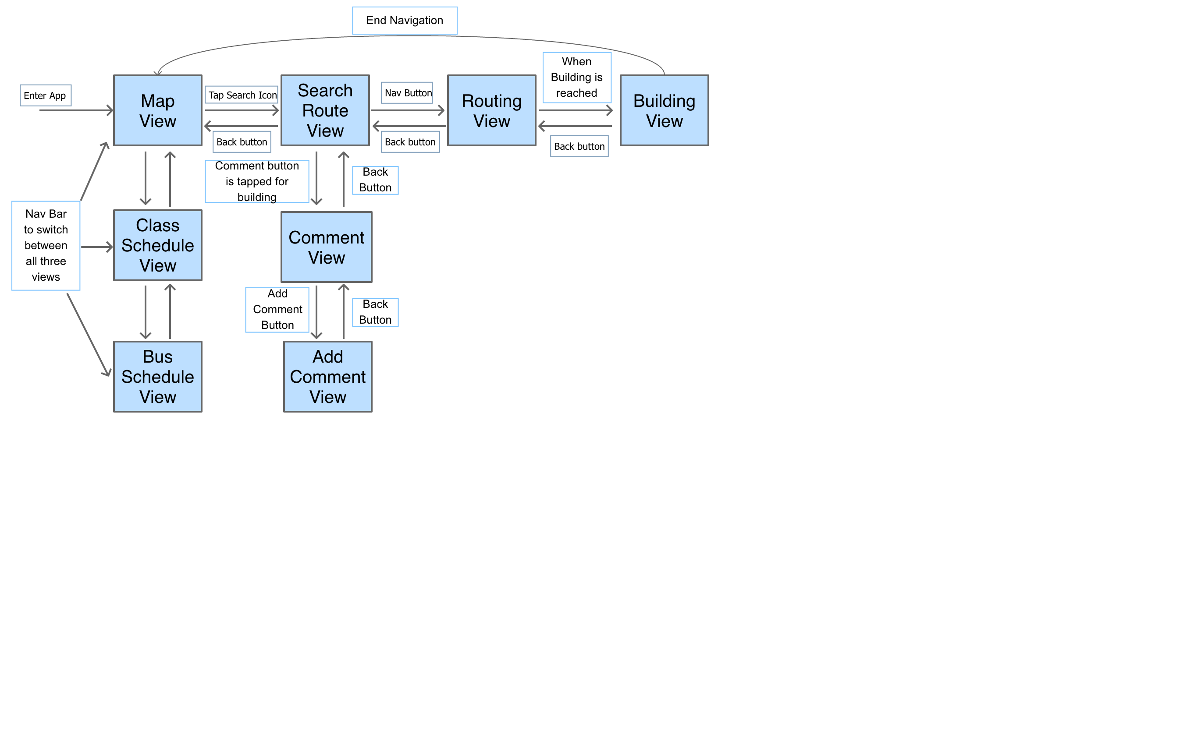

**Screen Sketches:**

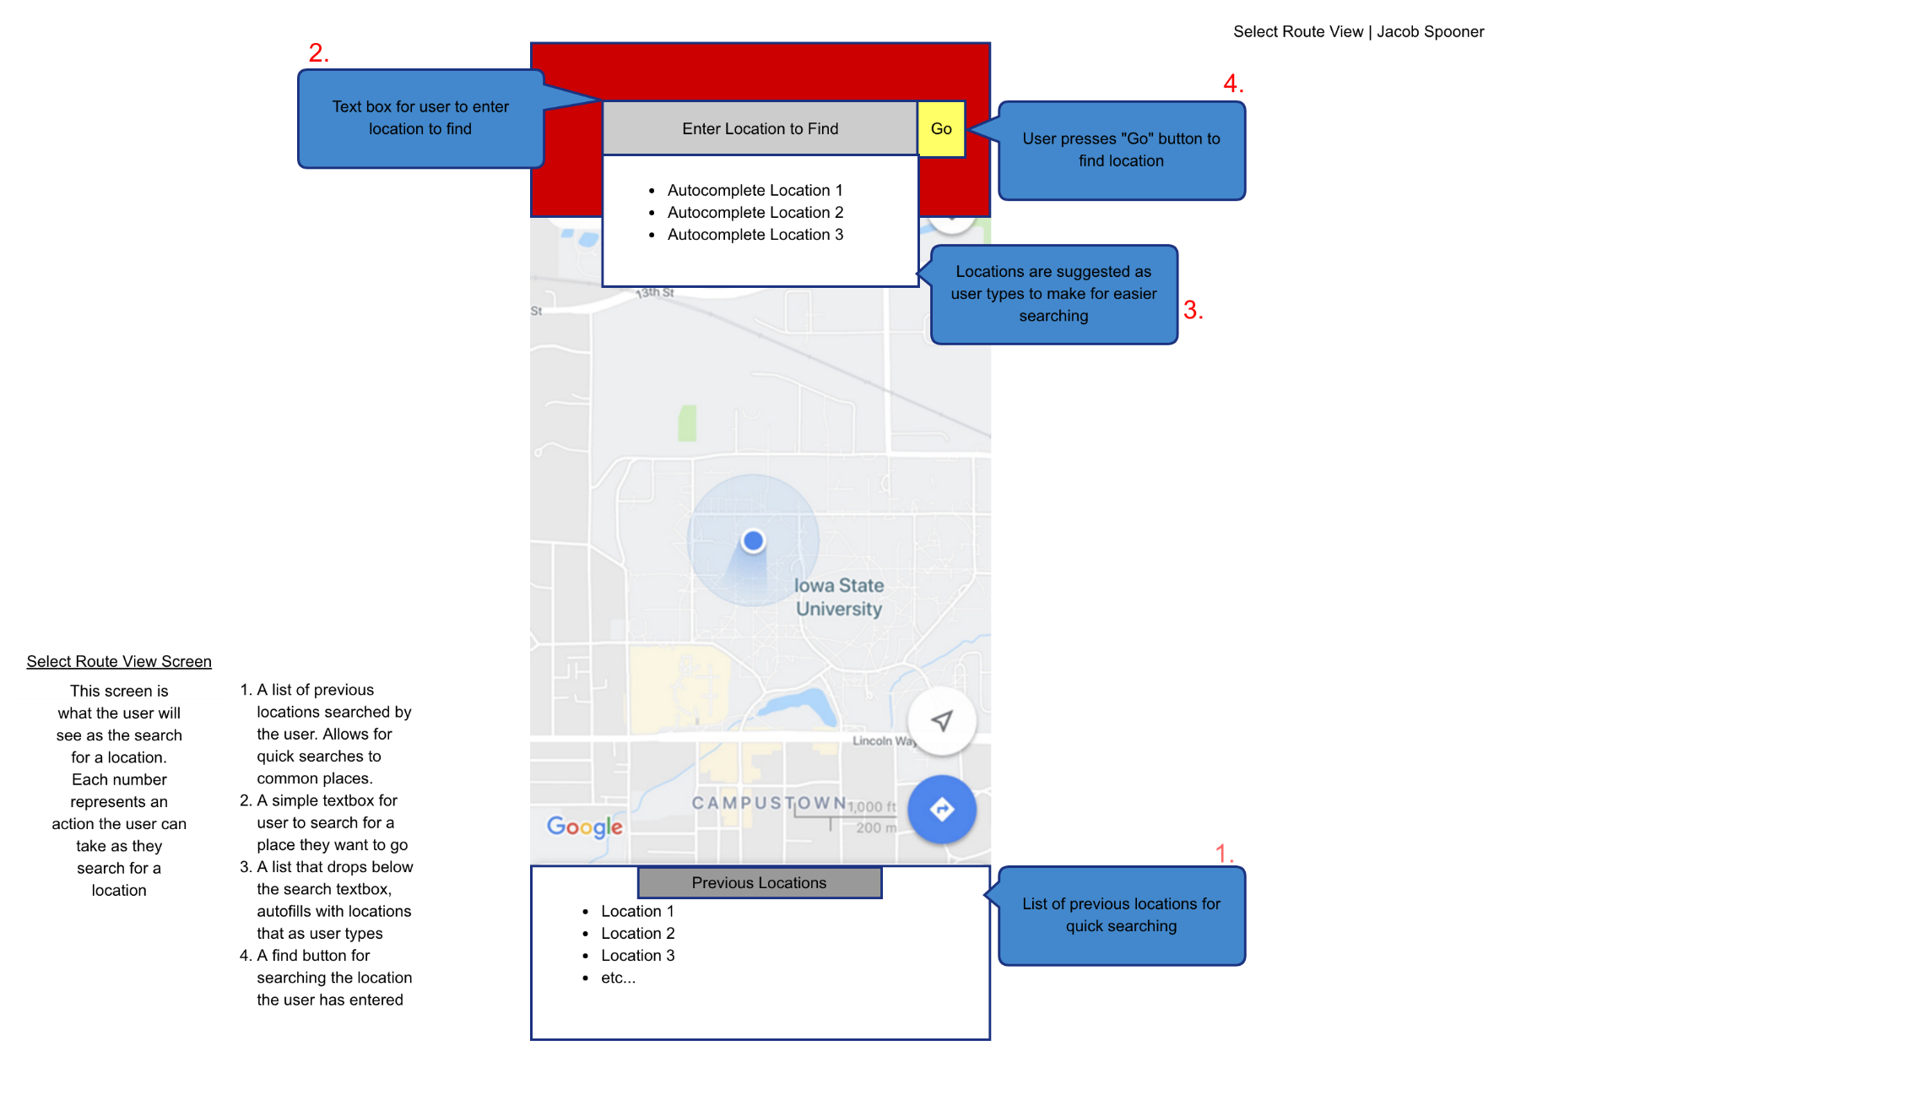

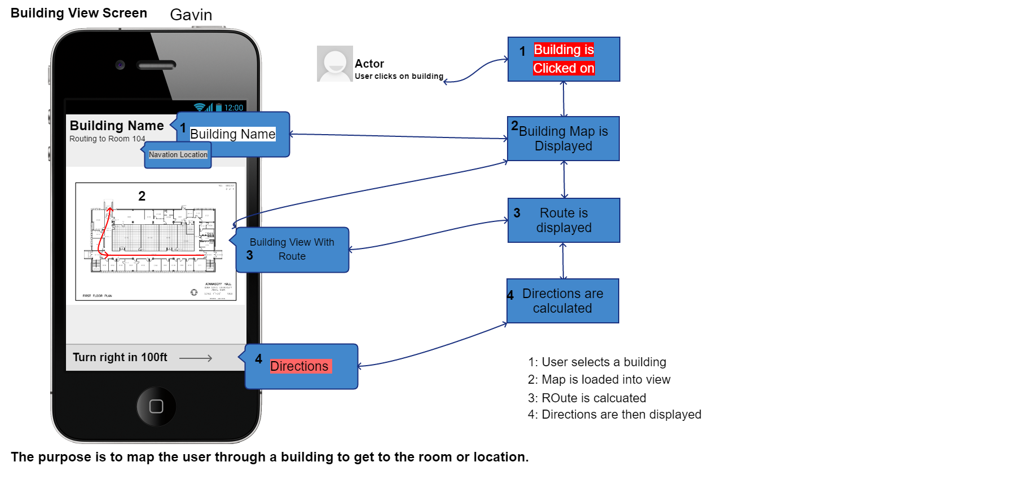

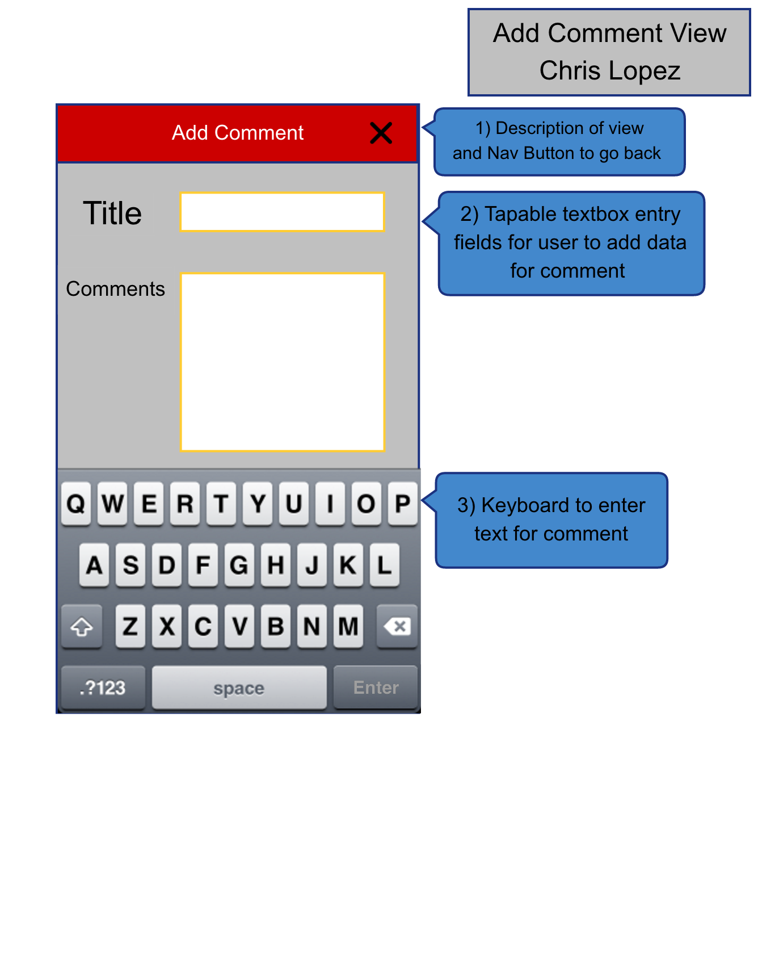

For this view, users will be able to add content to their comment. It can display the location name you are commenting on in header (1) can make a title for their post with comments describing further what they want to add. The keyboard (3) is provided for user input.

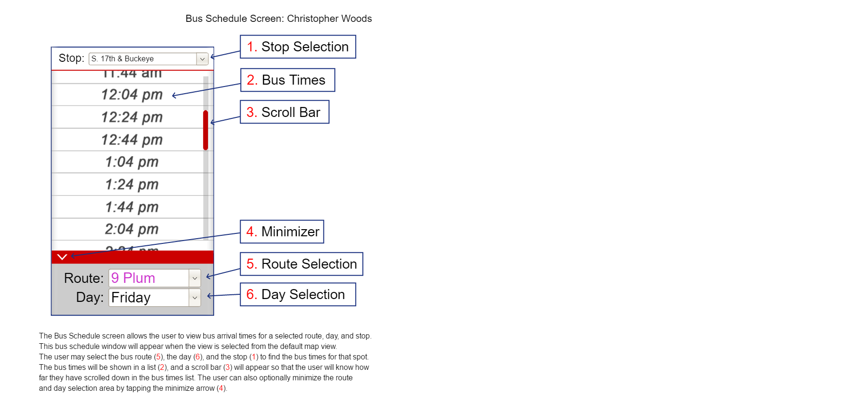

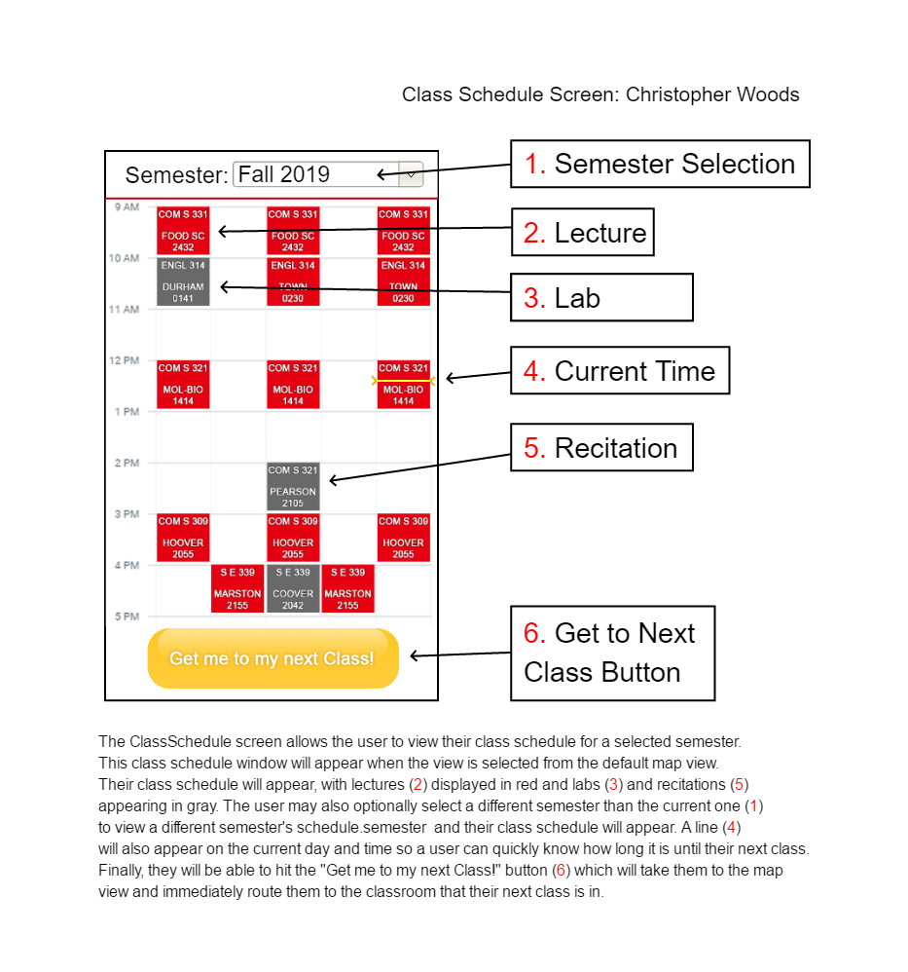

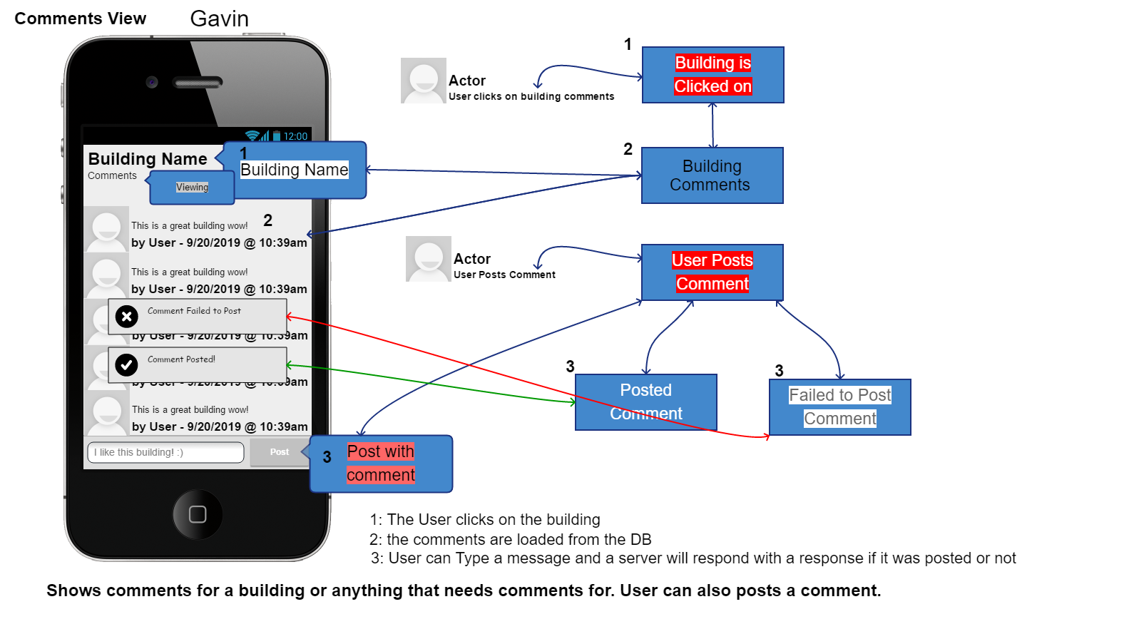

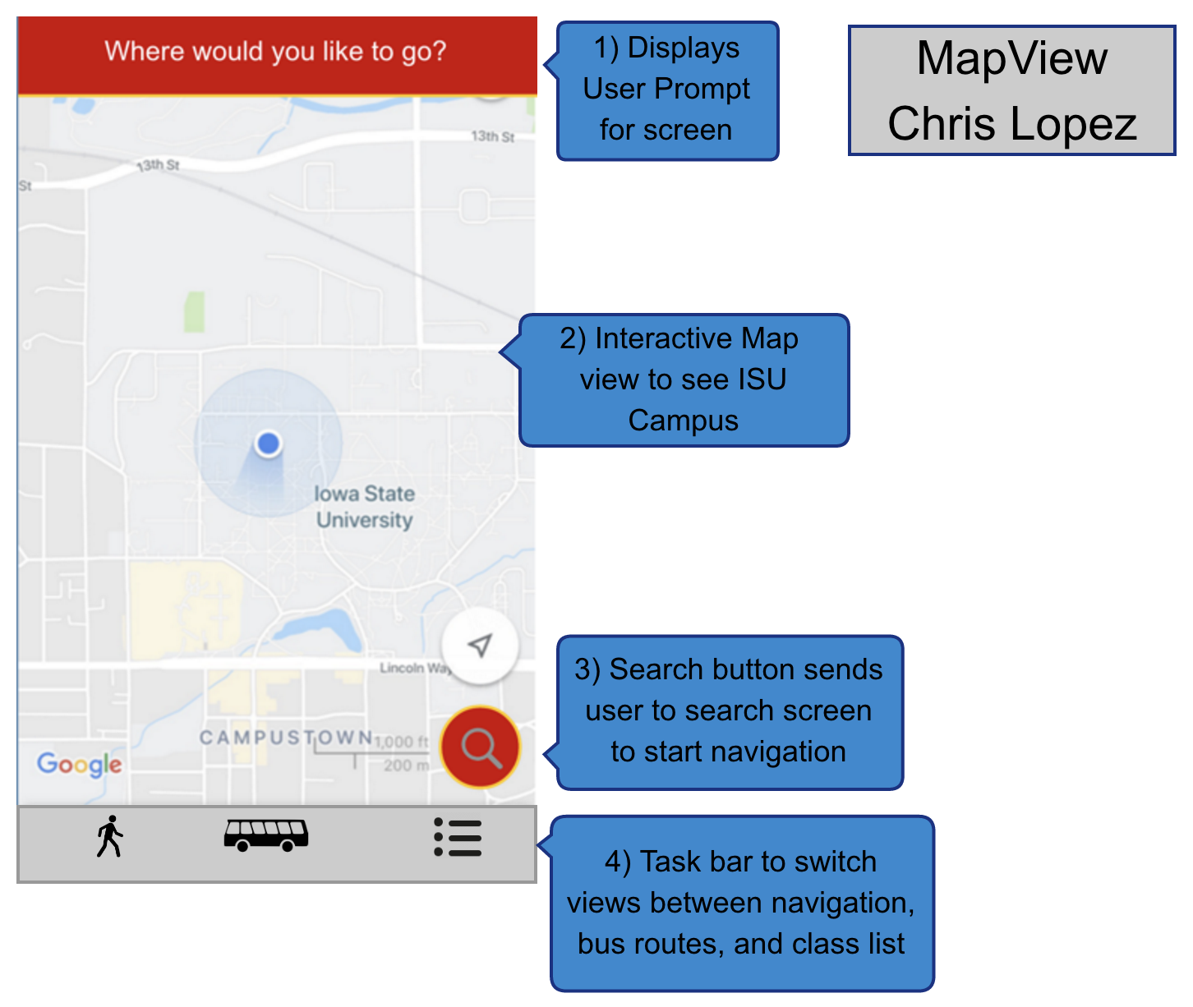

For this view users will be able to see their current location and interact with the map (2) to explore Iowa State's Campus. The Search button (3) will provide users the ability to search for locations on campus and start navigation. The bottom task bar allows switching between multiple views.

