This is a report.

***This is another report.***

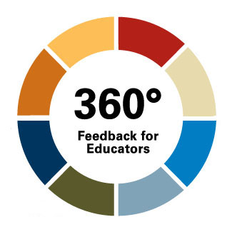

[google.com](https://google.com)

|  |  |  |  |  |  |
| --- | --- | --- | --- | --- | --- |
|  | **Heyyy** | **Heyy** | **Heyyy** | **Heyy** | **Heyyy** |
| Financial Knowledge |  |  |  |  |  |
| How my/our family expenses compare to state and/or national benchmarks |  |  |  |  |  |
| How farm/ranch financial ratios are used for business analysis |  |  |  |  |  |
| Where to find research-based estimates for costs of production |  |  |  |  |  |
| Women&#39;s roles in managing personal and business assets |  |  |  |  |  |
| Women&#39;s roles in managing personal and business assets |  |  |  |  |  |