**LAB 3**

**9/13/17**

**GAVIN MONROE**

PART 1 OR PROBLEM 1: **Mysterious Output:----------**

integerResult isn’t a double so it can’t get the decimal places after the integer. After correcting the usage of the declared vars you can see the output corrected and displayed correctly.

BEFORE:

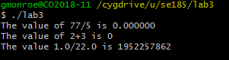

AFTER:

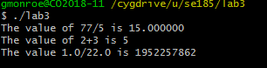

CORRECTED CODE:

// SE 185: Lab 3

// Problem 1: Mysterious Output

#include <stdio.h>

int main()

{

int integerResult;

double decimalResult;

decimalResult = 77 / 5;

printf("The value of 77/5 is %lf\n", decimalResult);

integerResult = 2 + 3;

printf("The value of 2+3 is %d\n", integerResult);

decimalResult = 1.0 / 22.0;

printf("The value 1.0/22.0 is %d\n", decimalResult);

return 0;

}

**Problem 2: Simple Arithmetic:**

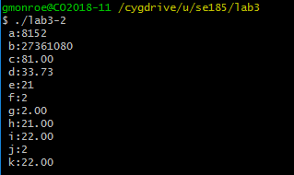

CODE:

// SE 185: Lab 3

// Problem 2: Simple Arithmetic

#include <stdio.h>

int main()

{

int a = (6427 + 1725);

int b = (6971 * 3925) - 95; //Could be a decimal if it was double

double c = 79 + 12 / 5;

double d = 3640.0 / 107.9;

int e = (22 / 3) * 3; //Could be a decimal if it was double

int f = 22 / (3 * 3); //Could be a decimal if it was double

double g = 22 / (3 * 3);

double h = 22 / 3* 3;

double i = (22.0 / 3) * 3.0;

int j = 22.0 / (3 * 3.0); //Could be a decimal if it was double

double k = 22.0 / 3.0 * 3.0;

printf(" a:%d\n b:%d\n c:%.2f\n d:%.2f\n e:%d\n f:%d\n g:%.2f\n h:%.2f\n i:%.2f\n j:%d\n k:%.2f\n", a, b, c, d, e, f, g, h, i, j, k);

return 0;

}

**PART 2:**



**CODE:**

double l = (23.567 * 23.567) / (4 * 3.14159);

double m = (3.28084 * 14);

double n = (76 - 32) * .5556;

**FROM TEXT FILE:**

a:8152

b:27361080

c:81.00

d:33.73

e:21

f:2

g:2.00

h:21.00

i:22.00

j:2

k:22.00

l:44.20

m:45.93

n:24.45

DOUBLES ARE CLEARLY needed when converting and doing formulas

**Problem 3: DualShock 4:**

Line 12: gets the x, y, z cords of the controller; Simply gets the input of the controller

Line 13: Then it prints the x, y, x limited to the 100th place and 5 padded over with long floats. And also displays the Result of what x, y, z is squared plus one another. This all happens through a loop.

CODE:

// SE 185: Lab 3

// Problem 3: Esplora

#include <stdio.h>

#include <math.h>

int main() {

double x, y, z;

while (1) {

scanf("%lf , %lf , %lf", &x, &y, &z);

printf("Magnitude of (%5.2lf,%5.2lf,%5.2lf) is: %6.2lf\n",

x, y, z, sqrt(x*x+y*y+z*z) );

}

return 0;

}