**Trials=10, no smoten/stopwords, year=int, NO length extractor**

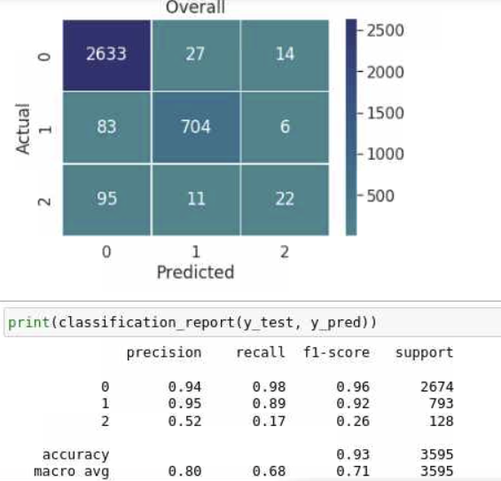

**Trials=100, no smoten/stopwords, year=int, NO length extractor**

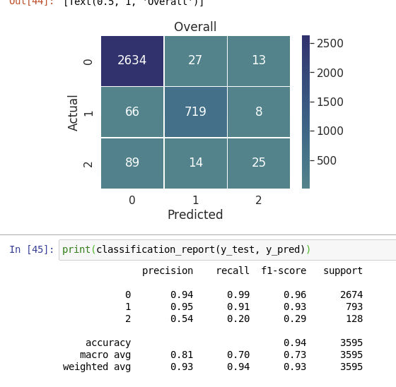

**Trials=500, no smoten/stopwords, year=int, NO length extractor**



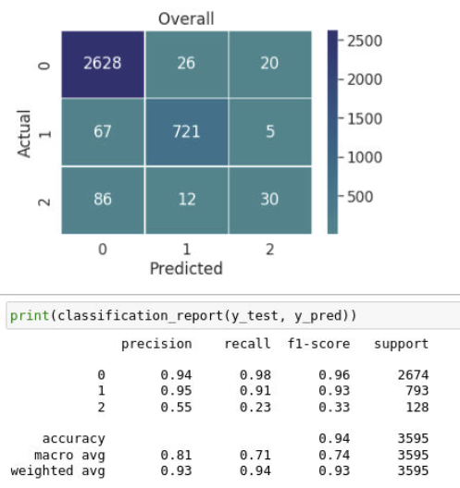

**Trials=500, smoten/stopwords, year=int, NO length extractor (faster)**



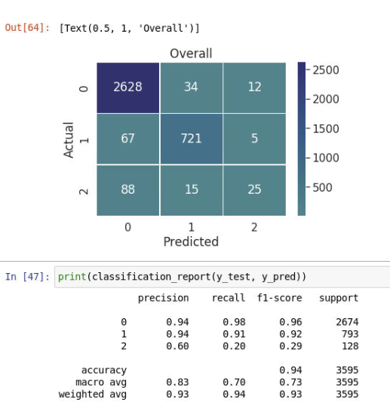

**Trials=100, smoten/stopwords, year=int, NO length extractor (faster)**



