Sample Test Case Document  
NEO-BIKE-BOOKING  
USER STORY U1: Admin functionalities.

|  |  |
| --- | --- |
| **Purpose:**  Verify the user story U1 (all parts).  Instructions: Anything in **RED** is mandatory, everything else is optional and should only be put in if it is needed to clarify how the test was performed. | |
| **Test Run Information:**  **Tester Name:** Goldy Jeyarani R  **Date(s) of Test:** 5/4/2021  Location/server being used: Test Server. | **Prerequisites for this test:** None |
| **Software Versions:**  Application: Neo-Bike-Booking alpha 0.1  Browser [used & those COTS supports]: Google Chrome v**75**.0.3770.100  Database: MySQL  Operating System: Windows, MAC OS, Linux. |
| **Required Configuration:** [ browser setup]No special setup needed |
| **NOTES and RESULTS:** | |

|  |  |  |  |  |
| --- | --- | --- | --- | --- |
| **STEP** | **TEST STEP/INPUT** | **EXPECTED RESULTS** | **ACTUAL RESULTS** | **PASS/FAIL** |
|  | Enters the details in the sign up form and clicks the submit button. | Able to navigate to the login page. | Able to navigate to the login page. | PASS |
|  | Enters the username and password and clicks the login button. | Able to see the dashboard. | Able to see the dashboard. | PASS |
|  | Click the profile link in the navbar. | Must be able to edit and click the submit button. | Must be able to edit and click the submit button. | PASS |
|  | Clicks the add bike link in the navbar. | Must be able to add the bike, click the submit button and see the bike details on the dashboard. | Must be able to add the bike, click the submit button and see the bike details on the dashboard. | PASS |
|  | Clicks the edit bike button. | Must be able to edit the bike details , click the submit button and see the edited bike details on the dashboard. | Must be able to edit the bike details , click the submit button and see the edited bike details on the dashboard. | PASS |
|  | Clicks the delete bike button. | Must be able to delete the bike , click the submit button and see the edited bike details on the dashboard. | Must be able to delete the bike , click the submit button and see the edited bike details on the dashboard. | PASS |
|  | Clicks the logout button. | Must be able to redirect to the login page. | Must be able to redirect to the login page. | PASS |

Screenshots relevant to the test case. Multiple screenshot for each test case to highlight and showcase all items validated

1.SIGN-UP FORM

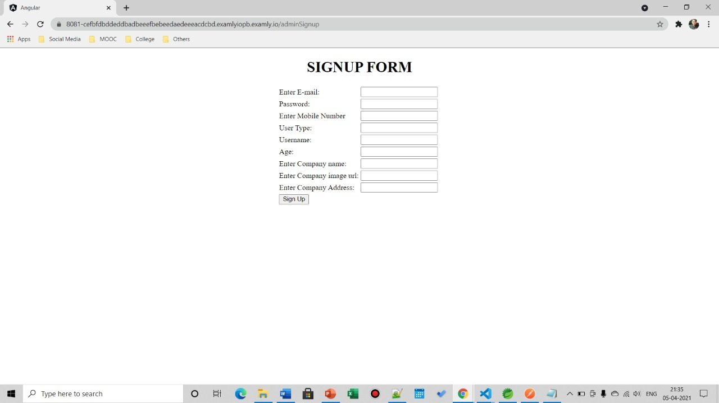

2. LOGIN

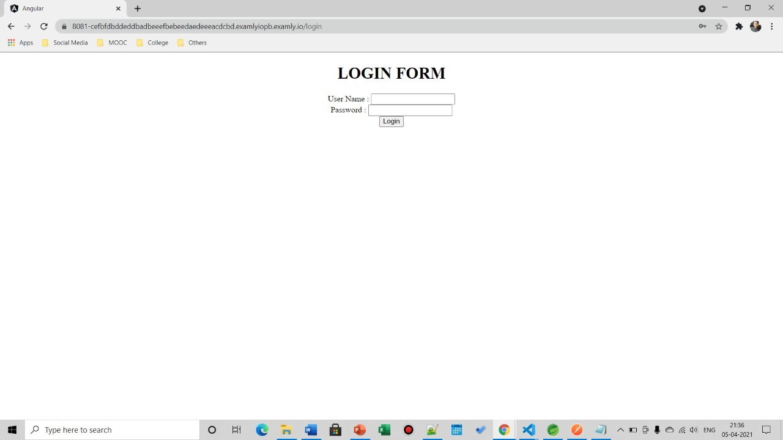

3.DASHBOARD

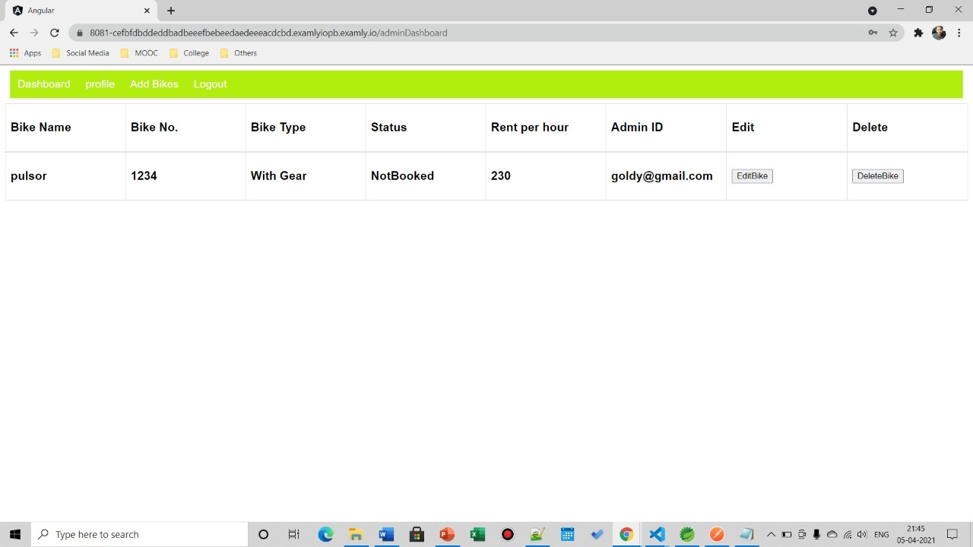

4.EDIT PROFILE

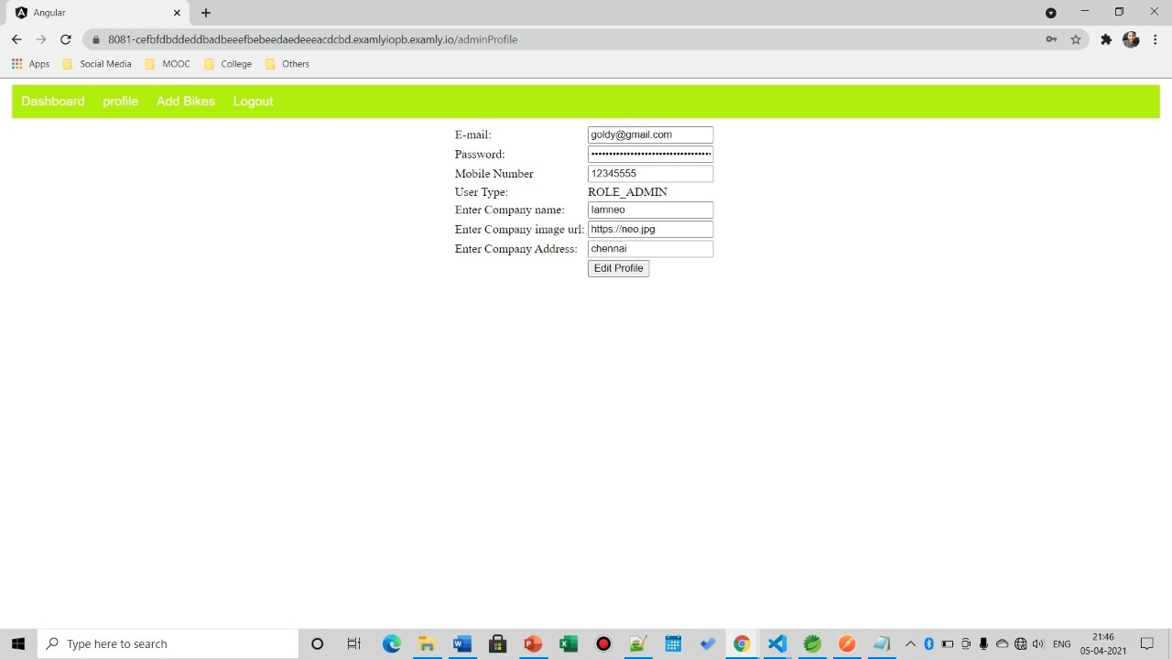

5.EDIT BIKE

