**Project Report: Kamero Research Base**

**Table of Contents**

1. Introduction
2. System Architecture
   * Backend
   * Database
3. Design Patterns and Principles
4. Process flow
5. Testing
   * Unit Testing
   * Test Coverage
6. Coding Conventions
7. Documentation
   * Code Documentation
8. Deployment
9. Future Additions and Enhancements
10. Conclusion

**Introduction**

**Kamero Research Base** is a web application designed to streamline the management of research materials and institutions. It allows lecturers to view assigned institutions, upload research materials, and review student uploads. Students can view available research topics and upload their research for review, digitizing the research process at institutions.

This report provides a comprehensive overview of the system's architecture, design patterns, testing strategies, coding conventions, documentation practices, and suggestions for future enhancements.

**System Architecture - Backend**

**Backend**

The backend is built using **Node.js** and **Express.js**. It follows a RESTful API design to handle HTTP requests and manage data interactions between the frontend and the database. Key components include:

* **Controllers**: Handle the core business logic. For example, lecturerController manages lecturer-related functionalities.
* **Middleware**: Includes authentication and authorization logic, such as authenticateToken.
* **Database Interaction**: Uses pg (node-postgres) to interact with a PostgreSQL database called Kamero-research-base.

**Database**

The system uses **PostgreSQL** as the relational database management system (RDBMS). The schema includes tables for users, institutions, research_materials, and research_topics.

* **Institutions Table**: Stores information about institutions.
* **Research Materials Table**: Stores uploaded research files and metadata.
* **Users Table**: Stores user credentials and roles.
* **Research Topics Table**: Stores different research topics.

**See ER – Diagram Below**

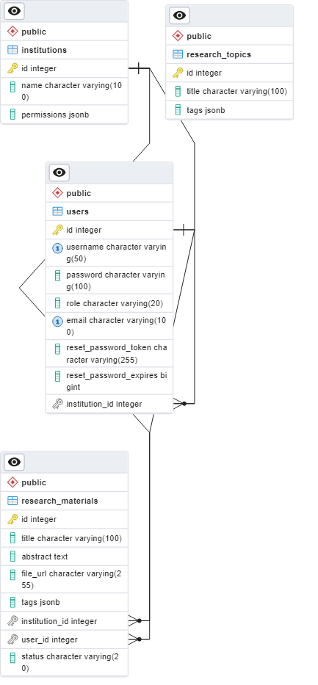

## Design Patterns and Principles

The project follows several design principles:

* **Separation of Concerns**: Different functionalities are separated into distinct modules (e.g., controllers, routes, services).
* **DRY (Don't Repeat Yourself)**: Common code is abstracted into reusable functions.
* **MVC (Model-View-Controller)**: The project loosely follows the MVC pattern, separating the data layer (models), the business logic (controllers), and the presentation layer (views).
* **RESTful Services**: The backend adheres to REST principles, making the API stateless and resource-based.

### ****Process Flow****

### ****Overview:****

* **Users:** Admin, Lecturer, Student.
* **Components:** Controllers (adminController, lecturerController, studentController), Routes (Views/Responses), Models (User, Research Material, Institution), Database.

### ****2. Process Flow for Each User****

* **Admin:**
  1. **Login/Register** - Admin logs into the system using credentials.
  2. **Manage Users** - Admin manages users (create, read, update, delete).
  3. **Manage Institutions** - Admin manages institutions.
  4. **View System Analytics** - Admin accesses system-wide analytics.
* **Lecturer:**
  1. **Login/Register** - Lecturer logs into the system.
  2. **View Assigned Institutions** - Lecturer views the institutions they are associated with.
  3. **Upload Research** - Lecturer uploads research materials to the system.
  4. **Review Student Uploads** - Lecturer reviews research materials uploaded by students.
  5. **View Institution Research** - Lecturer views all research materials associated with their institution.
* **Student:**
  1. **Login/Register** - Student logs into the system.
  2. **View Available Research** - Student views available research materials.
  3. **Upload Research** - Student uploads their research materials.

### ****3. Process Flow Diagram****

To visualize this:

* **Admin**:
  + Connects to authController -> Validates credentials.
  + Interacts with adminController -> Calls specific methods (e.g., manageUsers, manageInstitutions, viewSystemAnalytics).
  + adminController communicates with corresponding Models (e.g., User, Institution).
  + Models interact with the Database for CRUD operations.
  + Responses sent back to the admin (Success/Error).
* **Lecturer**:
  + Connects to authController -> Validates credentials.
  + Interacts with lecturerController -> Calls specific methods (e.g., viewAssignedInstitutions, uploadResearch, reviewStudentUploads, viewInstitutionResearch).
  + lecturerController communicates with Models (Institution, ResearchMaterial).
  + Models interact with the Database for data retrieval or updates.
  + Responses sent back to the Lecturer (Success/Error).
* **Student**:
  + Connects to authController -> Validates credentials.
  + Interacts with studentController -> Calls specific methods (e.g., viewAvailableResearch, uploadResearch).
  + studentController communicates with ResearchMaterial model.
  + Models interact with the Database for data retrieval or uploads.
  + Responses sent back to the student (Success/Error).

## Testing

## How the testing was conducted

### Unit Testing

Unit tests are written to validate individual components of the system, such as controller methods and utility functions. The tests ensure that each function behaves as expected in isolation. See the test cases covered below.

**adminController.test.js:**

|  |  |  |
| --- | --- | --- |
| Test Case | Expected Response | Reason for Testing |
| manageUsers - create user | Status 201, created user object | Verify user creation functionality |
| manageUsers - read user | Status 200, user object | Verify user retrieval functionality |
| manageUsers - read non-existent user | Status 404, error message | Verify proper handling of non-existent users |
| manageUsers - update user | Status 200, updated user object | Verify user update functionality |
| manageUsers - delete user | Status 204 | Verify user deletion functionality |
| manageUsers - invalid action | Status 400, error message | Verify handling of invalid actions |
| manageUsers - error handling | Status 500, error message | Verify proper error handling |
| manageInstitutions - create institution | Status 201, created institution object | Verify institution creation functionality |
| manageInstitutions - read institution | Status 200, institution object | Verify institution retrieval functionality |
| manageInstitutions - read non-existent institution | Status 404, error message | Verify proper handling of non-existent institutions |
| manageInstitutions - update institution | Status 200, updated institution object | Verify institution update functionality |
| manageInstitutions - delete institution | Status 204 | Verify institution deletion functionality |
| manageInstitutions - invalid action | Status 400, error message | Verify handling of invalid actions |
| manageInstitutions - error handling | Status 500, error message | Verify proper error handling |
| manageResearchTopics - create topic | Status 201, created topic object | Verify research topic creation functionality |
| manageResearchTopics - read topic | Status 200, topic object | Verify research topic retrieval functionality |
| manageResearchTopics - read non-existent topic | Status 404, error message | Verify proper handling of non-existent topics |
| manageResearchTopics - update topic | Status 200, updated topic object | Verify research topic update functionality |
| manageResearchTopics - delete topic | Status 204 | Verify research topic deletion functionality |
| manageResearchTopics - invalid action | Status 400, error message | Verify handling of invalid actions |
| manageResearchTopics - error handling | Status 500, error message | Verify proper error handling |
| viewSystemAnalytics | Status 200, analytics object | Verify system analytics retrieval functionality |
| viewSystemAnalytics - error handling | Status 500, error message | Verify proper error handling |

**authController.test.js:**

|  |  |  |
| --- | --- | --- |
| Test Case | Expected Response | Reason for Testing |
| forgotPassword - generate reset token | Status 200, reset token | Verify password reset token generation |
| forgotPassword - error handling | Status 500, error message | Verify proper error handling |
| resetPassword - invalid token | Status 400, error message | Verify handling of invalid reset tokens |
| resetPassword - valid token | Status 200, success message | Verify password reset functionality |
| resetPassword - error handling | Status 500, error message | Verify proper error handling |
| login - user not found | Status 401, error message | Verify handling of non-existent users |
| login - successful | JWT token, user object | Verify successful login functionality |
| login - error handling | Status 500, error message | Verify proper error handling |
| register - successful | Status 201, user object | Verify user registration functionality |
| register - error handling | Status 500, error message | Verify proper error handling |

**lecturerController.test.js:**

|  |  |  |
| --- | --- | --- |
| Test Case | Expected Response | Reason for Testing |
| GET /lecturer/institutions | Status 200, institutions array | Verify retrieval of assigned institutions |
| GET /lecturer/institutions - error | Status 500, error message | Verify proper error handling |
| POST /lecturer/research | Status 201, research object | Verify research upload functionality |
| POST /lecturer/research - error | Status 500, error message | Verify proper error handling |
| GET /lecturer/student-uploads | Status 200, uploads array | Verify retrieval of student uploads |
| GET /lecturer/student-uploads - error | Status 500, error message | Verify proper error handling |
| GET /lecturer/research | Status 200, research array | Verify retrieval of institution research |
| GET /lecturer/research - error | Status 500, error message | Verify proper error handling |

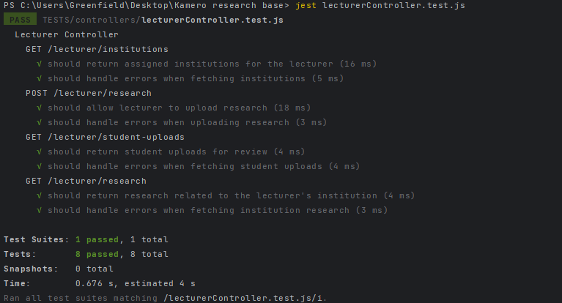  
  
**studentController.test.js:**

|  |  |  |
| --- | --- | --- |
| Test Case | Expected Response | Reason for Testing |
| GET /api/research | Status 200, research array | Verify retrieval of available research |
| GET /api/research - error | Status 500, error message | Verify proper error handling |
| POST /api/research - valid PDF | Status 201, research object | Verify research upload functionality |
| POST /api/research - invalid file type | Status 400, error message | Verify handling of invalid file types |
| POST /api/research - database error | Status 500, error message | Verify proper error handling |

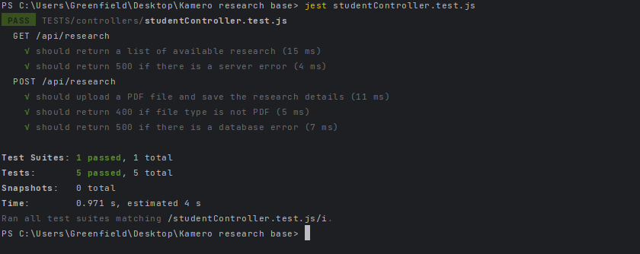

### Test Coverage

### All functions were covered.

## Coding Conventions

The project adheres to the following coding conventions:

* **Indentation and Spacing**: Proper indentation and spacing are maintained for readability.
* **Linting**: **ESLint** enforces coding standards and catches potential issues early.
* **File Naming**: Consistent naming conventions are used across the project (e.g., camelCase for variables, PascalCase for classes).
* **Error Handling**: Proper error handling mechanisms are in place, ensuring that the system gracefully handles unexpected scenarios.
* **Function Length**: Functions are kept short and focused on a single task.
* **Comments**: Important functions and complex logic are well-documented with comments.

## Documentation

### Code Documentation

* **JSDoc** is used for documenting functions, classes, and methods.
* Inline comments explain complex logic or non-obvious code snippets.

## Deployment:

The project could be set up for deployment on cloud platforms like AWS, G-Cloud, or Azure.

Continuous Integration/Continuous Deployment (CI/CD) pipelines have already been established using GitHub actions to automate testing, and could be extended to deployment.

## Future Additions and Enhancements

Several features can be added to improve the system:

1. **Role-Based Access Control (RBAC)**: Implement finer-grained permissions based on user roles.
2. **Notifications System**: Add real-time notifications for lecturers and students.
3. **Advanced Search**: Implement a search functionality that allows filtering research materials by tags, title, or institution.
4. **Analytics Dashboard**: Provide lecturers with a dashboard to view statistics about research submissions and reviews.
5. **Multi-Language Support**: Add internationalization (i18n) to support multiple languages.

## Conclusion

This report provides a comprehensive overview of Kamero Research Base, covering the system architecture, design patterns, testing strategies, coding conventions, and future improvements. Following the best practices outlined in this report, the system can be maintained and scaled effectively, ensuring its long-term success.