COMPUTER NETWORKS PROJECT REPORT
Private DNS, HTTPS/TLS, Reverse Proxy,
Load Balancing, Caching & Packet Analysis

TEAM 1
Gourav | Mac 2 - Edge Server / nginx / TLS / Load Balancer
Piyush | Mac 1 - DNS Server / Backend B
Alok | Mac 3 - Backend A / Test Client / Wireshark

Network: 10.7.0.0/19 | Gateway: 10.7.0.1

1. Executive Summary
This project implements a small private web-service architecture across three physical Macs connected to the same Wi-Fi LAN. A private DNS server resolves team hostnames to an edge server. The edge server terminates HTTPS/TLS, provides HTTP/2, and uses nginx as a reverse proxy and round-robin load balancer for two independent backend servers. The system also demonstrates HTTP caching with ETag validation, backend failover, controlled failure scenarios, and packet-level analysis in Wireshark.

2. Objectives
- Build and document a private LAN across three Macs.
- Configure private DNS for app.team1.test and api.team1.test.
- Create a local Certificate Authority (CA) and a trusted TLS certificate.
- Use nginx as an HTTPS reverse proxy and round-robin load balancer.
- Run Backend A and Backend B on separate physical machines.
- Demonstrate HTTP caching using Cache-Control and ETag / 304 Not Modified.
- Capture DNS, TCP and TLS traffic in Wireshark.
- Demonstrate expected failure modes and restore the system afterward.

3. Network Architecture
All three Macs are on the 10.7.0.0/19 network with gateway 10.7.0.1. Mac 1 provides private DNS and Backend B. Mac 2 is the public-facing edge within the LAN and runs nginx, TLS termination and load balancing. Mac 3 runs Backend A, acts as a test client, and performs Wireshark packet capture.
Machine | Person | Role | IP Address | Subnet Mask | Gateway | Interface | MAC Address
Mac 1 | Piyush | DNS + Backend B | 10.7.17.154 | 255.255.224.0 | 10.7.0.1 | en0 | 10:9f:41:c0:9e:e5
Mac 2 | Gourav | Edge / nginx / TLS / LB | 10.7.18.35 | 255.255.224.0 | 10.7.0.1 | en0 | e6:09:91:27:22:3b
Mac 3 | Alok | Backend A / Client / Wireshark | 10.7.4.38 | 255.255.224.0 | 10.7.0.1 | en0 | 72:36:67:c5:54:98

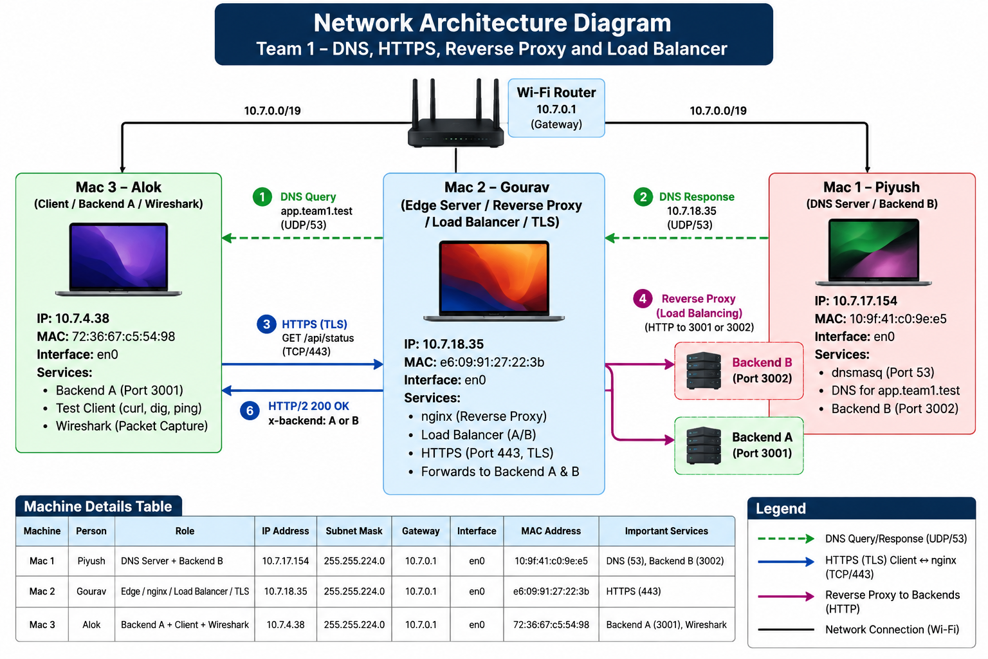
Figure 1. Team 1 network architecture and request flow.

4. Request Flow
DNS resolution: The client asks Mac 1 (10.7.17.154) for app.team1.test. dnsmasq returns Mac 2's IP, 10.7.18.35, with TTL 60 seconds.
TCP connection: The client opens a TCP connection to Mac 2 on port 443. The TCP three-way handshake is SYN, SYN-ACK and ACK.
TLS / HTTPS: Mac 2 presents the certificate signed by Team1 Local CA. The certificate covers app.team1.test and api.team1.test. TLS 1.2 and TLS 1.3 are enabled.
Reverse proxy: nginx accepts the HTTPS request and forwards it internally over HTTP to Backend A (Mac 3:3001) or Backend B (Mac 1:3002).
Load balancing: nginx uses round-robin selection. Repeated requests alternate between X-Backend: A and X-Backend: B.
Response: The selected backend returns JSON; nginx relays the response to the client over the encrypted HTTPS connection.

5. Service Configuration

5.1 Private DNS - Mac 1
dnsmasq provides the private records:
- app.team1.test -> 10.7.18.35
- api.team1.test -> 10.7.18.35
- Local TTL -> 60 seconds
- DNS service -> UDP/TCP port 53

5.2 Backend Services
Backend A runs on Mac 3 at 10.7.4.38:3001. Backend B runs on Mac 1 at 10.7.17.154:3002. Both expose:
- / - basic backend message
- /api/status - backend identity and health status
- /api/cached - cacheable content with Cache-Control and ETag

5.3 TLS and Certificate Authority
A local CA named Team1 Local CA was created on Mac 2 using OpenSSL. A server certificate for app.team1.test was signed by this CA with Subject Alternative Names for app.team1.test and api.team1.test. The CA certificate was installed as a trusted root on all three Macs. Private keys were retained on Mac 2 and were not distributed.

5.4 nginx Edge Server
nginx on Mac 2 listens on HTTPS port 443, enables HTTP/2 and TLS 1.2/TLS 1.3, and forwards requests to the two backend servers. The upstream configuration uses round-robin load balancing and failover behavior.

6. Verification and Test Results
Test | Result | Observed Evidence
Private DNS | PASS | dig app.team1.test returned 10.7.18.35 with TTL 60 using DNS server 10.7.17.154.
Trusted HTTPS | PASS | curl connected to app.team1.test:443 with certificate verification successful; no -k bypass was required.
HTTP/2 | PASS | HTTPS responses were received over HTTP/2.
Round-robin load balancing | PASS | Eight consecutive requests returned B, A, B, A, B, A, B, A.
Single-backend failover | PASS | With Backend A stopped, requests continued successfully through Backend B.
Both backends unavailable | PASS | nginx remained reachable over TLS and returned HTTP 502 Bad Gateway.
HTTP caching | PASS | /api/cached returned Cache-Control: max-age=60 and an ETag; a matching If-None-Match request returned 304 Not Modified.
Wrong port | PASS | app.team1.test resolved correctly, but connection to port 4443 was refused.
Wrong DNS server | PASS | Using 8.8.8.8 caused NXDOMAIN for app.team1.test because the private record is known only by the team's DNS server.
Wrong DNS record IP | PASS | DNS was temporarily changed to return 10.7.31.250; curl resolved the name but timed out while connecting to port 443.

7. Wireshark Packet Analysis
Traffic was captured on Mac 3 using the en0 Wi-Fi interface and saved as phase1_full_flow.pcapng. The capture demonstrates the complete protocol stack from name resolution through encrypted application traffic.
DNS: Filter: dns.qry.name contains "team1". The capture shows Mac 3 querying Mac 1 and receiving app.team1.test = 10.7.18.35.
TCP three-way handshake: The HTTPS connection shows SYN, SYN-ACK and ACK between Mac 3 and Mac 2 on TCP port 443.
TLS ClientHello: The ClientHello contains SNI for app.team1.test.
TLS 1.3: A normal TLS 1.3 connection shows ClientHello, ServerHello and encrypted handshake/application records.
TLS 1.2 certificate evidence: A forced TLS 1.2 capture exposes the Certificate handshake message. The issuer is Team1 Local CA and the subject is app.team1.test.
Encrypted application data: TLS Application Data packets are visible between Mac 3 (10.7.4.38) and Mac 2 (10.7.18.35), demonstrating that HTTP content is encrypted on the client-to-edge link.

8. Failure Analysis
- Wrong DNS server - Changing Mac 3 DNS to 8.8.8.8 produced NXDOMAIN. This proves the hostname is private and depends on Mac 1's DNS service.
- Wrong DNS record IP - Changing app.team1.test to 10.7.31.250 still produced a valid DNS answer, but HTTPS timed out. This separates DNS correctness from service reachability.
- One backend down - nginx automatically routed traffic to the remaining healthy backend, preserving service availability.
- Both backends down - TLS termination on nginx still succeeded, but nginx returned 502 because no upstream backend was available.
- Wrong port - The hostname resolved to the correct edge IP, but TCP port 4443 returned Connection refused because no process was listening there.

9. Key Technical Learnings
- DNS resolution and TCP/TLS connection establishment are separate stages.
- A reverse proxy hides backend addresses from clients and provides a single entry point.
- Round-robin load balancing distributes requests, while failover improves availability.
- TLS certificates bind a hostname to a public key and require a trusted issuer for validation.
- HTTP caching reduces repeated payload transfer using freshness rules and validators such as ETag.
- Wireshark makes the protocol sequence visible: DNS -> TCP -> TLS -> encrypted application data.
- A successful DNS lookup does not guarantee application reachability, and a reachable host does not guarantee a service is listening on a requested port.

10. Final System State
After all controlled failure tests, the configuration was restored to the normal operating state: app.team1.test resolves to 10.7.18.35 through Mac 1 (10.7.17.154), nginx is the HTTPS edge on Mac 2, and both Backend A and Backend B are available for round-robin traffic.

11. Evidence Checklist
☐ Network/IP details for all three Macs
☐ DNS query and response showing 10.7.18.35 and TTL 60
☐ Trusted HTTPS / certificate verification
☐ Round-robin X-Backend A/B output
☐ Single-backend failover
☐ 502 Bad Gateway with both backends stopped
☐ Cache-Control + ETag and 304 Not Modified
☐ Wrong-port Connection refused
☐ Wrong-DNS NXDOMAIN
☐ Wrong-record-IP timeout
☐ Wireshark DNS screenshot
☐ Wireshark TCP three-way handshake screenshot
☐ Wireshark TLS ClientHello / ServerHello screenshot
☐ Wireshark TLS 1.2 certificate screenshot
☐ Wireshark TLS Application Data screenshot
☐ phase1_full_flow.pcapng capture file

12. Conclusion
The project successfully integrates core networking concepts into one working three-machine system. Private DNS provides service discovery, TLS secures client traffic, nginx provides a stable edge and balances requests across two backends, HTTP caching demonstrates efficient web behavior, and Wireshark validates the underlying DNS, TCP and TLS exchanges. The controlled failure tests further demonstrate the difference between name resolution, host reachability, port availability, edge availability and backend availability.

