TestCase

public class broadcastReceiverTestJUnit {

SMSMessenger smsmessenger;

@Before

public void initialize() {

sms = new SMSMessenger();

}

@Test //does the app receive texts?

public void setup() {

assertEquals(sms.getString(), sms);

}

@Test //does the app receive texts?

public void broadcastReceiverTest() {

assertEquals(sms.getString(), sms);

}

}

**Instructions to Build and Use the Software**

1. Permissions
   1. Text boxes ask the user for permission to access SMS Messenger, SMS Send, and Contact Information from the phone
   2. When the User accepts, they may begin sending and receiving messages

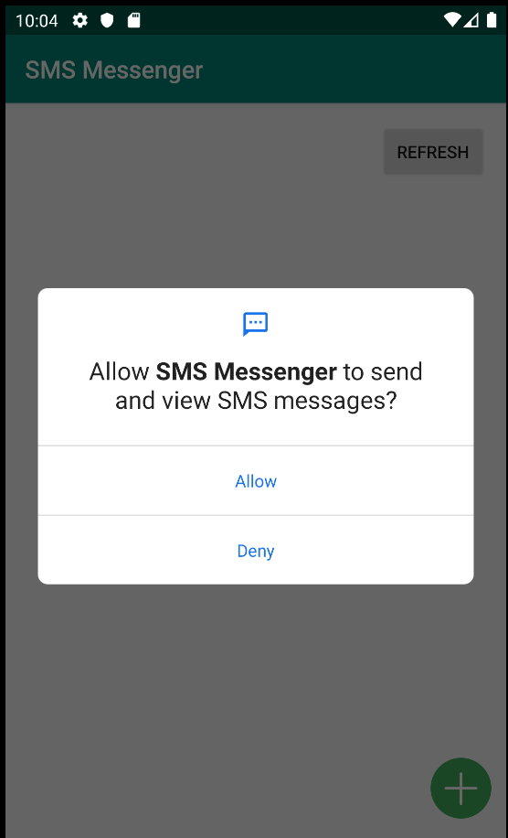

1. Sending Messages
   1. Sends a message to
2. Receiving Messages
   1. Another user sends a message to your phone. By clicking the Refresh button, the test will show up on the app.
   2. The messages are in order of the last text sent, and by the sender.

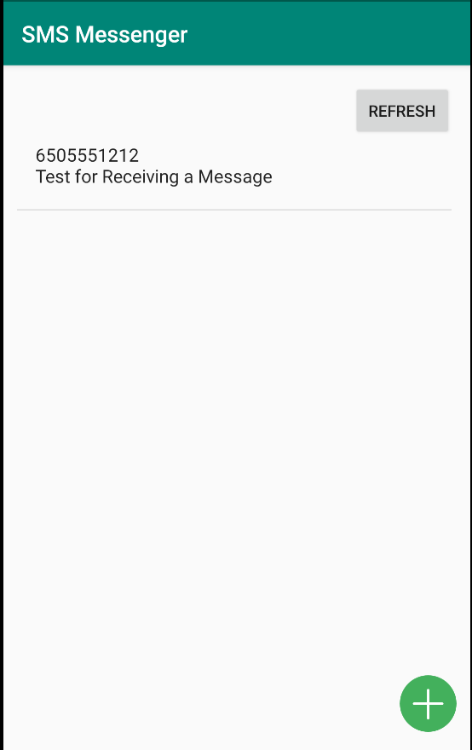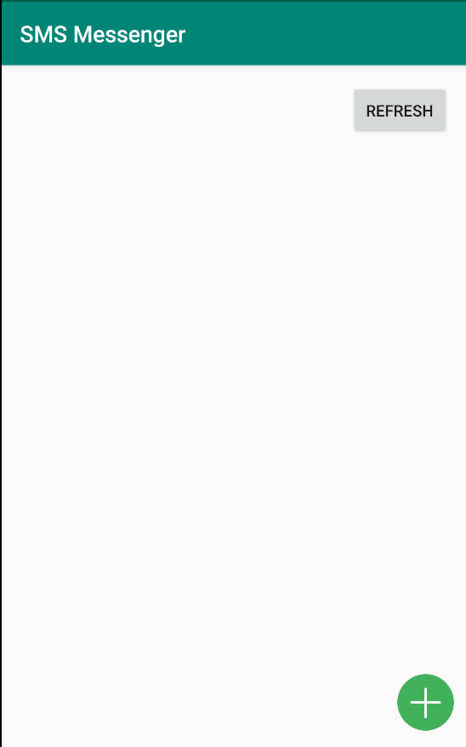

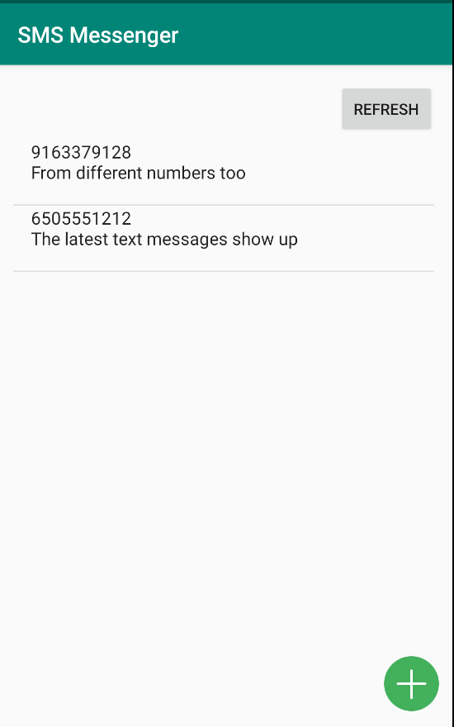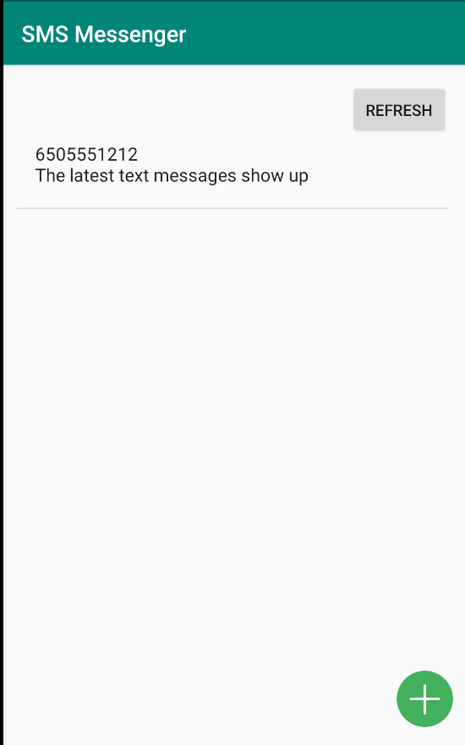

1. Individual Conversation Display
   1. See all texts between a sender and receiver
   2. Automatically updates
2. Toolbar including the Search Function
   1. Search texts using the toolbar

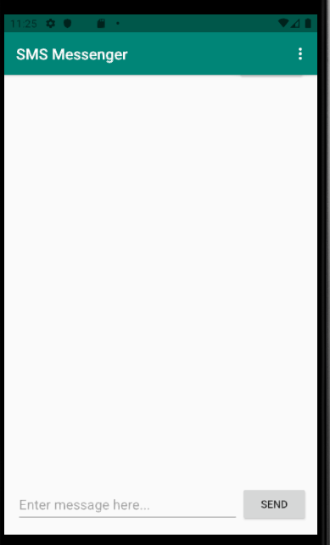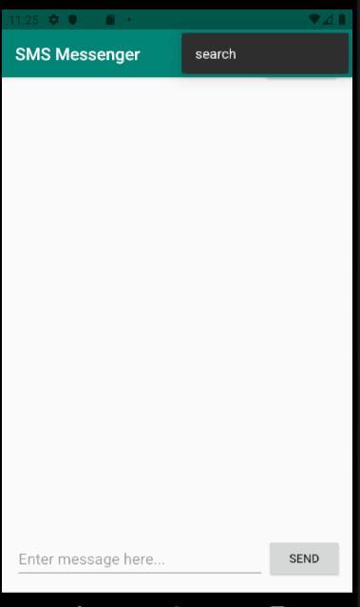

1. Connection to Contacts
   1. Search Contacts