Polyurethane Internal Measurement Probe
By Gabriel Wimmer
Contents:
Context 1
Objectives 2
Proposed Solution 2
Design Choices 2
Microprocessor 2
Power 3
Storage 3
Measurement 4
Probe Case 4
Code Summary 4
Testing and Results 5
Usage 5
Quick Start 5
Future Improvements 6
Code Improvements 6
Probe Improvements 6

Context
Many buggy teams heat their wheels to allow for better grip and speed throughout the hills. Different processes of holding the buggy above the ground prior to start (floating) or shielding the wheels before the starting time are employed to try and retain as much heat as possible. Fringe buggies are unique in that most of the buggies in their fleet have fairings to help shield their wheels. This provides aerodynamics benefits and it is presumed that the fairings (along with the fairing coverings) help retain heat. This project’s goal is to quantify the benefit of the fairing’s ability to retain heat and to determine if lining the insides with mylar or heat tape provide meaningful benefits.

Objectives
The main goal of the project is to reliably measure the loss of heat from the buggy’s wheels to determine the efficacy of fairings and fairing liner materials. We have currently performed tests on a stationary buggy by lifting it up, installing the heated wheels and manually spinning it, measuring temperatures with an infrared thermometer at different intervals. This does not provide a continuous stream of temperature information and doesn’t allow for testing heated wheels on a buggy rolling on the ground. It also requires removing the fairing covers to get an accurate reading. The infrared thermometer also appears to detect heat signals from the rim or other components in the fairings, sometimes muddying the results.
Ideally, we would prefer to get more temperature readings as the wheel cools down to determine the rate of cooling. We would also want to measure the temperature as the buggy rolls in a scenario that is more representative of an actual race.
To this end, we would need a device that continually measures the temperature of the wheel while storing or transmitting the results. This would require a device that fits within the fairings and that does not impede the function of the wheel, brakes or steering.
The device needs to also measure the initial temperature as the wheel comes out of the heater, meaning it must withstand temperatures up to 170F (the agreed upon max temperature for our wheels polyurethane).

Proposed Solution
The internals of the fairings have very little extra clearance. To ensure that the probe will not interfere with any of these critical components, the only viable free space appears to be between the spokes of rim. Due to the spinning of the wheels, batteries, sensors and microprocessors cannot be stored elsewhere on the buggy without the use of a slipring or modification of the buggy shell. This leaves ~2-3 cubic inches of space to fit a measurement probe.
To accomplish this, I decided to develop a battery powered, Arduino based, temperature probe that fits within the spokes of the wheels to record the temperature of the polyurethane as the buggy rolls. The device will store the measurements for output and review afterwards.

Design Choices

Microprocessor
To accomplish this, I opted to use an Arduino pro Mini 3.3v. This is one of the smaller microprocessors and its dimensions just barely fit within the allotted space. I opt for the 3.3v version instead of the 5v as I do not need the extra clock speed that the 5v version has. The 3.3v version allows me to use common coin cells to power the device, preventing the need for larger batteries.

Power
I chose to use a pair of CR2032 coin cell batteries. This is a small battery that has a diameter less than the width of the rims. It provides 3.3v DC and a peak current of ~20mA. Originally, I had desired to use a single CR2032 to power the Arduino as it would allow the probe to fit between a single gap between the spokes of the wheel. However, in testing, the CR2032 batteries only provided ~3.0-3.1v. The Arduino’s voltage controller is unable to power the device with this low of a voltage. I could skip the voltage controller and provide the coin cell’s power straight in to the Arduinos VCC but that raises more issues. As lithium batteries heat up, their voltage drops. Without going through the voltage controller, brownouts can occur that could cause permanent damage to the device. The storage solution that I use also has peak current draws that would exceed one coin cell’s peak current. This could be compensated with large capacitors, but that would defeat the point of only using one battery.
The current solution uses 2 CR2032 coin cells wired in series to provide ~6 volts to the Arduino’s voltage controller. This solution is resilient to the drops in voltage due to heat and will be able to withstand the current spikes demanded by the flash module’s writing. I also make use of a XXX uF ceramic capacitor to smooth the power and 10 uF Electrolytic capacitors to help with voltage dips when the flash memory writes.
It is crucial that Lithium Primary cells are used. A Lithium Polymer (LiPo) battery will combust at the temperatures that this probe needs to operate at. Lithium Primary cells are rated past 200F, making them a safe choice for this project.

Storage
While on a moving buggy, there are few options to reliably transmit the readings, meaning that our only viable option is to store the temperature readings to pull off of the probe after the test is done. The RAM on an Arduino does not have sufficient space to hold a meaningful amount of [temperature, timestamp] datapoints. Arduinos also possess EEPROM that could potentially be used, but there is only 1kB of space, meaning we can only hold ~40 datapoints if we store the temperature as an 8-byte unsigned integer and the timestamp as a 16-byte unsigned integer. EEPROM can only be written a limited amount of time, reducing the longevity of the device.
I looked into using a micro-SD card as they are capable of storing large amounts of information, but to get one that can withstand the high temperatures would be very costly.
This leaves flash memory. I choose a 32MB SPI flash module as it is lightweight, space efficient and will hold more datapoints than we will likely need. The test results will be stored to flash and then can be transferred via a serial USB connection to a PC. Data points will be buffered in RAM and then written to flash to prevent needing to write to flash for every measurement.

Measurement
I am using a 10kOhm thermistor paired with a 10kOhm resistor set up in a voltage divider to measure the temperature. The Arduino reads the voltage via an analog input pin and performs the Steinhart-Hart equation to get a Fahrenheit measurement. The probe can either be attached to the side of the wheel and taped on with reflective heat tape, or a small hole can be drilled into the polyurethane to insert the thermistor.

Probe Case
To properly attach to the rims of the wheels, I 3d modeled a case that fits snuggly between the spokes. Many popular 3d printing materials such as PLA and PETG have glass transition temperatures below or near 170F, ruling them out as potential options. Compared to other commonly used 3d printing filaments, nylon has a relatively high heat deflection temperature. When combined with carbon fiber additives, nylon is able to withstand temperatures way beyond what this use case requires. The specific polymer used is Polymaker’s PA6 CF.
Since the buggy can reach speeds of up to 40mph and have no dampening suspensions, the device must withstand severe vibrations. The case has holes to allow for zipties to ensure firm attachment. To protect the electronics, I opted to use a 2 part silicone potting compound. I specifically chose this McMasterCarr item: 74965A52 due to its gel like consistency, hoping to allow the compound to wick under the heat shrink to envelope the solder joints within.
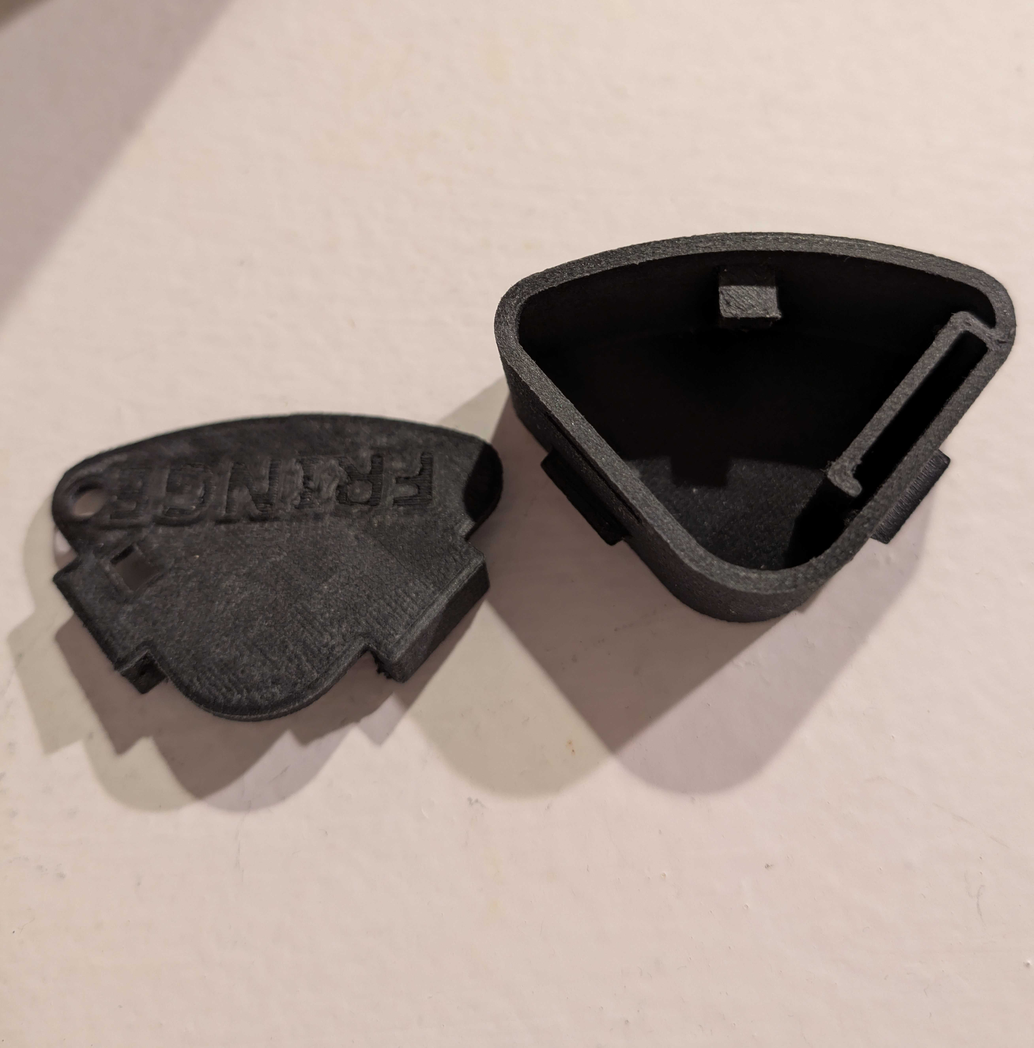Figure 1: Case and its lid

Code Summary
The code that runs on the Arduino starts by initializing key variables and data structures. As mentioned before, each datapoint is a temperature timestamp pair where the temperature is an unsigned 8-bit integer and the timestamp is an unsigned 16-bit integer. This gives us a temperature range of 0-255 Fahrenheit and a timestamp range of 0-65536. Our expected temperature readings are not expected to go past 170F, leaving us a good margin of safety.
The probe is controlled by a single button. A short press of the button will begin a testing sequence while holding the button for several seconds will begin data transfer. The testing sequence begins a loop of reading analog inputs from the thermistor and converting it to Fahrenheit via the Steinhart-Hart equation. These datapoints are saved into a buffer. After the buffer fills up, or the test ends, the buffer is written to the flash storage module. Currently, measurements are taken once per second.
The data transfer function relies on a UART serial connection to a computer. After plugging in the RX and TX pins, the Arduino can read all of the stored data from flash and print them out to a terminal on your PC for analysis.

Testing and Results
The control for our tests was performed by mounting the wheel to an open air frame and then spinning the wheel with a belt sander to simulate the road. The following tests were done with the wheel attached to a buggy to measure the impact of the buggy’s fairing, fairing cover and heat tape. These were also spun using a belt sander at the same speeds as the control.
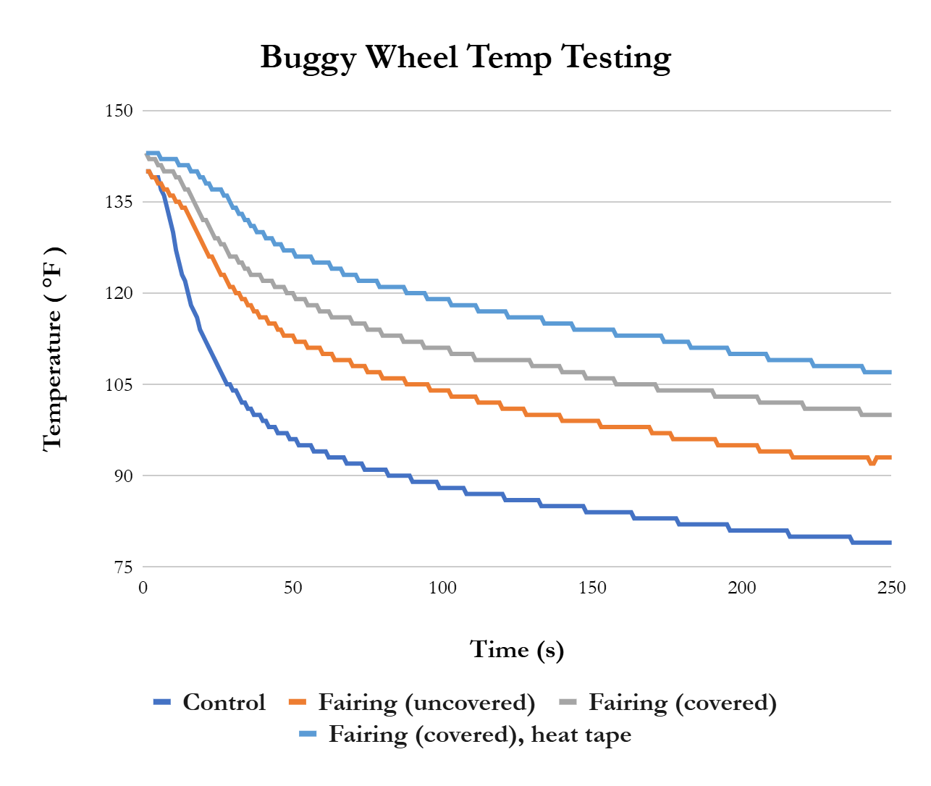

Usage

Quick Start
- Put battery case and probe case in a wheel
  - Put the lids on both to affix them to the spokes
- Connect the power from the battery pack to the probe
  - CRITICAL: Connect the black from the battery pack (negative) to the black wire from the probe. The yellow from the battery connects to the orange from the probe.
    - Incorrect connection here will permanently kill the probe
- Press the button on the probe (do not hold for longer than 4 seconds) to start recording temperatures
- When the measurements are done, connect to the USB serial device
  - Probe red -> usb blue, probe blue -> usb green, probe yellow -> usb red, probe black (ground) -> usb orange, probe orange (raw power) -> usb yellow
  - Incorrect connection of the ground and power will permanently kill the probe
- Use PUTTY to open a serial connection (baud rate 9600) on the devices comm port
- Press the button on the probe for more than 4 seconds to dump the measurements to the serial connection
To use the probe, open both the batter pack and the probe cases and place them between the spokes of the wheels. You can then place the lids on both of the cases, ensuring that the wires for the power supply are routed through the holes in the case, along with the thermistor. Also ensure that the

Future Improvements

Code Improvements
There are several areas in which the code can be improved. Right now, the constants used for the Steinhart-Hart equation are general ones for the given 10kOhm resistor and 10kOhm thermistor pair. To get a more accurate Fahrenheit reading, it would be better to calibrate these constants. For the purposes of measuring the decay in thermal energy, this isn’t as critical, but would help provide more useful information.

Probe Improvements
The case currently has a lid that clips on to the top, limiting the debris that can get into it. The clips that stick out from the case also serve to keep the case within the spokes of the wheels. Designing a case that better molds to the shape of the spokes would help prevent rattling and ensure a secure fit. Due to the slight differences in rim design, this would restrict which wheels the probe can be used on. A more robust attachment method would benefit the device greatly.

