CDJ Clock
CDJ Clock is the missing link between Pioneers Pro DJ Link and Ableton Live.
CDJ Clock generates MIDI beat clock from Pioneers Pro DJ Link. With CDJ Clock anything what understands MIDI Beat Clock can be synced to Pioneer CDJs. CDJ Clock runs on Mac.

Ableton Live can be tempo mastered from external sources. To sync external devices the preferred method is MIDI. One of the main functions of Pro DJ Link is BEAT SYNC between Pioneers CDJs by connecting the CDJs via Ethernet. The songs need to be analyzed with Recordbox to use this function. The beats then can be synced between the CDJs and DJM. It is not possible to natively connect to the Pro DJ Link, only the DJM (mixer) is sending out MIDI beat information’s on both the USB and the DIN connection.

The Problem: The DJM itself has a MIDI-Out function and sends MIDI beat clock signals but they were recalculated by build-in beat analyzing and will divert from the beat sync of the CDJs. Pressing the MIDI-Start/Stop button on the DJM will simple send out an MIDI Start or MIDI Stop signal when the button is pressed without any relation to the Pro DJ Link synchronization.

The Solution: Using CDJ Clock will recalculate the bpm based on the traffic information of the Pro DJ Link Ethernet connection between the CDJs and the DJM and continuously sends out a stable MIDI beat clock. This works between 60-180bpm. CDJ Clock will listen to MIDI commands. If a MIDI Start or MIDI Continue is received CDJ Clock waits for the next beat of Pro DJ Link and sends out the last MIDI Song Pointer and MIDI Continue. The MIDI Song Pointer can be moved in 4 or 32 beat steps.

Hardware Setup
To fully use CDJ Clock you need to connect the CDJs, DJM and the Mac with Ethernet and USB.

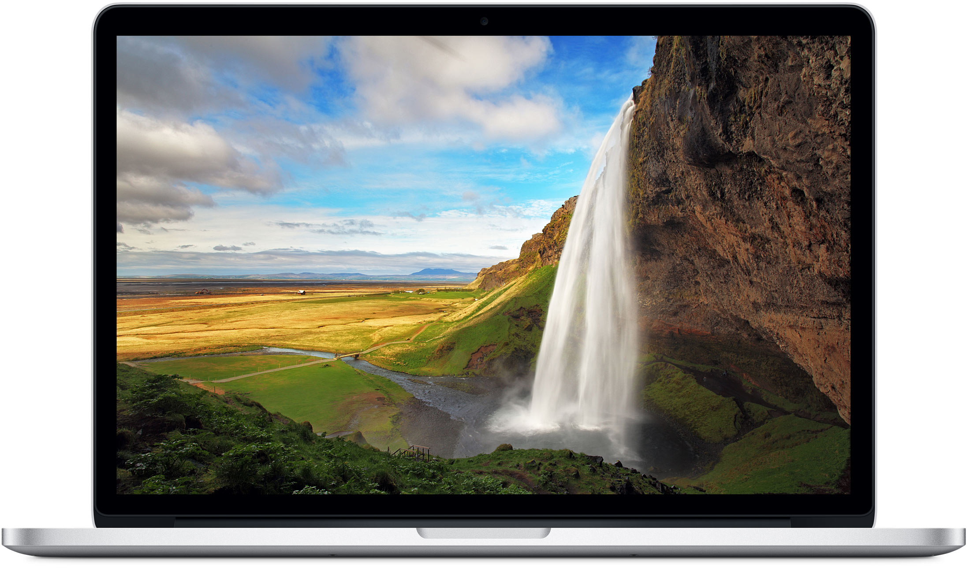
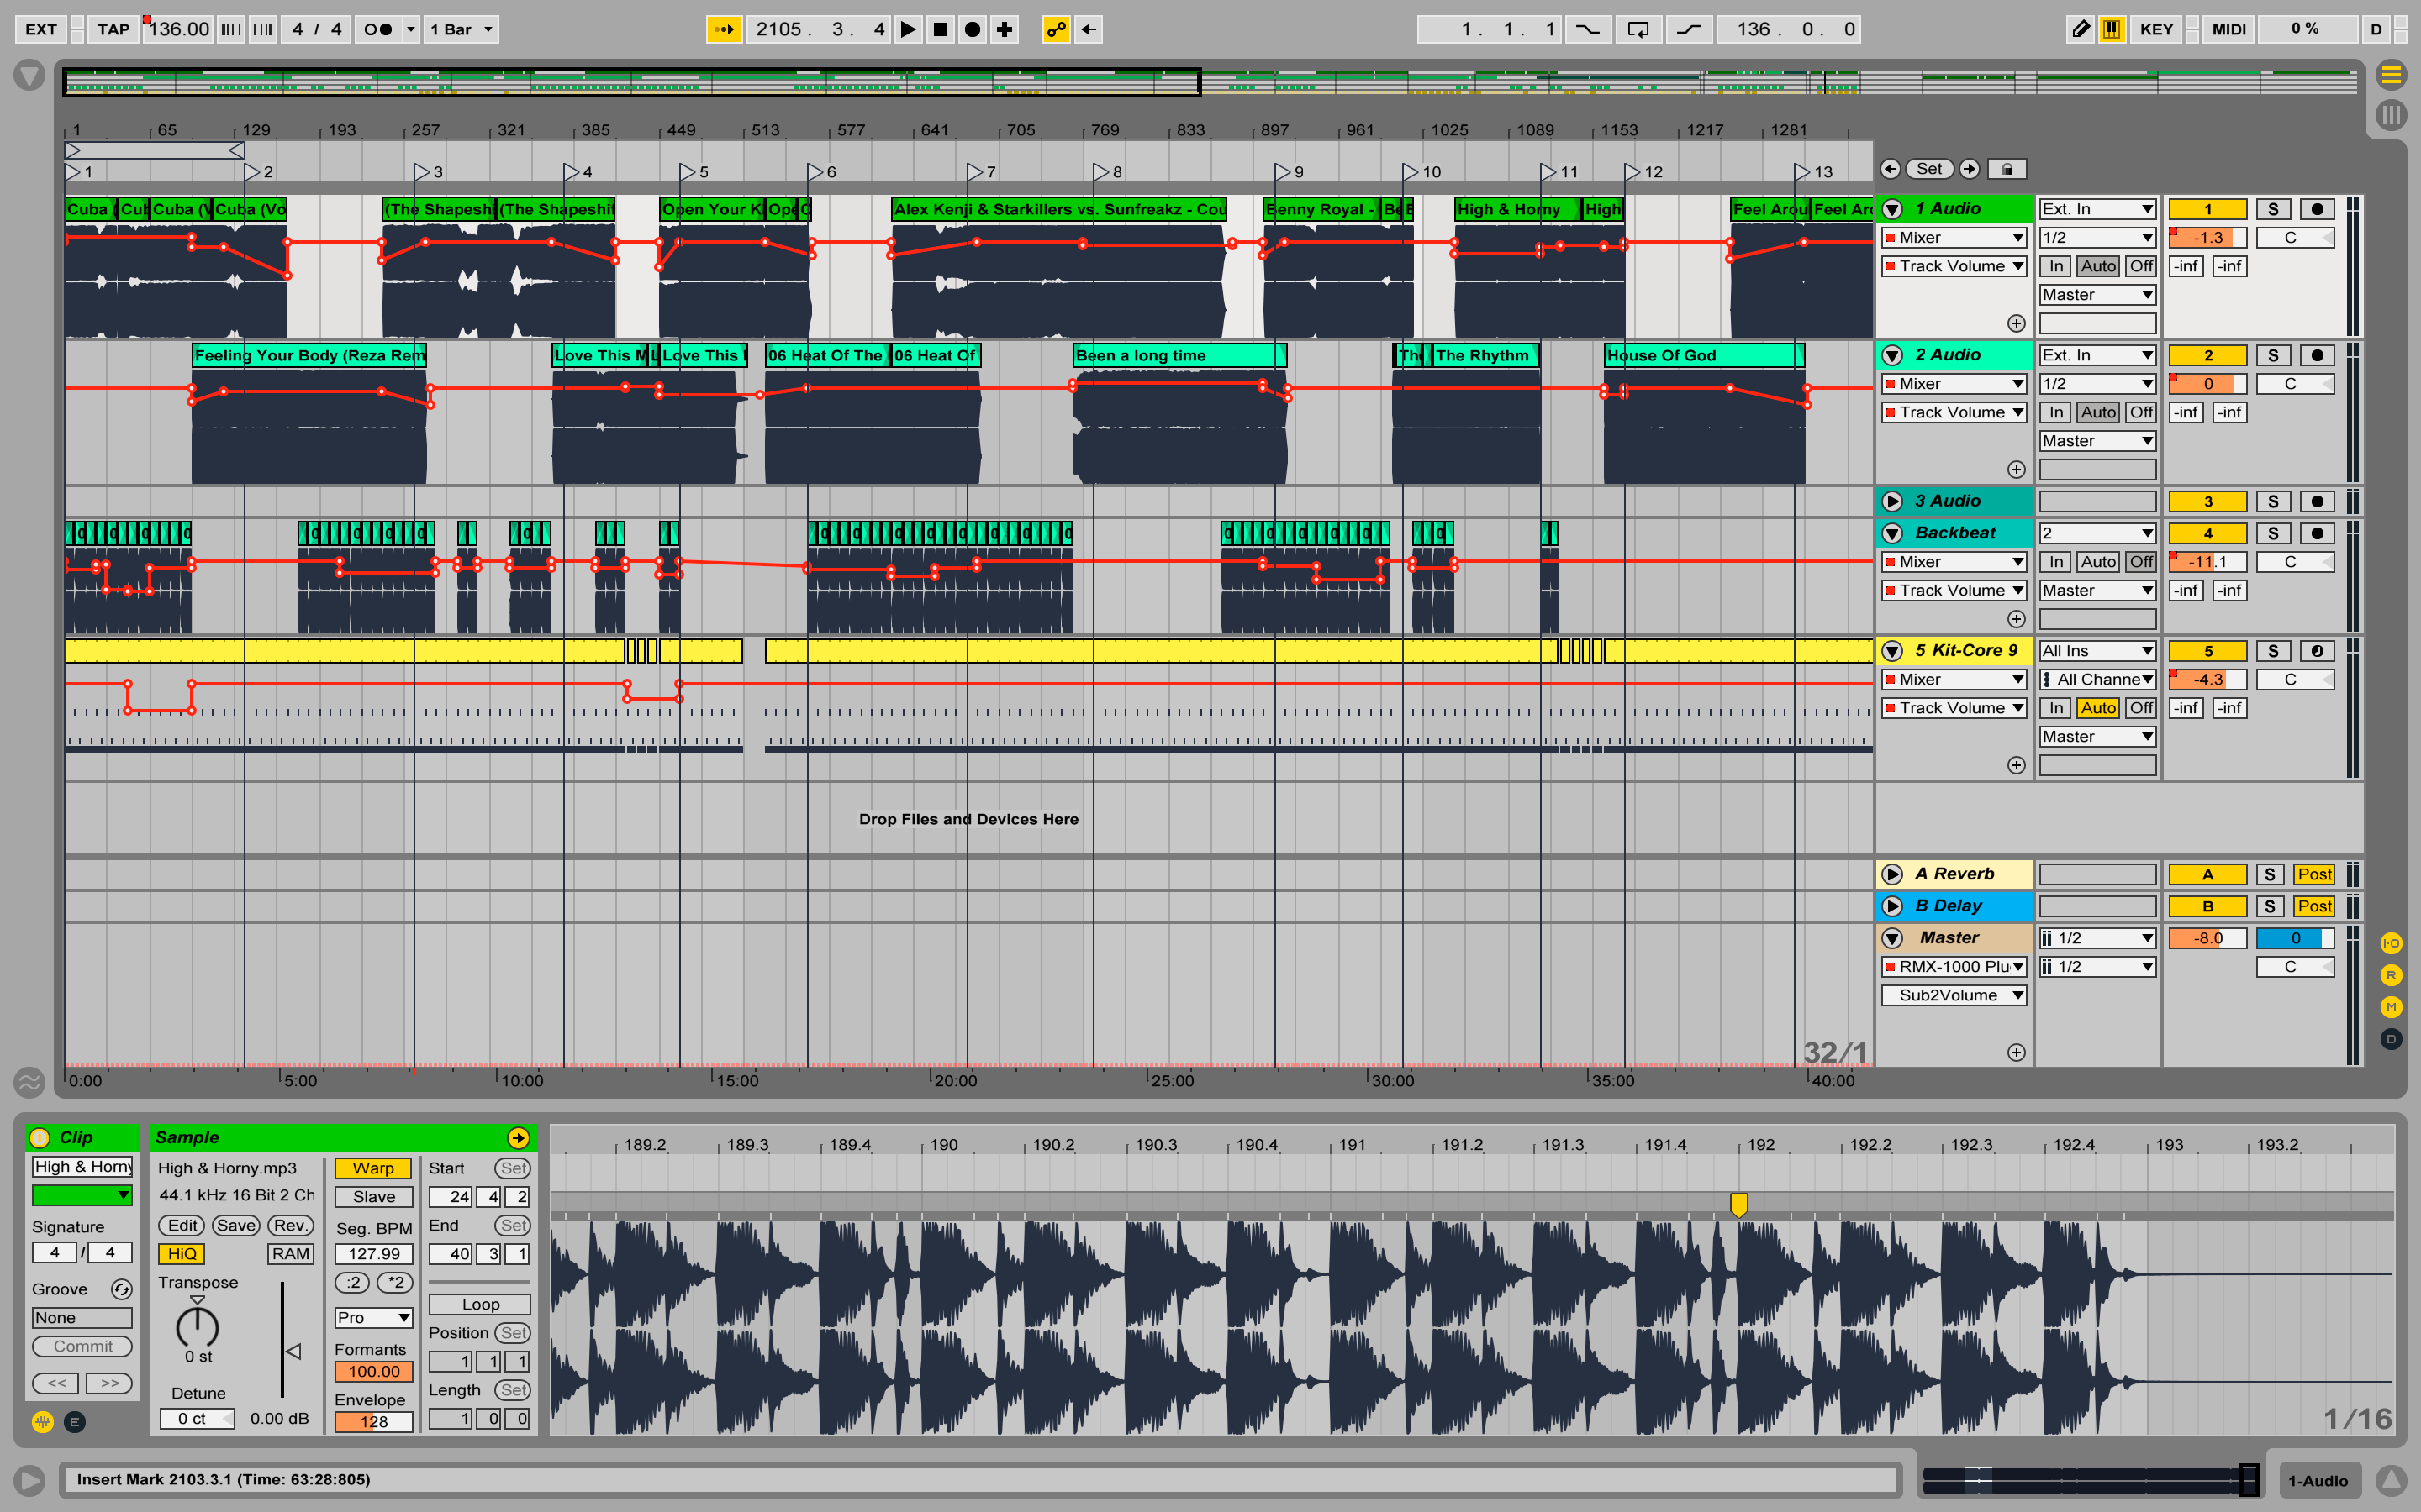
Typical Hardware Setup
Mac

Ableton Live

Ethernet
USB
S/PDIF
Ethernet
S/PDIF

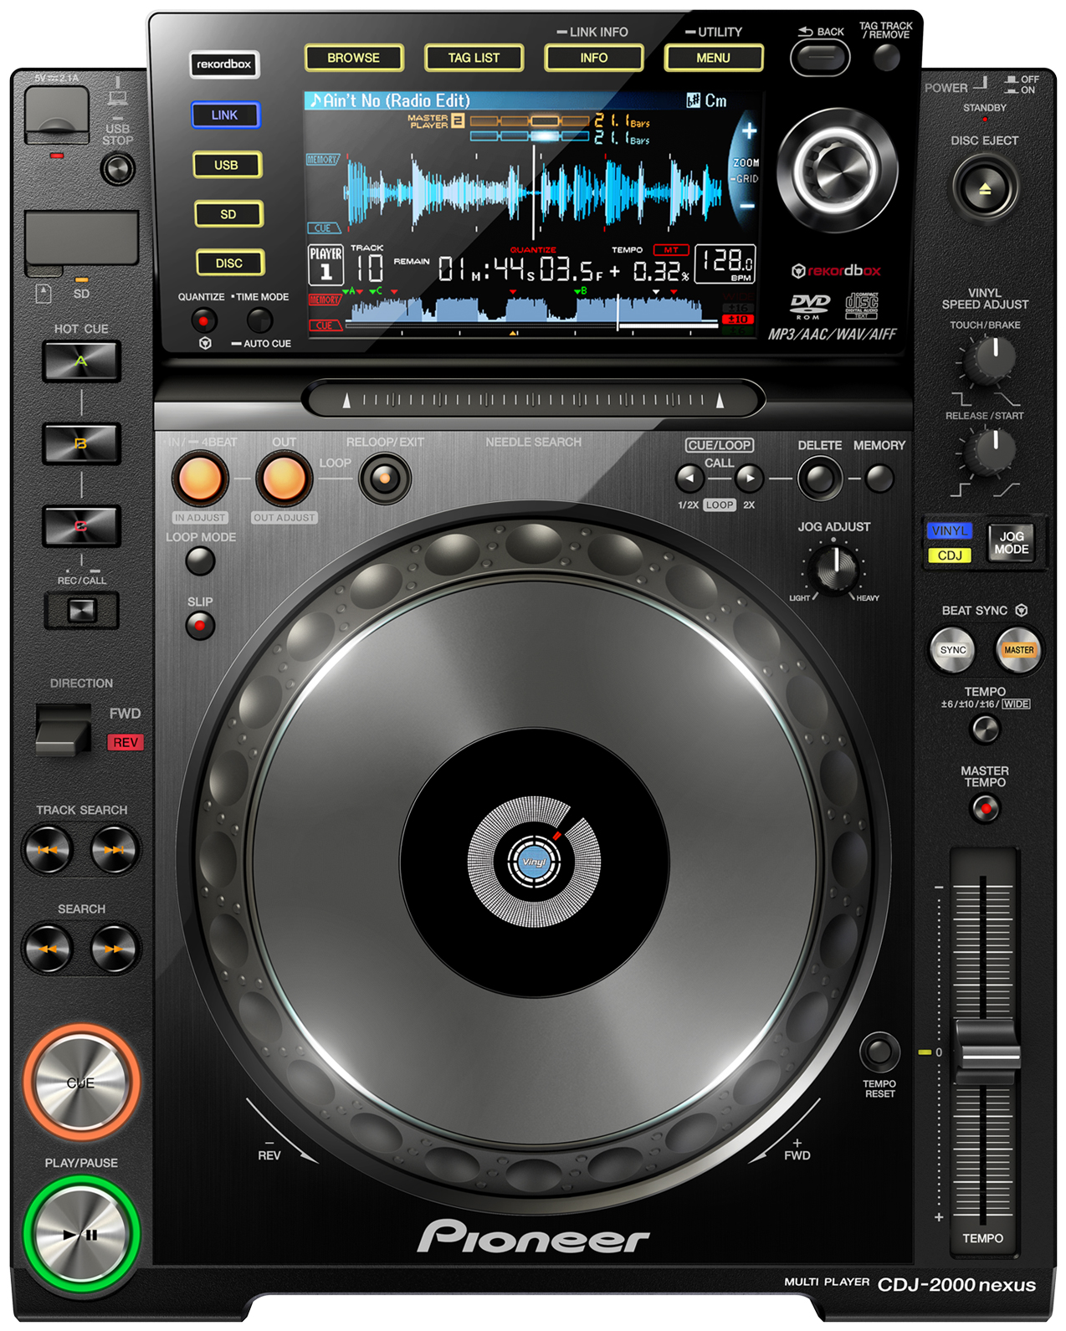
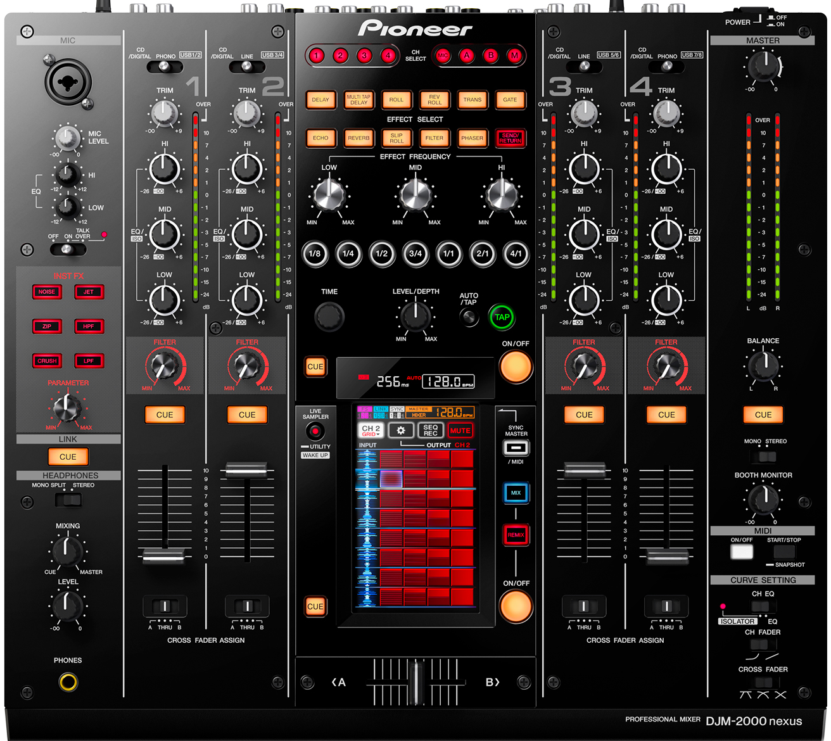
USB
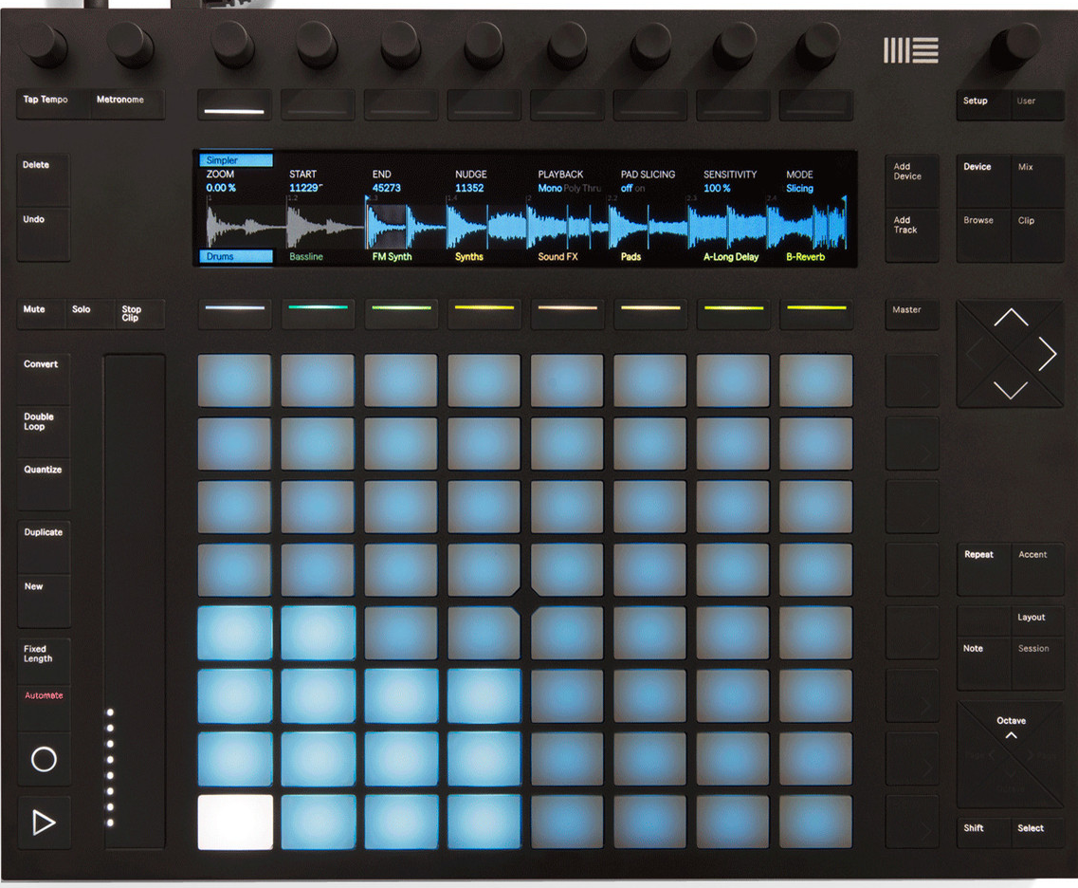

CDJ 1
CDJ 2
CDJ 4
DJM
Push

Connection diagram for a setup with 3 CDJ2000nxs, Ableton Push and DJM2000nxs connected to Ableton Live

The DJM2000nxs has a build in Ethernet hub. When using the DJM900 an external Ethernet hub is needed. The USB connection between the DJM and the Mac is used for digital sound and MIDI. The audio connection between the CDJs and the DJM can be made with S/PDIF or Cinch. The S/PDIF solution has the advantage to only use one cable per connection and is digital. There is no need to use a DJM as mixer. The CDJs alone connected via Ethernet hub can be assigned as CDJ 1 to 4 and sending beat information’s over the Ethernet connection. Even one single CDJ connected directly to a Mac via Ethernet can be used as a master for the CDJ Clock.

Software Setup
CDJ Clock syncs CDJs with Ableton Live or any other software what understands MIDI beat clock. The CDJ_Clock listens to the Ethernet UDP protocol between the CDJs, calculates and sends out via USB an MIDI beat clock. The CDJ_Clock can be controlled with any MIDI controller. The synchronisation can be started exactly to the next beat and sends out an MIDI continue signal.

The CDJ Beat Clock can be started to listen only to one CDJ or to the DJM or all CDJs. You need to switch on the sync on the CDJs when the program is listening to all CDJs otherwise it will run out of beat. If you start the program listen only to the DJM it doesn't matter if some of the CDJs are out of sync. Then the master can be any CDJ or the DJM.

The MIDI source, channel and address can be selected by passing an argument at the start of the program. The beat clock can be started and stopped. When it stops it sends out an MIDI song pointer of the last 4/4 beat. When it starts again it waits for the next 1/4 beat and sends an MIDI song pointer and an MIDI continue. The song pointer is the last 4/4 beat. Via virtual MIDI-in the song pointer can be jumped 4 beats (1bar) or 32 beats (8bars) forward or backwards.

Connect your Macs Ethernet to the DJM Ethernet (or the hub connecting the CDJs) and connect all hardware what sends MIDI statements. CDJ Clock is reading all MIDI sources at startup. After starting CDJ Clock you can disconnect and reconnect the devices. If any device was not connected before starting CDJ Clock, CDJ Clock does not see the device.

You need to start CDJ Clock as superuser.
Parameter: CDJ_Clock, Ethernet, MIDI-Channel, MIDI-Start, MIDI-Stop, SongPointer-Up SongPointer-Down, SongPointer-8barsUp, SongPointer-8barsDown, syncCDJ
Open a terminal and start the program with sudo:
sudo ./CDJ_Clock en3 16 117 118 115 116 111 112 (en3 for MacBook Retina)

CDJ Clock should be executable. The state can be change with chmod.

After starting the program it will show a list of all MIDI sources and connects to it (listen to it). You will see something like this:
3 sources
source 0: Bus 1 <-- connected
source 1: Session 1 <-- connected
source 2: Teensy MIDI <-- connected
Capture Device: en3 Filter: port 50001 Sync: CDJ4
MIDI Sync Start/Stop: Channel=16 Start=117 Stop=118 Up=115 Down=116 ShiftUp=111 ShiftDown=112

When playing a song on a CDJ the program starts counting the beats and plots something like this:
noBeat=0, BPM:0.000000 Tick:50.000000 CDJdiff:-7519.351440 BPMdiff:0.000000
MIDI-Clock STOP
Song Position Pointer = 0
noBeat=0, BPM:141.671115 Tick:27.462402 CDJdiff:471.163086 BPMdiff:141.67115
noBeat=0, BPM:141.668828 Tick:20.674489 CDJdiff:145.329590 BPMdiff:-0.002287
noBeat=0, BPM:141.642047 Tick:17.259471 CDJdiff:-18.751465 BPMdiff:-0.026781

If you want to assign a MIDI control simple press the button and the program will show the channel, address and on/off to use as a parameter for the CDJ Beat Clock like this:
Channel=16 NoteOn=116 Velocity=127
Channel=16 NoteOff=116 Velocity=0

There is no need to use any parameter when starting the program. The default is listen to DJM and Ehternet en0. Pressing the MIDI start/stop button on the DJM (or any device sending MIDI Start, Stop or Continue statements) will start or stop the CDJ Beat Clock.

In Ableton Live (link MIDI) the CDJ Beat Clock pops up as ProSync. You need to switch on Sync and Remote. Then switch on EXT (top left) for switch on external sync to Ableton live.

CDJ Beat Clock can be used with any software what understands MIDI beat clock.

This program is written by Georg Ziegler (DJ Yoi) and Alex Godbehere. For support or questions please contact dj.yoi@gmx.de

