A brief look at Fishers Iris data,
where it came from,
and where it has been used

Contents
- Introduction 1
- Original Article by Fisher 2
- The Species Problem in Iris by Edgar Anderson 4
- The Reduced Nearest Neighbor Rule by Geoffrey W. Gates. 5
- Python Applications by University of California 6
- Fuzzy-C and Attempting to Cluster By MATHWORKS 7
- The role of fuzzy logic in GIS modelling` by Phillipe Puig 8
- SPYDER(PYTHON Programming IDE) Console Output 9
- Discussion of SPYDER Console Output 15
- Conclusion 16
- References 17

Cut-off Date: on or before the 29th April 2018

Introduction
Fishers dataset is mentioned in lots of articles not only in the study of flowers but in computing/A.I and data analysis.
Fisher extended the theory about characteristics of craniometry (the measurement of parts of the head leading to the grouping of craniums/crania) to measure plants and to group plants based on their measurements. He doesn’t mention why he picked various species of the Iris plant.

Original Article by Fisher
Fisher’s dataset is mentioned is lots of articles not only in the study of flowers but in computing/A.I and data analysis.
Fisher,R.A. "The use of multiple measurements in taxonomic problems" Annual Eugenics, 7, Part II, 179-188 (1936); also in "Contributions to Mathematical Statistics" (John Wiley, NY, 1950).
The actual paper itself is available on WILEY website [Original]
It reveals that Fisher wished to find out what factors could be applied to the various variables to create a computable relationship between the different flowers.
Using matrices he was able to derive the factors for each of the 4 variables (page4 of the paper)
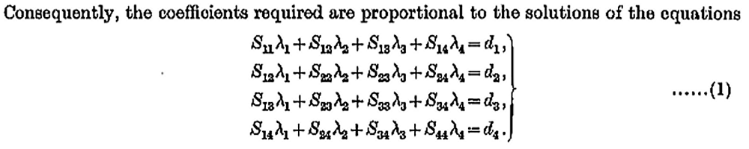
A similar dataset could therefore be used to ‘train’ an A.I type program to build up the factors and then a new dataset processed and the resulting graphs and tables produced used to decide on which species each flower was. This is how Neural networks training. They build up various and differing output factors for each input and/or output from each stage of the network leading to a final output/result.
He then goes into ANOVA Standard Deviations of each set and discovers that there is an overlap between the various species. This leads me to believe that the data should cluster well on a Scatter Diagram. However on the last page of his paper he shows that there is some overlap between Iris-veriscolor and Iris-virginica.

The diagram below is from the last page of the original article and shows some grouping but as the text mentions some overlap was expected due to the calculations in a previous section of the article.
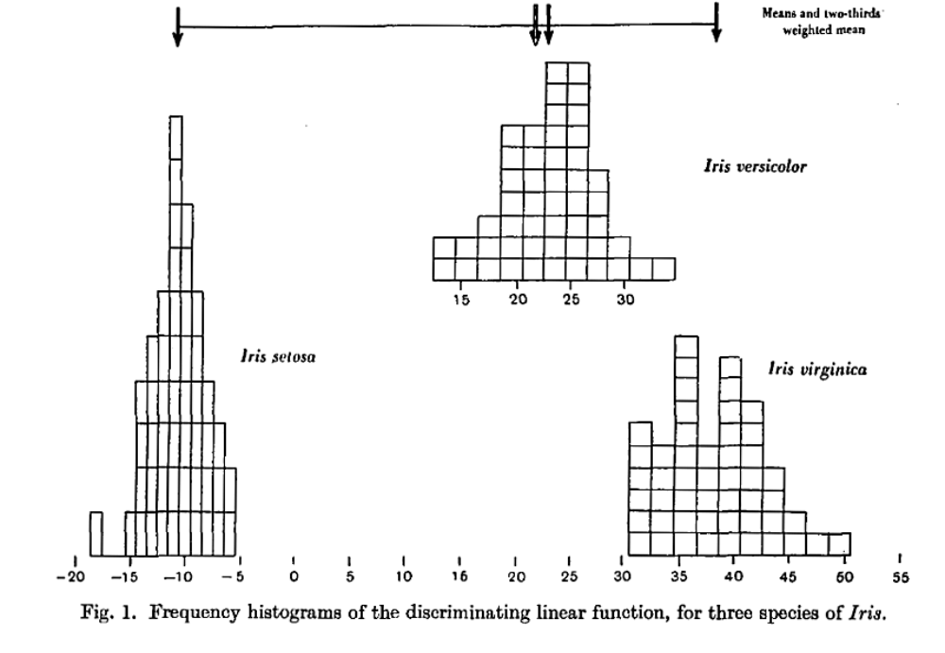
Also, from this graph it is curious that the Iris-virginica stops so suddenly at just above 30 cms and the same for the Iris-setosa which also stops suddenly at -5. This either implies something wrong with the data (collection or measurements) or that nature has a cut-off point for two of these flower species.

The Species Problem in Iris by Edgar Anderson
Meanwhile, a man called Edgar Anderson mentions Fisher for his research in the paper “The Species Problem in Iris”
In this paper, a graph called an ‘ideograph’ is created that represents that width/length of the flower [2].
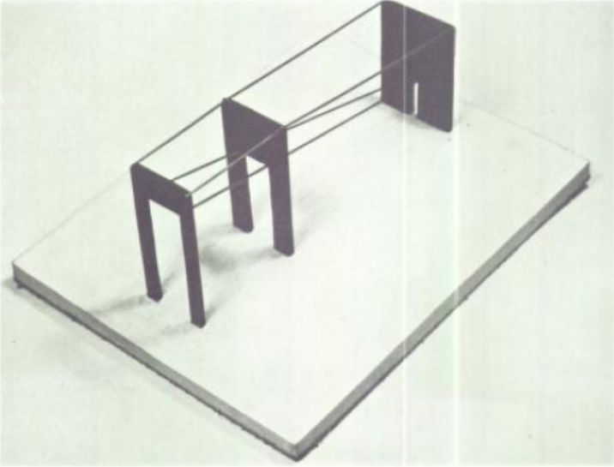
Plate 23: showing the relationship between Width/length for each species and the relationship between species.
In the same way that 3 bell-curves are used to show differences in Mean/Mode/Standard_Deviation/Variance.
These ideographs are a physical representation of the parameters of each species and whilst they are nothing like a bell curve, they do represent the key features of each species and when compared to each other provide a way to discriminate between each species. In the same way that cluster of data into various areas of a 2D or 3D graph can be used to discriminate between other types of flowers or any other group of similar items that have properties that can be measured.
Obviously these graphs can only be applied to a subset of anything that is measureable but it does provide a method to graph numerical data in a manner that I haven’t seen before.
At last on page 505, Anderson finally reveals graphs that are what I think as data analysis with some bar charts. [3]
Its also interesting to find out that Fishers Iris dataset was actually collected by Edgar Anderson [Puig, reference 9,page A-22]
http://dx.doi.org/10.2307/2394164

The Reduced Nearest Neighbor Rule by Geoffrey W. Gates.
In his paper, “The Reduced Nearest Neighbor Rule“ [7] gates tries to examine the best way to find the best way to separate an item based on its characteristics from other items that may not be in the same ‘class’. The overall aim to come up with the best method to calculate a number or numbers for each item so that it can be classified into some known area of an overall classification graph. Fisher’s IRIS data was used to examine various algorithms to classify the Iris’ into their own already known species classes. He suggests that the existing CNN (Condensed Near Neighbour) and RNN (Reduced Near Neighbour) and that the modified k-CNN and k-RNN methods offer no extra advantage to classifying the Iris data.
The idea being that when you already know the answer, derive some calculation that can come up with the same answer and then try it on various listings to see if it works.
Sadly in many of these experiments, when the nature is involved variation is the statisticians enemy because the variation can give non-ideal results (overlaps of classes) which to many then appears as errors that cannot be mathematically eradicated in the pure world of everything must be in one class and no-overlaps.
I’ve recently came across a similar project that has just got going in aviation in France, where a small team are about to try and classify every incident using the 1 or 2 line description of the event that has happened in recent years into ‘one of many buckets but one bucket only – no overlaps’.
It also reminds me of well-known consultant company that analysed a company structure and tried to minimize the structure by putting company sections and/or departments beside each other and other departments further away but can never get the arrangement 100% because in the real natural world there is always some overlap.
It is only in a manufactured world where items are produced to a fixed specification that items can be classified because their measurements can be analysed and the “matrix” has no variation therefore an output graph has clear clusters on it with no overlap.

Python Applications by University of California
On looking at the University of California website, the Center for Machine Learning and Intelligent Systems has a webpage in their archive [5] about Fisher’s dataset and they highlight that there is an error in the dataset in the 35th and 38th sample and supply the correction. Another problem with using secondary data that crops up.
On looking at the references on this page, the first one points to the original paper by Fisher but is now a broken-link.
Searching for the paper, revealed a GITHIB location but this only carries the reference itself but its interesting because it includes some descriptive statistics between line 55 and 60.[5]
Meanwhile on a webpage dedicated to the Python API the Fisher Dataset is reference #1. [6] In these few pages, the author goes onto to use numpy to put the data into sets for manipulation.

Fuzzy-C and Attempting to Cluster By MATHWORKS
In this article, Fuzzy-C and an attempt to calculate the centre of each class of Iris is demonstrated here.[8]
This would be similar in the way Fisher took the idea of craniometry and tried to apply it to the iris flower.
In computing terms, fuzzy logic allows for probability on the edges of overlapping groups.
It calculates where the centres of the so-called classes should be and then from there takes each data point and places then in the most suitable class that it can.
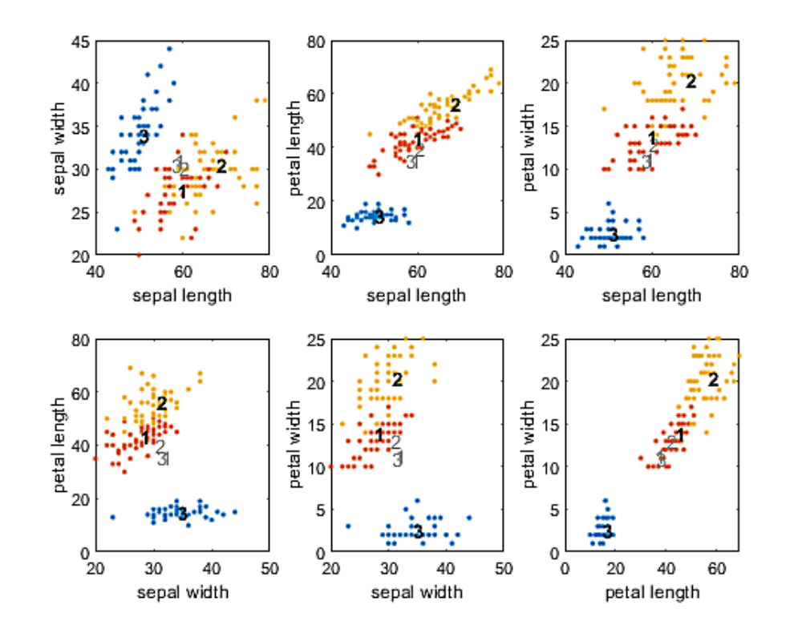
Extract from the article [8] showing the plotted output and
the classification zones for each species of Iris.

As can be seen from the graphs above, there is still some overlap. Species 3 is clearly separating out.
It looks like Nature is being inconvenient again by not creating everything so that it can be classified into classes by mathematical functions.

The role of fuzzy logic in GIS modelling` by Phillipe Puig
In his thesis “The role of fuzzy logic in GIS modelling” [9], the author attempts to classify various geospatial datasets essentially to do with fishery type data. However he does use the Iris dataset as well.
Automatic classification of nature is again the object of the exercise.
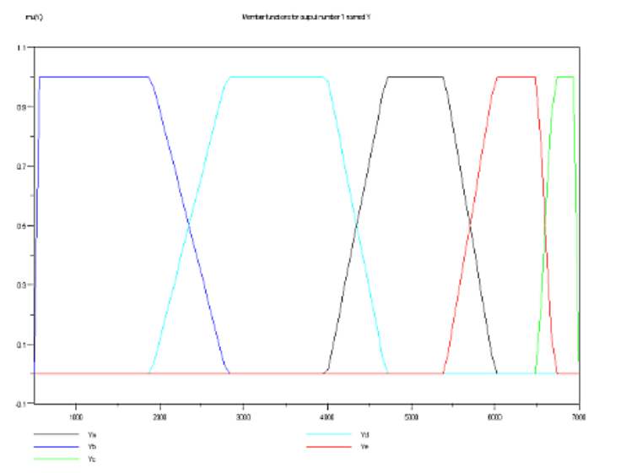
One of the diagrams to illustrate the fuzziness of the classification of the incoming data.

The author does admit that local datasets are required rather than some sort of global dataset. It seems that nature gets in the way again.

SPYDER(PYTHON Programming IDE) Console Output
In [112]: runfile('C:/DATA/STUDY/STUDY-GMIT/PYTHON-SOURCE/gmit--
project--20180423D.py', wdir='C:/DATA/STUDY/STUDY-GMIT/PYTHON-SOURCE')
# Program is running...
# Cleaning any previous report fle.
# Opening: iris.csv
# End of file
# Line count: 152 150
Sepal Length (cm)
=================
Samples : 150
Maximum : 7.9
Minimum : 4.3
Range : 3.6
Average : 5.84333
Std Dev : 0.8253
Sepal Width (cm)
================
Samples : 150
Maximum : 4.4
Minimum : 2.0
Range : 2.4
Average : 3.054
Std Dev : 0.43215
Petal Length (cm)
=================
Samples : 150
Maximum : 6.9
Minimum : 1.0
Range : 5.9
Average : 3.75867
Std Dev : 1.75853
Petal Width (cm)
================
Samples : 150
Maximum : 2.5
Minimum : 0.1
Range : 2.4
Average : 1.19867
Std Dev : 0.76061

# Box Plots
Box plot of Sepal Length CM
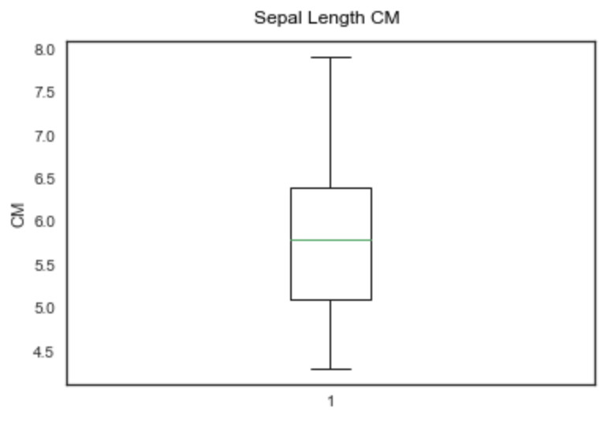
#
Box plot of Sepal Width CM
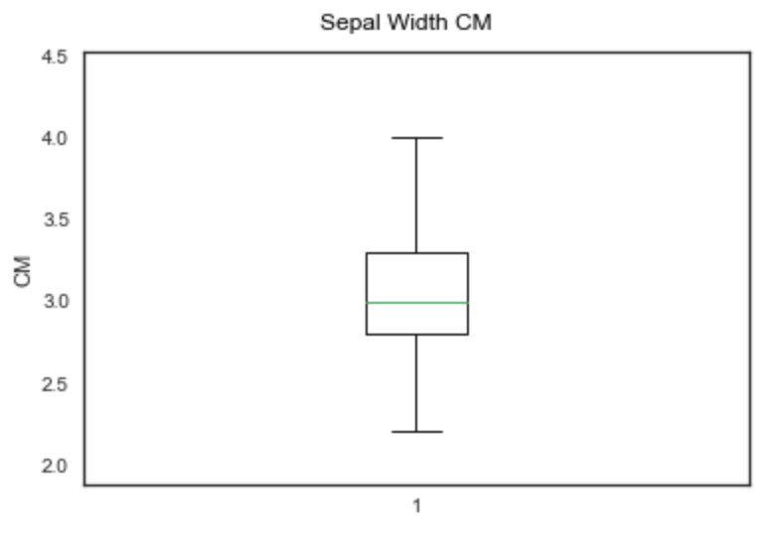
#

Box plot of Petal length CM
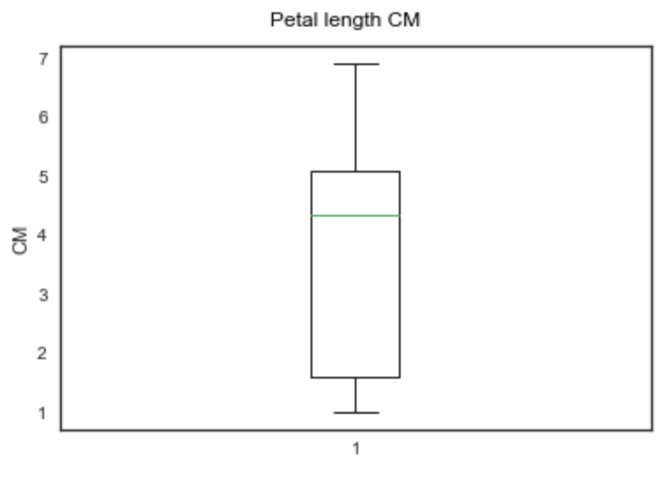
#
Box plot of Petal Width CM
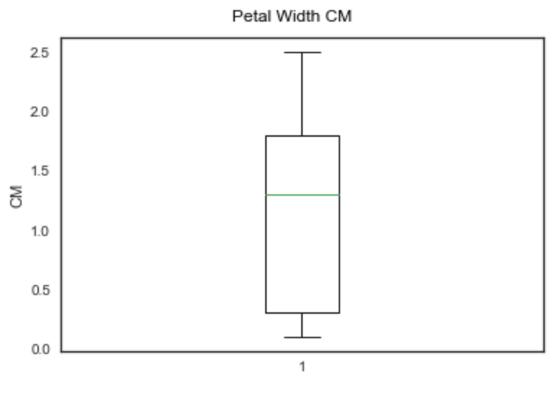
#
# Multiple box plot
Multiple Box plot
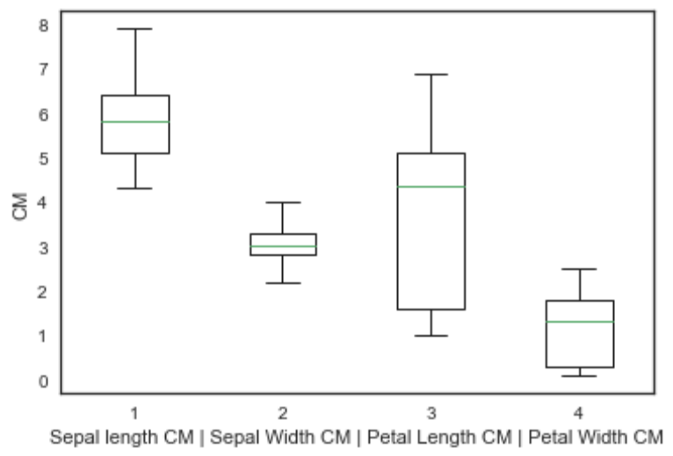
#
# Scatter Plots
Scatter plot of Sepal Length CM data.
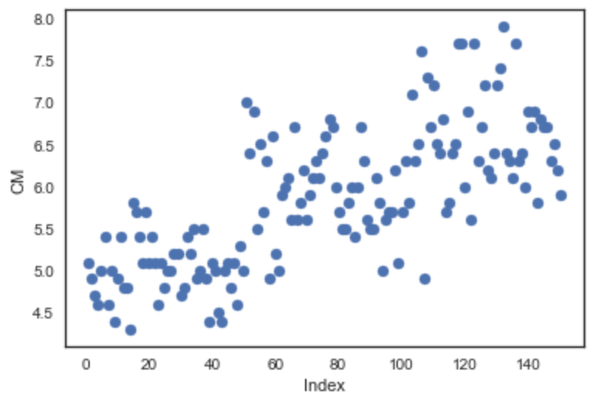
#
Scatter plot of Sepal Width CM data.
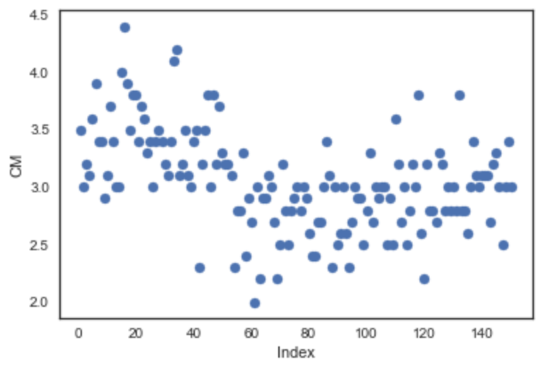
#
Scatter plot of Petal Length CM data.
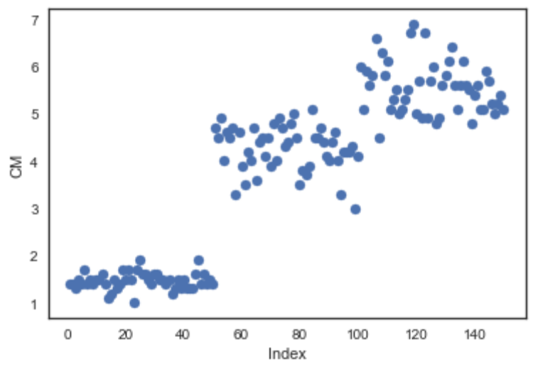
#

Scatter plot of Petal Width CM data.
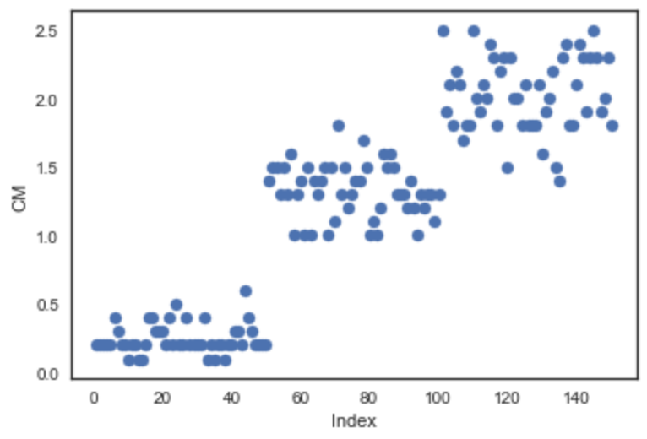
#
# Normal Probability Plots
Normal Probability Plot of Sepal Length CM data.
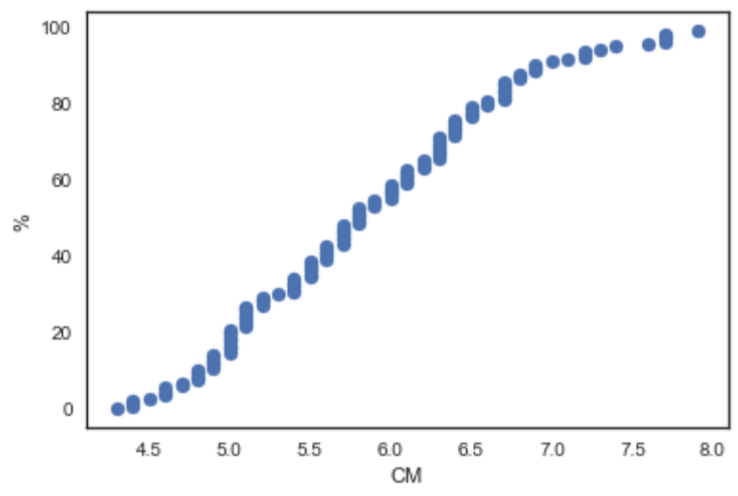
#
Normal Probability Plot of Sepal Width CM data.
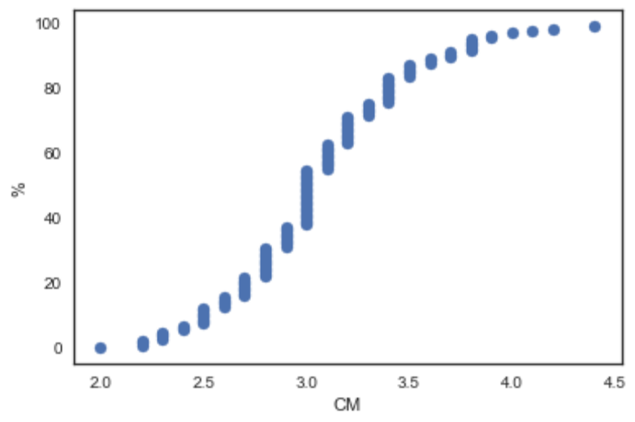
#
Normal Probability Plot of Petal Length CM data.
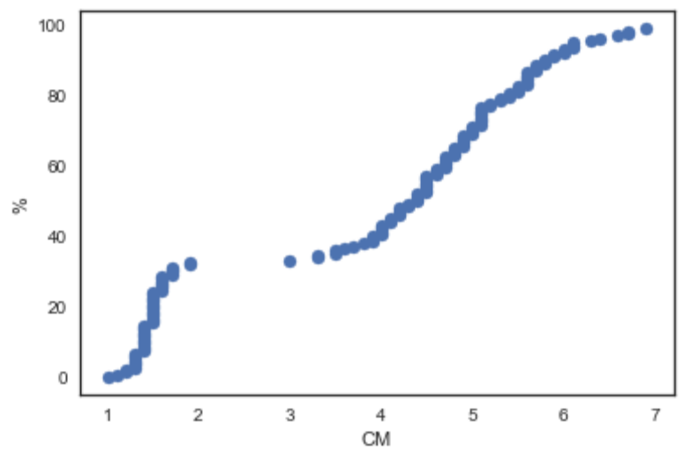
#
Normal Probability Plot of Petal Width CM data.
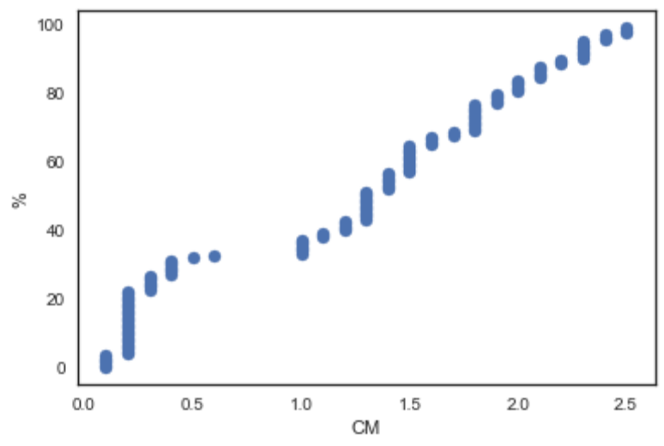
#
# Program is finished.

Discussion of SPYDER Console Output
The output text information which gives the Average, Std Deviation etc suggests that all the data is not normal.
Range v Std Deviation of data
Even the rule of thumb of 6 x Std Deviation should give a ball-park RANGE is not coming close on the 3 measurements taken – SEPAL WIDTH being the only one that does seem to operate to the rule of thumb.
Minimum Value
The minimum PETAL WIDTH fond was 0.1 – this doesn’t appear to be correct but this is what the input data contains.
Skewness.
Using the boxplots – SEPAL WIDTH seems to be the most balanced until the MEDIAN value is observed in the boxplot. It is also not centred. This suggests that all data for the 4 measurements/variables of the Iris are skewed.
Scatter plots
In all the scatter plots for the 4 measurements/variables- there is evidence of non-random activity.
Sepal Length, there is a clear upwards slope in the data.
Sepal Width, there is a clustering into two main clusters.
Petal Length, the data here has clustered into 3 noticeable clusters.
Petal Width, again 3 clear clusters.
This clustering suggest non-normal, non-random nature of the data. Some external influence has acted upon the data. Perhaps it was Nature herself – I don’t know.
Normal Probability graphs.
If the data is normal – the Normal Probability charts should look like an S – either a Wide one or a narrow one. If every measurement/variable was the same then the S would be very narrow and it would actually turn into a vertical line.
The NormProb graph of Sepal length is almost a straight line with some bending at the outer edges. Again, this is not a normal graph. This suggests a wide bell curve with some bell shape at the outer edges.
The NormProb graph for Sepal Width is the closest to an S-shape that this data can produce. There is a very shallow S-shape present.
The NormProb graph for Petal Length is not complete. There are measurements ‘’missing’’ or somehow the surveyors cold not find any Iris flowers with a Petal length of 2.5 cms.
The NormProb graph for Petal Width is also in trouble. Apparently there were no Iris Petals with a width of 0.75 cms found.

Conclusion
What can be said from this data analysis of the Iris flower is that once sufficient data is collected and that the data is relevant then further information can be derived and that the results of that derived data may be used to identify or discriminate between two or more possible results/situations especially in the natural (variations) world where multiple instances of the same thing are not identical as long as it is accepted that when dealing with nature and humans there will always be some data points that will not fit.
In my own job activities, I already know that the data I collect is always varying due to various inputs to the overall system and classifying the various separate subsections into nice clean well defined clusters is near impossible. Nature plays its part with the seasons changing at least 4 times a year plus the various storms that arrive which make an unsteady season even worse.
It is only in a manufactured world where design specification requires one item being manufactured to be the same as the previous item on that same production line that will result in everything fitting into a nice class/group/cloud on a graph even when some variation by machine-drift and go/no_go gauges being used..
If all the Iris flowers that Fisher (and Edgar Anderson) had found on his survey had been manufactured and plastic then his data could be classified without overlaps(fuzzy or otherwise).
Based on the graphs produced by my PYTHON program, the data is not very close to being Normal at all. This suggests an outside influence. The outside influence could be Nature or it could be the data itself. This is the problem with secondary data – you have no way of knowing how the data was really collected and if the data is useful or not until after you analyse its graphical ability.

References
[Original] https://onlinelibrary.wiley.com/doi/full/10.1111/j.1469-1809.1936.tb02137.x or
https://doi.org/10.1111/j.1469-1809.1936.tb02137.x Accessed: 01-April-2018

[1] http://biostor.org/reference/11559/page/2 Accessed: 01-April-2018
[2] http://biostor.org/reference/11559/page/35 Accessed: 01-April-2018
[2] http://biostor.org/reference/11559/page/36 Accessed: 01-April-2018
[2] http://biostor.org/reference/11559/page/37 Accessed: 01-April-2018
[3] http://biostor.org/reference/11559/page/49 Accessed: 01-April-2018
[4] https://archive.ics.uci.edu/ml/datasets/Iris/ Accessed: 01-April-2018
[5] https://gist.github.com/myui/143fa9d05bd6e7db0114 Accessed: 01-April-2018
[6] https://pythonhosted.org/bob.db.iris/py_api.html Accessed: 01-April-2018
[7] https://pdfs.semanticscholar.org/3c98/44194ec1a9e796b71efac33fc5439726b3aa.pdf Accessed: 01-April-2018
[8] https://ch.mathworks.com/help/fuzzy/examples/fuzzy-c-means-clustering-for-iris-data.html?requestedDomain=true Accessed: 01-April 2018
[9] https://espace.cdu.edu.au/eserv/cdu:13224/Thesis_CDU_13224_Puig_P.pdf
Accessed: 01-April-2018

For references for the programming side of this project, please see the file
PK-PYTHON-PROJECT-LOG.TXT

//END//

