Assignment 2018
Fundamentals of Data Analysis
Due: last commit on or before November 11th

Problem statement
The following assignment concerns the well-known Anscombe’s quartet dataset [2]. You are required to create a Jupyter [5] notebook analysing the dataset. There are four distinct tasks to be carried out in your Jupyter notebook.

1. Explain the background to the dataset – who created it, when it was created, and
any speculation you can find regarding how it might have been created.

2. Plot the interesting aspects of the dataset.

3. Calculate the descriptive statistics of the variables in the dataset.

4. Explain why the dataset is interesting, referring to the plots and statistics above.

Minimum standard
The minimum standard for this assignment is a git repository containing
a README,
a gitignore file
and
a Jupyter notebook.

The README need only contain an explanation of what is contained in the repository and how to run the Jupyter notebook.
Your notebook should contain the main body of work and should list all references used in completing the assignment.
A good submission will be clearly organised and contain concise explanations of the
particularities of the dataset. The analysis contained within the notebook will be well
conceived, interesting, and well researched. Note that part of this assignment is about the use of Jupyter notebooks and so you should make use of all the functionality available in the software including images, links, code and plots. You may use any Python libraries that you wish, whether they have been discussed in class or not.

Advice for students
• Your git commit history should be extensive. A reasonable unit of work for a single
commit is a small function, or a handful of comments, or a small change that fixes
a bug. If you are well organised you will find it easier to determine the size of a
reasonable commit, and it will show in your git history.
• Using information, code and data from outside sources is sometimes acceptable —
so long as it is licensed to permit this, you clearly reference the source, and the
overall assignment is substantially your own work. Using a source that does not
meet these three conditions could jeopardise your mark.
• You must be able to explain your assignment during and after its completion. Bear
this in mind when you are writing your README. If you had trouble understanding
something in the first place, you will likely have trouble explaining it a couple
of weeks later. Write a short explanation of it in your README, so that you can
jog your memory later.
• Everyone is susceptible to procrastination and disorganisation. You are expected
to be aware of this and take reasonable measures to avoid them. The best way
to do this is to draw up an initial straight-forward assignment plan and keep it
updated. You can show the examiner that you have done this in several ways. The
easiest is to summarise the assignment plan in your README. Another way is to
use a to-do list like GitHub Issues.
• Students have problems with assignments from time to time. Some of these are
unavoidable, such as external factors relating to family issues or illness. In such
cases allowances can sometimes be made. Other problems are preventable, such
as missing the submission deadline because you are having internet connectivity
issues five minutes before it. Students should be able to show that up until an
issue arose they had completed a reasonable and proportionate amount of work
and took reasonable steps to avoid preventable issues.
• Go easy on yourself - this is one assignment in one module. It will not define
you or your life. A higher overall course mark should not be determined by a
single assignment, but rather your performance in all your work in all your modules.
Here, you are just trying to demonstrate to yourself, to the examiners, and
to prospective future employers, that you can take a reasonably straight-forward
problem and solve it within a few weeks.
References
[1] Software Freedom Conservancy. Git.
https://git-scm.com/.
Page 3 of 4
Fundamentals of Data Analysis Assignment 2018
[2] R data sets. Anscombe’s quartet of identical simple linear regressions.
https://vincentarelbundock.github.io/Rdatasets/csv/datasets/anscombe.
csv.
[3] Inc. GitHub. Github.
https://github.com/.
[4] GMIT. Quality assurance framework.
https://www.gmit.ie/general/quality-assurance-framework.
[5] Project Jupyter. Project jupyter home.
http://jupyter.org/.
Page 4 of 4

1. Explain the background to the dataset – who created it, when it was created, and
any speculation you can find regarding how it might have been created.

2. Plot the interesting aspects of the dataset.

3. Calculate the descriptive statistics of the variables in the dataset.

4. Explain why the dataset is interesting, referring to the plots and statistics above.

1
The Anscombe’s Quartet dataset was constructed to show that even though 4 different sets of numbers can be shown to be totally different when plotted – their standard deviation and variance can be the same.
F. J. Anscombe himself was a British statistician who later on in his career worked at Princeton University and University of Chicago[1]
In 1973 he wrote an article “Graphs in Statistical Analysis” for the The American Statistician [2], where he gave his dataset and described how each set had the same His theory was that when statistics are being taught that little time is dedicated to graphs.
He submitted 4 sets of fictcious data now known as Anscombe’s Quartet. [Section 3 of his paper see ref[2]]
The sets he said sets 1,2 & 3 had the same X values, and the values were only used once.
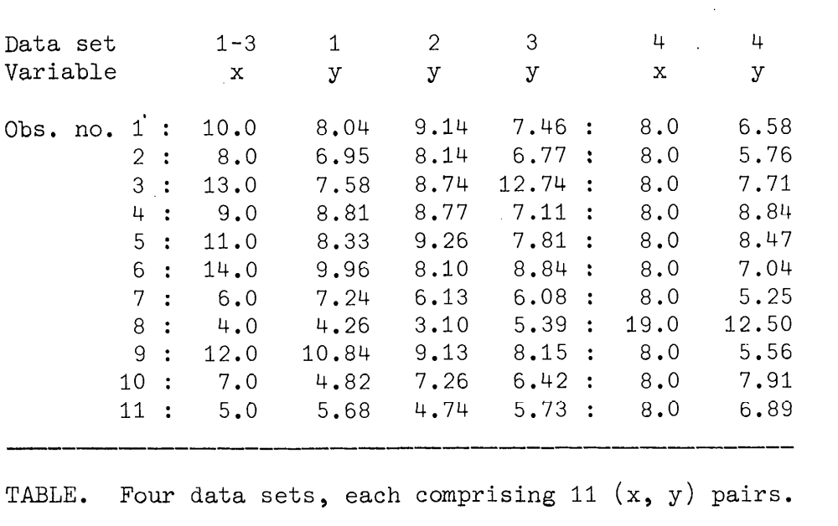
His point of these datasets was because of a then recent article where he had noticed how the presence or not of data from Alaska could affect the results of a survey regarding expenditure on public school education.

[1] https://amstat.tandfonline.com/doi/pdf/10.1080/00031305.1961.10481775#.W9eTUk3yy-8 visited: 20181029
[2] http://links.jstor.org/sici?sici=0003-1305%28197302%2927%3A1%3C17%3AGISA%3E2.0.CO%3B2-J
Visted: 20181029

2
The plots from Anscombe’s Quartet of datasets.
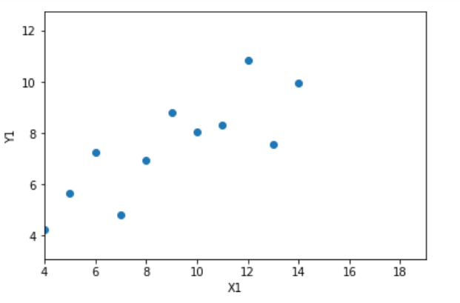 | 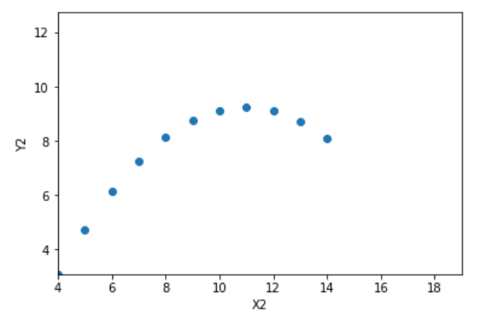
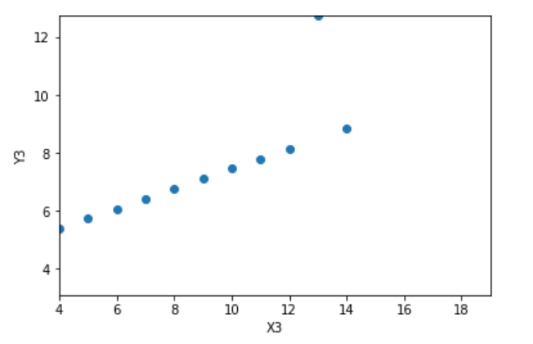 | 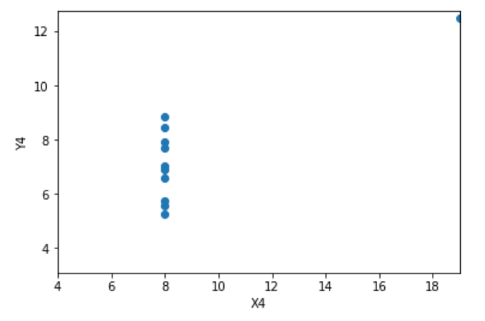

3
Descriptive stats of X1 are  Median : 9.0  Average : 9.0  Min/Max : 14.0 4.0  Range : 10.0  Std Dev : 3.3166247903554  Variance: 10.0  Descriptive stats of X2 are  Median : 9.0  Average : 9.0  Min/Max : 14.0 4.0  Range : 10.0  Std Dev : 3.3166247903554  Variance: 10.0  Descriptive stats of X3 are  Median : 9.0  Average : 9.0  Min/Max : 14.0 4.0  Range : 10.0  Std Dev : 3.3166247903554  Variance: 10.0  Descriptive stats of X4 are  Median : 8.0  Average : 9.0  Min/Max : 19.0 8.0  Range : 11.0  Std Dev : 3.3166247903554  Variance: 10.0 | Descriptive stats of Y1 are  Median : 7.58  Average : 7.500909090909091  Min/Max : 10.84 4.26  Range : 6.58  Std Dev : 2.031568135925815  Variance: 3.752062809917356  Descriptive stats of Y2 are  Median : 8.14  Average : 7.500909090909091  Min/Max : 9.26 3.1  Range : 6.16  Std Dev : 2.0316567355016177  Variance: 3.752390082644628  Descriptive stats of Y3 are  Median : 7.11  Min/Max : 12.74 5.39  Average : 7.5  Range : 7.3500000000000005  Std Dev : 2.030423601123667  Variance: 3.747836363636364  Descriptive stats of Y4 are  Median : 7.04  Min/Max : 12.5 5.25  Average : 7.500909090909091  Range : 7.25  Std Dev : 2.0305785113876023  Variance: 3.7484082644628103

4
In the dataset as already stated, Anscombe deliberately set out to generate data that had different elements but the overall descriptive statistics would be the same thereby giving the impression that the data was the same but when graphed the answer is clearly not the same.
The Variance or Standard deviation normally gives am impression of the width of a bell curve and if the variance or standard deviation are the same then one would already be under the impression that there wasn’t much difference between them ( F-test etc).
The averages are also very close to each other which would also lead a person to consider that the middle of the bell curve may well be in the same position too.
The medians are not exactly the same but are very close.

