Modular Design
eClerx Service Limited India
Internship report

Submitted in partial fulfilment of the requirements for the award of degree of

BACHELOR OF TECHNOLOGY
In
COMPUTER SCIENCE AND ENGINEERING

Submitted To
LOVELY PROFESSIONAL UNIVERSITY
PHAGWARA, PUNJAB


From 06/08/2019 to 13/12/2019
Submitted By Submitted to :
Name of the Student : Gyan Prakash Shashi Ojha
Registration Number : 11612737 Senior Process Manager
Signature of the Student :
Declaration by Supervisor

To whom it may concern
This is to certify that Gyan Prakash, 11612737 from Lovely Professional University, Phagwara, Punjab, has worked as an intern in eClerx Service Limited India on Modular Design under my supervision from August, 2019 to present. It is further stated that the work carried out by the student is a record of original work to the best of my knowledge for the partial fulfillment of the requirements for the award of the degree, Bachelor of Technology.

External Supervisor  Name: Shashi Ojha  Designation: Senior Process Manager  Signature:  Date: | Internal Supervisor  Name: Amanpreet Kaur  Designation: Asst. Professor  Signature:  Date:

Student Declaration

To whom it may concern
I, Gyan Prakash, 11612737, hereby declare that the work done by me on Modular Design from August, 2019 to Present under supervision of Shashi Ojha, Senior Process Manager, eClerx India and Amanpreet Kaur, Asst. Professor, Lovely Professional University, Phagwara, Punjab, is a record of original work for the partial fulfilment of the requirements for the award of the degree, Bachelor of Technology.

Gyan Prakash, 11612737

Acknowledgement

I would like to express my gratitude to my manager, Shashi Ojha and my mentor, Gyan Prakash, who has been guiding me through the period of the internship. I would also like to thank LPU for paving the path for me.
Contents

1. Chapter 1 - Introduction of eClerx Service Limited India  2. Chapter 2 - Introduction To Project Undertaken – Modular Design  3. Chapter 3 - Description of work done  4. Conclusion  5. References | 6  11  16  29  30

Chapter 1
Introduction of eClerx India

Eclerx was founded in 2000 by Anjan Malik and PD Mundhra with the goal of transitioning, managing and transforming complex business processes. Following successful careers in investment banking, Anjan and PD, graduates of University of Pennsylvania’s Wharton School of Business, jointly identified significant opportunities for providing innovative services and solutions to large global companies undergoing rapid business transformation challenged by legacy systems, new technology, data inaccuracies, and ever-changing processes and work flows. Created from humble beginnings in a small office in Mumbai, today eClerx employs over 9500+ people with offices located in the US, UK, India, Italy, Ireland, Thailand, and Singapore.

  - Company’s Vision and Mission: -

Creating enduring value for those most in need, for our communities and our world: - No matter our achievements or number of clients, philanthropy is fundamental to who we are. eClerx has a strong vision of what it means to be a responsible company in today’s society. We place great importance on the role our firm and employees can play in the communities in which we live and work. As we grow and expand our capabilities and innovations in the marketplace, we remain cognizant of our responsibility as change agents in our communities. That’s why we are committed to facilitating, funding and supporting social and economic transformations across various under reserved communities.

At eClerx, we believe that when you educate a child you can transform the world. Talent and resources should go beyond optimizing businesses. They are part and parcel of expanding individual potential and helping them lead better, more productive lives. That’s why we’re committed to working toward a better future for the most disadvantaged and vulnerable populations in our world.

eClerx Cares: - Children rights and education are central to our Corporate Social Responsibility mission. The eClerx family is active in helping to measurably and demonstrably improve the lives of underprivileged children. eClerx Cares, our India based CSR Committee operates under the guidance of eClerx Board of Directors to coordinate and manage our Corporate Social Responsibility initiatives.
To maximize our impact, we actively partner with NGOs and education stakeholders to find and advance effective solutions that address today’s most pressing development and educational challenges. Our partners work to secure the well-being of disadvantaged Indian youth by supporting education and child welfare initiatives throughout India. This includes vocational education and training for children living in city slums, rural villages and tribal areas as well as those who are unemployed or minimally employed. The eClerx Cares Committee approves and monitors projects we fund through our NGO partners. The eClerx Cares Council is responsible for coordinating and advancing our employee engagement initiatives, for example, eClerx employees have volunteered ad-funded efforts that have brought substantial impact to more than 30,000 lives.

Our Work with NGO Partners: - As part of our social responsibility goals
eClerx is proud to partner with the following non-governmental organizations.
eClerx provides critical business operations services to over fifty global Fortune 500 clients, including some of the world’s leading companies across financial services, cable & telecom, retail, fashion, media & entertainment, manufacturing, travel & leisure, software and high-tech. Incorporated in 2000, eClerx is one of India’s leading process management and data analytics companies and is today traded on both the Bombay and National Stock Exchanges of India. eClerx employs 9,000 people across its global sites in the US, UK, India, Italy, Germany, Singapore, and Thailand.
Deep Domain: - We have in-depth knowledge in creating multi-client experiences, as well as industry and product expertise across the areas we specialize in.
Automate & Re-engineer: - We leverage our technology, analytic and industry expertise to engineering, automate and improve functions with a focus on business outcomes and cost reduction.
Complex Functions: - We specialize in transitioning, managing and transforming complex business-facing functions for many of the world’s largest organizations

1.2 Origin and growth of company

Origin: - The company founded in March, 2000. PD Mundra and Anjan Malik are the founder of this organization. The Company headquarter is in Mumbai, India. There are number of employees under many process around 10000 employees are there in our company.
Our Company was originally incorporated on March 24, 2000 as eClerx Services Private Limited under the Companies Act, 1956. Our Company was converted to a public limited company and the name was changed to eClerx Services Limited, pursuant to resolutions of the shareholders passed in the AGM held on August 1, 2007. The Registrar of Companies, Mumbai issued a fresh certificate of incorporation consequent to the conversion on August 28, 2007. Eclerx is an Indian IT consulting and outsourcing multinational company based in Mumbai and Pune. Eclerx is a public limited company whose shares are listed on the Bombay Stock Exchange and National Stock Exchange of India.
The company listed on the bourse on Monday, 31 December 2007. In April 2012, eClerx acquired Agilest Inc to grow its footprint in the U.S. cable and telecom industry.

On 31 March 2015, eClerx acquired Creative Services Agency CLX Europe, for a total purchase consideration of up to EUR 25 million.

1.3 Growth of company: -

1.3.1 Excellence - Excellence is a journey - we achieve our goals by constantly improving, innovating and applying the highest standards.

1.3.2 Integrity - We are thoughtful, honest and empathetic in our interactions with clients, vendors, shareholders and each other.

1.3.3 Client Centric - Our clients' success is our goal – everything we do keeps their best interest at the forefront.

1.3.4 People - We care deeply about our people – we encourage learning, promote growth and celebrate diversity.

1.3.5 Learning - Our employees are a crucial part of our success – we strive to nurture and develop our employees with best-in-class learning opportunities

1.3.6 Managing complexity while minimizing cost - eClerx provides critical business operations services to over fifty global Fortune 500 clients, including some of the world’s leading companies across financial services, cable & telecom, retail, fashion, media &, manufacturing, travel & leisure, software and high-tech. Incorporated in 2000, eClerx is one of India’s leading process management and data analytic companies and is today traded on both the Bombay and National Stock Exchanges of India. eClerx employs 9,000+ people across its global sites in the US, UK, India, Italy, Germany, Singapore, Thailand.

1.4 Various departments and their functions

1.4.1 Digital – eClerx Digital is the trusted partner of choice to the world’s largest global brands for creative production, e-commerce / web operations, and analytic & insights services. We improve profitability for their digital businesses. Our team of 3000+ full-time digital delivery employees at our five production hubs in Mumbai, Pune, Chandigarh, Verona and Phuket apply deep digital expertise to effectively support the most demanding global clients by employing a follow the sun delivery model. eClerx Digital’s innovative delivery model drives the “metrics that matter” for our clients: improved acquisition, conversion and retention and overall lifetime value of your customer 24x7x365.

Marketing - Maximize your marketing efforts to build awareness, generate leads, and increase sales.

E-Commerce - Remove the friction from the user experience to reduce cart abandonment and increase average order value.

Business Intelligence & Analytic - Make sense of and use your data for personalization, consistently accurate forecasting, and to direct resources towards profitable activities.

Operations & Finance - Understand and optimize varied data and system processes for maximum return

Creative - Create stunning assets for use in print and digital

1.4.2 Financial Markets - For financial organizations across the world, eClerx Markets, offers consulting, technological innovation, and process management expertise to uniquely solve operational challenges. With nearly two decades of industry experience complemented by the application of smart automation and robotics, our team of experts deliver holistic solutions across the trade life cycle, change management, data analytic, compliance, cash securities operations, document digitization and generation, and outreach

Trade Support – Supporting post-executions activities across all instrument’s types, both cash and derivatives.

Client Life Cycle – Gather, validate, digitize and distribute client related information, ensuring compliance with local regulations across multiple jurisdictions

Reference Data – Organization-wide data management solutions covering client, product, market and risk-related information

Asset Servicing – Supporting management of all corporate actions, income collection, claim settlements and position reconciliations

Settlements and clearing – A complete service covering position and cash reconciliations, static data management, collateral management and forecasting

Analytic – Full spectrum of analytical services from business intelligence and digital analytic, to predictive modeling and forecasting.

Remediation Engagement / Project work - Supporting change functions across all middle- and back-office functions, with expertise in Project Management, Project

1.4.3 Customer Operations - eClerx improves customer experience and operational efficiency by leveraging deep domain knowledge, advanced automation, and data analytic.

eClerx Customer Operations specializes in providing operational expertise and process excellence throughout the customer journey. We create solutions and services, utilizing a blend of technology and domain knowledge that support our clients’ evolving needs. Our suite of offerings enhances the customer experience by providing quality monitoring/insights, advanced analytic, automation, superior technical operations support and digital care services. We assist companies in developing, implementing and operating multichannel customer interaction capabilities – transforming everyday touch points into a superior customer experience.

Contact Quality Monitoring & Insight - Customer Interaction Monitoring Mystery Shopping

Advanced Technical Operations - Avoidable Truck Rolls Dispatch Services Reverse Logistics

Digital Care Services - Advanced Chat Services Advanced Technical Support

Analytic & Automation - Automation and AI Business Insights and Analytic Platforms Tools

1.4.4 Organization chart of the company: -  

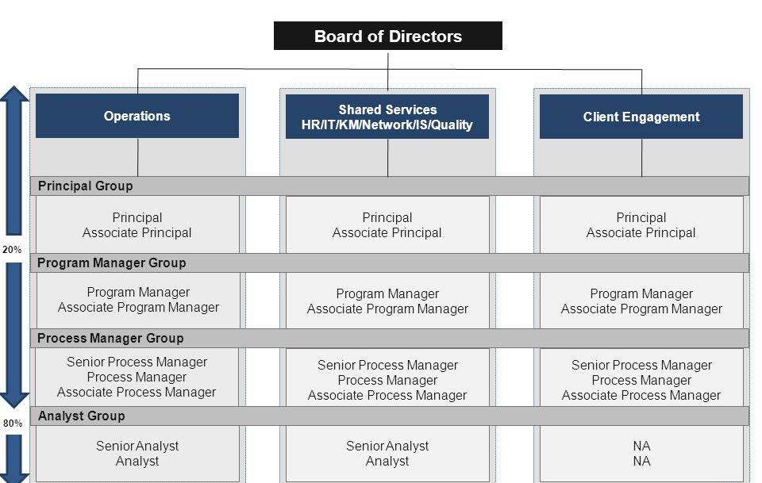

Fig: 1.1
Chapter 2
Introduction to Project Undertaken – Modular Project
This project comes under Digital department. This project is responsible for making a Landing Page of a website with the help of Modular Design concept. The project contains different modules or integrated parts of a Landing Page. Users have to simply Drag the different modules into Droppable area and make a Landing Page and Download the Page.
There are various languages used to perform this task. The core of the technology stack used is HTML & CSS, JavaScript, JQuery and Bootstrap.
- HTML & CSS: HTML (the Hypertext Markup Language) and CSS (Cascading Style Sheets) are two of the core technologies for building Web pages. HTML provides the structure of the page, CSS the (visual and aural) layout, for a variety of devices. Along with graphics and scripting, HTML and CSS are the basis of building Web pages and Web Applications. HTML is the language for describing the structure of Web pages. HTML gives authors the means to:
  - Publish online documents with headings, text, tables, lists, photos, etc.
  - Retrieve online information via hypertext links, at the click of a button.
  - Design forms for conducting transactions with remote services, for use in searching for information, making reservations, ordering products, etc.
  - Include spread-sheets, video clips, sound clips, and other applications directly in their documents.
  - With HTML, authors describe the structure of pages using markup. The elements of the language label pieces of content such as “paragraph,” “list,” “table,” and so on.
CSS is the language for describing the presentation of Web pages, including colors, layout, and fonts. It allows one to adapt the presentation to different types of devices, such as large screens, small screens, or printers. CSS is independent of HTML and can be used with any XML-based markup language. The separation of HTML from CSS makes it easier to maintain sites, share style sheets across pages, and tailor pages to different environments.
- Bootstrap: Bootstrap is a free and open source front end development framework for the creation of websites and web apps. The Bootstrap framework is built on HTML, CSS, and JavaScript (JS) to facilitate the development of responsive, mobile-first sites and apps.
  - Responsive design makes it possible for a web page or app to detect the visitor’s screen size and orientation and automatically adapt the display accordingly; the mobile first approach assumes that smartphones, tablets and task-specific mobile apps are employees' primary tools for getting work done and addresses the requirements of those technologies in design.
  - Bootstrap includes user interface components, layouts and JS tools along with the framework for implementation. The software is available precompiled or as source code.
  - Mark Otto and Jacob Thornton developed Bootstrap at Twitter as a means of improving the consistency of tools used on the site and reducing maintenance. The software was formerly known as Twitter Blueprint and is sometimes referred to as Twitter Bootstrap.
  - In computers, the word bootstrap means to boot: to load a program into a computer using a much smaller initial program to load in the desired program (which is usually an operating system).
  - In the physical world, a bootstrap is a small strap or loop at the back of a leather boot that enables you to pull the entire boot on and in general usage, bootstrapping is the leveraging of a small initial effort into something larger and more significant. There is also a common expression, "pulling yourself up by your own bootstraps," meaning to leverage yourself to success from a small beginning.
- JavaScript: JavaScript is a dynamic computer programming language. It is lightweight and most commonly used as a part of web pages, whose implementations allow client-side script to interact with the user and make dynamic pages. It is an interpreted programming language with object-oriented capabilities.
  - JavaScript was first known as LiveScript, but Netscape changed its name to JavaScript, possibly because of the excitement being generated by Java. JavaScript made its first appearance in Netscape 2.0 in 1995 with the name LiveScript. The general-purpose core of the language has been embedded in Netscape, Internet Explorer, and other web browsers.
  - The ECMA-262 Specification defined a standard version of the core JavaScript language.
  - JavaScript is a lightweight, interpreted programming language.
  - Designed for creating network-centric applications.
  - Complementary to and integrated with Java.
  - Complementary to and integrated with HTML.
  - Open and cross-platform
- JQuery: jQuery is a lightweight, "write less, do more", JavaScript library.
  - The purpose of jQuery is to make it much easier to use JavaScript on your website.
  - jQuery takes a lot of common tasks that require many lines of JavaScript code to accomplish, and wraps them into methods that you can call with a single line of code.
  - jQuery also simplifies a lot of the complicated things from JavaScript, like AJAX calls and DOM manipulation.
  - The jQuery library contains the following features:
  - HTML/DOM manipulation
  - CSS manipulation
  - HTML event methods
  - Effects and animations
  - AJAX

- Modular Design
Modular design is a technique where everything is built using a block grid pattern. Each of the elements of the design fit into the modules in rectangular patterns.
The concept of modular components is nothing new. It’s used in a variety of industries such as manufacturing, construction, and aerospace. In automaking, Volkswagen has become one of the most profitable automakers on the planet by utilizing the commonality of components across brands and models.
For example, the chassis on the VW Touareg is the same as the Audi Q7, and carries all the way to the Porsche Cayenne. Much like the VW Passat, Audi A6/7 and Porsche Panamera. Think about home building: I recently saw a 4,000-square foot house brought in on trucks. Pretty much all manufacturing is based on the theory of reusable parts. Software development has been doing this for almost thirty years as well; it’s called object-oriented programming, where objects are continuously usable in a variety of means.
- Learning from Lego
  - To find a better metaphor, I went back to Lego — the epitome of modular atomic design. Turns out we don’t ever need to worry about padding and margin when we “nest” a small Lego structure in a large Lego structure, and then in an even larger Lego structure. In fact, there is no such concept as “nesting” in Lego. All the elements appear to live on the same level, not in multiple layers.
  - But what does that mean for web design? We have to nest web elements for the semantic structure and for easy selecting. I’m not saying that we should change our HTML structures, but in our stylesheet, we could put spacing only on the lowest-level web elements (or “atoms” to quote atomic design terms) and not the many layers in between.
  - Take a look at the top of any individual Lego brick. If you see the space around the outside of the pegs as the padding of a web element, and everything inside the padding as the content, you will find that all Lego bricks have a consistent padding surrounding the content, which is exactly half of the gap between elements.
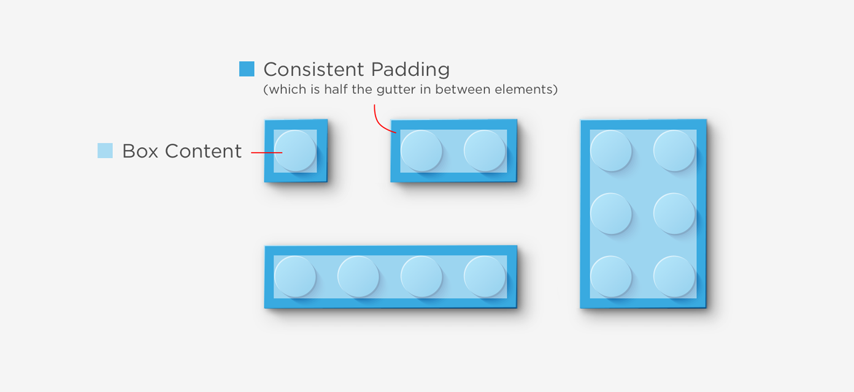

Difference between Template and Modular Design

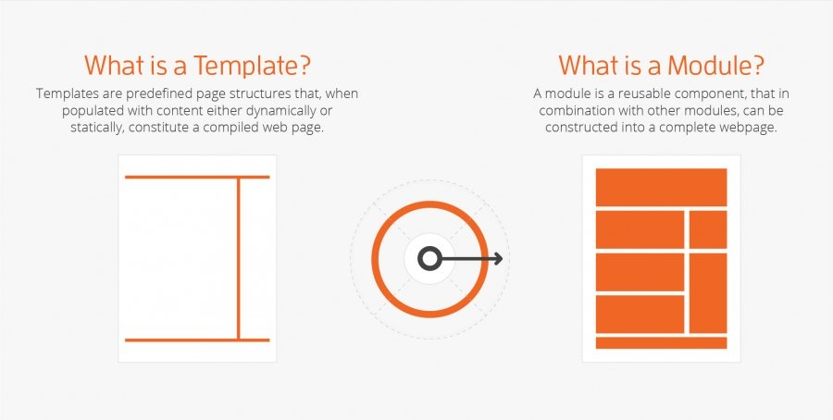

Templates are the whole structure of the page which cannot be changed individually or in modules. One change can affect the all other pages. On the other hand this is not with the Modular as one can change the page of website individually or in modules and one changes does not affect the all other modules of the page.
- Benefits of Modular Design for Non-profits and Foundations
We understand that in the social sector you are often in the position of figuring out how to best maximize your budget, so when it comes to investing in website design and development you need a website that will not only stand the test of time, but allow you the flexibility to grow and evolve. That’s why there are two reasons in particular why we’re fans of modular design for non-profits and foundations.

  - Modular design offers the freedom to create content on-the-fly. Breaking up pages into modules means that building a page consists of moving parts around until you like how it looks, functions and communicates. And all of this can be accomplished in-house in a matter of minutes, making it easy to build and adapt pages based on the needs of your different departments, locations or leadership team members.
  - One of the most appealing aspects of modular web design is that it’s budget-friendly. When a designer is creating page templates, they’re creating specific pages that serve particular functions. But what if you like the gallery on one page, and the sidebar from another? In template-based design, a designer would have to create a new template that combines the two elements, meaning agency support and added costs.
  - The world moves fast, and with it come new opportunities. In terms of your website, this can mean new content, new content formats, or entirely new technology. The beauty of modular design is that it’s future ready. It gives your website the flexibility to grow and evolve over time. You can add new technology and features without having to do a complete redesign of your website.

- Modular Design Work Best For

The larger your website is, the better modular design can work for you. Modular design means that even the largest of organizations can develop new pages as quickly as startups. It gives you repeatability at a larger scale. It also creates a more streamlined, more consistent UI. All of your branding components are built in to the modules so every new piece will fit the look and feel of the site.
Varsity Spirit tasked The Creative Momentum with implementing a modular design on their new site. As one of the country’s leading organizations and brands in the cheerleading and dance team space, their content needs were vastly different from department to department. We were able to build a user-friendly site with an entire toolbox of modules they can repurpose without ever having to involve developers. As a result, their marketing team is able to spin up brand new pages within a day and make changes to suit individual department needs.

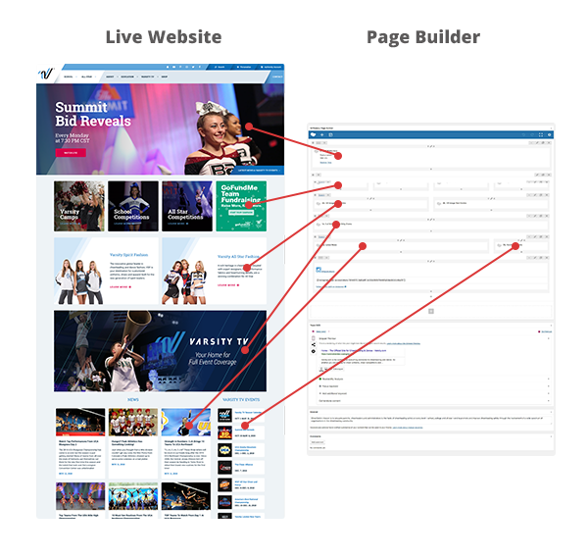

2.1 Scope of work
All the parts which are in inventory or will be available soon are managed by the automation work done by this department.
All the technicians who are available or will be available and at what point of time all of their tracking and update service are created and managed by this department.
A big section of Home Services department is dependent on the work done under this project. Other projects which expose various other services to the customer have the backbone as Modular Design.
At one point or the other I have been exposed or used all the technologies used in this project. There are various web services and batch jobs are there which have to be managed or to be written.
2.2 Importance and Applicability
All the parts which are in inventory or will be available soon are managed by the automation work done by this department.
All the technicians who are available or will be available and at what point of time all of their tracking and update service are created and managed by this department.
A big section of Digital department is dependent on the work done under this project. Other projects which expose various other services to the customer have the backbone as Modular Design.
For most of the jobs entry point is a shell script. They have packaged all the needed pre-processing that is needed to be done for the run of a job. Some of the jobs are just straight out shell scripts too if they have little processing to perform or are fairly simple.
2.3 Role and Profile
Currently I am an intern in eClerx Services Limited India. I am assigned Modular Design Web Page Builder to work on. Agile methodology is followed in the company. Those created JIRA tickets are assigned or taken according to knowledge or time availability and limits to team members. There are many a times when some of the things are preempted and are given a high priority, so accordingly tasks are given or taken up.
Chapter 3
Description of work done
After the completion of formal training given to interns, I was asked to go through the existing projects and understand the structure and their architecture. Most of them were web services. This whole was done for complete months, including the formal training.
From end of October I was put into Modular Design Page Builder. My first work was to work, under the guidance of my manager, on Modular Design which was used to make different modules of a website with the help of HTML & CSS and Bootstrap.
I had one month to make the interface of a Web Page Builder which is on the concept of Modular Design project in HTML & CSS and Bootstrap for building the interface of Web Page Builder. This whole system comprised of JavaScript and JQuery programs which was written by me in this span of time.
The task was very critical, and my inputs were taken very seriously as I was working full time on it. I had gone through many different websites and different templates to make the shopping cart more user-friendly and tried to keep the code simpler and more structured to keep the track of error which can be handled easily.
After completion of analysis and the research and development. I coded the complete front end using bootstrap version 3.7.7 and the complete the functionality of the page builder with the help of JQuery and JavaScript.
After the first version of the page builder was created, our manager decided to add some more features into the Page Builder. Many of the ideas were kept in the meetings and then the many points were kept in front of everyone and then two of the ideas were chosen and were decided to add more features in the Page Builder and those were the text editable, photos uploading, sortable modules etc. In the Present date I am still working on this project to make it more reliable and user friendly.

3.1 Activities and handled equipment
I was working with the following tools to complete the task:
- Visual Studio Code Editor: Visual Studio Code is a source-code editor developed by Microsoft for Windows, Linux and mac OS. It includes support for debugging, embedded Git control and GitHub, syntax highlighting, intelligent code completion, snippets, and code re-factoring. It is highly customizable, allowing users to change the theme, keyboard shortcuts, preferences, and install extensions that add additional functionality. The source code is free and open source and released under the permissive MIT License. The compiled binaries are freeware and free for private or commercial use.
Visual Studio Code Editor is known best for writing the JavaScript Code. Since Node is the language, which is completely based on the JavaScript, the preferred code editor was Visual Code Studio for me. Also we deal with the JSON file while working with Node,js and VS code also provides these features and hence this was the preferred editor again.
- CodePen: CodePen is a social development environment. At its heart, it allows you to write code in the browser, and see the results of it as you build. A useful and liberating online code editor for developers of any skill, and particularly empowering for people learning to code. We focus primarily on front-end languages like HTML, CSS, JavaScript, and preprocessing syntaxes that turn into those things. People use CodePen for all sorts of things: prototyping new ideas, reduced test cases for bugs, sending clients things to look at, evaluating potential hires, to finding inspiration. People also use CodePen as a sort of resume and portfolio, showing off their best design and development work.
- JSFiddle: JSFiddle is a great tool for testing and sharing Web code. While you don't need to register for a free account, it's useful, since you can maintain a list of your projects, or "fiddles", on the dashboard. There are three main windows where you can type HTML (upper middle), JavaScript (lower middle) and CSS (upper right). Then you can run the code and view the results in a fourth window (lower right).
  - JSFiddle color-codes the syntax and offers a nice "tidy up" feature that reformats the code using appropriate indentation and spacing. You can also use the JSLint button to check your JavaScript syntax, which is a nice bonus.
  - When you edit a fiddle, you can create a new version of it by clicking the Update button. Or you can fork the code using the Fork button. The nice thing about the Update button is that it creates a new URL with a version number for the fiddle. This makes it easy to go back to previous versions of fiddles from the more recent ones, in case you need to refer back to previous code.that data is only eventually consistent by default.
- JavaScript: JavaScript often abbreviated as JS, is a high-level, just-in-time compiled, object-oriented programming language that conforms to the ECMAScript specification. JavaScript has curly-bracket syntax, dynamic typing, prototype-based object-orientation, and first-class functions.
Alongside HTML and CSS, JavaScript is one of the core technologies of the World Wide Web. JavaScript enables interactive web pages and is an essential part of web applications. The vast majority of websites use it, and major web browsers have a dedicated JavaScript engine to execute it.
As a multi-paradigm language, JavaScript supports event-driven, functional, and imperative (including object-oriented and prototype-based) programming styles. It has APIs for working with text, arrays, dates, regular expressions, and the DOM, but the language itself does not include any I/O, such as networking, storage, or graphics facilities. It relies upon the host environment in which it is embedded to provide these features.
Initially only implemented client-side in web browsers, JavaScript engines are now embedded in many other types of host software, including server-side in web servers and databases, and in non-web programs such as word processors and PDF software, and in run time environments that make JavaScript available for writing mobile and desktop applications, including desktop widgets.
- Bootstrap: Bootstrap is a web framework that focuses on simplifying the development of informative web pages (as opposed to web apps). The primary purpose of adding it to a web project is to apply Bootstrap's choices of color, size, font and layout to that project. As such, the primary factor is whether the developers in charge find those choices to their liking. Once added to a project, Bootstrap provides basic style definitions for all HTML elements. The result is a uniform appearance for prose, tables and form elements across web browsers. In addition, developers can take advantage of CSS classes defined in Bootstrap to further customize the appearance of their contents. For example, Bootstrap has provisioned for light- and dark-colored tables, page headings, more prominent pull quotes, and text with a highlight. Bootstrap also comes with several JavaScript components in the form of jQuery plugins. They provide additional user interface elements such as dialog boxes, tool tips, and carousels. Each Bootstrap component consists of an HTML structure, CSS declarations, and in some cases accompanying JavaScript code. They also extend the functionality of some existing interface elements, including for example an auto-complete function for input fields.
The most prominent components of Bootstrap are its layout components, as they affect an entire web page. The basic layout component is called "Container", as every other element in the page is placed in it. Developers can choose between a fixed-width container and a fluid-width container.
- JQuery UI: jQuery UI is a curated set of user interface interactions, effects, widgets, and themes built on top of the jQuery JavaScript Library. Whether you're building highly interactive web applications or you just need to add a date picker to a form control, jQuery UI is the perfect choice.
3.2 Challenges faced
There were lots of challenges that arrived during my internship phase. The major challenge that was faced by me was providing the functionality to the web page builder. As many times the code was not working and many times there will be conflict between JQuery and JavaScript Files which results in 3-4 days to solve that issues.
Another challenge faced was not having clarity about the components involved as it involves a lot of business-related terms to be understood. It took me time to understand them and take decision. I was helped by many experienced colleagues in the organization and of course I was helped a lot by my manager as well.
From there on I was a bit comfortable in the territory I started to look over the other technical issues and problems which were actually about to come in the implementation of the project.
The another hurdle that came during the making of the project was the features that we were about to make in the Modular Design. There were lots of debates in the meeting about which all features needs to be added in the Modular Design and then finally the First version of the Project of Web Page builder is completed.
There were some things like I had to learn, like control-m, I had to figure its interface out well enough so that I can use it well.
Another challenge that I faced was that one of the colleague whose was guiding me during the training of the Chatbot left the organization in the middle. At the initial stage, it became a huge workload for me but with time everything came into proportion and everything was handled by me with the help of Internet.
It happens many times that we take a decision and that turns out to be a wrong decision and then we later on realize that the decision was wrong. The same happened many times with me as well. But it’s never too late, we move a step backwards and then face the same problem and with the different alternative for the same problem and succeeded in solving the issues.
3.3 Learning Outcomes
I learned about the following things and technologies:
- HTML & CSS: HTML (the Hypertext Markup Language) and CSS (Cascading Style Sheets) are two of the core technologies for building Web pages. HTML provides the structure of the page, CSS the (visual and aural) layout, for a variety of devices. Along with graphics and scripting, HTML and CSS are the basis of building Web pages and Web Applications. HTML is the language for describing the structure of Web pages.
CSS is the language for describing the presentation of Web pages, including colors, layout, and fonts. It allows one to adapt the presentation to different types of devices, such as large screens, small screens, or printers. CSS is independent of HTML and can be used with any XML-based markup language. The separation of HTML from CSS makes it easier to maintain sites, share style sheets across pages, and tailor pages to different environments.
- Modular Design: Modular design is a technique where everything is built using a block grid pattern. Each of the elements of the design fit into the modules in rectangular patterns. The concept of modular components is nothing new. It’s used in a variety of industries such as manufacturing, construction, and aerospace. In automaking, Volkswagen has become one of the most profitable automakers on the planet by utilizing the commonality of components across brands and models.
- JQuery: : jQuery is a lightweight, "write less, do more", JavaScript library.
  - The purpose of jQuery is to make it much easier to use JavaScript on your website.
  - jQuery takes a lot of common tasks that require many lines of JavaScript code to accomplish, and wraps them into methods that you can call with a single line of code.
  - jQuery also simplifies a lot of the complicated things from JavaScript, like AJAX calls and DOM manipulation.
  - The jQuery library contains the following features:
  - HTML/DOM manipulation
  - CSS manipulation
  - HTML event methods
  - Effects and animations
  - AJAX
- JavaScript: JavaScript is a client scripting language which is used for creating web pages. This means that JavaScript code is written into an HTML page. When a user requests an HTML page with JavaScript in it, the script is sent to the browser and it's up to the browser to do something with it. It is a standalone language developed in Netscape. It is used when a web page is to be made dynamic and add special effects on pages like rollover, roll out and many types of graphics.
- Bootstrap: Bootstrap is a potent front-end framework used to create modern websites and web apps. It's open-source and free to use, yet features numerous HTML and CSS templates for UI interface elements such as buttons and forms. Bootstrap also supports JavaScript extensions. Bootstrap has a big community and friendly support.Bootstrap is easy to set up and create a working layout in less than an hour. You don't need to know HTML and CSS well to use bootstrap, it's a plus if you're a back end developer and need to do some UI changes. It's fully customizable, I can choose which components I'd like to use and use variables file to get do even more color and behavior customization. When you update the version of Bootstrap, you won't see tons of errors because their core team cares about backwards compatibility. Bootstrap offers a lot of helper classes that make development of a responsive website easy and fast. Bootstrap’s components are well-adopted to the ecosystem of popular JS MVC Frameworks like Angular. Bootstrap provides several ways to include it into your project.
- Team Coordination: How to coordinate with teams and within a team. How to resolve issues in the team.
- Control-M: Control-M helps you speed up and simplify application delivery, improve SLA, and manage the behind-the-scenes data and applications that batch jobs require. It integrates, automates, and orchestrates application work flows across on-premises, private, and public cloud environments, so your jobs get delivered on time, every time.

Chapter 4
Making of Landing Page
The making of Landing Page with the Page Builder is to simply drag the modules from the different modules list and Drop in the container where the page is actually is supposed to be build and many more functionality is to be performed. Suppose User drag the Navigation bar and drop it into the container. Again user drags the Image content section and drops it into the container. So the same process is repeated again and again. If user wants to delete the particular section then user can use the delete button to delete the particular section and drop the new section. User can also change the text of heading and paragraph to change according to their needs and requirements. After the whole process is done, now the user can preview the created Landing Page with the Preview button so they can see the actual page when it downloaded. One more features is to they can change the font style of the entire website with the help of settings which are in the page builder. Finally, user can Download the created page and see the page.

- Introduction
This project is about make the webpage in Modular Design concept. In this Project we have made different modules of websites. We had divided the content into different sections like the Banner, Mid-section, Tabs-section, Shop and Footer.
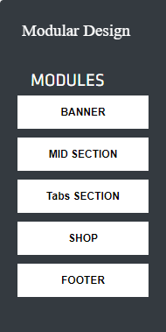
display: none
In the above figure we make a div and under that div we take two div one for the sidebar and another for the container where the element is going to be dropped. In the sidebar we make a div named “BANNER” in which we take another div for the content of the banner section. Since it is not displayed in the sidebar div because we hide the content of the banner section with “display” “none” property. It will displayed when the element is dropped into the droppable container. Similarly, we do with all different modules of the webpage.
As this is a modular website so every part of the webpage is in made with modular concept. In this we also added the Edit, Download, Preview and Save buttons.
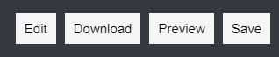

There is also a container where we drag the modules into it.
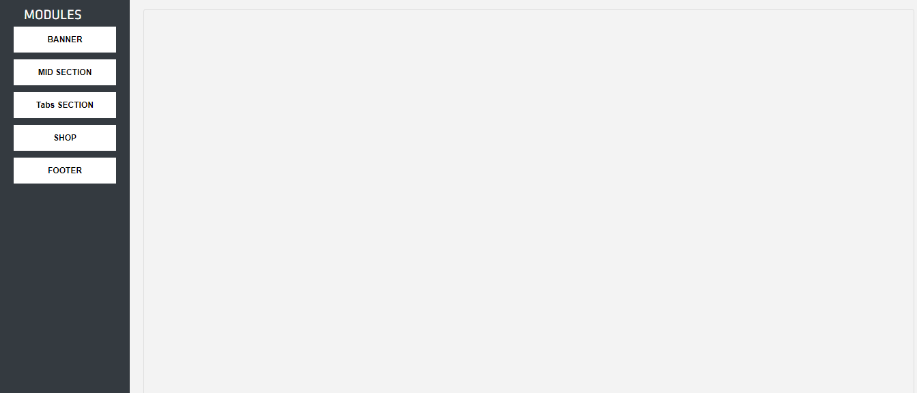

- Working
In this project we have created different modules. User can take any module of his/her choice and drag from the sidebar containing different modules and drop in the container.
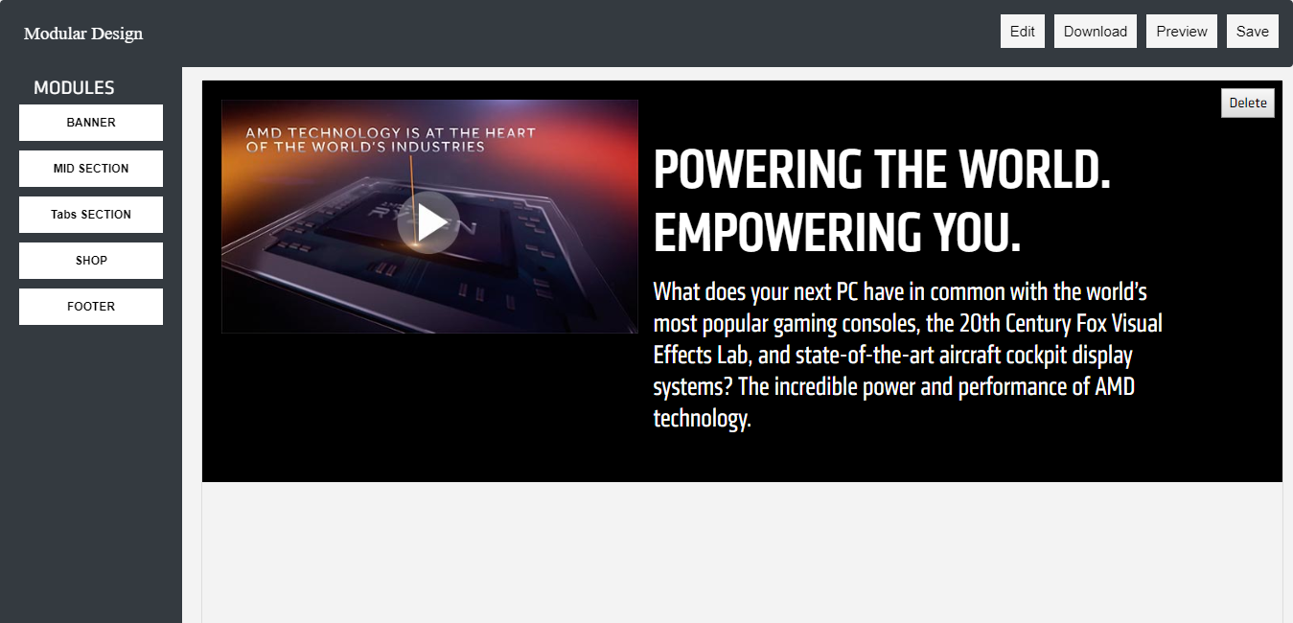
- Drag and Drop function
In the above figure we have drag the midsection module and drag into the container. For making the element Draggable we used the JQuery UI function “.draggable ()” to make the element draggable.
$("#neww4,#neww8,#neww14,#neww13,#neww6,#neww7,#neww144,#neww22").draggable({
helper:"clone",cursor: "pointer",});
In the code we just provide the id’s of the element which we want to draggable.
After dragging the element we drop into the container with the help of again JQuery UI function “.droppable ()” to make the element droppable into it.
$("#new1").droppable({
drop: function( event, ui) {
ui.draggable.clone().appendTo("#new1");

In the above code we make the container with id “new1” droppable with the function “.droppable ()”. In that we give the id of the container and also make the event “drop” to make the droppable function to be occurred. In the drop event we used the function “appendTo” to whatever element we want to drag is appending to the container.

- Make the content to be editable

Similarly, we make the every module draggable and it will be droppable into the container. After the dropping the element dropped into the container. Now, if user want to change something like the content then they can change the content like to change the heading, paragraph etc. For make the element editable we used the method “contenteditable=true” for each part of webpage which is supposed to be editable. Just like in the below figure we can change the module heading.

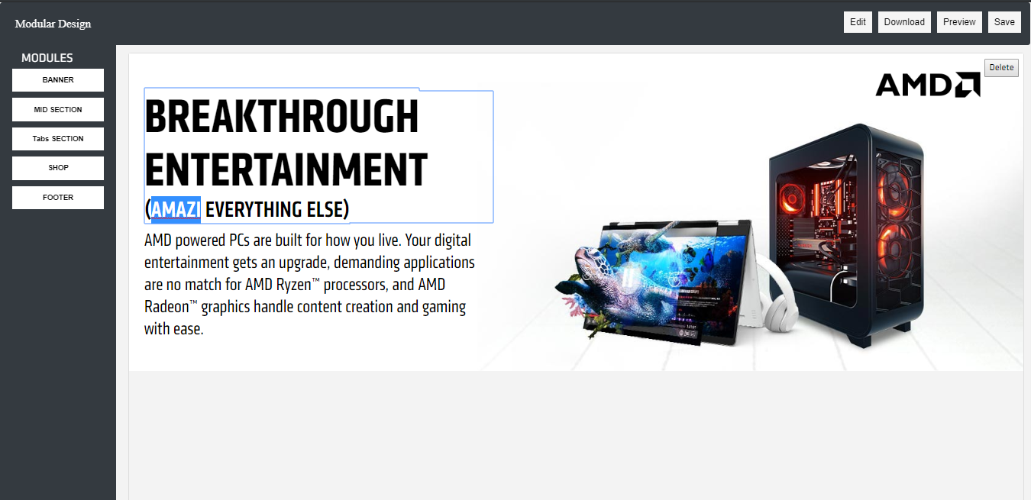
Content of the module is editable

- Make the modules sortable

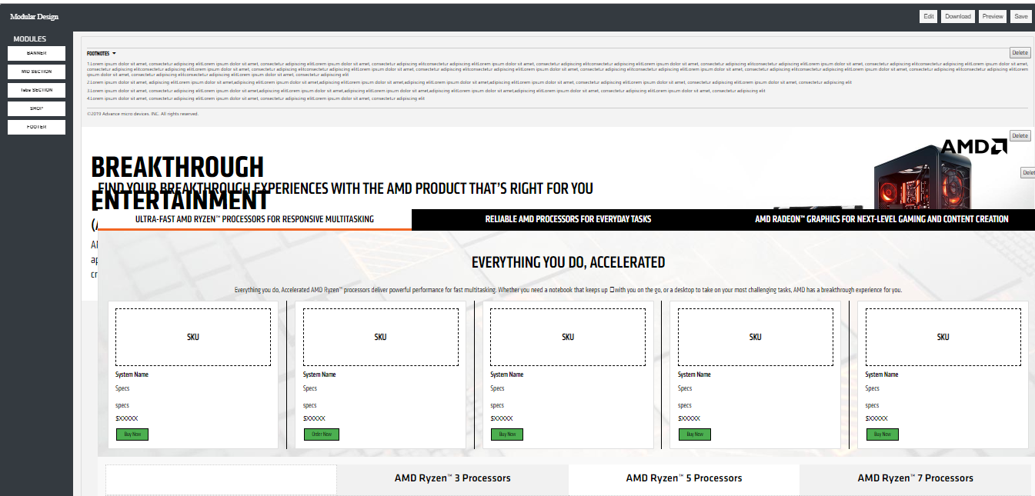

In the above figure we make the modules to be sortable which means that we can able to change the position such that if we want the banner section after mid-section then we have to just grab the module and drop it after the mid-section. Then the banner section will be set after the mid-section.
For that we just use the JQuery function “.sortable ()” to make the modules sortable.

$("#new1").sortable({
helper: 'clone',
receive: function (event, ui) {
ui.item.remove();
}
});

In the above code we have taken a .sortable () function in which we provide the id “new1” of the container such that every element of the container sortable. After that we make an event such that whenever we grab the container and drop it, then the event will remove the duplicate element created when we drop it into the container.

- Save Button

After when the user will satisfying with the content which he/she had made then the user will save the content with the Save button.
If user want to do changes something they can change the paragraph, heading etc. of that module and save the changes using the Save button.
SAVE BUTTON
function saveEdits() {
var editElem = document.getElementById("new1");
var userVersion = editElem.innerHTML;
localStorage.userEdits = userVersion;
}
function checkEdits() {
if(localStorage.userEdits!=null)
document.getElementById("new1").innerHTML = localStorage.userEdits;
}

In this code we have taken a function named saveEdits (). In which we have taken a variable editElem, in this variable we get the element which is going to be editable by document.getlementById (). After that we have taken another variable userVersion where all the editable content where going to be stored locally into a variable.
Another function checkEdits () such that when the editable element is none then all the content will be same as the previous. And when the editable element is there then it will save the change which we had made.

<body class="edit builder" onload="checkEdits()" >

We have to attached onload=”chechEdits ()” to the body tag. Then the function of the save button will work.

- Preview Button
Similarly they can do with all other modules. They just have to drag the modules and drop in the container and do changes if they want and save the content. After drag the container into its respective positions and did changes in the content. Now they can preview their webpage using the Preview button. As with the help of preview buttons they can see what the website look like in actual after make the changes.
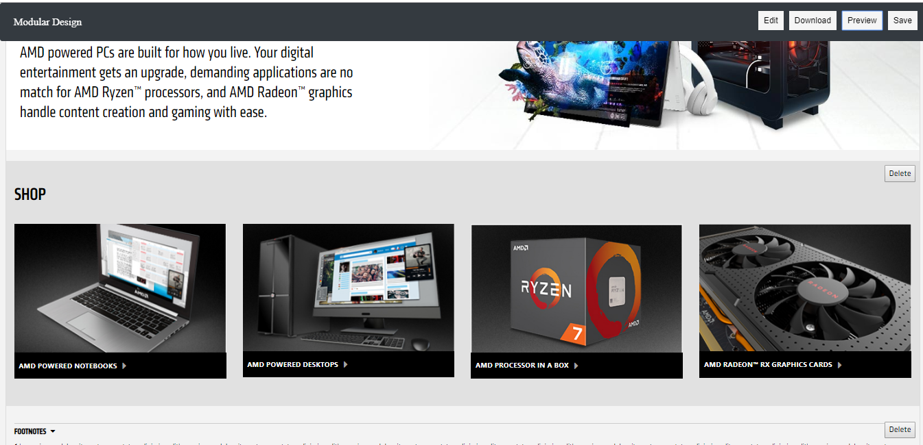
Body will be shift towards left.

$("#pre").click(function (){
$(".sidebar-nav").css("display","none");
$("body").css("margin-left","0px");
$(".navbar").css("margin-left","0px");
});

In the above figure when user click on the preview button then the side bar will disappear as we provided the “display” “none” property to the side bar and at the same time body of the webpage will margin-left to “0 px” and navigation bar will also margin-left to “0 px”.

- Download Button
If they want to add something more in the website they can use the Edit button. After satisfying with the changes done in the website. Now user can download the website code with the help of Download button.
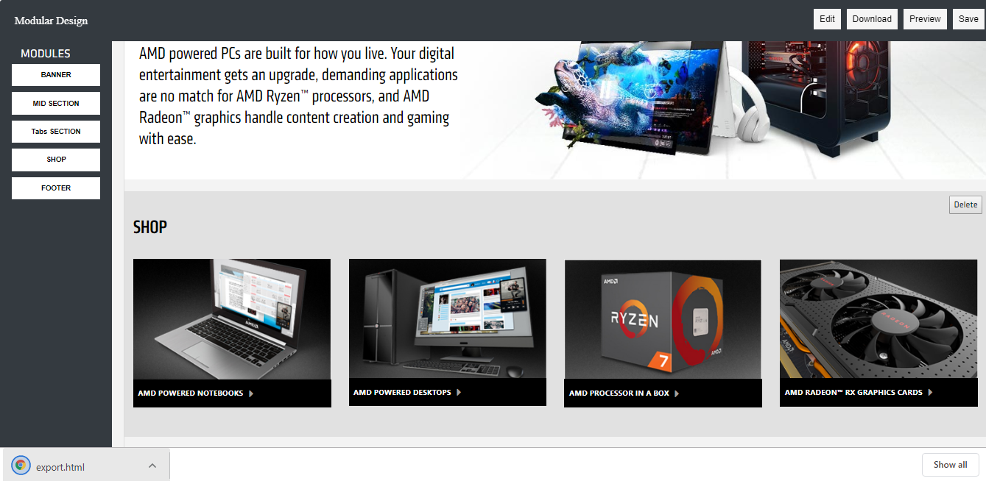
Downloaded Material

We have taken different modules of each section with its own HTML and CSS code such that no conflicts of code between different modules. Like the Banner section has its own code and Mid-Section has its own code and respectively.
function download(filename, exp_content) {
var element = document.createElement('a');
element.setAttribute('href', 'data:text/html,' + encodeURIComponent(exp_content));
element.setAttribute('download', filename);
element.style.display = 'none';
document.body.appendChild(element);
element.click();
document.body.removeChild(element);
}
// Start file download.
document.getElementById("download").addEventListener("click", function(){
var editableElements = document.querySelectorAll("[contenteditable=true]");
for (var i = 0; i < editableElements.length; i++) {
editableElements[i].setAttribute("contentEditable", false);
}
$(".header, .topnav, #about, #services").css("display","block");
var csslinks = "<link rel='stylesheet' type='text/css' href='https://stackpath.bootstrapcdn.com/font-awesome/4.7.0/css/font-awesome.min.css'> <link rel='stylesheet' href='https://cdnjs.cloudflare.com/ajax/libs/bootswatch/3.3.7/darkly/bootstrap.min.css'>";
var exp_content = csslinks + style + content + script_start +script ;
var filename = "export.html";
download(filename, exp_content);
}, false);

In this code we had taken a function named download and passing two parameters namely filename which provide the name of the file when you click the Download button to the function and a content which provide the content which going to be downloaded. After that we had created a variable name element in which we have pass the anchor tag into it. Then we will use the set Attribute () function in which we push the “href”, which provide the link and “data: text/html” which provide the content and lastly it will encoded and compressed into a downloaded file.
Again, we have taken a variable csslinks in which we put all the css links into it. Similarly, we have taken another variable style where we put all the CSS styles into it. Another variable exp_content which we had pass in our function. In which we concatenate all the variables which we are using in our download function.

Conclusion
Since our internship period, it has been a great learning experience at eClerx Service Limited, India. Currently, I am excited over working on new tasks which involve dealing with one of the greatest known client of eClerx. Getting involved in critical tasks has taught me a lot and provided knowledge on how to approach problems and different kinds of problems. And if stuck into those problems then how to come up with a different solution or a different approach to deal with the problem.
As there is a huge shift towards cloud technologies, In future I see getting myself exposed to more technologies and nourish my technical skills more. I also want to get my pre-placement offer at eClerx Service Limited, India after completion of my internship. I am very excited for the future projects that I will get and it’s fun dealing with the new projects and gaining lots and lots of experience.
References
- https://css-tricks.com/
- https:// https://www.w3schools.com/
- https:/ https://jqueryui.com/
- https://getbootstrap.com/
- http:// https://www.javascript.com/
- https:// https://codepen.io/
- https://eclerx.com/
- https:// https://jsfiddle.net/

