  - ACADEMIC PERFORMANCE FEEDBACK MANAGEMENT INFORMATION SYSTEM

User Manual
A practical guide for students and lecturers
Document details | Value
Prepared for | APFIS project handover and university project review
Authors | Gosego Sebaetse and Thamsanqa Ndlakuse
Version | 1.0
Prepared | 29 October 2026
Audience | Students, lecturers and project-day reviewers

About this manual
A practical guide for students and lecturers This guide describes the APFIS implementation in the repository snapshot reviewed for this document. The example manuals supplied with the request informed the section structure only; their AACMS features and claims are not part of APFIS.
Implementation note: APFIS is a prototype for local demonstration and academic review. It is not connected to an institutional learning management system, student information system, email service, or production database.

Contents
- 1. About APFIS
- 2. Start the applications
- 3. Student Performance Assistant
- 4. Lecturer Decision Support System
- 5. Understand the results
- 6. Privacy and responsible use
- 7. Troubleshooting
- 8. Quick workflow reference

1. About APFIS
APFIS provides two separate tools for academic performance planning. The Student Performance Assistant helps a student enter assessment details and marks, review a calculated profile, and explore improvement options. The lecturer Decision Support System helps a lecturer review a module cohort, identify students whose best-case mark is below the pass threshold, plan an individual target, and explore assessment-weight ranges.
The tools do not share student records. The student assistant does not receive a lecturer alert or message, and the lecturer DSS does not send recommendations to a student's device. A lecturer and student can discuss the separate results outside the application.

2. Start the applications
For the local demonstration, start the student app at port 5002, the lecturer app at port 5001, and the landing page at port 5000. Open http://localhost:5000 in a modern browser and choose the tool you need. If you are given a direct local link, use the Student Performance Assistant on port 5002 or the Lecturer Decision Support System on port 5001.
The lecturer app starts with a simulated CS101 sample module. It is provided so the dashboard can be explored immediately. Do not treat those sample values as official or real student results.

3. Student Performance Assistant

3.1 Begin a new student model
1. On the welcome screen, choose the new-student path.
2. In Phase 1, enter the student details and module, then define assessment categories, item counts and weights. Confirm the assessment framework before continuing.
3. Select Continue to Phase 2. The assessment categories expand into individual assessment rows.
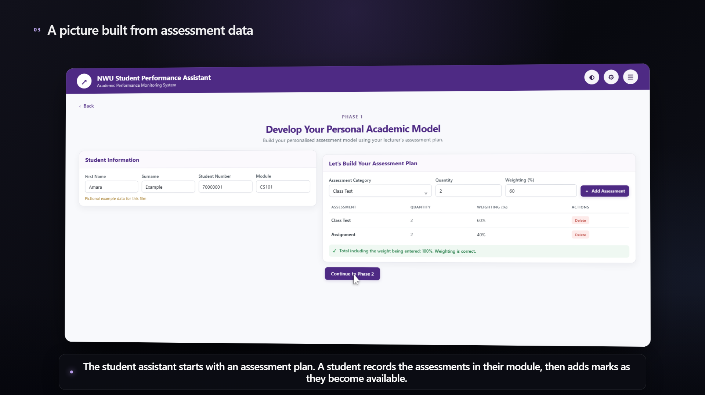
Figure 1. Student assistant Phase 1 assessment setup. Use fictional values for a demonstration.

3.2 Enter marks and review the profile
1. In Phase 2, enter marks for assessments that have been completed. Leave future assessments blank; a blank is not the same as a mark of zero.
2. Select Generate Model to calculate the profile from the assessment framework and marks you entered.
3. Review current participation, academic standing, completed work and remaining assessments. Check that the module and marks are correct before using the estimate.
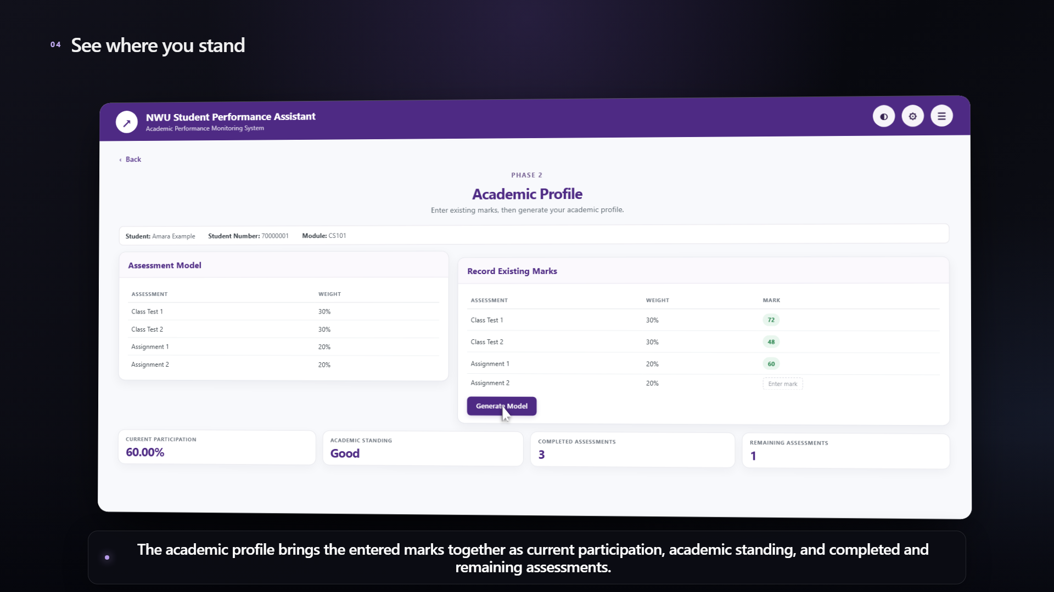
Figure 2. Phase 2 profile summarises the entered assessment results.

3.3 Explore improvement options
1. Continue to Phase 3 and select a target/improvement option supported by the screen.
2. Review the feasible option cards and any required result shown for remaining assessment items.
3. Treat the values as planning estimates based on your inputs. They are not an official final grade or a guarantee of a future result.
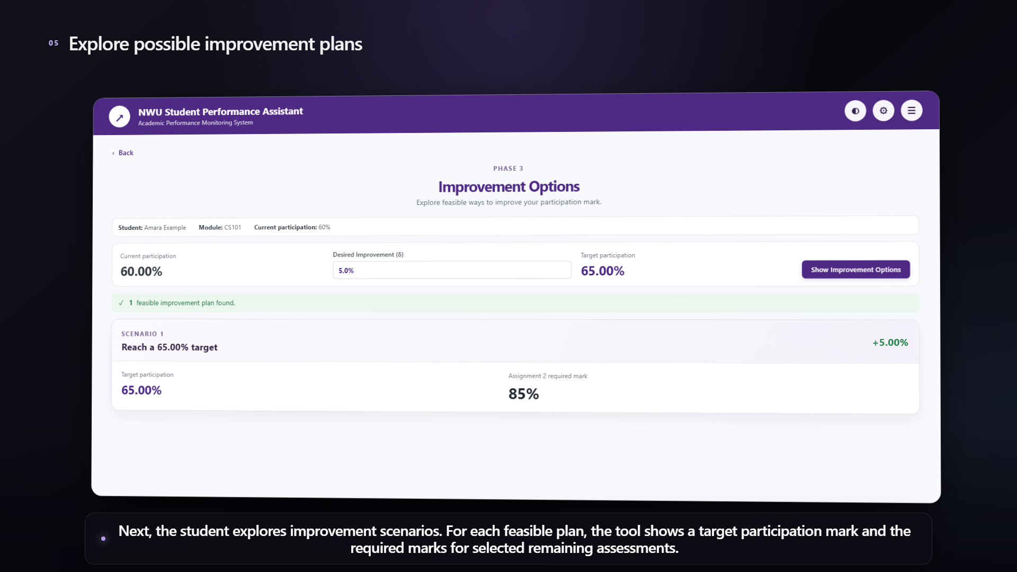
Figure 3. Phase 3 displays improvement options calculated from the entered marks.

3.4 Review and export the summary
1. Open Phase 4 to review the student information, assessment framework, marks and displayed profile/options.
2. Use the CSV export control if you want to save the assessment information for your own use.
3. To continue later, retain the downloaded APFIS CSV. On the welcome screen choose the returning-student option, select that file and import it.
The returning workflow expects the CSV structure created by this application. Do not edit the file structure manually. The CSV contains student details and assessment framework/marks; it is not a system backup of every calculated value.
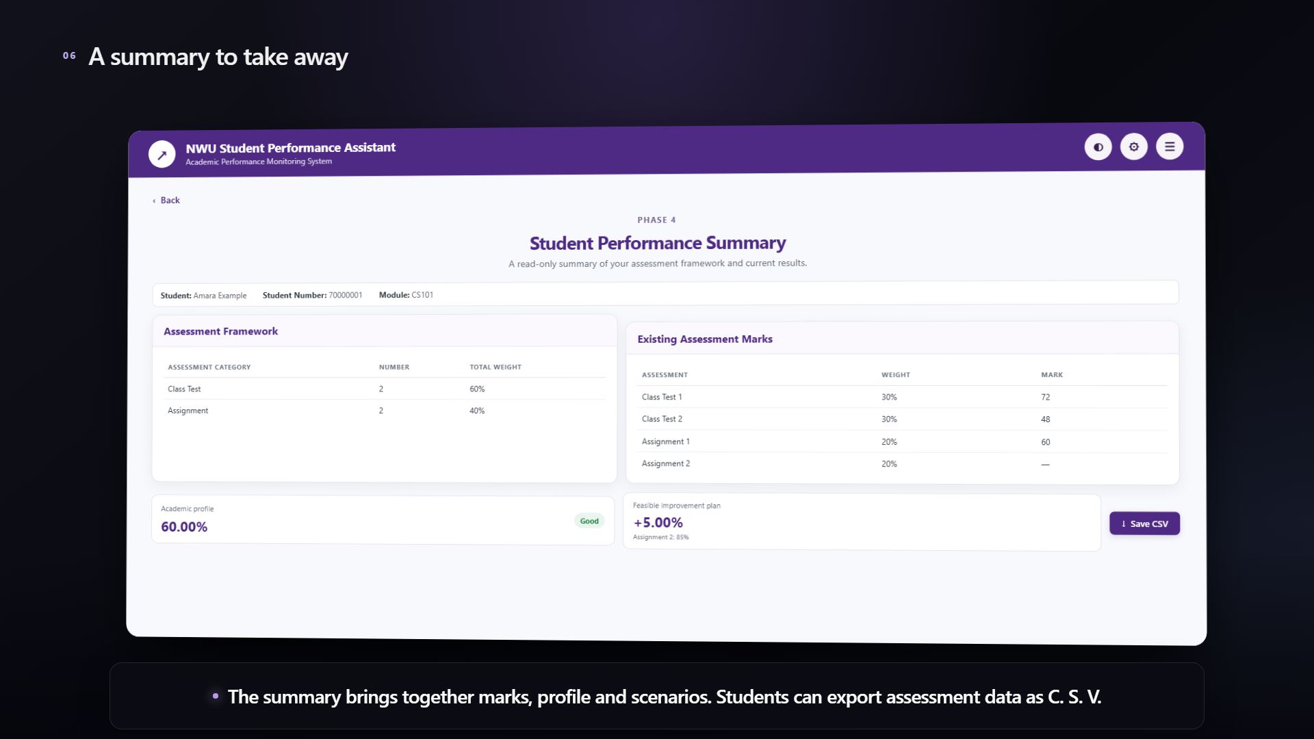
Figure 4. Phase 4 read-only student performance summary.

4. Lecturer Decision Support System

4.1 Open the module dashboard
1. Open the lecturer DSS. The sample module dashboard displays cohort-level participation, dropped marks, at-risk count and class size.
2. Use the navigation panel to open the student list, module/assessment plan, at-risk view, settings or tutorial.
3. Use the module controls to create a module, import a supported CSV file, or switch modules. Follow the page validation messages.
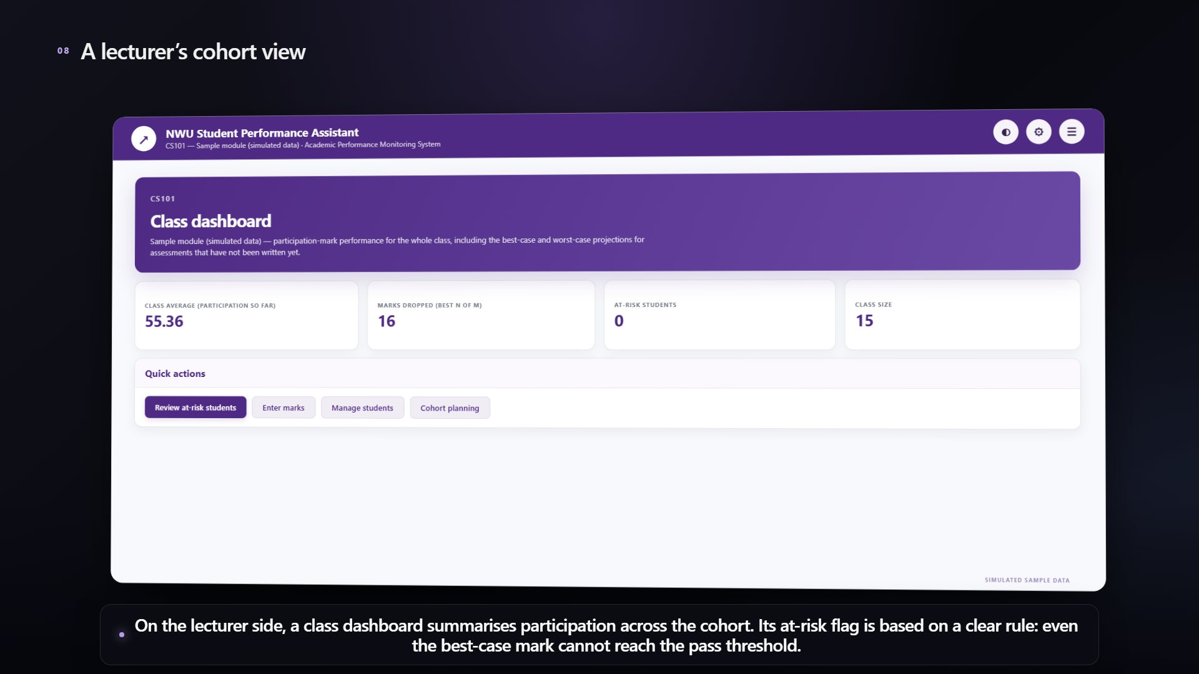
Figure 5. Lecturer dashboard. The displayed cohort values come from the bundled simulated sample data.

4.2 Add students and assessment marks
1. Create or select a module and define its assessment plan, including weight, number of items, and how many items count where best-N-of-M is used.
2. Add one student or import a supported student/mark CSV. The sample module and any demonstration data must remain simulated or anonymised.
3. Enter marks on the 0–100 scale. Leave an uncompleted assessment blank. Review the validation messages if a mark is outside the accepted range.

4.3 Review the at-risk list
The at-risk view lists students whose maximum feasible final participation mark is below the module pass threshold. If no rows appear, the current data contains no student meeting that rule. This does not mean the system evaluated all forms of academic risk.
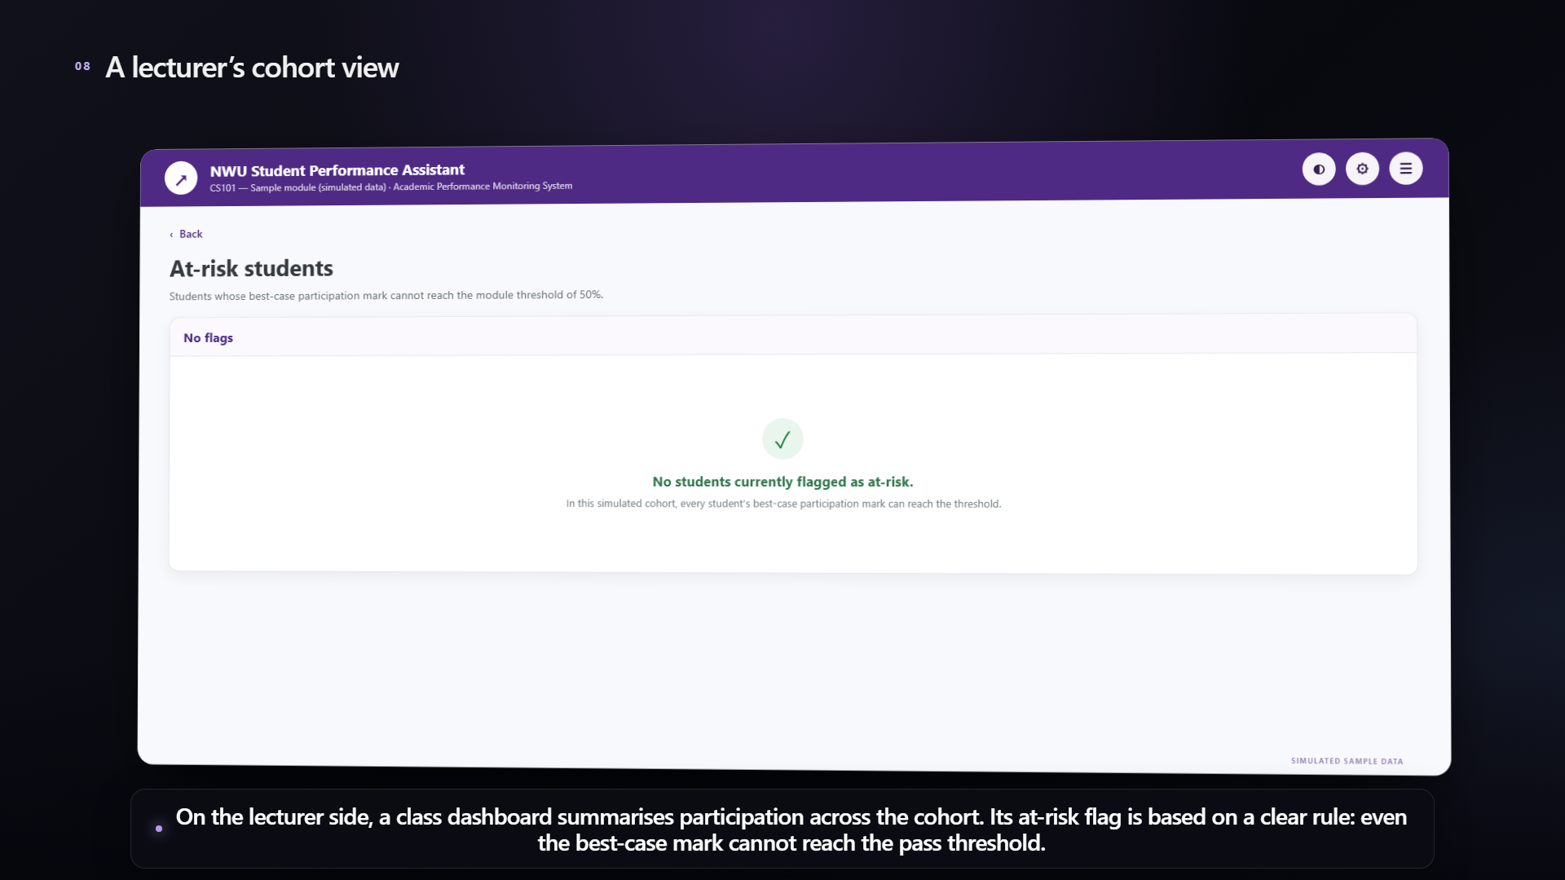
Figure 6. At-risk view. In the bundled sample module, no student is currently flagged by the rule.

4.4 Open a student and plan a target
1. Select a student in the cohort list to open the individual detail view.
2. Review the accrued participation mark, current standing, feasible final range and remaining assessment items.
3. Choose an absolute target inside the displayed feasible range. The page shows the minimum uniform level required across remaining items and any skippable-item notes that apply.
The lecturer DSS calculates and displays a plan for the lecturer. It does not send this plan to the student or create a notification.
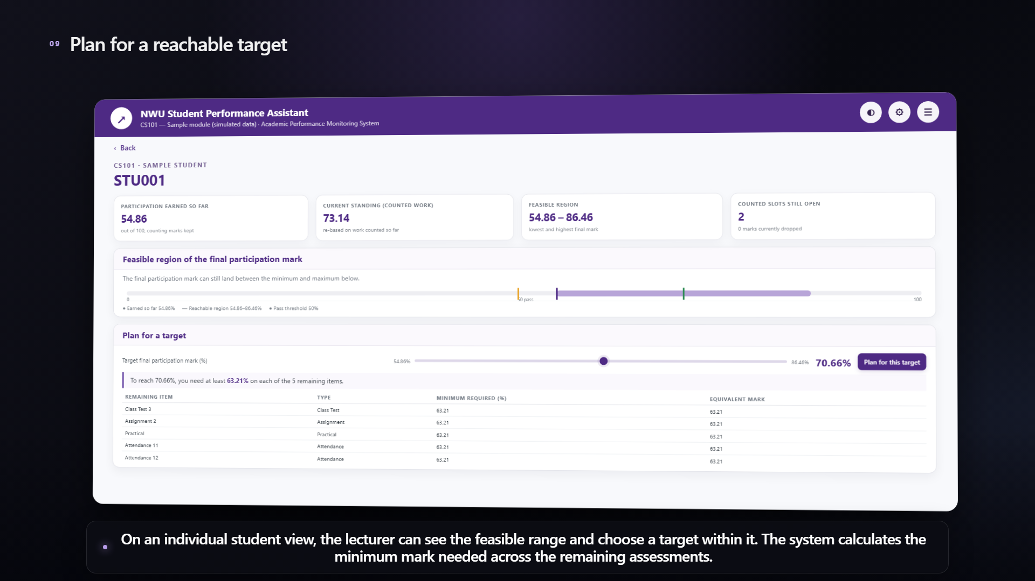
Figure 7. Lecturer individual plan with a feasible range and target requirements.

4.5 Explore cohort assessment weights
1. Open cohort planning and enter a target class average.
2. For each assessment, enter a minimum and maximum weight. Minimums must be positive, the minimum cannot exceed the maximum, the ranges must allow a 100% total, and the solver enforces a 1% minimum weight.
3. Calculate weights and review the solver status, proposed weights and resulting average. Treat this as a planning scenario rather than a guaranteed outcome.
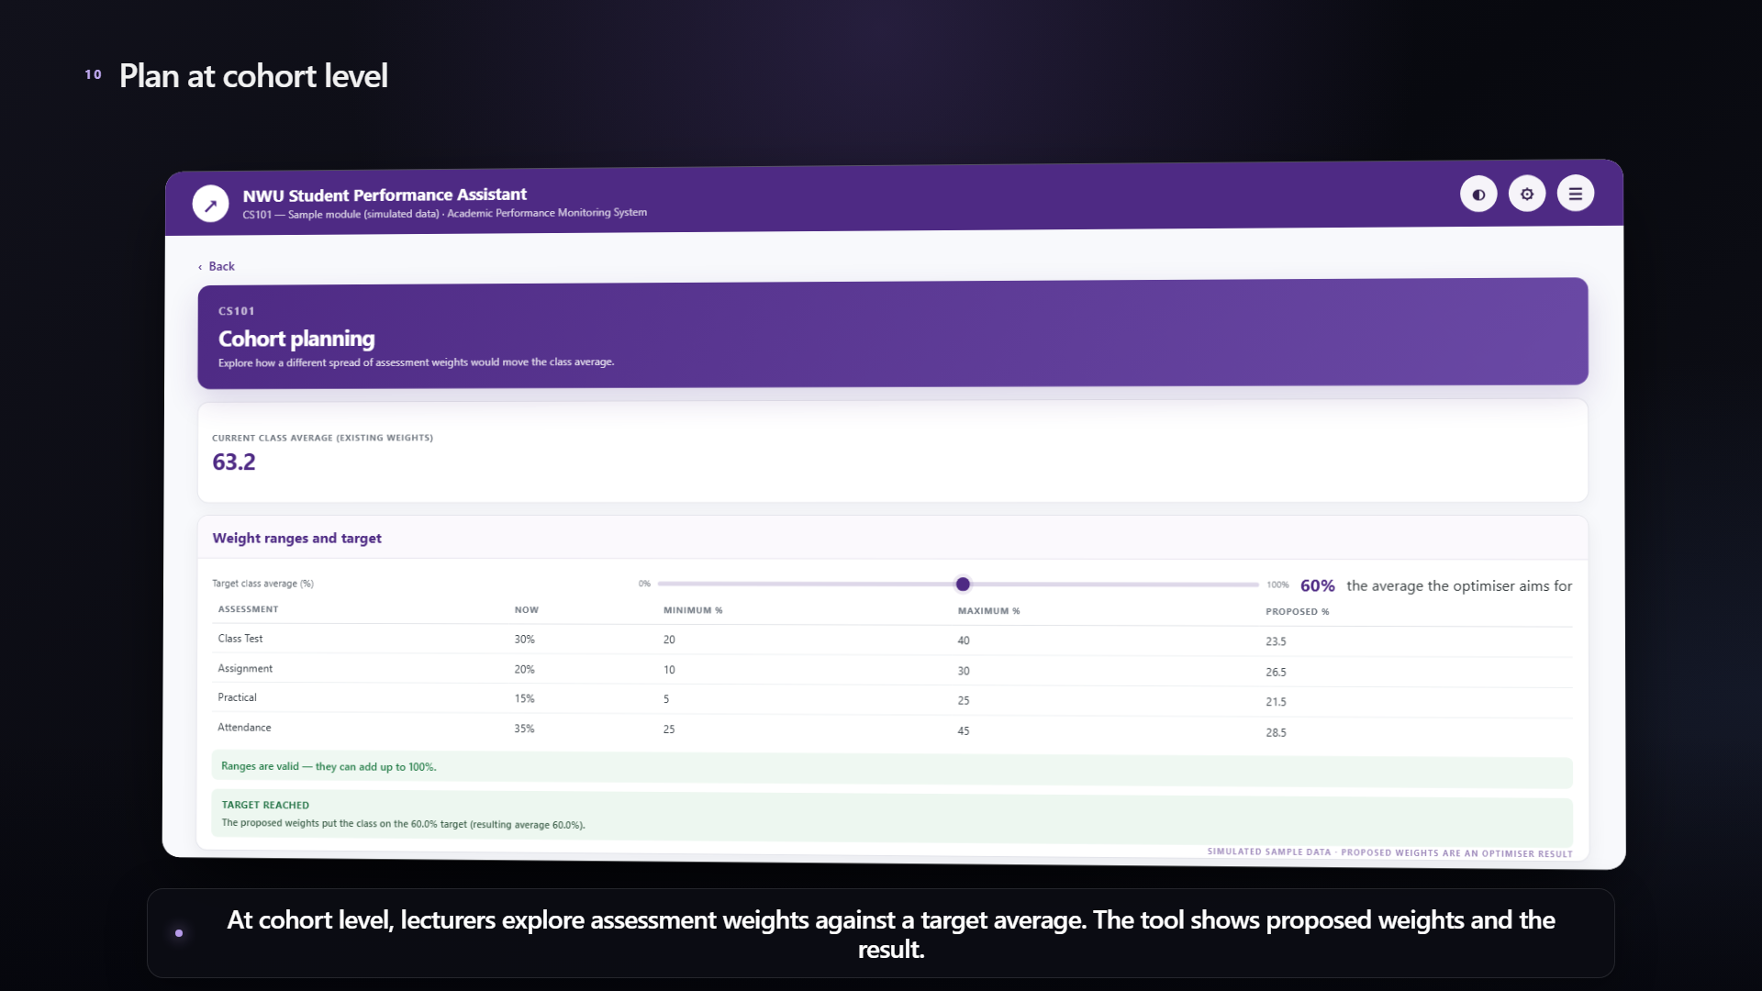
Figure 8. Lecturer cohort planner displays weight ranges and an optimisation result.

5. Understand the results
Label | How to read it
Participation so far | Weighted contribution accrued from marks that currently count.
Standing | Average across the work that has counted so far; it may differ from the accrued contribution.
Feasible range | The minimum and maximum final mark possible under the entered assessment plan.
At risk | The best-case feasible final mark is below the configured pass threshold.
Required mark | The modelled mark level needed to reach the selected target, assuming the entered assessment plan and marks are correct.
Cohort weight proposal | An optimisation result under the entered ranges and target; it is not a prediction of student behaviour.

6. Privacy and responsible use
- Keep the tools separate: the lecturer DSS and student assistant do not share records.
- The student assistant saves data in the current browser's local storage. Use a private device/profile and avoid a shared public computer when entering personal details.
- Lecturer module data is held in server memory and is cleared when the lecturer service restarts. Use CSV export only where appropriate and store exported files securely.
- For demonstrations, use invented names and marks. The bundled lecturer cohort is simulated.
- APFIS does not read LMS logins, submissions or attendance activity and does not send email, push notifications or in-app messages to students.
- Use the output to support discussion and planning. Confirm marks, weights and pass rules against the official module information.
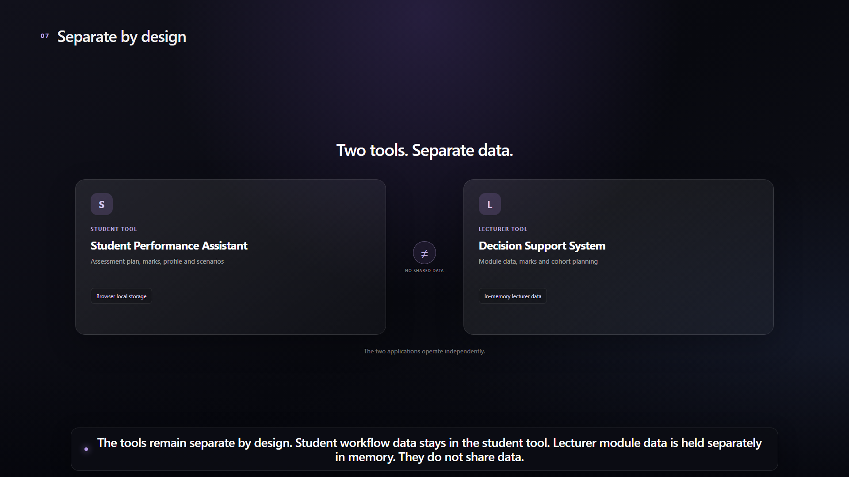
Figure 9. The two tools operate independently and do not share student data.

7. Troubleshooting
Problem | What to check
Landing page says an app is unavailable | Confirm the relevant local server is running on port 5001 or 5002; restart it if needed.
Student phases do not show saved information | Use the same browser and origin; check that local storage is available and that the model was saved in Phase 1.
Returning CSV is rejected | Choose the CSV exported by APFIS and avoid changing its section headings or rows.
Marks are not accepted | Enter a number from 0 to 100; leave an unwritten assessment blank.
Lecturer data disappeared | The lecturer store is in memory and resets when that service restarts. Re-import a suitable CSV or recreate the demo data.
No student appears on the at-risk page | The rule only flags a student when their maximum feasible final mark is below the configured pass threshold.
Weight calculation reports invalid ranges | Check positive minimums, minimum ≤ maximum, and whether all ranges can total exactly 100%.

When asking a developer for help, include which tool and screen you were using, the steps immediately before the issue, and the exact validation message. Remove names, student numbers and marks from screenshots unless the data is fictional and approved for sharing.

8. Quick workflow reference
Student assistant | Lecturer DSS
Welcome → assessment plan → enter existing marks → generate profile → explore improvement options → review/export summary | Choose module → define assessment plan → add/import cohort → review dashboard and at-risk rule → open student target plan → explore cohort weight ranges

