localhost Ltd

*** spl@sh ***

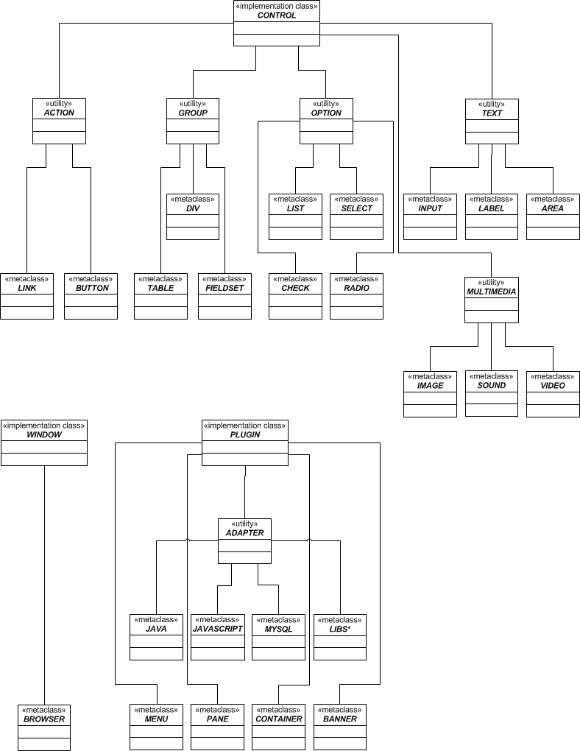

      - The spl@sh extension provides a subsystem of classes.

Diagram & Description

The spl@sh extension provides a set of classes divided and categorized in groups. The three main classes or implementation classes are:
- WINDOW (defines general features of a window)
- CONTROL (defines general features of controls)
- PLUGIN (defines general features of plugins)

The utilities are intermediate classes that group related meta-classes.
The utilities classes are:
- ACTION (classes of objects that cause an event)
- GROUP (classes that handle objects that group other objects)
- OPTION (classes that handle objects that offer options)
- TEXT (classes that handle text)
- MULTIMEDIA (classes that handle images or video)
- ADAPTER (classes that bridge different languages or libraries with spl@sh)

Meta-classes are classes which were extended by utility classes. They inherit common options but differ in object specific options.

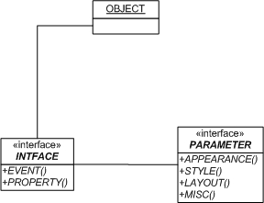

(2) The framework object and its interfaces.

Each object of the framework has METHODS and ATTRIBUTES. EVENTS trigger one or more METHODS and PROPERTIES that cause changes to ATTRIBUTES.
Each object provides an interface with EVENTS and PROPERTIES that interact according to another interface that provides PARAMETERS. These PARAMETERS are related to APPEARANCE, to STYLE, to LAYOUT or to MISCELLANEOUS options.

